SENIOR FIVE TERM 3 PHYSICS 2026

TOPIC 1/6: REFLECTION OF LIGHT

Competency: The learner investigates the light reflecting properties of different surfaces and their applications in real life.

Optics
Optics is the study of light energy and its properties

Evidences that light is a form of energy
- When light enters our eyes, it enables us to see.
- When light is absorbed by green plants, it enables then to make their food by photosynthesis
- When light is incident on certain materials, the surface electrons acquire energy and escape. This process is called photoelectric emission.

Light rays
The path taken or indicating the direction along which light energy travels is known as a ray of light. A ray is indicated with an arrow.
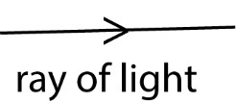

Beam of light
A group of light is called a beams. There are three types of beams namely

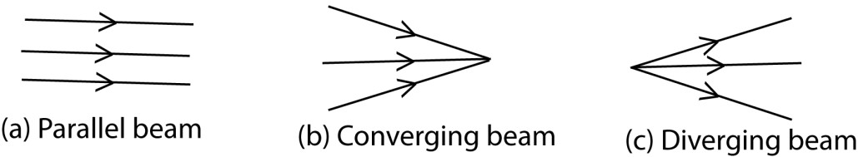
Reflection of light at a plane mirror
Reflection is the bouncing back of light energy when it meets an obstacle

Laws of reflection of light
Consider a ray of light AO incident on a plane surface and then reflected along OB as shown.

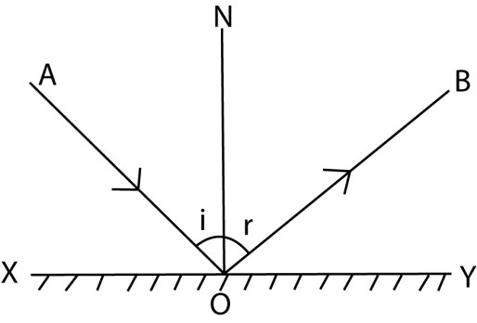
O = point of Incidence.
AO = incident ray OB = reflected ray.
ON = normal to the reflecting surface
<i = angle of incidence
<r =angle of reflection

LAW 1:
The incident ray, the reflected ray, and the normal at the point of incidence all lie in the same plane.
LAW 2:
The angle of incidence is equal to the angle of reflection.

Example 1
State laws of reflection

Types of reflection:
- Regular reflection: This occurs when a parallel beam of light incident on a smooth surface such as a plane mirror gets reflected as a parallel beam as shown.

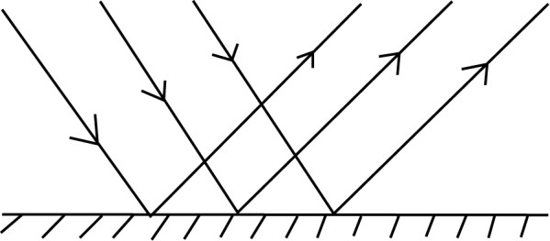

- Diffuse /irregular reflection: This occurs when a parallel beam of light incident on a rough surface such as a paper gets reflected while scattered in different directions as shown
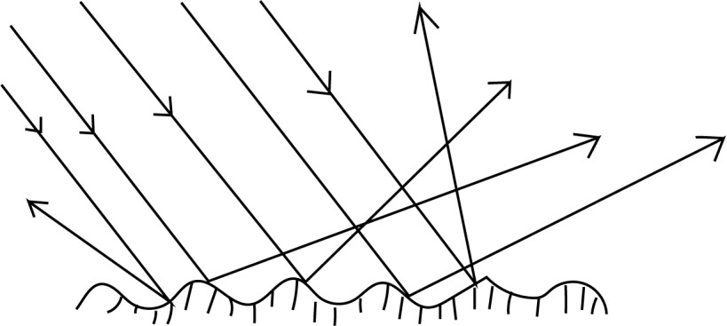

Differences between regular and irregular reflection
Regular reflection | Irregular reflection
Occurs on smooth surface | Occurs on a rough surface
Parallel incident beam is reflected parallel | Parallel incident beam is scattered after reflection
Reflected beam is very bright | Reflected beam is dull

Deviation of light at plane mirror surfaces
This is the property of a plane mirror to deviate incident light from its original direction to another.

Let g be the glancing angle made by the ray AO with the mirror XY as shown

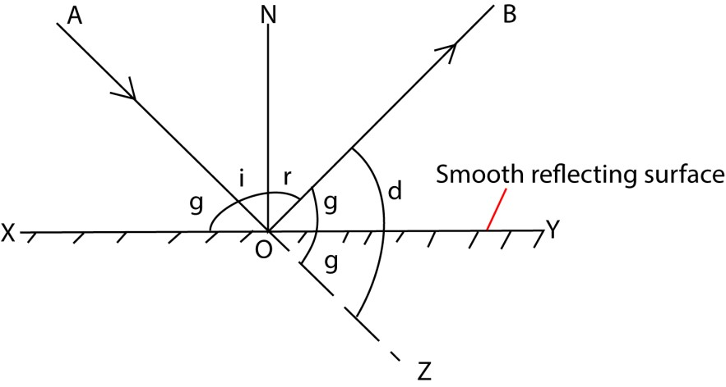
d = ZOB d = g + YOB YOB = (90-r) but r =i (laws of reflection) ➔ (90 – r) = (90 – i) = g d = g + g d = 2g

Hence, the angle of deviation of a ray by a plane surface is twice the glancing angle

Example 2
Prove that a ray incidence on a plane mirror, d = 2g. where d is the deviation and g is the glancing angle.

Deviation of reflected ray by rotated mirror
Let XY be the initial position of the mirror with ray AO making a glancing angle g. By keeping the direction of the incident ray fixed, the mirror is rotated through an angle α to a new position X’Y’ as shown.

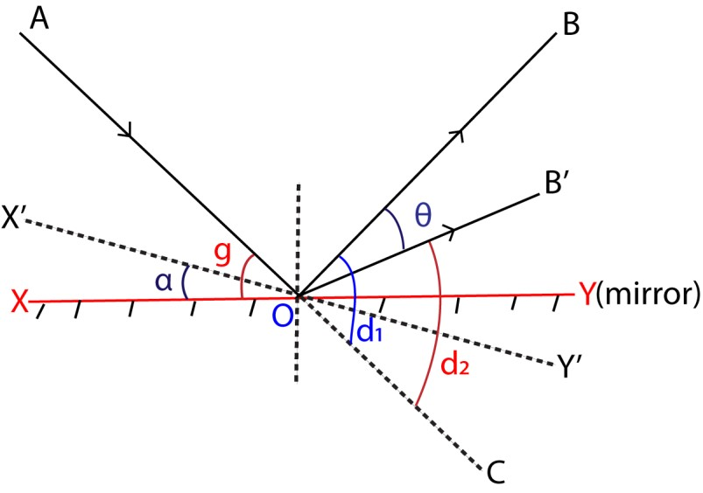

Case 1 (mirror in position XY)
Glancing angle = g
Deviation d₁ = 2g……… (i)

Case 2(mirror in position X’Y’)
Glancing angle = (g – α) Deviation d₂ = 2(g – α) …..(ii) θ = d₁ –d₂
= 2g - 2(g – α)
= 2g-2g + 2α
= 2α

Hence, if the direction of incident ray is constant, a reflected ray rotates through an angle = 2α, when the mirror is rotated through an angle α.

This is applied in optical lever in mirror galvanometer where a beam of light serves as a pointer.

Advantages of optical lever to metallic pointer (i) Its weight is negligible hence highly sensitive (ii) Magnifies the angle of rotation.
(iii) Can be used to measure very small electric current and small changes in length due to expansion and contraction of solid.

Action of optical lever

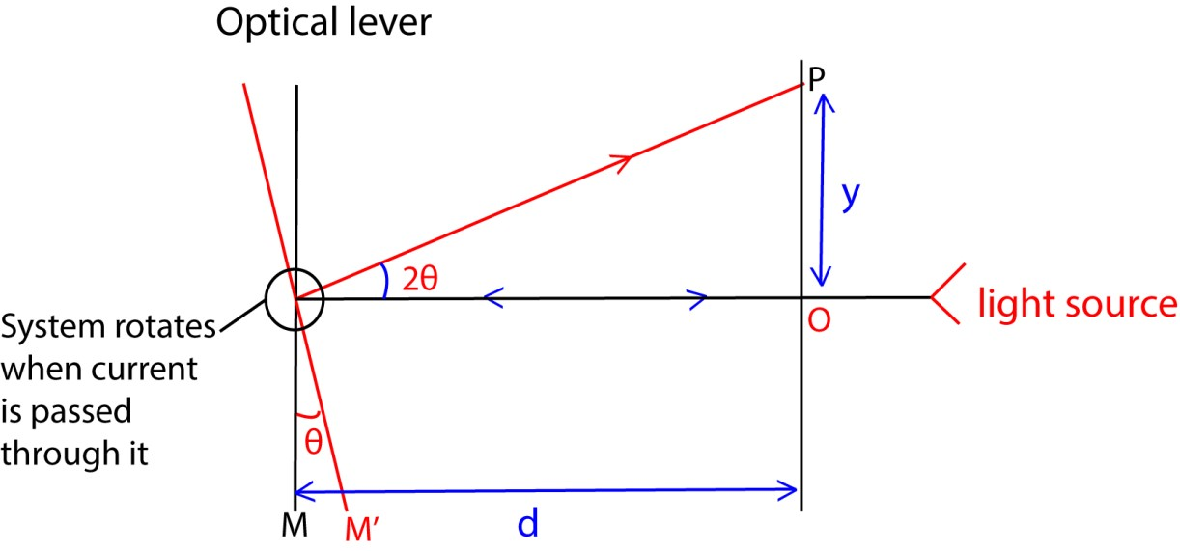

- A beam of light from the light source is normal to the mirror and is reflected back through the same direction at O
- Current through the galvanometer causes the coil to rotate the mirror through an angle θ to position M’ and the beam of light is reflected through angle 2θ and deflected to position P by displacement y.

Example 3
- Describe briefly the action of optical lever.
- An optical galvanometer of sensitivity 0.05 radian per M.A is used to measure current of 0.2A. the distance of the cell from the linear scale is 30cm. Find the displacement of light spot on the scale from the initial position.
Solution

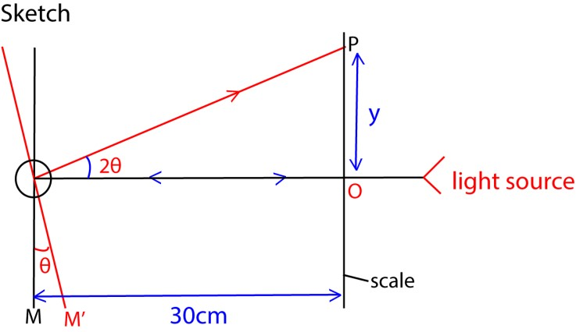
360⁰ = 2π radian
1MA of current through the coil turns the mirror through an angle 0.05radian
It implies that, 0.02MA turns the mirror through 0.05 x 0.2 = 0.01radians The reflected ray turns through 2θ= 2 x 0.01 = 0.02 radians

But tan2θ = y/30 tan 0.02 = y/30;
y = 0.6cm

Deviation by successive reflections at two inclined mirrors
Consider an incident ray of light reflected successively from two mirrors M₁ and M₂ inclined at an angle θ to each other at O as shown



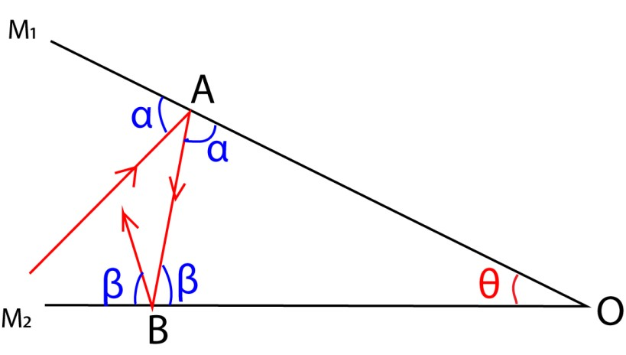
Let the glancing angles at A and B be a

re
sp
ec
t
i
v
e
l
y
.
Deviation by M₁ = 2α ( clockwise direction )
Deviation by M₂ = 2β ( clockwise direction )
Total deviation = 2α + 2β

= 2 (α + β ) ----------------------(i)
But, α + β + θ = 180⁰ ( Angle sum of a triangle )
=> α + β = ( 180⁰ - θ ) ---------------------(ii)

Combining equation ( i ) and (ii) gives
Total deviation = 2(180⁰ - θ) (clockwise direction)
= 360⁰ - 2θ (clockwise direction) = 2θ (anti-clockwise direction)

Thus, the deviation produced by two inclined mirrors is twice the angle between the mirrors when a ray under goes two successive reflections.

NOTE
- Clock wise deviation (360⁰ - 2 θ) + anti-clockwise deviation (2 θ) = 360⁰
- The above result finds application in the sextant, a device for measuring the angle of elevation of the sun or stars.

The sextant
A sextant is an instrument used in navigation for measuring the angle elevation of the sun or stars or the angle between two objects in space. It works on the principle of two inclined mirrors. The estimation of this angle, is known is sighting or shooting the object, or taking a sight.

Principle of a Sextant
The principle of a sextant is that, when the ray of light is reflected from two mirrors in succession in the same plane, then the angle between the incident and reflected ray is two times the angle between the mirrors.
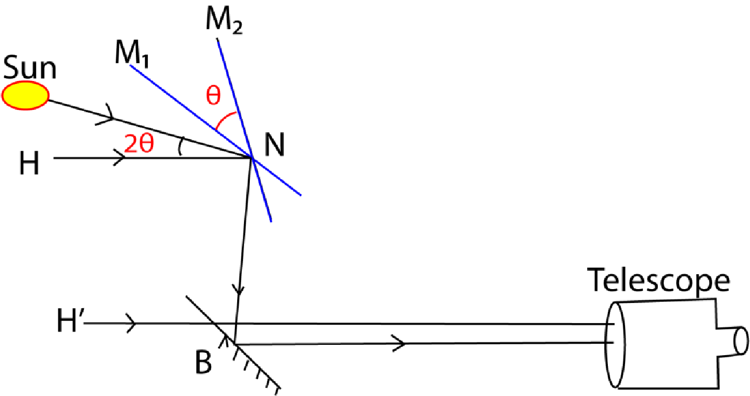
- A sextant consists of a fully silvered mirror M1which can be rotated about a horizontal axis and a fixed half silvered mirror B.
- Mirror M1 is adjusted to become parallel to B by rotating it until the image of the horizon, H’ is seen directly through the un silvered part of mirror B. Note that, if the two mirrors are parallel, the incident ray from any observed body must be parallel to the observer’s line of sight through the horizon glass
- H is the horizon as seen by successive reflection by successive reflection in mirror M₁ and B respectively
- The mirror M₁ is rotated to position M₂ such that the image of the horizon H, sun coincides with H’
- The angle of rotation is measured from the scale on the instrument. The elevation of the sun is 2θ.

Example 4
Describe briefly how the elevation of the sun can be determined using the principle of the sextant or briefly describe the operation of the sextant.

Image formation in plane mirrors
Consider an object A placed in front of a mirror M.

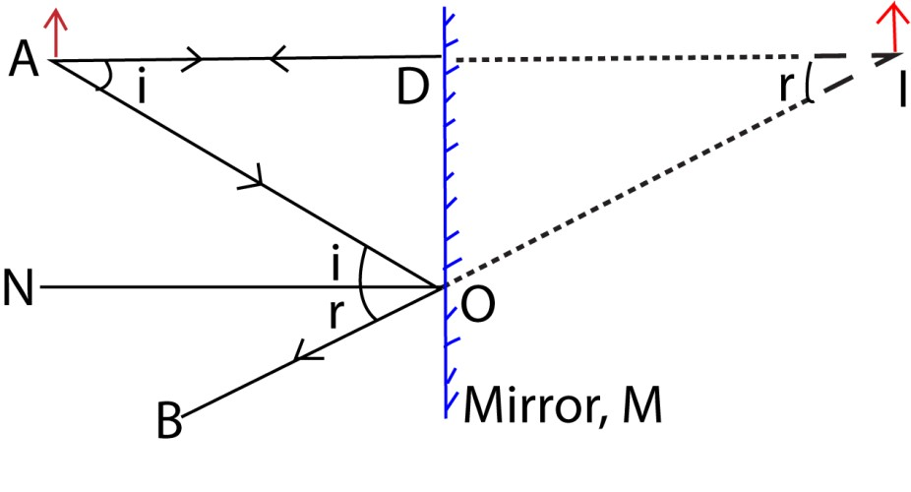

A ray AD from A incident normally on the mirror at D is reflected back along DA. Thus this reflected ray appears to come from a point I behind the mirror. The intersection I of the rays AD and BO is the image position.

From above,
<DAO = <AON --------------------------- (alternating angles)
<AON = < NOB -------------------------- (2nd law of reflection)
<NOB = < DIO ---------------------------- (corresponding angles)
Combining all the equations gives
<DAO = <AON = < NOB = < DIO

=> <DAO = < DIO tan < DAO = tan < DIO
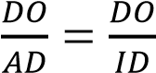
Thus AD = ID.
The image is as far behind the mirror as the object is in front

CHARACTERISTICS OF IMAGES FORMED BY PLANE MIRRORS
- It is virtual
- It is erect
- It is laterally inverted
- It is of the same size as the object
- It is as far behind the mirror as the object is in front

Uses of plane mirrors
- Dressing mirrors
- In telescope
- In periscopes

Number of images formed by two plane mirror inclined at an angle, θ
Two plane mirrors inclined at an angle θ to each other. The number of images formed is given by the formula

n = 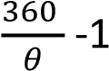

Example 4
What is the number of images formed between two mirrors inclined at 600 to each other?
(5)

Image location by no parallax

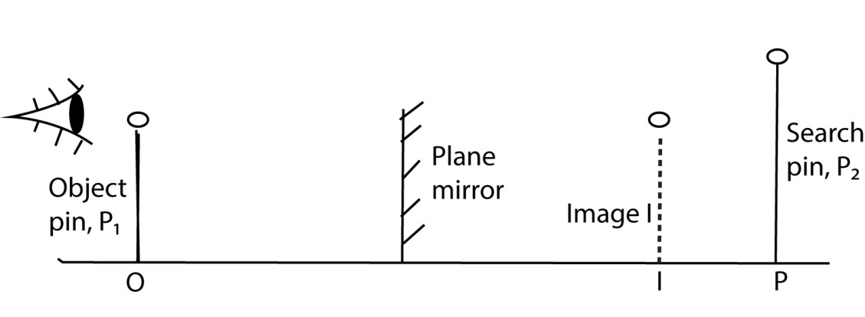

An object pin O is placed in front of a plane mirror to form a virtual image I.

A large search pin P is placed behind the mirror and moved to such a position that there is no parallax between pin P2 and the image I.

The image position has therefore been located.

NOTE
Parallax is the perceived change in position of an object seen from two different places No parallax method of locating an image involves an image coinciding in positionwith a search pin such that when the observer’s head is moved sideways, both the image and the search pin appear to move in the same direction. This is when there is no relative motion between them.

Example 5
A man 2m tall whose eye level is 1.84m above the ground looks at his image in a Vertical mirror. What must be the minimum vertical length of the mirror so that the man can see the whole of himself completely in the mirror?

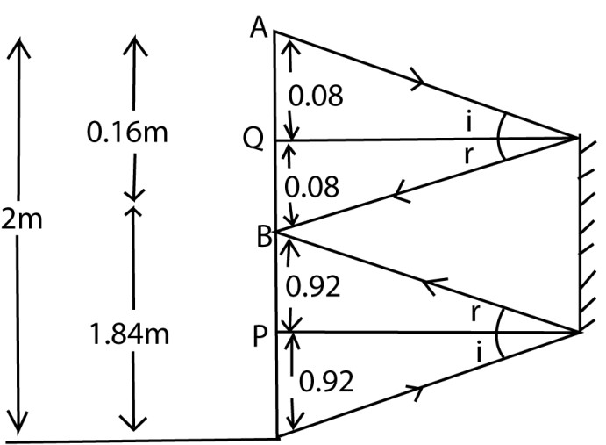

Rays from the top of the man are reflected from the top of the mirror and are incident in the man’s eyes (point B is the man’s eye level)

Since AQ = BQ then, BQ 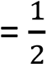 x 0.16 = 0.08m Similarly BP = PC.
Thus BP 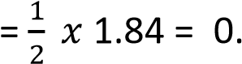92m

The minimum length of the mirror = BQ + BP
= 0.08 + 0.92 = 1m

Comparison of plane mirrors and reflecting prisms
- Un like in prisms, plane mirrors produce multiple images
- The silvering in plane mirrors wears out with time while no silvering is required in prisms
- Unlike in prisms, plane mirrors exercise loss of brightness when reflection occurs at its surface.

Revision exercise 1

1. (a) (i) With the ais of digrams, differentiatebetween regular and irregular refelection
(03marks)
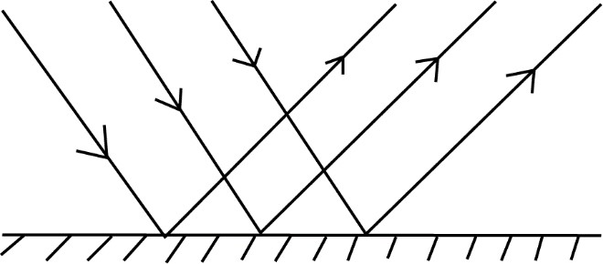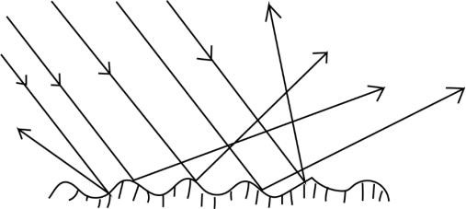

Regular reflection

Irregular reflection

Differences between regular and irregular reflection
Regular reflection | Irregular reflection
Occurs on smooth surface | Occurs on a rough surface
Parallel incident beam is reflected parallel | Parallel incident beam is scattered after reflection
Reflected beam is very bright | Reflected beam is dull

(ii) Show that if two plane mirrors are inclined at an angle, x, then the total deviation of a light ray produced is 2x after reflection once in each mirror. (03 marks)
Deviation by successive reflections at two inclined mirrors
Consider an incident ray of light reflected successively from two mirrors M₁ and M₂ inclined at an angle x to each other at O as shown

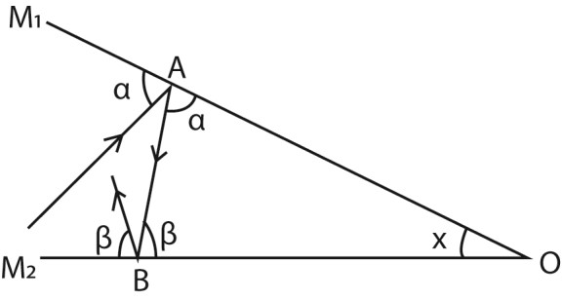

Let the glancing angle at A and B be α and β respectively
Deviation by M₁ = 2α (clockwise direction)
Deviation by M₂ = 2β (clockwise direction)
Total deviation = 2α + 2β
= 2(α + β) …………………. (i)
But α + β + x = 180 (Angle sum of a triangle)
α + β = 180 – x ……………………... (ii)
Combining (i) and (ii)
Total deviation = 2(180 – x) (clockwise)
= 360 - 2x (clockwise)

= 2x (anticlockwise)

- (a) (i) State two differences between real and virtual images (02marks)
A real image is formed by actual intersection of rays and can be formed on a screen while virtual image is formed by apparent intersection of rays and cannot be formed on a screen.
(ii) Explain with the aid of a diagram how thick plane mirror forms multiple images (04marks)
Formation of multiple images in thick plane mirror
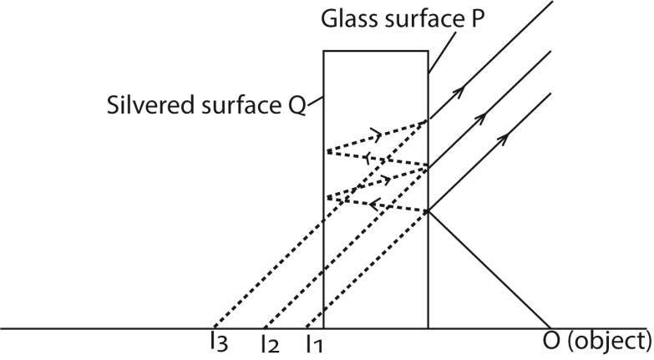
Multiple images are formed due to partial reflection and refraction at the non-silvered surface of the mirror.
    - İmage I₁ is formed by reflection on the glass surface P
    - The image I₂ (the brightest is formed by reflection of the most light on the silvered surface Q
    - Others by partial refraction

- (a) (i) State the laws of reflection of light. (02marks)
    - The incident ray, the reflected ray and the normal at the point of incidence all lie in the same plane
    - The angle of incidence is equal to the angle of reflection
(ii) A ray of light is incident on a plane mirror. The mirror is then turned through an angle α keeping the direction of the incident ray constant. If a reflected ray turned through angle β, find the relationship between α and β.
Let XY be the initial position of the mirror with ray AO making a glancing angle g. By keeping the direction of the incident ray fixed, the mirror is rotated through an angle α to a new position X’Y’ as shown.

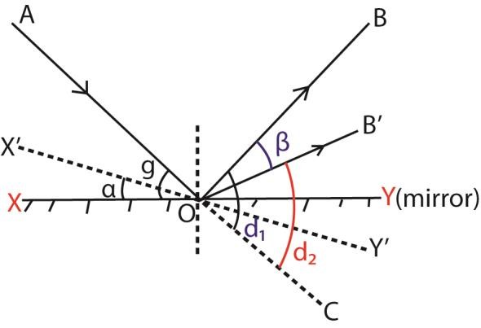

Case 1 (mirror in position XY)
Glancing angle = g
Deviation d₁ = 2g……… (i)
Case 2(mirror in position X’Y’)
Glancing angle = (g – α) Deviation d₂ = 2(g – α) …..(ii) β = d₁ –d₂ = 2g - 2(g – α)
= 2g-2g + 2α
= 2α

(b) Describe how a sextant is used to determine the angle of elevation of a star. (05marks)
Setup
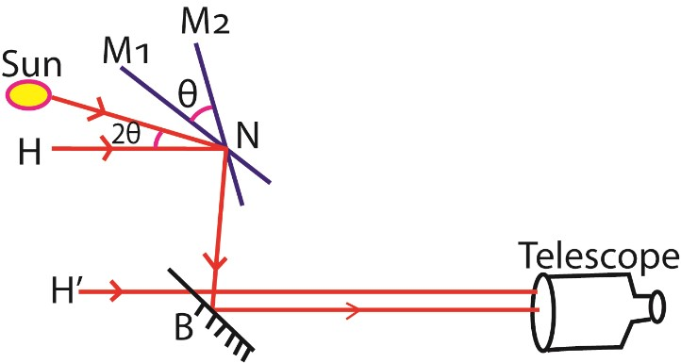
- A sextant consists of a fully silvered mirror M1which can be rotated about a horizontal axis and a fixed half silvered mirror B.
- Mirror M1 is adjusted to become parallel to B by rotating it until the image of the horizon, H’ is seen directly through the unsilvered part of mirror B by successive reflection in mirror M₁ and B respectively
- The mirror M₁ is rotated to position M₂ such that the image of the horizon H, and the sun coincides at H’
- The angle of rotation is measured from the scale on the instrument. The elevation of the sun is 2θ.

4. (a) (i) Distinguish between real and virtual images. (02marks)

A real image is one formed by actual intersession of rays and can be formed on the screen while a virtual image is formed by apparent intersession of rays and cannot be formed on a screen.
(ii) Describe how the position of an image in a plane mirror can be located (03marks)

Image location by no parallax

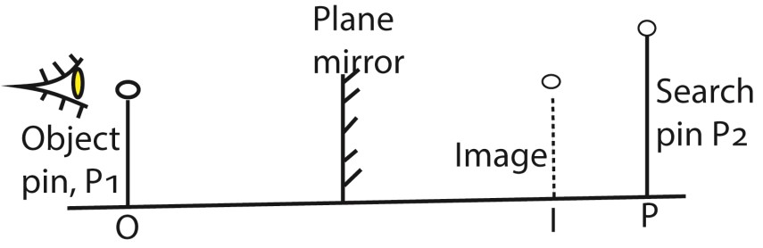

- An object pin O is placed in front of a plane mirror to form a virtual image I.

- A large search pin P is placed behind the mirror and moved to such a position that there is no parallax between pin P2 and the image I.

- The image position has therefore been located.

(b) The diagram in the figure below shows a ray of light undergoing two successive reflections at points X and Y in two mirrors M₁ and M₂ inclined at an angle θ.
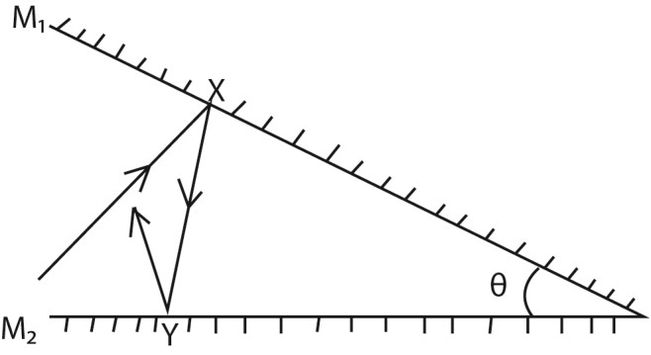
Show that the ray is deviated through an angle 2θ (03marks)
Consider an incident ray of light reflected successively from two mirrors M₁ and M₂ inclined at an angle θ to each other at O as shown

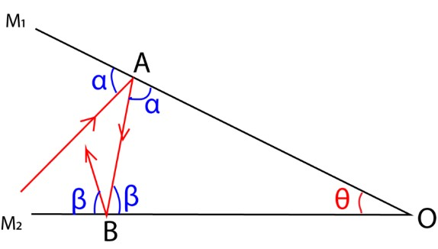
Let the glancing angles at A and B be α and β respectively.
Deviation by M₁ = 2α (clockwise direction)
Deviation by M₂ = 2β (clockwise direction)
Total deviation = 2α + 2β
= 2 (α + β) ---------------------- (i)
But, α + β + θ = 180⁰ (Angle sum of a triangle) ⇨ α + β = (1800 - θ) ---------------------(ii)

Combining equation ( i ) and (ii) gives
Total deviation = 2(180⁰ - θ) (clockwise direction)
= 360⁰ - 2θ (clockwise direction)
= 2θ (anti-clockwise direction)
5. (a) (i) State the laws of reflection (02marks)
  - Incident ray, refracted ray and the normal at the point of incidence all lie in the same plane
  - Angle of reflection is equal to the angle of incidence
(ii) Show that the image formed in a plane mirror is as far behind the mirror as the object is in front. (04marks)
Consider an object A placed in front of a mirror M.

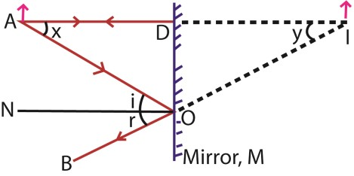

A ray AD from A incident normally on the mirror at D is reflected back along DA.

The Ray AO is reflected along OB and appears to come from point I behind the mirror.
The intersection I of the rays AD and BO is the image position.

From above angles, x = i (alternating angles) i = r (2nd law of reflection) r = y (corresponding angles)
Combining all the equations gives x = i = r = y
⇨ angle x = angle y Tan x = t a n y 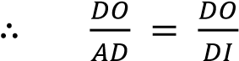
Thus AD = ID.
The image is as far behind the mirror as the object is in front

Reflection at curved mirrors

Curved mirrors are of two types namely;

- Concave (Converging) mirror: it is part of the sphere whose centre C is in front of its reflecting surface.

- Convex (Diverging) mirror: it is part of the sphere whose centre C is behind its reflecting surface.

Consider the reflection of a parallel narrow beam of light at curved mirrors as shown.

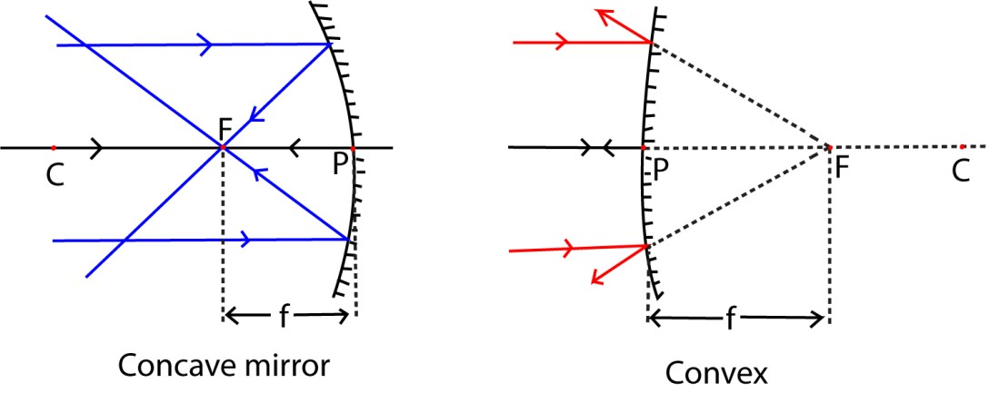

Definitions
- Centre of curvature C: it is the centre of the sphere of which the mirror forms part.
- Radius of curvature r: it is the radius of the sphere of which the mirror forms part.
- Pole of the mirror: it is the mid-point (centre) of the mirror surface.
- Principal axis CP: it is the line that passes through the centre of curvature and the pole of the mirror.
- Secondary axes: These are lines parallel to the principal axis of the mirror.
- Paraxial rays: These are rays drawn close and parallel to the principal axis 7. Marginal rays: These are parallel rays furthest from the principal axis of the mirror.
- (i) Principal focus “F” of a concave mirror: it is a point on the principal axis where paraxial rays incident on the mirror and parallel to the principal axis converge after reflection by the mirror.

(ii). Principal focus “F” of a convex mirror: it is a point on the principal axis where paraxial rays incident on the mirror and parallel to the principal axis appear to diverge from after reflection by the mirror
- (i) Focal length “f” of a concave mirror: it is the distance from the pole of the mirror to the point where paraxial rays incident and parallel to the principal axis converge after reflection by the mirror.

(ii) Focal length “f” of a convex mirror: it is the distance from the pole of the mirror to the point where paraxial rays incident and parallel to the principal axis appear to diverge from after reflection by the mirror.
- Aperture of the mirror: it is the length of the mirror surface.

Reflection of a parallel wide beam of light at curved mirrors

Consider the reflection of a wide parallel beam of light incident on a concave mirror as shown.
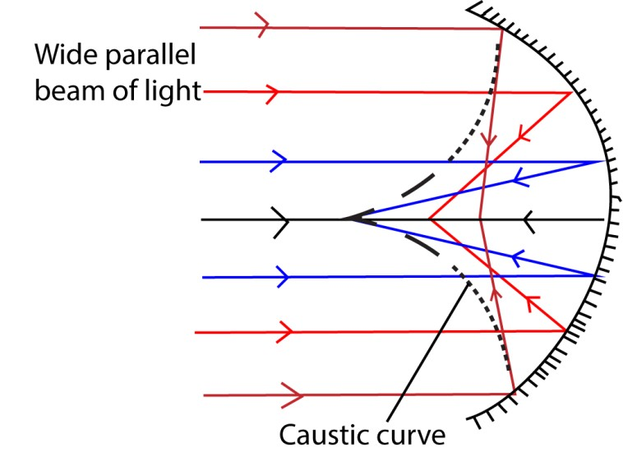

When a wide parallel beam of light is incident on a concave mirror, the different reflected rays are converged to different points. However these reflected rays appear to touch a surface known as a caustic surface having a cusp (an apex) at the principal focus F.

Note
- The marginal rays furthest from the principal axis are converged nearer to the pole of the mirror than the paraxial rays.

- Similarly, if a wide parallel beam of light is incident on a convex mirror, the different reflected rays appear to have diverged from different points.

Hyperbolic mirror

This is a type of concave mirror that reflects all the parallel incident beam on to a unique point F, the principal focus of the mirror.

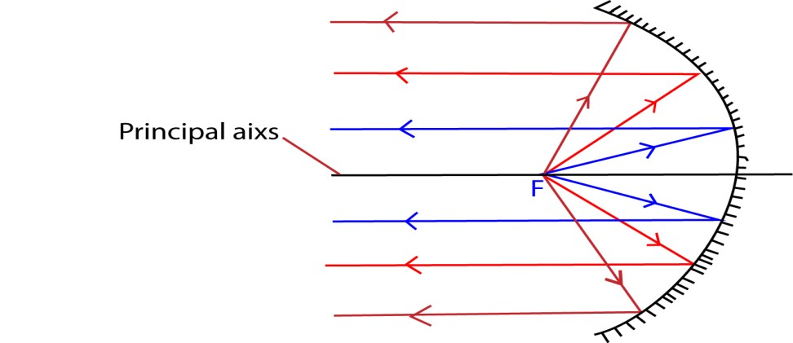

Note that in car headlight and torches, the reflecting surfaces are hyperbolic. When a bulb is placed at the principal focus of reflecting surface, a strong parallel beam of light is obtained. Hyperbolic mirrors are also used in reflecting telescopes.

Example 6
Explain why parabolic surface is preferred to concave surface in car headlights?

Solution
Parabolic mirror reflect a wide beam of light of high intensity from a lamp at its principal focus.

Concave mirror reflect light of low intensity of light which diminish with distance since they do not reflect parallel beam when a lamp a lamp is placed at their principal focus.

Geometrical rules for the construction of ray diagrams
The following is a set of rules for easy location of the images formed by spherical mirrors
- Rays parallel to the principal axis are reflected through the principal focus.
- Rays through the principal focus are reflected parallel to the principal axis.
- Rays passing through the centre of curvature are reflected back along their own paths.
- Rays incident to the pole are reflected back, making the same angle with the principal axis. NOTE:
  - The normal due to reflection at the mirror surface at any point must pass through the centre of curvature.

  - The image position can be located by the intersection of two reflected rays initially coming from the object.

Real and virtual images
A real image: This is the image formed by the actual intersection of light rays from an object and can be received on the screen.

A virtual image: This is the image formed by the apparent intersection of light rays and cannot be received on the screen

Images formed by a concave mirror
The nature of the image formed by a concave mirror is either real or virtual depending on the object distance from the mirror as shown below;

(i) Object between F and P the image is
- Behind the mirror
- Virtual
- Erect
- Magnified

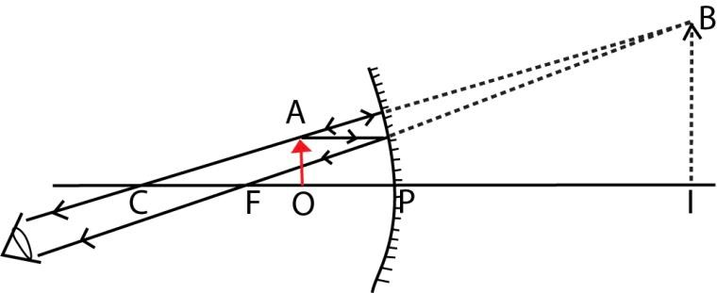

The property of a concave mirror to form erect, virtual and a magnified image when the object is nearer to the mirror than its focus makes it useful as a shaving mirror and also used by dentists for teeth examination.

- Object at F the image is
  - at infinity
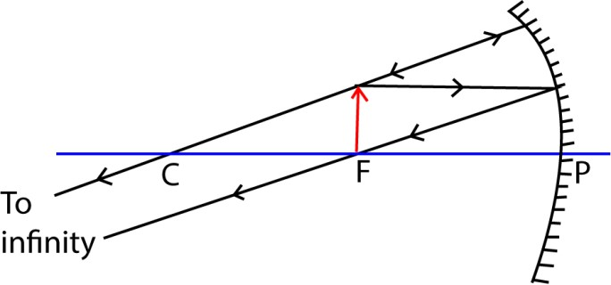

- Object between F and C the image is
  - Beyond C
  - Real
  - Inverted
  - Magnified

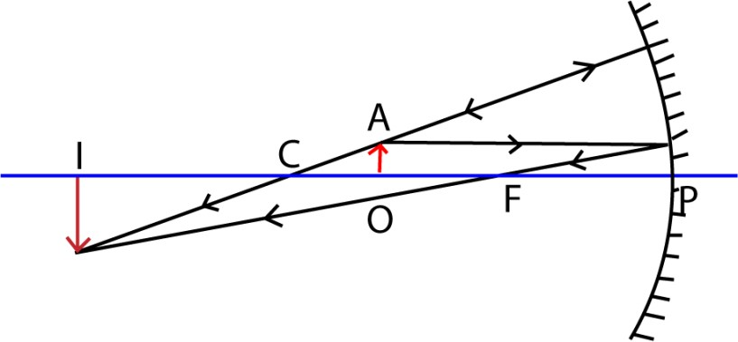

- Object at C the image is
  - At C
  - Real
  - Inverted
  - Same size as the object

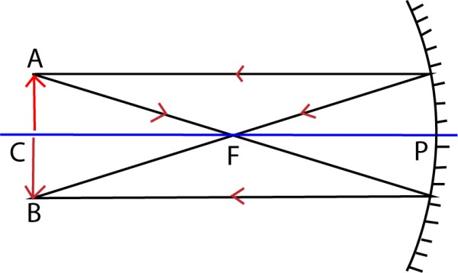
- Object beyond C the image is
  - Between C and F
  - Real
  - Inverted
  - Diminished

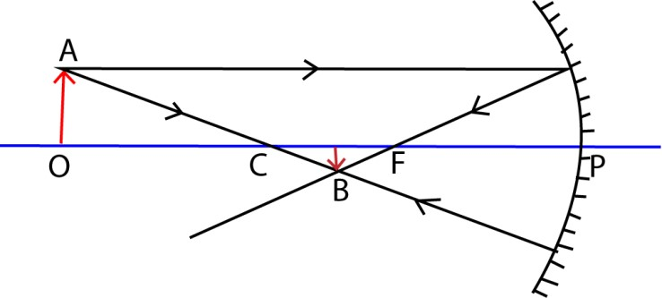

- Object at infinity the image is
  - At F - Real
  - Inverted
  - Diminished

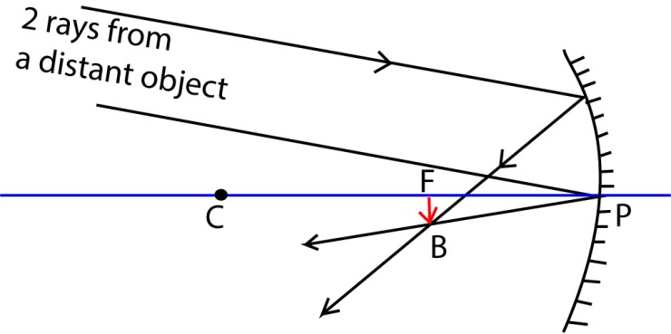

Note;
Generally the image of an object in a concave mirror is virtual only when the object is nearer to the mirror than its focus.

Uses of concave mirrors
- They are used as shaving mirrors.
- They are used by dentists for teeth examination.
- They are used as solar concentrators in solar panels.
- They are used in reflecting telescopes, a device for viewing distant objects
- They are used in projectors, a device for showing slides on a screen.

Images formed by a convex mirror
The image of an object in a convex mirror is erect, virtual, and diminished in size no matter where the object is situated as shown below
.

In addition to providing an erect image, convex mirrors have got a wide field of view as illustrated below.

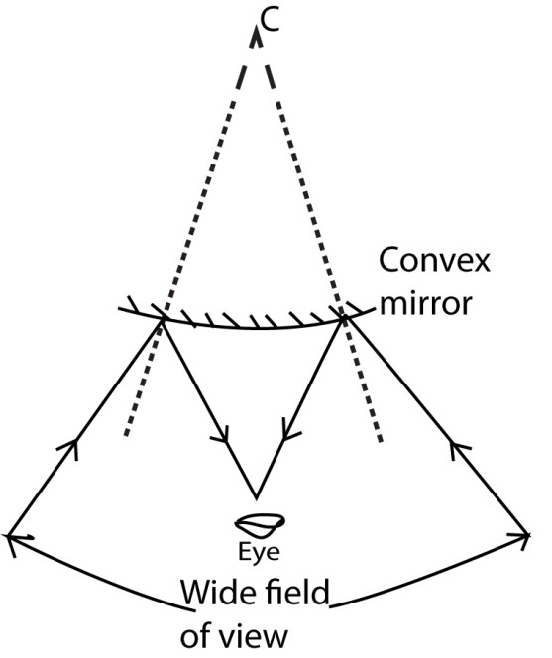

Uses of convex mirrors
- They are used as car driving mirrors
- They are used in reflecting telescopes, a device for viewing distant objects

Relationship between the focal length f and the radius of curvature r of curved mirrors

Consider the reflection of a paraxial ray, AX, parallel to the principal axis of a concave mirror as shown.

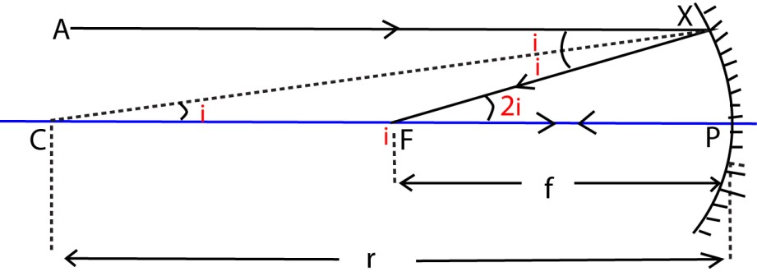

Taking FP = focal length and C = centre of curvature, then , CX, is the normal to the mirror surface and, CP, is the radius of curvature.
tan 2i  2i
If, X, is close to P, then tan 2i  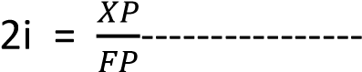(for small angles)

Similarly tan i  i = 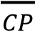
=> i =
Combining equations (i) and (ii) gives,
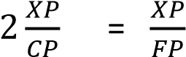
Canceling XP throughout and simplifying for CP gives
CP = 2FP where CP = r, FP = f r = 2f.

Thus, the radius of curvature of a concave mirror is twice its focal length.

Note:
It can be shown that the relation between f and r holds for both concave and convex mirrors.(This is left as an exercise for the reader)

Mirror formula and sign convention
In order to obtain a formula which holds for both concave and convex mirrors, a Sign rule or convention must be obeyed and the following shall be adopted.

- Distances of real objects and images are positive.

- Distances of virtual objects and images are negative.

Note:
A concave mirror has a positive focal length while a convex mirror has a negative focal length.

Concave (converging) mirror formula
Consider the incidence of ray OX on to a concave mirror from a point object O placed along the principal axis that is reflected in the direction XI making an angle θ with the normal CX.

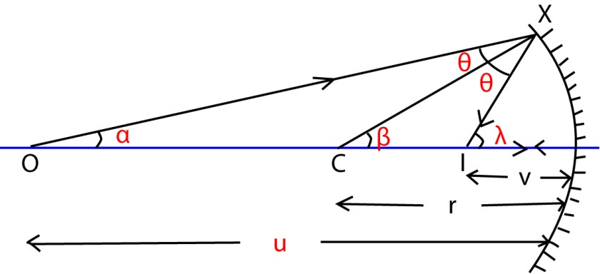

Ray OP strikes the mirror incident normally at P is reflected back along its own path.
The point of intersection I of the two reflected rays is the image position.

From OXC, α + θ = β -------------------------------(i) From  CXI, β + θ =  ------------------------------(ii) Equation (i) - Equation (ii) eliminates θ to give. α - β = β - 
=> α +  = 2 β -----------------------------------------(a)
If X is very close to P, then
Equation (a) becomes = 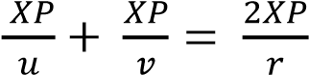
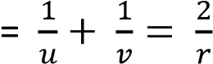
But 2 = 2f
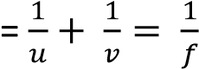
Note:
The focal length of a concave mirror is a positive distance.

Convex (diverging) mirror formula
Consider the incidence of ray OX on to a convex mirror from a point object O placed along the principle axis and then suddenly reflected in the direction XK making an angle with the normal XN.

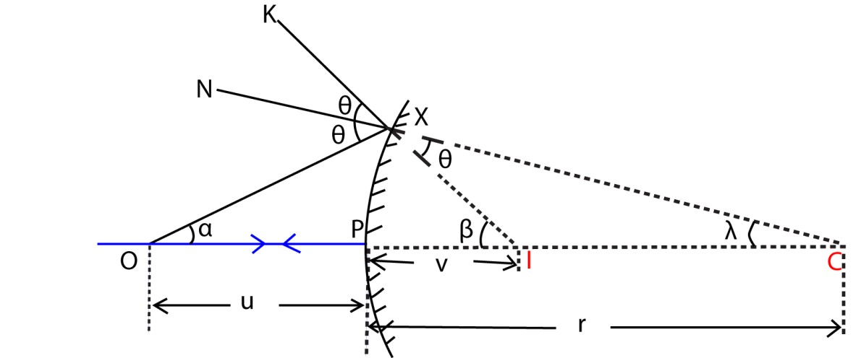

From XIC, θ +  = β
=> θ = β -  --------------------------------(i)

From OXI, α + β = 2θ --------------------------------(ii) Substituting equation (i) into (ii) gives.
α + β = 2 (β - α )
=> α - β = -2 ---------------------------------------(a) If X is very close to P, then

Equation (a) becomes
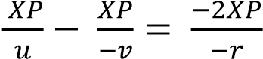
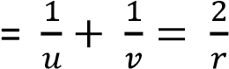
But 2 = 2f
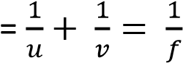
Note that the focal length of a convex mirror is a negative distance.

Formula for magnification
Linear magnification, m, 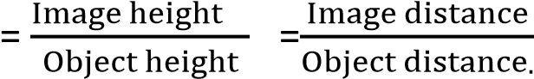.

Proof
Consider the incidence of ray AP on to the pole of a concave mirror from an object of height h placed a distance, u, from the mirror and then reflected back making the same angle with the principal axis to form an image of height h₁, located at distance, v, from the mirror as shown

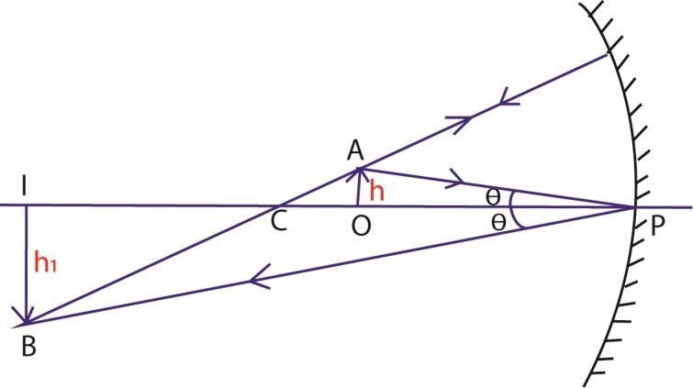

Ray AP makes an angle θ with the normal OP, then,
From OAP, 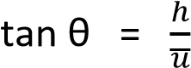 ……………………….(i)

Please find free new curriculum notes, exams and marking guides on digitlteachers.co.ug website 26 | P a g e

From IPB, 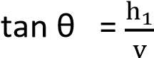……………………………………..(ii)
Equating equation (i) and (ii) gives

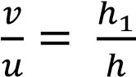

Thus magnification, m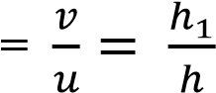
NOTE:
- No signs need be inserted in the magnification formula.
- Using the mirror formula, a connection relating magnification to the focal length of the mirror with either the object distance or the image distance can be established.

Relationship connecting m, v and f

Using the mirror formula; 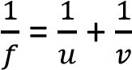
Multiplying, v, throughout we get
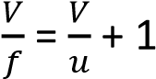
Since = m
Then, = m + 1 or m = 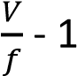

Examples 7
An object is placed 10cm in front of a concave mirror of focal length 15cm. Find the image position and magnification.
Solution:
For a concave mirror, focal length f = +15cm, u = 10cm.
Using the mirror formula 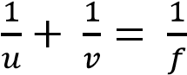 gives
v = 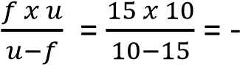 30cm
The negative sign implies that the image formed is virtual and it is formed 30cm from the mirror.
Hence, Magnification, m 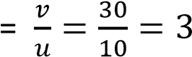

Examples 8

The image of an object in a convex mirror is 6cm from the mirror. If the radius of curvature of the mirror is 20cm, find the object position and the magnification.
Solution:
For a convex mirror,

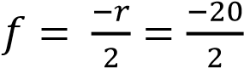 = 10cm
v = -6cm (The image in a convex mirror is always virtual)
Using the mirror formula 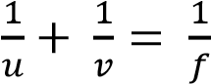, gives
u = 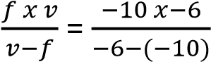 = 15cm
Magnification, m 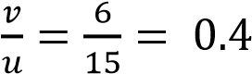

Examples 9

Show that an object and its image coincide in position at the centre of curvature of a concave mirror. Hence find the magnification produced in this case.

Solution

At the centre of curvature of a concave mirror, object distance u = r where r is the radius of curvature of the mirror.

Using the mirror formula = 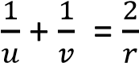 and substituting r for u gives
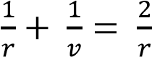
V= r
Thus the image is also formed at the centre of curvature and therefore it coincides in position with its object.

Hence magnification m = 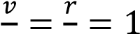

 The object and its image are of the same size in this case.

Examples 10
A concave mirror forms on a screen a real image of three times the size of the object. The object and screen are then moved until the image is five times the size of the object. If the shift of the screen is 30cm, determine the
- focal length of the mirror
- shift of the object

Solution
- Using the relationship m = 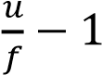 for values m₁= 3 and m₂ = gives v₁ = (m₁ +1)f …………………………….a v₂ = (m₂ + 1)f ………………………… b
For m₂ > m₁, it follows that v₂ > v₁

thus, the given shift in image = v₂ – v₁ = 30cm

Equation a – equation b gives v₂ – v₁ = (m₂ – m₁)f

f = 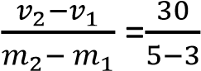 = 15cm

- Using the relationship 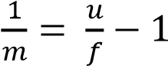 for values m₁= 3 and m₂ = gives
u 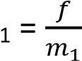+1 …………………(a) u 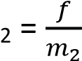+1 …………………(b)
For m₂ >m₁, follows that u₁ > u₂
The required shift in object distance is equal to u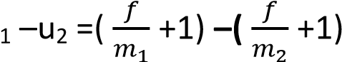
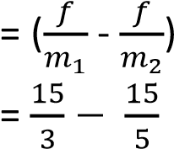= 2cm
Examples 11
A concave mirror P of focal length 15cm faces a convex mirror Q of focal length
10cm placed 25cm from it. An object is placed between P and Q at a point 20cm from
P.
- Determine the distance from Q of the image formed by reflection, first in P and then in Q
- Find the magnification of the image formed in (i) above

Solution

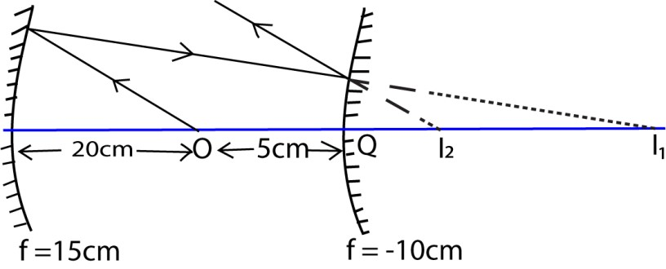

Consider the action of a concave mirror u = 20cm, and f = 15cm

Using the mirror formula 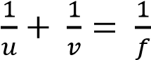, gives, v = 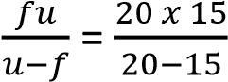 = 60cm
The image distance from a concave mirror = 60cm

Thus, the image distance behind a convex mirror = 60 – (5 + 20)cm = 35cm. Consider the action of a convex mirror

The image formed by a concave mirror acts as a virtual object for the convex mirror. Thus u = -35cm and f = -10cm

Using the mirror formula 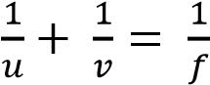, gives, v = 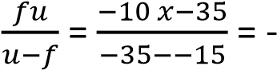 14cm
A final virtual image is 14cm behind the convex mirror

Magnification, m = 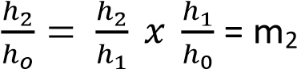 x m₁
m = 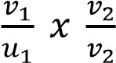 where u₁ = 20cm, v₁ = 60cm, u₂ = 35cm, v₂ = 14cm
thus m = 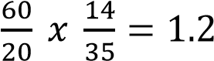

Examples 12
A small convex mirror is placed 60cm from the pole and on the axis of a large concave mirror of radius of curvature 200cm. The position of the convex mirror is such that a real image of a distant object is formed in the plane of a hole drilled through the concave mirror at its pole.
- (i) Draw a ray diagram to show how a convex mirror forms an image of a non- axial point of a distant object
(ii) Suggest a practical application for the arrangement of the mirrors in a (i) above.

- Calculate the
  - radius of curvature of the convex mirror.

  - height of the real image if the distant object subtends an angle of 0 5 at the pole of the convex mirror.

Solution
(a)(i)
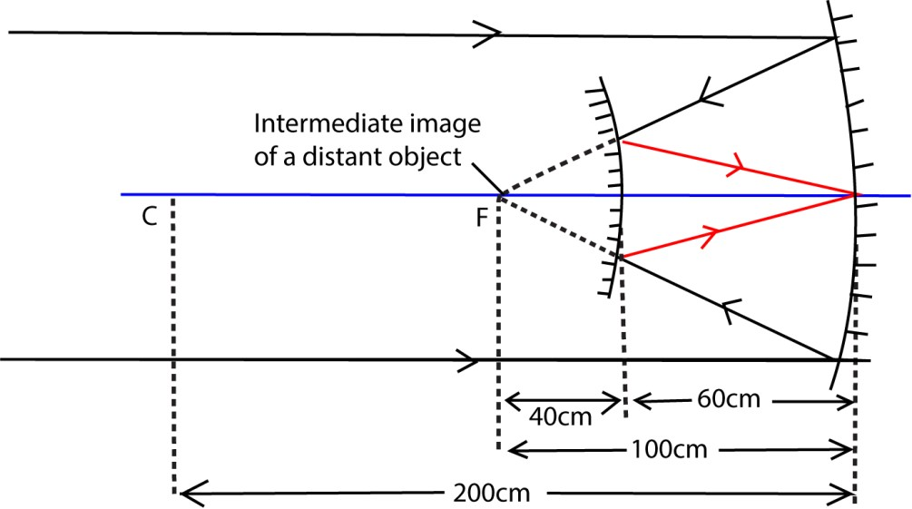

(ii) The mirror arrangement finds application in a reflecting telescope, a device for viewing distant objects

(b) (i) Consider the action of a concave mirror
The image of a distant object is formed at the principal focus of the concave mirror. This image acts as a virtual object for a convex mirror.

Consider the action of a convex mirror u = -40cm and v = 60cm

Applying the mirror formula 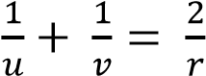, gives r = 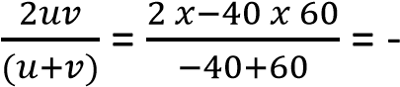 240 cm
The required radius of curvature r = 240cm

(ii) Consider the magnification produced by a convex mirror
Let h1 = height of the intermediate image formed by a concave mirror as shown.

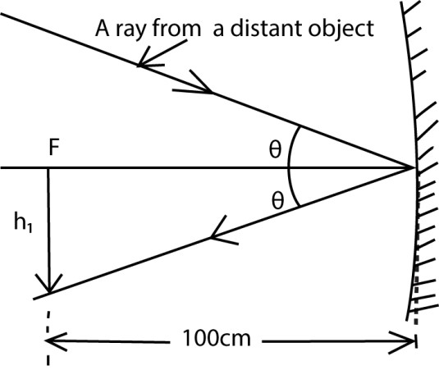

From above, tan 0.50 = 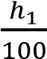
h1 = 0.873cm
Let h2 = height of the image formed by a convex mirror
Magnification, m = 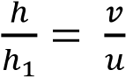
h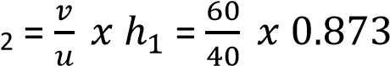 = 1.3 cm
Required image height = 1.3cm

Revision EXERCISE 2
- Define the terms centre of curvature, radius of curvature, principal focus and focal length of a converging mirror.
- Distinguish between real and virtual images.

- Explain with the aid of a concave mirror the term a caustic surface.
.
- .Explain why a parabolic mirror is used in searchlights instead of a concave mirror

- An object is placed a distance u from a concave mirror. The mirror forms an image of the object at a distance v. Draw a ray diagram to show the path of light when the image formed is:

(i) real (ii) virtual

- Give two instances in each case where concave mirrors and convex mirrors are useful.

- (i) Explain the suitability of a concave mirror as a shaving mirror.
(ii) Explain with the aid of a ray diagram why a convex mirror is used as a car driving mirror.

- Show with the aid of a ray diagram, that the radius of curvature of a concave mirror is twice the focal length of the mirror

- Use a geometrical ray diagram to derive the relation

- Derive the relation connecting the radius of curvature r object distance u and image distance v of a diverging mirror.

- An object is placed perpendicular to the principal axis of a concave mirror of focal length f at a distance (f+ x) and a real image of the object is formed at a distance (f + y). Show that the radius of curvature r of the mirror is given by

r =2 xy

12. (i) Define the term linear magnification.

- Show that in a concave mirror, linear magnification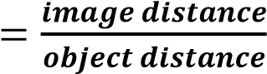

- A concave mirror of focal length 15cm forms an erect image that is three times the size of the object. Determine the object and its corresponding image position.[u =10cm, v = 30cm]

- A concave mirror of focal length 10cm forms an image five times the height of its object. Find the possible object and corresponding image positions.

[u = 12cm, v = 60cm OR u = 8cm, v =40cm]

- A concave mirror forms on a screen a real image which is twice the size of the object. The object and screen are then moved until the image is five times the size of the object. If the shift of the screen is 30cm, determine the
Please find free new curriculum notes, exams and marking guides on digitlteachers.co.ug website 33 | P a g e

  - focal length of the mirror[10cm]
  - shift of the object [3cm]

- A concave mirror of radius of curvature 20cm faces a convex mirror of radius of curvature 10cm and is 28cm from it. If an object is placed midway between the mirrors, find the nature and position of the image formed by reflection first at the concave mirror and then at the convex mirror.

[ A final virtual image is 17.5cm behind the convex mirror]

- A small convex mirror is placed 100cm from the pole and on the axis of a large concave mirror of radius of curvature 320cm. The position of the convex mirror is such that a real image of a distant object is formed in the plane of a hole drilled through the concave mirror at its pole.
(a) (i) Draw a ray diagram to show how a convex mirror forms an image of a non- axial point of a distant object

- Suggest a practical application for the arrangement of mirrors in a (i) above.
- Calculate the radius of curvature of the convex mirror [150cm]
(b) If the distant object subtends an angle of 3 × 10⁻³ radians at the pole of the concave mirror, calculate the
- size of the real image that would have been formed at the focus of the concave mirror. [0.48cm]
- size of the image formed by the convex mirror. [0.8cm]

Determination of the focal length of a concave mirror

Method (1) using a pin at C
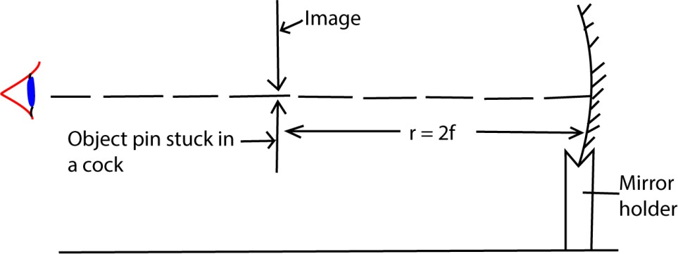

An object pin is placed in front of a mounted concave mirror so that its tip lies along the axis of the mirror. The position of the pin is adjusted until it coincides with its image such that there is no parallax between the pin and its image. The distance r of the pin from the mirror is measured.
The required focal length f 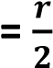

Note
- In the position where there is no parallax between the object pin and its image, there is no relative motion between the object and its image when the observer moves the head from side to side.
- When the pin coincides with its image, the rays are incident normal to the mirror and are thus reflected along their own path. Therefore the pin coincides with its image at the centre of curvature of the mirror.

Method (2) using an illuminated object at C
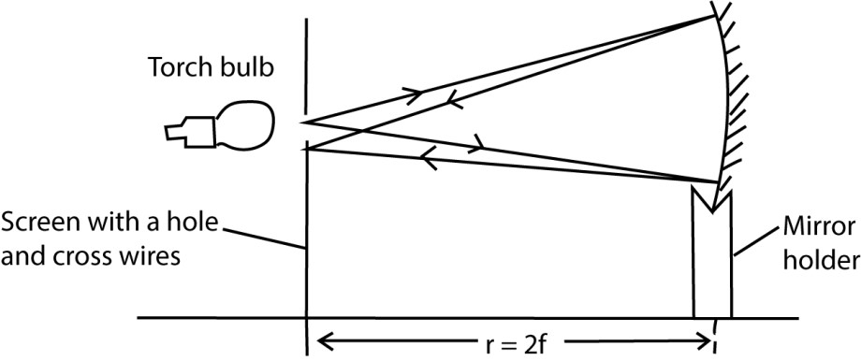

Align an illuminated bulb, a screen and a concave mirror mounted in a holder as shown above. The mirror position is adjusted to or from the screen until a sharp image of the cross-wire is formed on the screen besides the object. The distance r of the mirror from the screen is measured.
The required focal length f 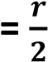

Method (3) Using no parallax method in locating V

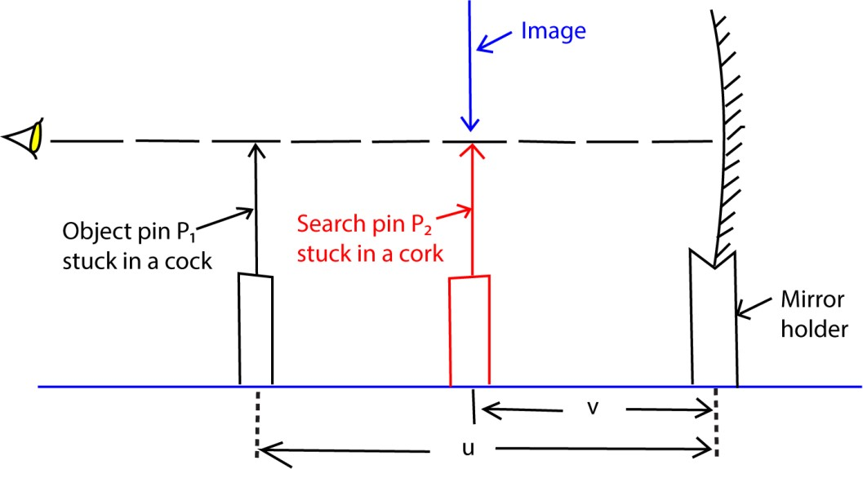

An object pin P1 is placed at a distance u in front of a mounted concave mirror so that its tip lies along the axis of the mirror. A search pin P2 placed between the mirror and pin p1 is adjusted until it coincides with the image of pin p1 by no-parallax method. The distance v of pin p2 from the mirror is measured. The procedure is repeated for several values of u and the results are tabulated including values of uv, and u+v.

A graph of uv against u+v is plotted and the slope s of such a graph is equal to the focal length f of the mirror.

NOTE:

If a graph of against is plotted, then each intercept C =

Determination of focal length of a convex mirror

Method (1) Using a convex lens.

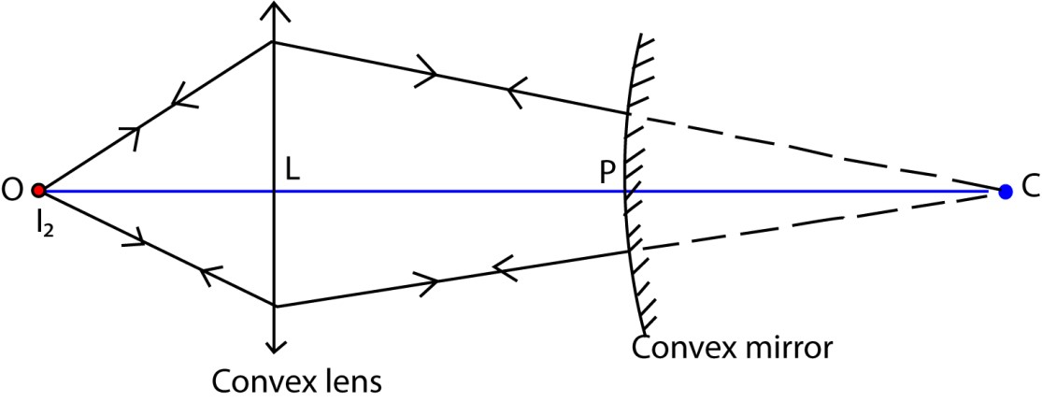

- The apparatus is arranged as shown above
- An object, O is placed in front of a convex lens L and its image formed at C (iii) The distance LC is measured and recorded.
- The convex mirror whose focal length, f, is required is placed is placed between L and C with its reflecting surface facing the lens.
- The lens is then moved along the axis, OC until a converging beam incident normally on the mirror forms its image at O
- Distance LP is measured
PC = LC – LP thus, f can be determined from f = 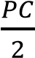 Method (2) using No parallax.

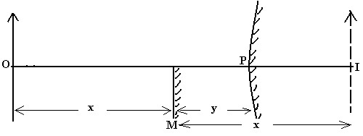

26

  - An object pin O is placed in front of a convex mirror as shown in the diagram above
  - A virtual diminished image is formed at I.
  - A plane mirror M is placed between O and P so as to intercept half the field of view of the convex mirror.
  - Mirror M is adjusted until its own image of O coincides with I by no parallax method.
  - Measure the distances x and y.
  - The focal length of the mirror is calculated from 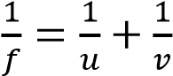

Where u = (x + y) and v = (y-x)

Note:
- The two images coincides when they are as far behind the plane mirror as the object is in front.
- Substituting for u = x + y and v = y - x in the mirror formula gives 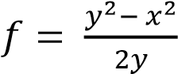

Examples 13

An object O is placed 40cm in front of a convex lens of focal length 15cm forming an image on the screen. A convex mirror situated 4cm from the lens in the region between the lens and the screen forms the final image besides object O.
- Draw a ray diagram to show how the final image is formed.

- Determine the focal length of the convex mirror.

Solution

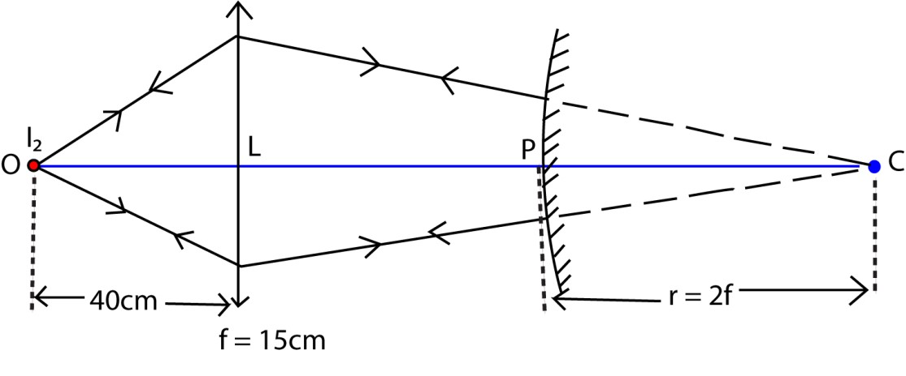

Consider the action of a convex lens u =40cm, and f = 15cm

Using the lens formula 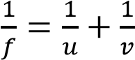 give

Image distance v of the lens = 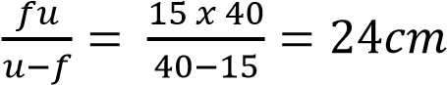

The radius of curvature r = (24 4)cm = 20cm

Using the relation r = 2f
⇨ 2f = 20cm f = 10cm
Thus f = -10cm “The centre of curvature of a convex mirror is virtual”

Examples 14

A plane mirror is placed 10cm in front of a convex mirror so that it covers about half of the mirror surface. A pin 20cm in front of the plane mirror gives an image in it, which coincides with that of the pin in the convex mirror. Find the focal length of the convex mirror.

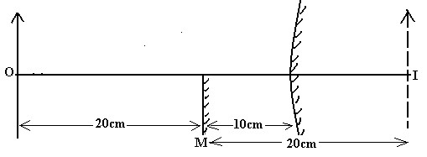

Consider the action of a convex mirror u = 30cm and v = - (20 - 10 ) = -10cm “The image formed is virtual “

Using the lens formula 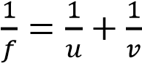 give

Image distance v of the lens = 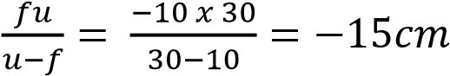

Revision exercise 3
- Describe an experiment to determine the focal length of a concave mirror.

- You are provided with the following pieces of apparatus: A screen with cross wires, a lamp, a concave mirror, and a meter ruler. Describe an experiment to determine the focal length of a concave mirror using the above apparatus.

- Describe an experiment, including a graphical analysis of the results to determine the focal length of a concave mirror using a no parallax method.

- Describe an experiment to measure the focal length of a convex mirror

- Describe how the focal length of a diverging mirror can be determined using a convex lens.

- Describe how the focal length of a convex mirror can be obtained using a plane mirror and the no parallax method.

- A plane mirror is placed at a distance d in front of a convex mirror of focal length f such that it covers about half of the mirror surface. A pin placed at a distance L in front of the plane mirror gives an image in it, which coincides with that of the pin in the convex mirror. With the aid of an illustration, Show that 2df = d² – L².

Topical revision questions
1. (a) (i) With the ais of digrams, differentiatebetween regular and irregular refelection (03marks)

Regular reflection Irregular reflection
Differences between regular and irregular reflection
Regular reflection | Irregular reflection
Occurs on smooth surface | Occurs on a rough surface
Parallel incident beam is reflected parallel | Parallel incident beam is scattered after reflection
Reflected beam is very bright | Reflected beam is dull

(ii) Show that if two plane mirrors are inclined at an angle, x, then the total deviation of a light ray produced is 2x after reflection once in each mirror. (03 marks)
Deviation by successive reflections at two inclined mirrors
Consider an incident ray of light reflected successively from two mirrors M₁ and M₂ inclined at an angle x to each other at O as shown

Let the glancing angle at and B be α and β respectively
Deviation by M₁ = 2α (clockwise direction) Deviation by M₂ = 2β (clockwise direction)
Total deviation = 2α + 2β
= 2(α + β) …………………. (i) But α + β + x = 180 (Angle sum of a triangle)
α + β = 180 – x ……………………...(ii)
Combining (i) and (ii)
Total deviation = 2(180 – x) (clockwise)
= 360 - 2x (clockwise)
= 2x (anticlockwise)
Thus, the deviation produced by two inclined mirrors is twice the angle between the mirrors when a ray under goes two successive reflections.
- Describe an experiment to determine the focal length of a convex mirror using a plane mirror and a pin. (04marks) The setup is shown below

26

(i) An object pin O is placed in front of a convex mirror as shown in the diagram above (ii) A virtual diminished image is formed at I.
  - A plane mirror M is placed between O and P so as to intercept half the field of view of the convex mirror.
  - Mirror M is adjusted until its own image of O coincides with I by no parallax method.
  - Measure the distances x and y.
  - The focal length of the mirror is calculated from 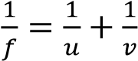
Where u = (x + y) and v = (y-x)

- (i) Sketch a ray diagram to show how a concave mirror forms a magnified real image of a real object. (02marks)

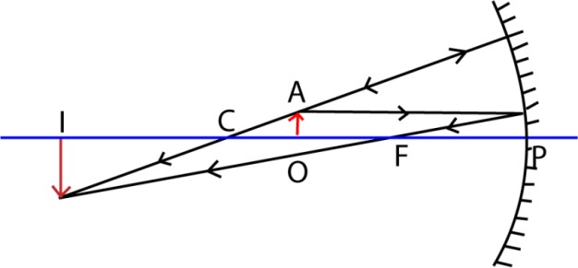
Note that the object is between F and C while the image is real and inverted beyond C

(ii) A concave mirror of radius of curvanture 48cm produces a real image whose size is three times that of the object,. Determine the position of th object.m(02marks)
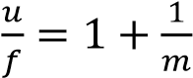
- 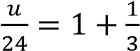
- u = 32cm
Or
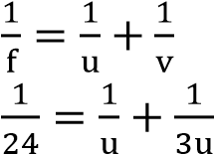
u = 32cm

- Describe an experiment to determine the refractive index of a liuid using a concave mirror. (04marks)
An experiment to determine refractive index of a liquid using a concave mirror

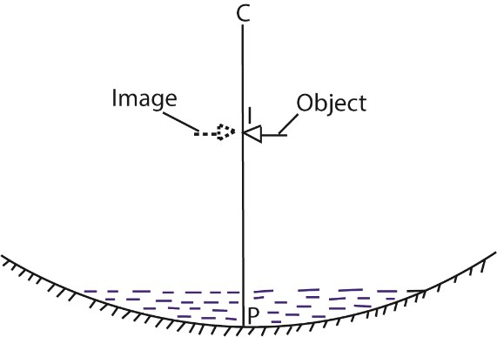

  - A concave mirror is placed on a horizontal table with its reflecting surface facing upwards.
  - A clamped pin with its tip along the principal axis above the concave mirror is coincided with its image at C and distance PC is measured
  - A small quantity of the liquid under test is poured into a concave mirror and a new point I at which the object pin coincides with its image is obtained. - Distance IP is measured.
  - The required refractive index of a liquid, 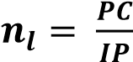

- Explain the meaning of a caustic curve. (02 marks)
When a wide parallel beam of light is incident on a converging mirror, the reflected rays converge at different points along the axis of the mirror. A curve, S, called a caustic curve, with an apex or cusp at principal focus, F is formed which passes through the points of intersection of the reflected and incident rays.
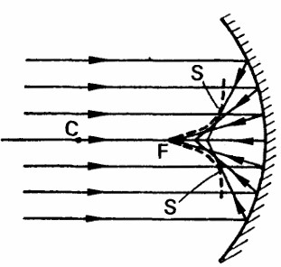

2. (a) (i) State two differences between real and virtual images (02marks)
A real image is formed by actual intersection of rays and can be formed on a screen while virtual image is formed by apparent intersection of rays and cannot be formed on a screen.
(ii) Explain with the aid of a diagram how thick plane mirror forms multiple images (04marks)
Formation of multiple images in thick plane mirror
Multiple images are formed due to partial reflection and refraction at the non-silvered surface of the mirror.
- İmage I₁ is formed by reflection on the glass surface P
- The image I₂ (the brightest is formed by reflection of the most light on the silvered surface Q
- Others by partial refraction

- A convex mirror forms a real image which is three times the linear size of the object. When the object is displaced though a distance y, the real mage formed is four times the linear size of he object. If the distance between the two image positions is 20 cm, find the
  - focal length of the mirror (03marks)
M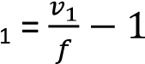 and M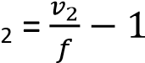
M₂ – M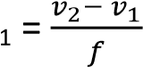
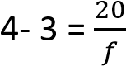
f = 20cm
  - distance, y. (03marks)
Also 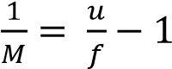
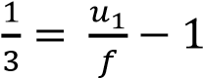
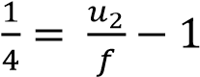
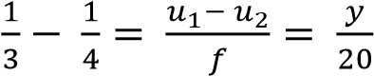
y = 1.67cm
- Use a geometrical ray diagram to derive the relation, 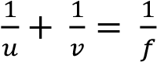 for concave mirror. (05marks)
Consider the incidence of ray OX on to a concave mirror from a point object O placed along the principal axis and then suddenly reflected in the direction XI making an ang with the normal CX.

Ray OP strikes the mirror incident normally at P and thus reflected back along its own path. The point of intersection I of the two reflected rays is the image position.
From ∆ OXC, α + θ = β ……………….. (i)
From ∆ CXI β + θ = λ …………………. (ii) Eliminating θ from eqn. (i) and eqn. (ii) α + λ = 2β ……………………………………. (iii)
If X is very close to P, then
Equation (a) becomes = 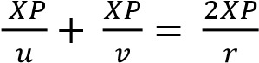
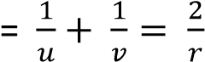
But 2 = 2f
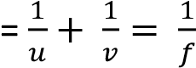

(d) Explain how mirage is formed. (03marks)
On a hot day, layer on air near the ground are hotter and lens dense than layers above. This leads to total internal reflection of rays of light from the sky. And mirage is the image of the sky to the eye by total internal reflection
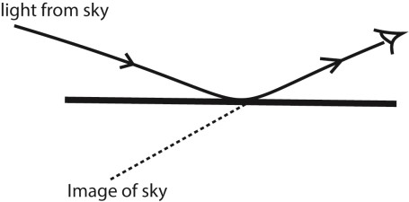
- (a) (i) Describe how the focal length of a convex mirror can be measured using a convex lens of known focal length. (04marks)

Determination of the focal length of a convex mirror can be measured using a convex lens of known focal length.

  - The apparatus is arranged as shown above
  - An object, O is placed in front of a convex lens L and its image formed at C (iii) The distance LC is measured and recorded.
  - The convex mirror whose focal length, f, is required is placed is placed between L and C with its reflecting surface facing the lens.
  - The lens is then moved along the axis, OC until a converging beam incident normally on the mirror forms its image at O (vi) Distance LP is measured
PC = LC – LP thus, f can be determined from f =

  - The plane mirror, P, in the figure below is adjusted to a position20cm from optical pin, the image of the pin in P coincides with its image in M.
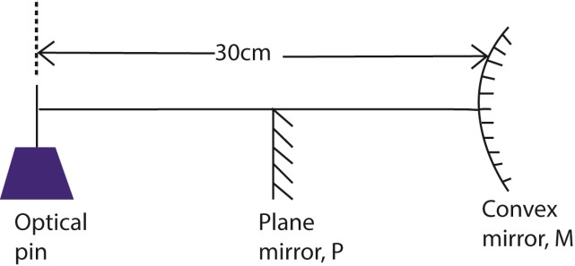
Calculate the focal length of the convex mirror. (04marks)
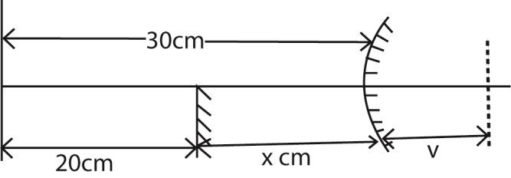
v = 20 – x
= 20 – (30-20) = 10cm
Using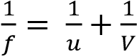
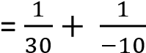
f = 15cm
(b) A pin is clamped horizontally above a concave mirror with its tip along the principal axis. When the pin is adjusted, it coincides with its image at a distance R from the mirror. When a small liquid of refractive index, n, is put on the mirror, the pin again coincides with its image at a distance R’ from the mirror. Show that the refractive index, n, is given by
n = 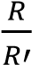 (04marks)
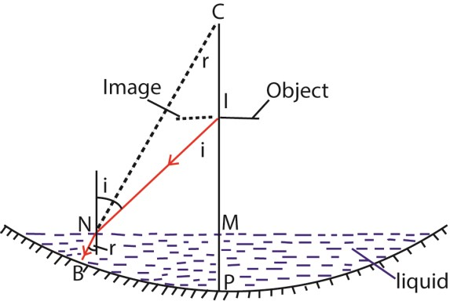
Setup

From n =

From the diagram, sin i = and sin r =
n = 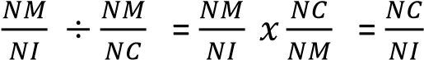
For small angle, i, and small liquid
NC  and NI 
Thus, n = 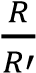
- (a) (i) State the laws of reflection of light. (02marks)
    - The incident ray, the reflected ray and the normal at the point of incidence all lie in the same plane
    - The angle of incidence is equal to the angle of reflection
  - A ray of light is incident on a plane mirror. The mirror is then turned through an angle α keeping the direction of the incident ray constant. If a reflected ray turned through angle β, find the relationship between α and β.
Let XY be the initial position of the mirror with ray AO making a glancing angle g. By keeping the direction of the incident ray fixed, the mirror is rotated through an angle α to a new position X’Y’ as shown.

Case 1 (mirror in position XY)
Glancing angle = g
Deviation d₁ = 2g……… (i)
Case 2(mirror in position X’Y’)
Glancing angle = (g – α) Deviation d₂ = 2(g – α) …..(ii) β = d₁ –d₂ = 2g - 2(g – α)
= 2g-2g + 2α
= 2α

(b) Describe how a sextant is used to determine the angle of elevation of a star. (05marks)
Setup
( ) A sextant consists of a fully silvered mirror M1which can be rotated about a horizontal axis and a fixed half silvered mirror B.
- Mirror M1 is adjusted to become parallel to B by rotating it until the image of the horizon, H’ is seen directly through the unsilvered part of mirror B by successive reflection in mirror M₁ and B respectively

- The mirror M₁ is rotated to position M₂ such that the image of the horizon H, and the sun coincides at H’
- The angle of rotation is measured from the scale on the instrument. The elevation of the sun is 2θ.

(c) Describe an experiment to determine the refractive index of a small quantity of a liquid using a concave mirror. (05marks)

An experiment to determine refractive index of a liquid using a concave mirror

- A clamped pin with its tip along the principal axis above the concave mirror is coincided with its image at C and distance PC is measured
- A small quantity of the liquid under test is poured into a concave mirror and a new point I at which the object pin coincides with its image is obtained. - Distance IP is measured.
- The required refractive index of a liquid, 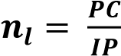

(d) A plane mirror is placed 10cmin front of a convex mirror so that it covers about half of the convex mirror surface. A pin placed 20cm in front of the plane mirror gives an image which coincides with that of the pin in the convex mirror. Find the focal length of the convex mirror. (04marks)

Consider the action of a convex mirror u = 30cm and v = - (20 - 10) = -10cm “The image formed is virtual “

Using the lens formula 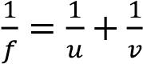 give

Image distance v of the lens = 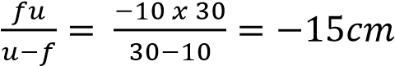

5. (a) Distinguish between a real and virtual image (02marks)

A real image is formed by actual intersection of rays and can be formed on a screen while a virtual image is formed by apparent intersection of rays and cannot be formed on a screen.
(b) Derive an expression relating the focal length, f, of a convex mirror to the object distance, u and image distance, v.
Consider the incidence of ray OX on to a convex mirror from a point object O placed along the principle axis and then suddenly reflected in the direction XK making an angle q with the normal XN.

Fr

From triangle XIC, θ + λ = β
    - θ = β – λ ………………………………….. (i)
From triangle OXI, α + β = 2θ ……………………………….. (ii)
Substituting (i) into (ii)
α + β = 2(β – λ)
    - α – β = -2λ ……………………………………………………………. (iii)
If X is very close to P. then
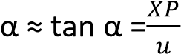, β = 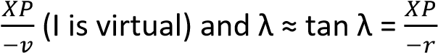(C is virtual)
Equation (iii) becomes
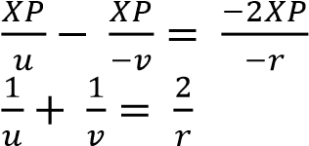
But 2 = 2f
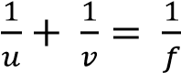
(c) A convex mirror forms an image half the size of the object. The object is then moved towards the mirror until the image is three quarter that of the object. If the image is moved by a distance of
0.6cm, calculate
- focal length of the mirror. (03marks)
Using 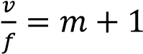
Initially, 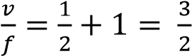 ……………………. (i)
When the object was displaced
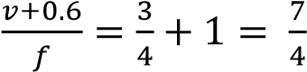 …………………………… (ii)
Eqn. (i) and Eqn. (ii)
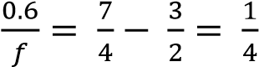; f= 2.4cm
- new potion of the object (03marks)
v + 0.6 = 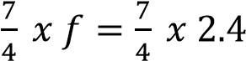 = 4.2 cm
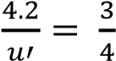
u' = 5.6cm
The object is 5.6 cm from the mirror.
6. (a) (i) Distinguish between real and virtual images. (02marks)

A real image is one formed by actual intersession of rays and can be formed on the screen while a virtual image is formed by apparent intersession of rays and cannot be formed on a screen.
(ii) Describe how the position of an image in a plane mirror can be located (03marks)
Method 1: IMAGE LOCATION BY NO PARALLAX

- An object pin O is placed in front of a plane mirror to form a virtual image I.

- A large search pin P is placed behind the mirror and moved to such a position that there is no parallax between pin P2 and the image I.

- The image position has therefore been located.

(b) The diagram in the figure below shows a ray of light undergoing two successive reflections at points X and Y in two mirrors M₁ and M₂ inclined at an angle θ.
Show that the ray is deviated through an angle 2θ (03marks)
Consider an incident ray of light reflected successively from two mirrors M₁ and M₂ inclined at an angle θ to each other at O as shown

Let the glancing angles at A and B be α and β respectively. Deviation by M₁ = 2α (clockwise direction)
Deviation by M₂ = 2β (clockwise direction)
Total deviation = 2α + 2β
= 2 (α + β) ---------------------- (i)
But, α + β + θ = 180⁰ (Angle sum of a triangle) ⇨ α + β = (1800 - θ) ---------------------(ii)

Combining equation ( i ) and (ii) gives
Total deviation = 2 (180⁰ - θ) (clockwise direction)
= 360⁰ - 2θ (clockwise direction)
= 2θ (anti-clockwise direction)

(c) (i) What is a radius of curvature of a convex mirror? (01mark)
Radius of curvature of a convex mirror is the radius of a hollow sphere of which the mirror forms part
(ii) Describe the experiment to determine the focal length of a convex mirror using a plane mirror. (05marks)

26

(i) An object pin O is placed in front of a convex mirror as shown in the diagram above (ii) A virtual diminished image is formed at I.
- A plane mirror M is placed between O and P so as to intercept half the field of view of the convex mirror.
- Mirror M is adjusted until its own image of O coincides with I by no parallax method. (v) Measure the distances x and y.
(vi) The focal length of the mirror is calculated from 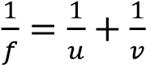
Where u = (x + y) and v = (v-x)(virtual)
(d) A small convex mirror is placed 0.60m from the pole and on the axis of a large concave mirror of radius of curvature 2.0m. The position of the convex mirror is such that a real image of a distant object is formed in the pane of a hole drilled through the concave mirror at its pole. Calculate the radius of curvature of the convex mirror. (04marks)
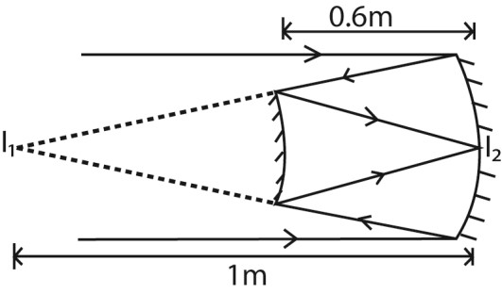
I1 is the virtual object of convex mirror that produces a real image, I2 Action of convex mirror; u = -(1-0.6) = -0.4; v = 0.6
From 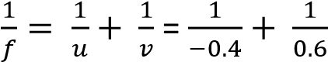
f = -1.2m but radius of curvature = 2f = 2 x 1.2 = 2.4m
7. (a) (i) State the laws of reflection (02marks)
  - Incident ray, refracted ray and the normal at the point of incidence all lie in the same plane
  - Angle of reflection is equal to the angle of incidence
(ii) Show that the image formed in a plane mirror is as far behind the mirror as the object is in front. (04marks)
Consider an object A placed in front of a mirror M.

A ray AD from A incident normally on the mirror at D is reflected back along DA.
The Ray AO is reflected along OB and appears to come from point I behind the mirror. The intersection I of the rays AD and BO is the image position.

From above angles, x = i (alternating angles) i = r (2nd law of reflection) r = y (corresponding angles)
Combining all the equations gives x = i = r = y
⇨ angle x = angle y
Tan x = t a n y
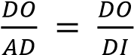
Thus AD = ID.
The image is as far behind the mirror as the object is in front
(b) (i) Draw a ray diagram to show how a concave mirror forms a real image of a real object placed perpendicular to its principal axis. (01mark)

(ii) Describe an experiment, including a graphical analysis of the results to determine the focal length of a concave mirror using the No-parallax method. (06marks)
Experiment to determine focal length of concave mirror using no parallax method

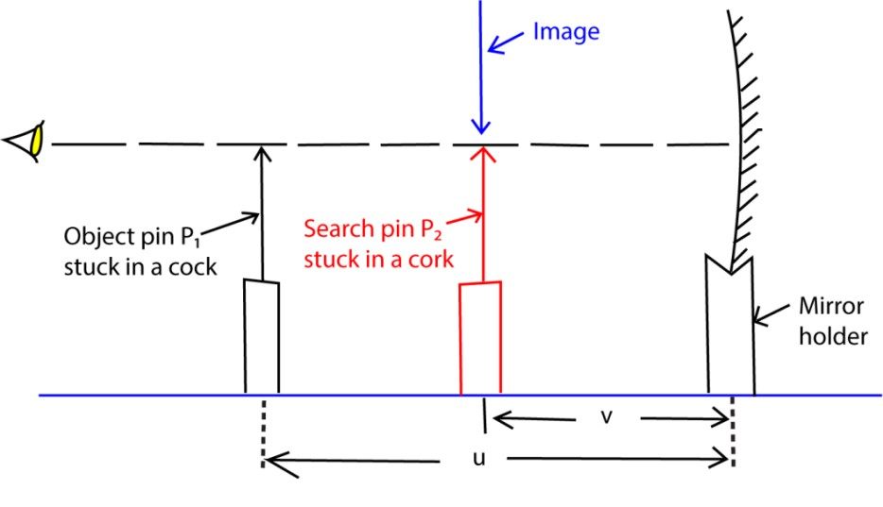

- An object pin P₁ is placed at a distance u in front of a mounted concave mirror so that its tip lies along the axis of the mirror.
- A search pin P₂ placed between the mirror and pin P₁ is adjusted until it coincides with the image of pin p₁ by no-parallax method.
- The distance v of pin P₂ from the mirror is measured.
- The procedure is repeated for several values of u and the results are tabulated including values of uv, and u+v.

A graph of uv against u+v is plotted and the slope s of such a graph is equal to the focal length f of the mirror.

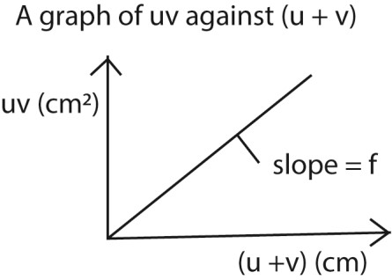

(c) A concave mirror M of focal length 20.0cmis placed 90cm in front of a convex mirror, N, of focal length 12.5cm. An object is placed on the common axis of M and N at a point 25.0 cm in front of M.
- Determine the distance from N of the image formed by reflection, first in M and then in N. (05marks)
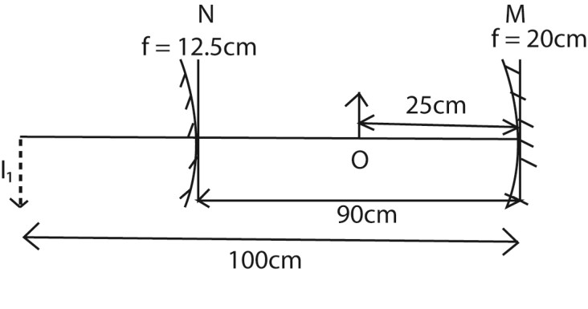
For M
From 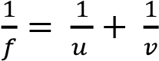
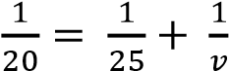; v = 100cm
For mirror N u = -10cm, f = -12.5cm, v = ?
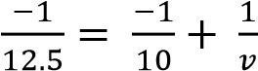; v = 50cm
So the distance of the final image from N is 50cm
- find the magnification of the image formed in (c)(i) above (02marks)
Let the magnification due to M and N be M₁ and M₂ respectively
M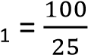 = 4 and M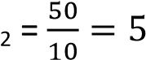
Resultant magnification, M = M₁ x M₂ = 4 x 5 = 20
8. (a) Define the focal length of a concave mirror. (01mark)
Focal length “f” of a concave mirror: it is the distance from the pole of the mirror to the point where paraxial rays incident and parallel to the principal axis converge after reflection by the mirror.
(b) An object is placed at a distance u from a concave mirror, the mirror forms an image of the object at a distance v. Draw diagrams to show the path of light rays when an image formed is (i) real (02marks)
(ii) virtual (02marks)

(c) Use a geometrical diagram to derive the relation, 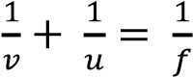 (05marks)
Consider the incidence of ray OX on to a concave mirror from a point object O placed along the principal axis and then suddenly reflected in the direction XI making an ang with the normal CX.

Ray OP strikes the mirror incident normally at P and thus reflected back along its own path. The point of intersection I of the two reflected rays is the image position.
From ∆ OXC; α + θ = β ………………………………….. (i)
From ∆ CXI; β + θ = λ …………………………………… (ii)
Eqn. (i) and (ii)
α + λ = 2β ……………………………………………………... (a)
If X is close to P then.
Equation (a) becomes
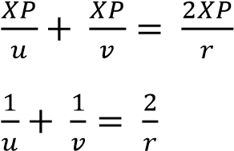
But r = 2f
Thus, 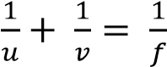
- A concave mirror of radius of curvature 40.0cm contains a liquid to a height 2.0cm. A pin clamped horizontally and viewed from above is observed to coincide with its image when it is 27.0 above the surface of the liquid. Calculate the refractive index of the liquid. (04marks)
R = 40.0cm, d = 2.0cm and h=27.0cm
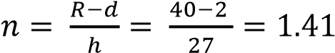
- You are provided with the following pieces of apparatus:
A screen with a cross wire, a lamp, a concave mirror, and a meter rule. Describe an experiment to determine the focal length of the concave mirror using the above apparatus.

Align an illuminated bulb, a screen and a concave mirror mounted in a holder as shown above. The mirror position is adjusted to or from the screen until a sharp image of the cross-wire is formed on the screen besides the object. The distance r of the mirror from the screen is measured.
The required focal length f 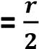
9. (a) (i) State the laws of reflection of light. (02marks)
    - The incident ray reflected ray and the normal at the point of incidence all lie in the same plane
    - Angle of incidence is equal to the angle of reflaction.
(ii) Show that an incident ray of light reflected successively from two mirrors inclined at an angle θ to each other, is rotated through 2θ. (04marks)

Consider an incident ray of light reflected successively from two mirrors M₁ and M₂ inclined at an angle  to each other at O as shown

Let the glancing angles at A and B be  and  respectively.
Deviation by M₁ = 2 (clockwise direction)
Deviation by M₂ = 2 (clockwise direction)
Total deviation = 2 + 2 
= 2 ( + ) ----------------------(i)
But,  +  +  = 180 ( Angle sum of a triangle )
⇒  +  = (180   ) ---------------------(ii)

Combining equation ( i ) and (ii) gives
Total deviation = 2 (180   ) ( clockwise direction )
= 360  2 (clockwise direction)
= 2 (anti-clockwise direction)

(b) Describe how a sextant is used to measure the angle of elevation of a sun. (05marks)
The principle of a sextant is that, when the ray of light is reflected from two mirrors in succession in the same plane, then the angle between the incident and reflected ray is two times the angle between the mirrors.
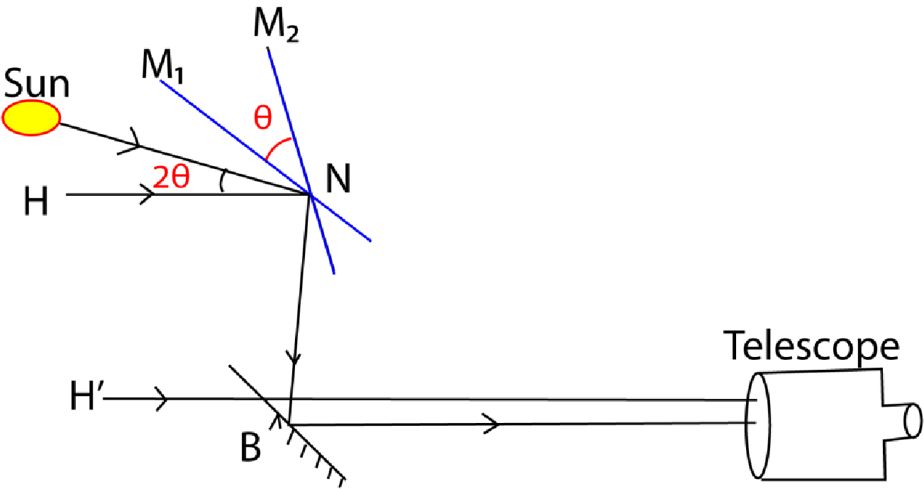
- A sextant consists of a fully silvered mirror M1which can be rotated about a horizontal axis and a fixed half silvered mirror B.
- Mirror M1 is adjusted to become parallel to B by rotating it until the image of the horizon (the line at which the earth's surface and the sky appear to meet), H’ is seen directly through the unsilvered part of mirror B by successive reflection in mirror M₁ and B respectively
Note that, if the two mirrors are parallel, the incident ray from any observed body must be parallel to the observer’s line of sight through the horizon glass
- The mirror M₁ is rotated to position M₂ such that the image of the horizon H, and the sun coincides at H’
- The angle of rotation is measured from the scale on the instrument. The elevation of the sun is 2θ.

(c) (i) Describe an experiment to measure the focal length of a convex mirror. (05marks)

Determination of focal length of a convex mirror.

Method (1) Using a convex lens.

(vii) The apparatus is arranged as shown above
(i) An object, O is placed in front of a convex lens L and its image formed at C (ii) The distance LC is measured and recorded.
- The convex mirror whose focal length, f, is required is placed is placed between L and C with its reflecting surface facing the lens.
- The lens is then moved along the axis, OC until a converging beam incident normally on the mirror forms its image at O
- Distance LP is measured
PC = LC – LP thus, f can be determined from f =
Or
Method (2) using No parallax.

26

  - An object pin O is placed in front of a convex mirror as shown in the diagram above
  - A virtual diminished image is formed at I.
  - A plane mirror M is placed between O and P so as to intercept half the field of view of the convex mirror.
  - Mirror M is adjusted until its own image of O coincides with I by no parallax method.
  - Measure the distances x and y.
  - The focal length of the mirror is calculated from 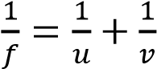

Where u = (x + y) and v = (y-x)

Note:
- The two images coincides when they are as far behind the plane mirror as the object is in front.
- Substituting for u = x y and v = y x in the mirror formula gives 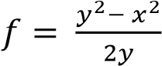

(ii) A concave lens of focal length 20cm is placed 10cm in front of a concave mirror of focal length 16cm. Calculate the distance from the lens at which an object would coincide with its image. (04marks)
Ray diagram
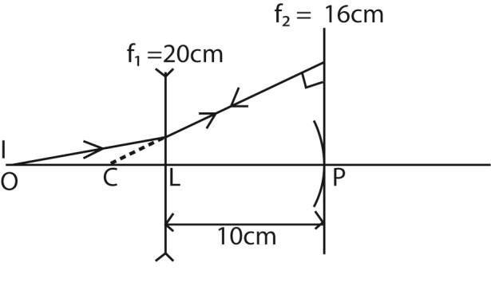
The object to coincide with the image if the rays strike the concave mirror normally
i.e. CP = 2f₂ = 16 x 2 = 32cm
but LP = 10cm
⇨ CL = 22cm
For concave mirror
Object distance be = u
Image distance = -22cm
From 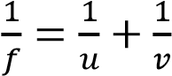
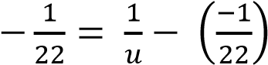; u = -220cm
10. (a) Define the terms radius of curvature and focal length of a converging mirror. (02marks) Radius of curvature of a converging mirror is the distance from the pole of the converging mirror to the center of curvature.
Focal length of converging mirror is the distance from the pole of the mirror to the principal focus.
- (i) Draw a ray diagram to show the formation of a real image of a real object in a converging mirror (02marks)
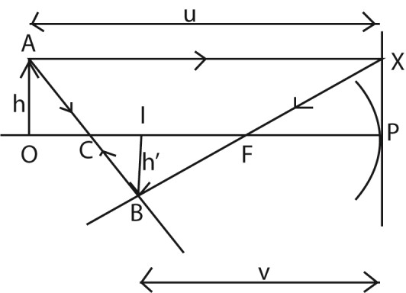
(ii) Use the ray diagram in (b)(i) to derive the expression, 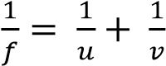; where u. v and f are the object distance, image distance and focal length respectively. (05marks) PC = r and PF = f
Triangle OAC and triangle ICB are similar

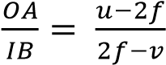
Also triangle
Triangle
XRF and PQF are similar
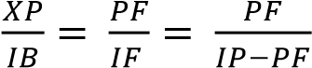
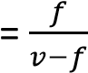
But XP = OA
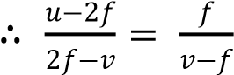
uv – uf -2vf +2f² = 2f² –vf
uv –uf-vf=0
after dividing by uvf
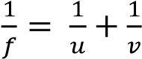
- (i) With the aid of ray diagram, describe the structure and action of a reflecting telescope in normal adjustment. (05marks)
The objective is a large parabolic mirror with a circular aperture of long focal length. A beam of from a distant object is reflected and intercepted by a convex mirror.
The convex mirror forms a real and inverted image at I, the pole of the objective mirror and principal focus of the eyepiece
The eyepiece forms a virtual, magnified image at infinity.
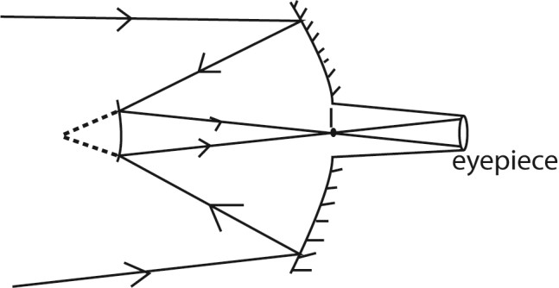

(ii) State two advantages of reflecting telescope over an astronomical telescope. (02marks)
- has high resolving power
- has no chromatic aberration
- produce brighter images
- cheap
- spherical aberration is minimized
-
(d) An astronomical telescope has objective of focal length 100cm and eyepiece of focal length 10cm. Calculate the separation of the objective if the lenses are arranged in such a way that the final image is formed at 25cm from the eye. (04marks) Action of the eyepiece f = 10cm, v = -25cm, u= ?
From 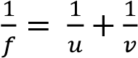
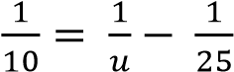, u = 7.1cm
Separation of lenses = f₀ + u
=100 + 7.1 = 107.1cm

TOPIC 2/6: REFRACTION OF LIGHT
Competency: The learner explores the refractive properties of different materials for application in industries and medicine.

Refraction at plane surfaces
Refraction is the bending of light at an interface between two media of different optical densities
Or
It is the change in speed of light when travelling from one medium to another of different optical density. Or
It is the change in direction of light from one media to another of different optical densities.

Laws of refraction
Consider a ray of light incident on an interface between two media as shown.
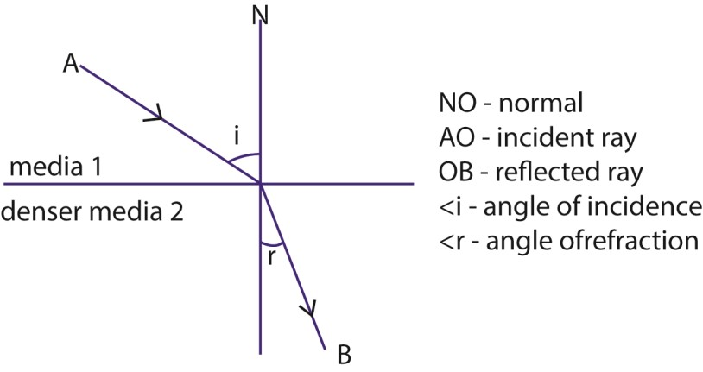

Generally if light is incident from a less dense media to a denser media, it is refracted towards the normal at the point of incidence. From a denser media to a less dense media light rays bends away from the normal.

Laws of refraction
Law 1: The incidence ray, the normal and refracted ray at the point of incidence all lie in the same plane.

Law 2: The ratio of the sine of angle of incidence to the sine of angle of refraction is constant for a given pair of media (Snell’s law)

That is 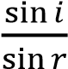 = constant
The constant in Snell’s law is known as refractive index of the two media

Refractive index, n
It is the ratio of the sine of angle of incident to the sine of angle of refraction for a ray of light traveling from air in to a given medium.

OR
This is the ratio of the speed of light in a vacuum to speed of light in a medium.

Thus refractive index, n = 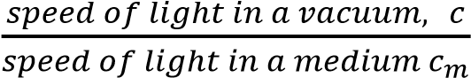

Where speed of light in a vacuum c = 3.0 x 10⁸ ms⁻¹.

The refractive index, n for a vacuum is 1. However if light travels from air to another medium, the value of n is slightly greater than 1.For example, n = 1.33 for water and n =1.5
for glass.

The principle of reversibility of light
It states that the paths of light rays are reversible. This means that a ray of light can travel from medium 1 to 2 and from 2 to 1 along the same path.

Relations between refractive indices
Case i:
Consider a ray of light traveling from medium 1 (air) to medium 2 (glass) as shown.

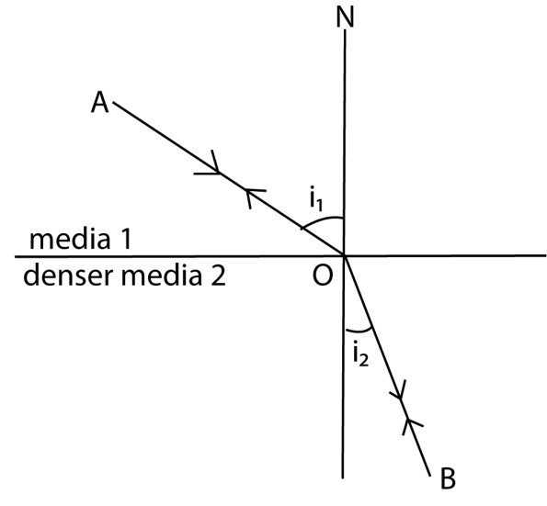

Suppose i₁ and i₂ are the angles of incidence and refraction respectively in medium 1 and medium 2, then

For light traveling from (1) to (2), refractive index 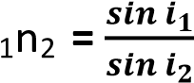

For light traveling from (2) to (1) , refractive index 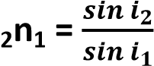
It implies that 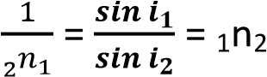
Or ₁n₂ x ₂n₁ = 1

Case II:
Consider a ray of light moving from medium 1 (air) through a series of media 2, 3 and then finally emerge into medium 1 (air) as shown.

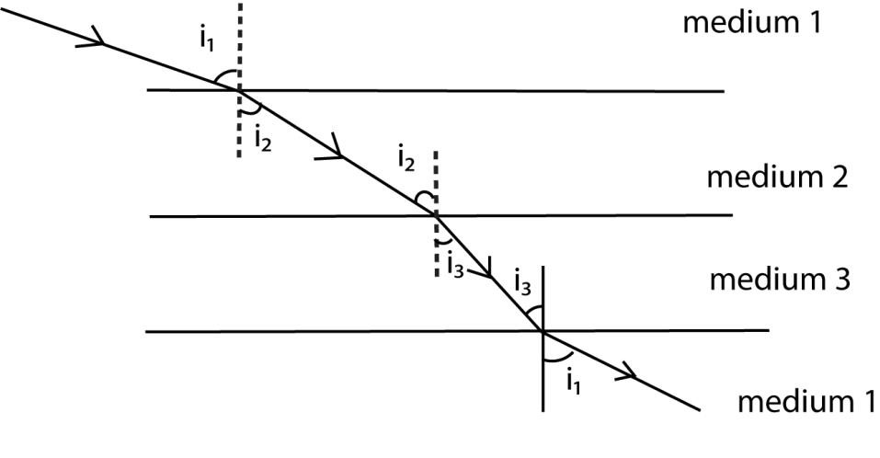

At medium 2-medium 3 interface, Snell’s law gives.
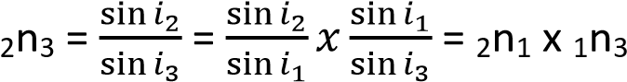
2n3 = 2n1 x 1n3
Using 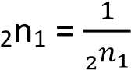
-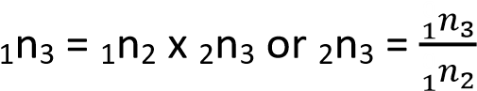

General relation between n and sin i
Consider a ray of light moving from air through a series of media 1, 2 and then finally emerge into air as shown.

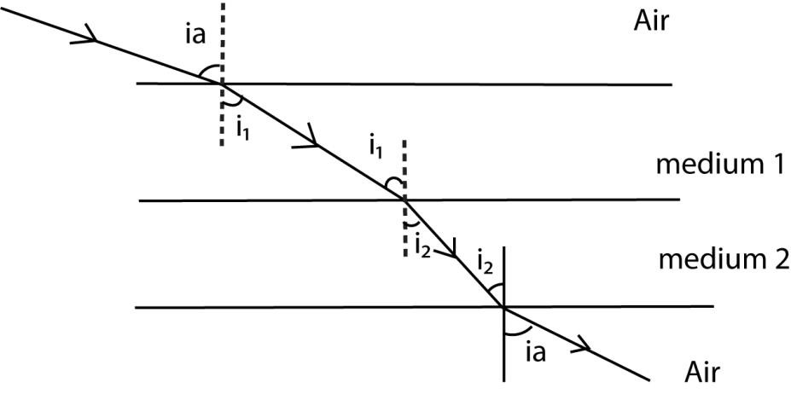

At air – medium 1 interface, Snell’s gives 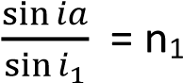
=> sin ia = n₁ sin i₁ …………………………. (i)

At air - medium 2 interface, Snell’s gives 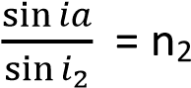
=> sin ia = n2 sin i2 ………………………….. (ii)

Equating equation (i) and (ii) gives

n₁sin i₁ = n₂ sin i₂. n sin i = a constant.

Examples 1
Monochromatic light incident on a block of material placed in a vacuum is refracted through an angle θ. If the block has a refractive index n and is of thickness t, show that this light takes a time T = 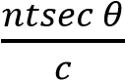 to emerge from the block. Where c is the speed of light in a vacuum.
Solution:
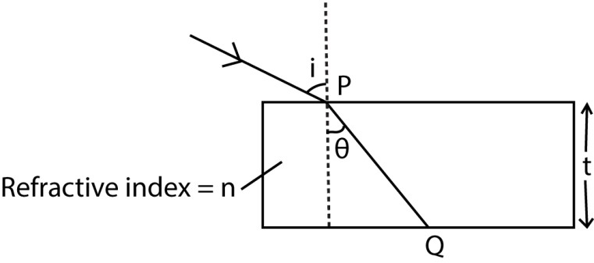
Let T be the time taken by light to travel from point P to Q in the medium.
Thus, time T 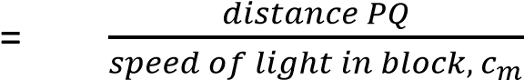

Where distance PQ 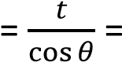 tsec θ

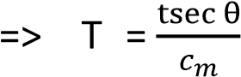 ……………………………………………………(i)

By definition, n = 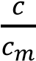
or cm = ……………………………………………… (ii)
Substituting equation (ii) in to (i) gives, T = 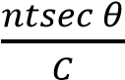

Example 2
A monochromatic beam of light is incident at 60⁰ on a water-glass interface of refractive index 1.33 and 1.5 respectively as shown

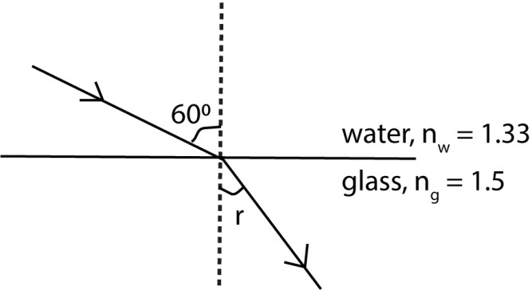

Calculate the angle of reflection r.

Solution
Applying Snell’s law gives

nw sin 60⁰ = ng sin r 1.33 sin 60⁰ = 1.5 sin r Thus < r = 50.2⁰.

Example 3
A ray of light propagating from air is incident on an air-glass interface at an angle of 60⁰. If the refractive index of glass is 1.5, calculate the resulting angle of refraction. Solution
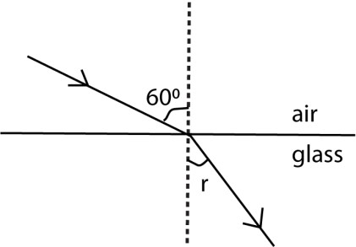

Applying Snell’s law gives
n_{a} sin 60⁰ = n_{g} sin r but n_{a} = 1 , n_{g} = 1.5
=> 1sin 60⁰ = 1.5sin r
< r = 35.6⁰.

Example 4
A monochromatic ray of light is incident from a liquid on to the upper surface of a transparent glass block as shown.
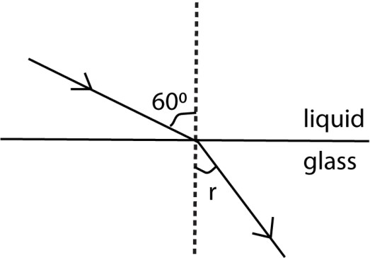
Given that the speed of light in the liquid and glass is 2.4 x 10⁸ ms⁻¹ and 1.92 x 10⁸ ms⁻¹ respectively, find the angle of refraction, r.

Solution:
Applying Snell’s law gives
n_{l}sin 60⁰ = ng sin r

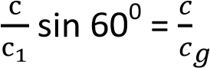 sin r
=> sin r = 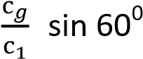 but cg =1.92 x10⁸ ms ^{-1 ,} cl =2.4 x10⁸ ms ⁻¹
sin r = 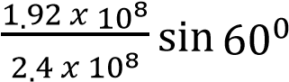
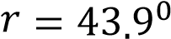

Example 5
A small fish is 3.0m below the surface of the pond and 2.5m from the bank. A man 2.0m tall stands 4.0m from the pond. Assuming that the sides of the pond are vertical, calculate the distance the man should move towards the edge of the pond before movement becomes visible to the fish. (Refractive index of water = 1.33).

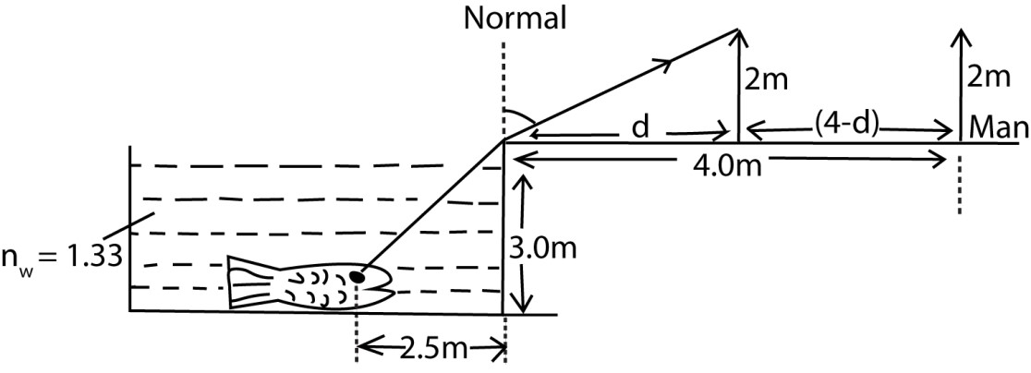

i

r

θ

From the diagram, tan i = 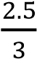
- i = 39.81⁰
Applying Snell’s law at the edge of the pond gives

nw sin i = na sin r

1.33sin 39.81⁰ = 1sin r
< r = 58.4⁰

<θ= 90⁰ – 58.4⁰ = 31.6⁰

From the diagram tan θ =
- d = 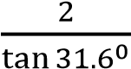 = 3.2m
Thus required distance traveled = 4 - d
= 4 - 3.2
= 0.8m

Sidewise displacement of light rays
When light travels from one medium to another, its direction is displaced sideways. This is called lateral displacement.
Consider a ray of light incident at an angle i on the upper surface of a glass block of thickness t, and then suddenly refracted through an angle r causing it to suffer a sidewise displacement d.
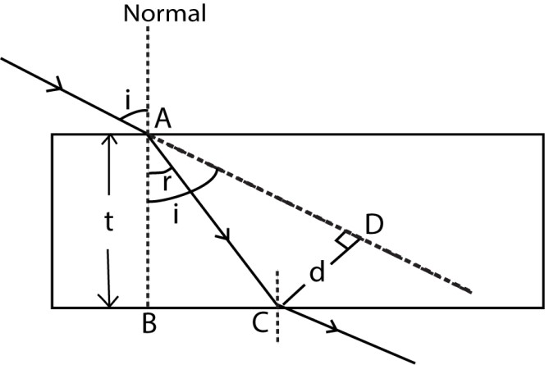

From  ABC, AC 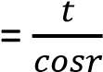 ………………………. (i)

From the diagram, <CAD = ( i - r)

From ACD, AC 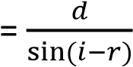 ……………………(ii) Equating equation (i) and (ii) gives
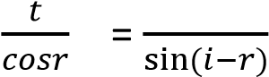
- d = 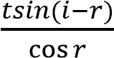
Note
The horizontal displacement of the incident ray, BC = t. tan r

Example: 6
The figure below shows a monochromatic ray of light incident from a liquid of refractive index 1.33 onto the upper surface of a glass block of refractive index 1.42
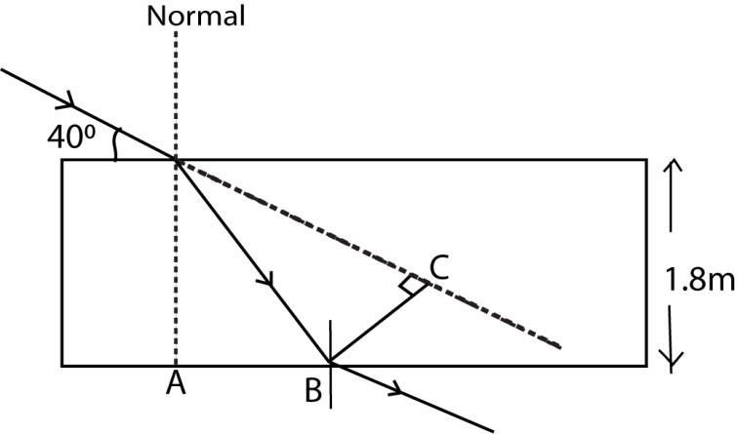

Calculate the;
- horizontal displacement AB.
- lateral displacement BC of the emergent light.

Solution
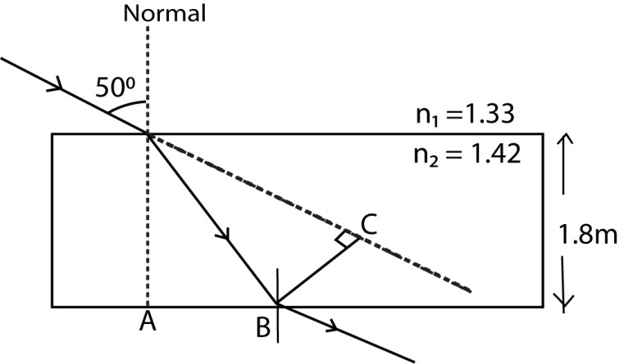
(i) Applying Snell’s law at the liquid- glass interface gives, n_{l} sin 50⁰ = n_{g} sin r.
1.33 sin 50⁰ = 1.42 sin r

<r = 4 5 . 8 ⁰

Horizontal displacement AB = t tan r
= 1.8 tan 45.8⁰
= 1.851cm

(ii) Lateral displacement d = 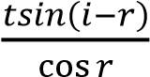
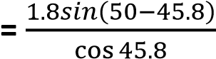
= 1.89 cm

Revision exercise 1

- What is meant by refraction of light?
- (i) State the laws of refraction of light.
  - State what brings about refraction of light as it travels from one medium to another.
- (i) What is meant by the refractive index of a material?
  - Light of two colors blue and red is incident at an angle γ from air to a glass block of
r
thickness t. When blue and red lights are refracted through angles of θ b and θ r respectively, their corresponding speeds in the glass blocks are V_{b} and V_{r}.

Show that the separation of the two colors at the bottom of the glass block
d = 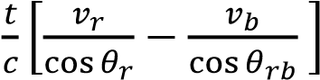 where 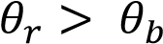 and c is the speed of light
  - Light consisting of blue and red is incident at an angle of 60⁰ from air to a glass block of thickness 1.8cm. If the speeds of blue and red light in the glassblock are 1.86 x 10
⁸ ms⁻ ¹ and 1.92 x 10 ⁸ ms⁻ ¹ respectively, find theseparation of the two colors at the bottom of the glass block. [0.54cm]
- Show that when the ray of light passes through different media separated by plane boundaries, nsinα= constant where n is the absolute refractive index of a medium and α is the angle made by the ray with the normal in the medium.
- Show that when the ray of light passes through different media 1 and 2 separated by plane boundaries, ₁n₂ x ₂n₁ = 1 where n is the refractive index of a medium.
- Show that when the ray of light passes through different media 1, 2 and 3 separated by plane boundaries, ₁n₃ = ₁n₂ x ₂n₃ where n is the refractive index of a medium.
- Show that a ray of light passing through a glass block with parallel sides of thickness t suffers a sidewise displacement d 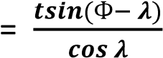 where 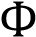 is the angle of incidence and is the angle of refraction.

Critical angle and total internal reflection
Consider a ray of light incident on an interface between two media as shown.
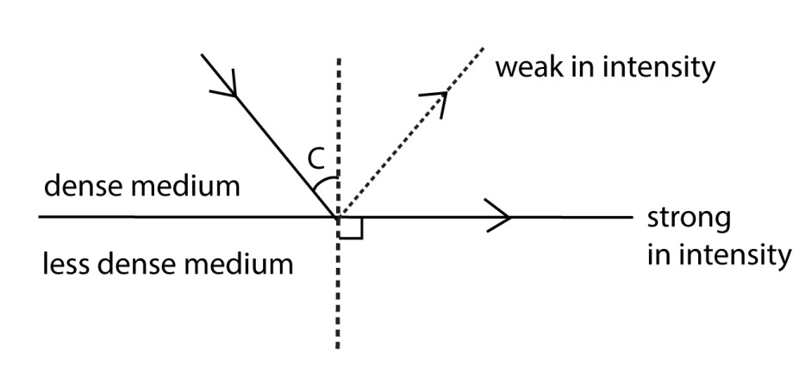

Critical angle is the angle of incidence in the dense medium which results into an angle of refraction of 90⁰ in the adjoining less dense medium.

If the angle of incidence is greater than the critical angle, all the incident light energy is reflected back in the dense medium and total internal refection is said to have occurred.

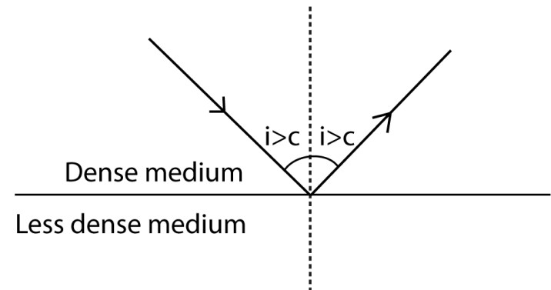

NOTE :
- At critical point Snell’s law becomes.
n₁sin c = n₂sin 90⁰

=> sin c = 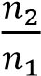
c = sin⁻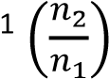

where n₁ and n₂ are the refractive indices of the dense and the less dense medium respectively.

However if the less dens medium is air, then Snell’s law becomes n₁sin c = na sin 90⁰
- sin c = 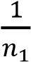

- The conditions for total internal reflection to occur are;
  - Light should travel from an optically denser to a less dense medium.
  - The angle of incidence at the boundary of the media should be greater than the critical angle.

Application of total internal reflection.
- It is responsible for the formation of a mirage.
- It is responsible for the formation of a rainbow.
- It is responsible for the transmission of light in optical fibres.
- It is responsible for the transmission of sky radio waves
- It is responsible for the transmission of light in prism binoculars.

Formation of a mirage
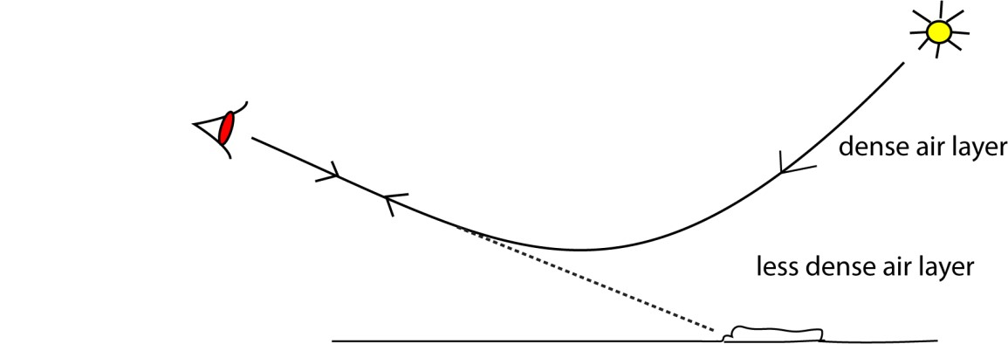
On a hot day, the air layers near the earth’s surface are hot and are less dense than the air layers above. Therefore as light from the sky pass through the various layers of air, light rays are continually refracted away from the normal till some point where light is totally internally reflected. An observer on earth receiving the totally internally reflected light gets an impression of a pool of water on the ground and this is the virtual image of the sky.

An optical fibre

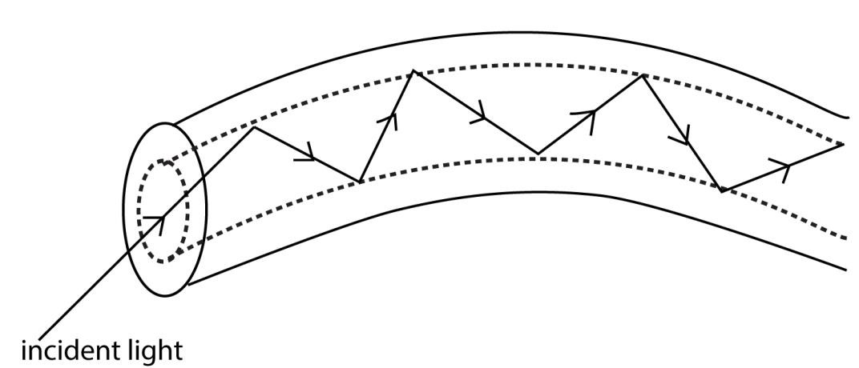

When a light ray enters in to the fibre, it bounces from one edge to another by total internal reflection. These successive total internal reflections enable the transmission of light in optical fibres.

Note
- An optical fibre finds a practical application in an endoscope, a device used by Doctors to view organs inside the human body.
- Optical fibres are used in telecommunication systems (i.e. Telephone or TV signals are carried along optical fibers by laser light).

Sky radio waves

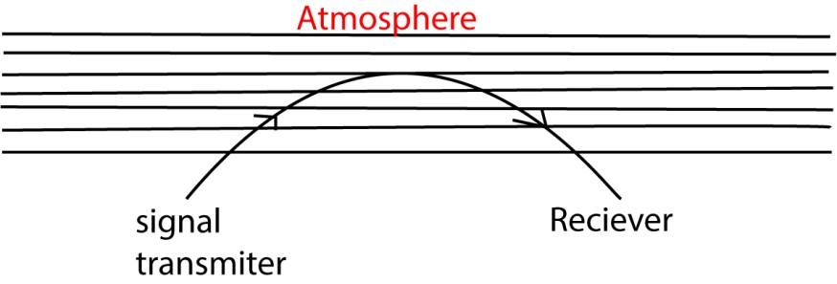
- Radio are refracted like light waves
- Radio waves from a radio station on earth’s surface are directed to atmosphere, a region of ionized gas formed at very high altitudes.
- As the optical density of the atmosphere decreases with height, the waves are totally internally reflected and can be received at the other side of the earth.

Estimation of refractive index of a liquid by an air-cell method

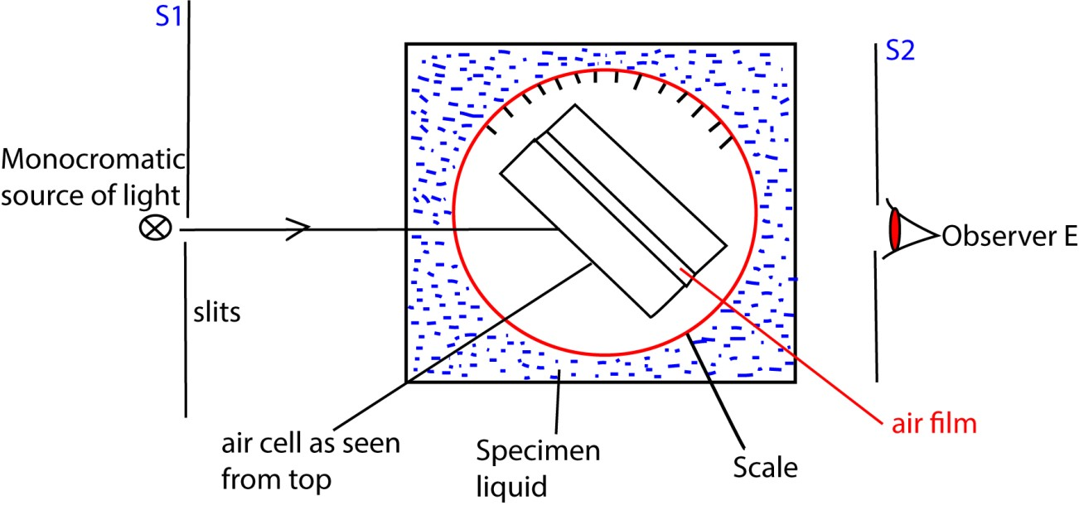

- The air cell is immersed in a liquid under test.
- A beam of monochromatic light is directed onto the air cell and then observed through the cell from the opposite side at E.
- The cell is then rotated on one side until light is suddenly cut off and the angular position θ₁ is noted.
- The cell is again rotated in the opposite direction until light is suddenly cut off and the angular position θ₂ is noted.
-
- The refractive index of the liquid can then be calculated from n 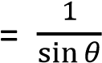 where θ = 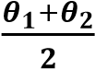
NB: The source of light should be monochromatic so that the extinction of light is sharp since monochromatic light does not undergo dispersion, as it is with white light.

Theory of the air-cell method

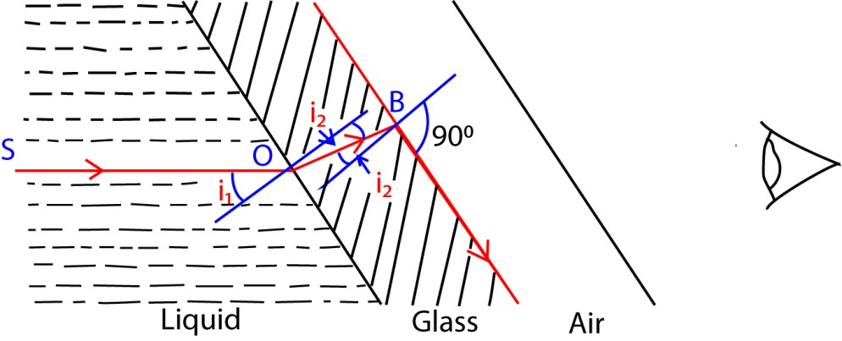

Ray OS is refracted along OB in glass. However, at B total internal just begins. Suppose i1 is the angle of incidence in the liquid, i2 is the angle of incidence in the glass while n and ng are the corresponding refractive indices, Then applying the relation n sin i = a constant gives nsin i₁ = ng sin i₂ = nasin 90⁰ n sin i1 =na sin 90⁰
⇨ n sin i₁ = 1
thus, 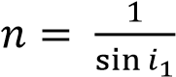
But 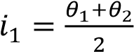
Hence 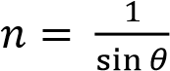

Examples 7

The critical angle for water-air interface is 48˚ 42’ and that of glass-air interface is
38˚ 47’. Calculate the critical angle for glass-air interface.
Solution
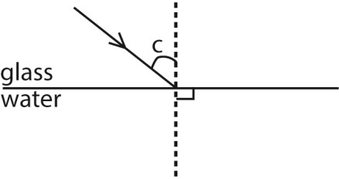

Applying Snell’s law gives ngsin c = nw sin 90⁰……………………………………….(i).

Given that for water-air interface cw = 48⁰ 42’. n_{w} sin c_{w} = 1
n_{w} sin 48⁰ 42’ = 1
- n_{w} = 1.33 ………………………………………………………………(ii)

Also for glass-air interface c_{g} = 38º47’ n_{g} sin c_{g} = 1
- n_{g} sin 38⁰ 47’ = 1 n_{g} = 1.67 . ………………………………………………..… (iii)

Substituting equation (ii) and (iii) into equation (i) gives
1.67sin c = 1.33 sin 90⁰ c = 52.8⁰

Note that 1⁰ = 60’

Examples 8
The refractive index for red light is 1.634 of crown glass and the difference between the critical angles of red and blue light at the glass-air interface is 0.56’.What is the refractive index of crown glass for blue light

Solution
Analysis the critical angle between two media for red light is greater than that for any other light colour. This gives rise to the ray diagram below

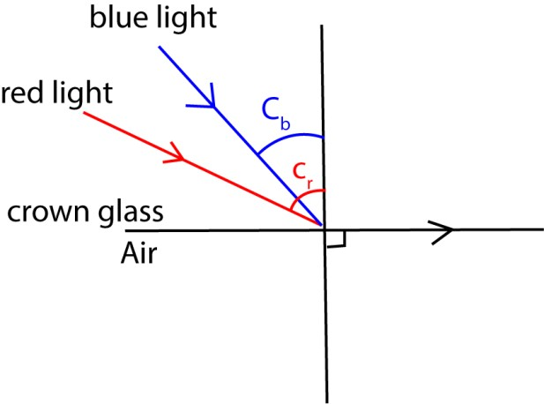

Since c_{r} > c ---(i)

Applying Snell’s law to red light gives
n_{r} sin c_{r} = 1
163 sin c_{r} = 1
=> c_{r} = 37.73⁰

Equation (i) now becomes cb = cr - 0⁰56’ cb = 37.73⁰ - 0⁰56’ cb = 36.8⁰
Applying Snell’s law to blue light gives nb sin cb = 1 nb sin 36.8⁰ = 1
=> nb =1.67

Examples 9
(i) A glass block of refractive index ng is immersed in a liquid of refractive index n_{l}. A ray of light is partially reflected and refracted at the interface such that the angle between the reflected and the refracted ray is 90⁰. Show that ng = n_{l}tan α where α is the angle of incidence from the liquid to glass.
When the procedures in (i) above are repeated with the liquid removed, the angle of incidence increases by 8⁰.
Given that n_{l} = 1.33, find ng and the angle of incidence at the liquid-glass interface. Find angle r.

Solution
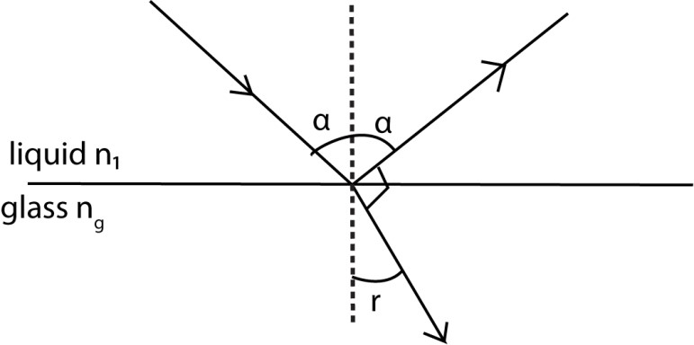
Applying Snell’s law at the liquid-glass interface gives n_{g} sinr = n_{l} sin α

But r + 90⁰+ α = 180⁰
=> r = 90⁰ - α
 n_{g} sin (90⁰ - α) = n_{l} sin α.

From trigonometry, sin (90⁰ - α) = cos α
=> n_{g} cos α = n_{l} sin α.

Dividing cos α on both sides gives n_{g} = n_{l} tan α.

(ii) When the liquid is removed.

From ng = nl tan α …………………………………………………………………..(i)
=> ng = na tan (α + 8⁰ ) but na = 1

 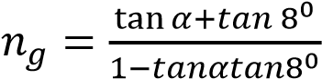
 
n_{g} ( 1- tan α tan 8⁰ ) = tan α + tan 8⁰

n_{g} - n_{g} tan α tan 8⁰ = tan α + tan 8⁰ ………………………………………..(ii)

from equation (i) tan 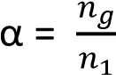
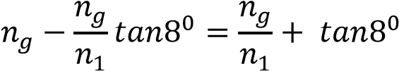
but nl = 1.33
n²g - 2.340 ng + 1.326 = 0 ………………………………………………..(iii)

Equation (iii) is quadratic in ng and solving it gives ng = 1.39 or ng not physically possible.

Using e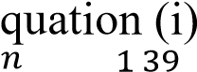
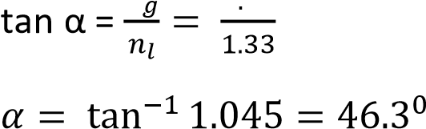
The required angle of incidence = α + 8⁰
= 54.3⁰

Examples 10
 
The figure below shows a liquid layer confined between two transparent plates X and Y of refractive index 1.54 and 1.44 respectively.
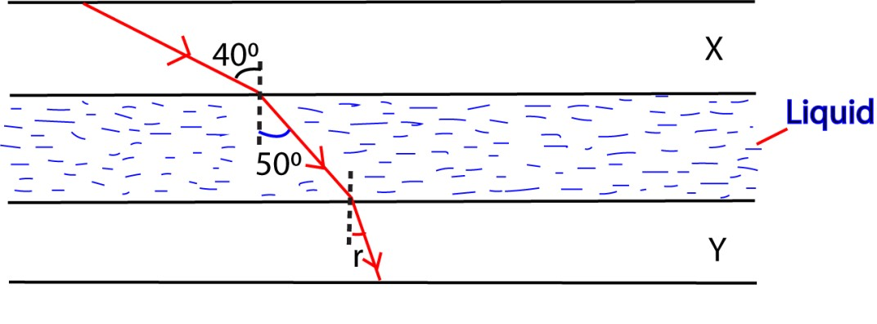
A ray the interface between media X and the liquid is refracted through an angle of 50 by the liquid.
Find the
(i) refractive index of the liquid.
Applying Snell’s law at the plate X – liquid interface gives nx 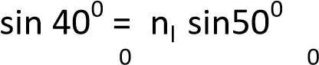
1.54 sin 40 = n_{l} sin 50 n_{l} 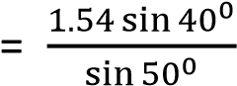

 n_{l} = 1.29

(ii) angle of refraction ,r in the medium Y.

Applying Snell’s law at the liquid – plate Y interface gives n_{l} sin 50⁰ = ny sin r
1.29 sin 50⁰ = 1.44 sin r

 <r = 43.3⁰
(iii) Minimum angle of incidence in the medium X for which the light will not emerge from medium Y.

For light not to emerge from plate , it grazes the liquid – plate Y interface.
Applying Snell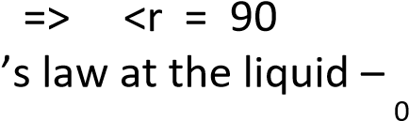plate Y interface gives
n_{l} sin i_{l} = n_{y} sin 90
1.29 sin i_{l} = 1 . 4 4 sin 90⁰
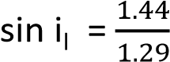 ………………………………….(i)
Moreover, applying Snell’s law at the plate X – liquid interface gives nx sin ix = nl sin il
1.54 sin i_{x} = 1.29 sin i_{l} …………………………………..(ii) Substituting equation (i) in (ii) gives 1.54 sin i_{x} 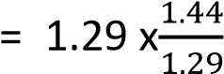
<i_{x} = 69.2⁰

Examples 11
 
The diagram below shows a cross-section through the diameter of the light pipe with an incident ray of light in its plane.
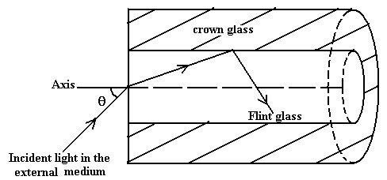

The refractive indices for flint glass, crown glass and the external medium are n₁, n₂ and n₃ respectively. Show that a ray that enters the pipe is totally reflected at the flint-crown
Glass interface provided sin θ = where θ is maximum angle of incidence in the external medium
√
[

]

Solution
Analysis for light to be totally reflected, it must be incident at a critical angle on the flintcrown glass interface
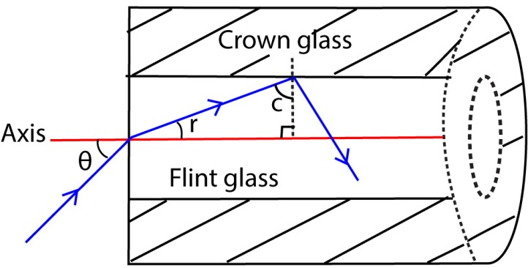

Applying Snell’s law at the external medium-flint glass interface gives n₃sin θ = n₁sin r
but r + c = 90⁰
 r = 90⁰ - c
=> n₃ sin θ = n₁sin ( 90⁰ - c )
 n₃ sin θ = n₁ cos c
- cos c = 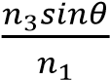 ……………………………………………….(i)
Applying Snell’s law at the flint-crown glass interface gives
n₁sin c = n₂sin 90⁰

- sin c = 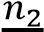 ………………………………………….(ii)

Using the trigonometric relation sin²c + cos²c = 1, then

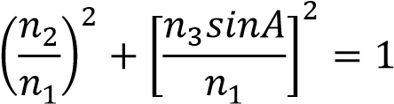
Thus, sin θ =
√

2

Revision exercise 2
- Explain the term total internal reflection and give three instances where it is applied.
- With the aid of suitable ray diagrams, explain the terms critical angle and total internal reflection.
- Show that the relation between the refractive index n of a medium and critical angle c for a ray of light traveling from the medium to air is given by n 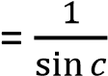
- Show that the critical angle, c at a boundary between two media when light travels from medium 1 to medium 2 is given by 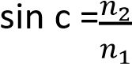 where n₁and n₂ are the refractive indices of the media respectively.
- Explain how a mirage is formed.
- Explain briefly how sky radio waves travel from a transmitting station to a receiver.
- Describe how you would determine the refractive index of the liquid using an air cell.
- 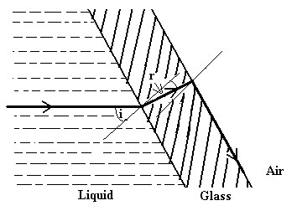
In the figure above, a parallel sided glass slide is in contact with a liquid on one side and air on the other side. A ray of light incident on glass slide from the liquid emerges in air along the glass-air interface. Derive an expression for the absolute refractive index ,n, of the liquid in terms of the angle of incidence i in the liquid-medium.
- The diagram below shows a cross-section through the diameter of the light pipe with an incident ray of light in its plane.
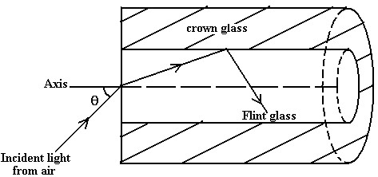
The refractive indices for flint glass and crown glass are n₁ and n₂ respectively. Show that a ray which enters the pipe is totally reflected at the flint-crown glass
Interface provided where θ is the maximum angle of incidence at the air-flint glass interface.

√

- A liquid of refractive index n_{L} is tapped in contact with the base of a right-angled prism of refractive index n_{g} by means of a transparent cylindrical pipe as shown.
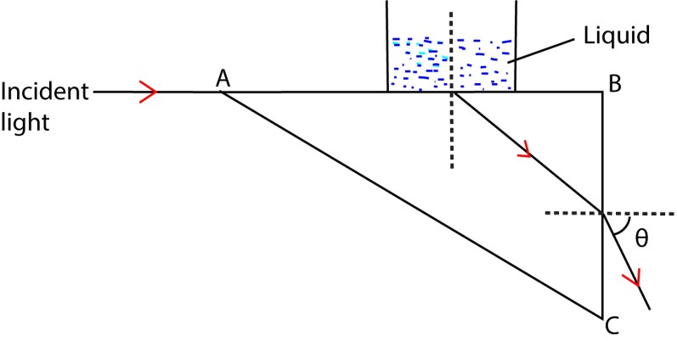
Show that a ray of light which is at a grazing incidence on the liquid-glass interface emerges in to air through face BC at an angle θ below the horizontal provided 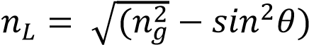. Hence find n_{L} if n_{g} = 1.52 and θ = 47.40.

Real and apparent depth
Consider an object O viewed normally from above through a parallel-sided glass block of refractive index ng and thickness t as shown.
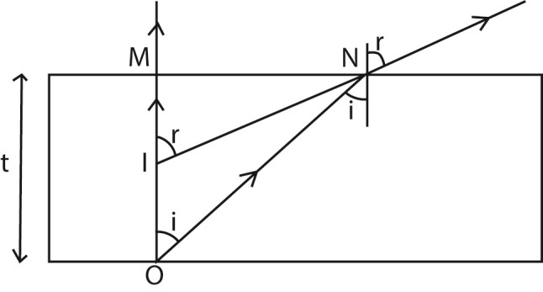
A ray from an object O normal to the glass surface at M passes un deviated. While the ray ON inclined at a small angle i to the normal is refracted at N. The observer above the glass block sees the image of the object O at I.

Applying Snell’s law at C gives ng sin i = na sin r------------------------------------(i).

From the diagram, 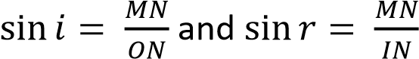
Equation (i) now becomes n_{g}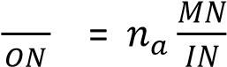
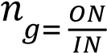
Since angle i is very small, then ON  OM and IN  IM
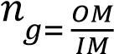
From the diagram, OM = real depth and IM = apparent depth.

Hence n_{g} 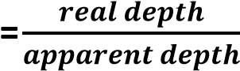.

If the apparent displacement of the object OI = d, then IM = ( t - d ).

So that ng 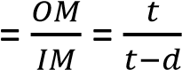
Thus, apparent displacement, d = 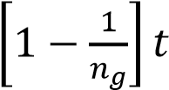
NOTE
- The apparent displacement d of an object O is independent of the position of O below the glass block. Thus the same expression above gives the displacement of an object which is some distance in air below a parallel-sided glass block.
- If there are different layers of different transparent materials resting on top of each other, the apparent position of the object at the bottom can be found by adding the separate displacements due to each layer.

Examples 12
An object at a depth of 60cm below the surface of water of refractive index is

observed directly from above the water surface. Calculate the apparent displacement of the object
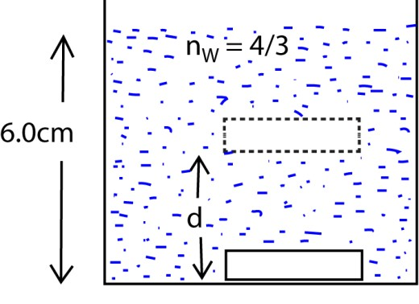

Using

the
r
e
lation

d =
[

]

gives;

d = 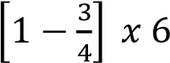 = 1.5 cm

Examples 13
A tank contains a slab of glass 8cm and refractive index 1.6. Above this is a depth of 4.5cm of a liquid of refractive index 1.5 and upon these floats 6cm of water of refractive index
. Calculate the apparent displacement of an object at the bottom of the tank to an observer looking down wards directly from above.
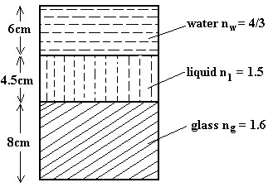Using the relation d =
S
ol
u
tion

[

]

d
=

*

+

+
*

+

+

[

]

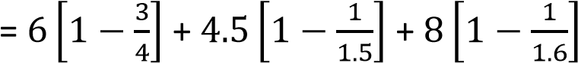
= 1.5 + 1.5 + 3 = 6cm.

Examples 14
A small object is placed 20cm in front of a concave mirror of focal length 15cm. A parallelsided glass block of thickness 6cm and refractive index 1.5 is then placed between the mirror and the object. Find the shift in the position and size of the image
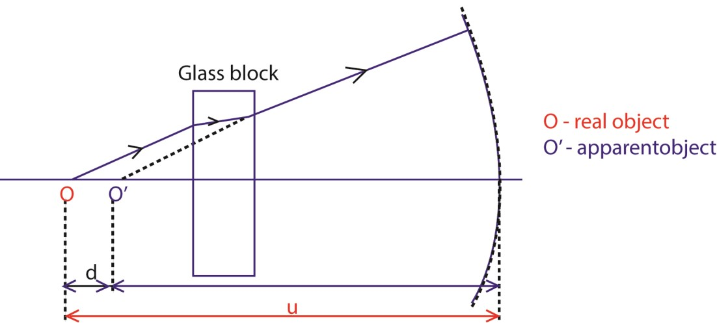

48

Consider the action of a concave mirror in the absence of a glass block u = 20cm and f = 15cm
Using the mirror formula 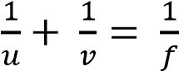 gives
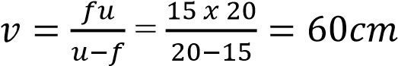
Thus in the absence of a glass block, image distance = 60cm
In this case, magnification, m = 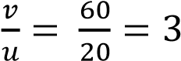
Consider the action of a glass block
Apparent displacement = 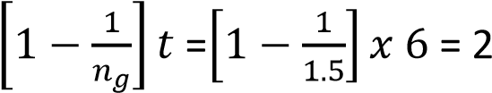cm
Thus in the presence of a glass block, object distance u¹ = (20 – 2) cm =18cm

”The object is displaced and it appears to be 18cm in front of the mirror”

Consider the action of a concave mirror in the presence of a glass block u₁ = 18cm and f = 15cm
Using the mirror formula 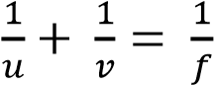 gives
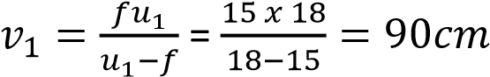

 The required shift in the image position = v₁ – v = (90 – 60) cm = 30cm

In this case, magnification, m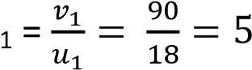

Determination of refractive index of a liquid using a concave mirror method
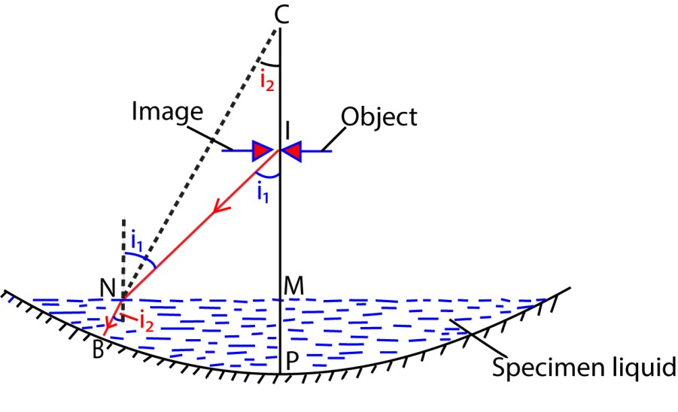
A small quantity of the liquid under test is poured into a concave mirror of known radius of curvature r. An object pin is moved along the principal axis of the mirror until it coincides with its image at I. The distance IP is noted. The required refractive index 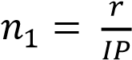

Proof
For refraction at N, n_{l} sin i₂ = na sin i₁ ………………………………………….. (i) From the diagram, sin i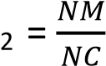 and sin i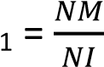
Equation (i) now becomes n_{l} 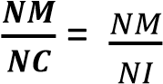
On simplifying, n_{l} 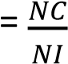
But N is very close to M hence NC  MC and NI  MN => n_{l} 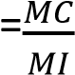
Also for a small quantity of the liquid, M is close to P => MC CP = r, and MI  IP. Thus n_{l} 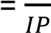
Note:
- If the specimen liquid is of reasonable quantity, then its depth d cannot be ignored. In this case, n_{l} 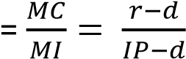
- If the radius of curvature r of the concave mirror is not known, first determine it using the method discussed in the previous section.

Examples 15
A liquid is poured in to a concave mirror to a depth of 2.0cm. An object held above the liquid coincides with its own image when its 27.0cm above the liquid surface. If the radius of curvature of the mirror is 40.0cm, calculate the refractive index of the liquid

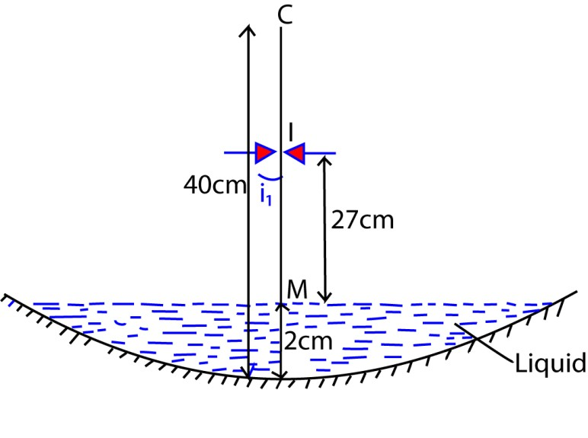
Using the relation n_{l} = r – d

MI
= 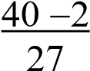

 n_{l} = 14

Examples 16
A liquid is poured into a concave mirror to a depth of 2.0cm. An object held above the liquid coincides with its image when it is 45.5cm from the pole of the mirror. If the radius of curvature of the mirror is 60.0cm, calculate the refractive index of the liquid.
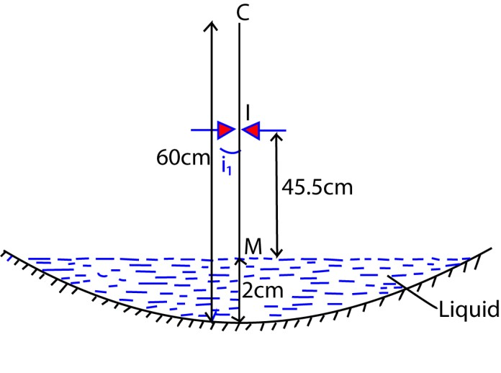

Using

the
r
e
lation

n
l

=

(45.5
-
2)
cm

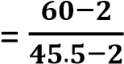
 n_{l} = 1.33

Examples 17
A small concave mirror of focal length 8cm lies on a bench and a pin is moved vertically above it .At what point will the pin coincide with its image if the mirror is filled with water of refractive index 4/3.

Solution

For a small concave mirror, the quantity of water is small that its depth d can be ignored Using the relation n_{l} 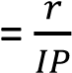 where r = 2f = 2 x 8 = 16cm
IP = 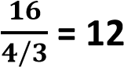

Therefore the pin coincided with its image at a height of 12cm above the mirror

Measurement of refractive index of a glass block by apparent depth method

- A vertically traveling microscope having a graduated scale T besides it is focused on lycopodium particles placed at O on a sheet of white paper. The scale reading a on T is noted.
- A glass block whose refractive index is required is placed on the lycopodium particle on a paper and the microscope is raised until the particles are refocused at I. The scale reading b is again noted.
- Lycopodium particles are then poured on top of the glass block and the microscope is re-raised until the particles are again refocused. The new scale reading c is then noted. The refractive index of the block can then be calculated from

Note
The refractive index of a liquid can be found by focusing on a sand particle at the bottom of an empty container and the scale reading a is noted. The specimen liquid is then put in the container and the traveling microscope is refocused on the sand giving a scale reading b. Finally the traveling microscope is focused on the liquid surface giving a scale reading c.

Thus n_{L}
 

Examples 18
A microscope is focused on a mark at the bottom of the beaker. Water is poured in to the beaker to a depth of 8cm and it is found necessary to raise the microscope through a vertical distance of 2cm to bring the mark again in to focus. Find the refractive index of water.

= 1.33 (2 decimal point)

Observation of sunlight situated below the horizon

Light from the sun S is successively refracted from the different layers of the atmosphere due to the different optical densities they have. To an observer O on the earth’s surface, sunlight appears to have come from point S1.

The apparent shape of the bottom of a pool of water

When the observer moves the eye from E1 towards E3 the apparent position of O moves from I₁ to I₃ along a curve due to refracted rays bending away from the normal as shown above. Thus the bottom of the pool of water appears curved, being shallower near the edge than at the centre.

The apparent size of a fish situated in water

A large surface of water is not completely flat but consists of countless ripples whose convex surface on air acts as a convex lens of long focal length. In consequence the fish is within the focal length of the lens hence it appears magnified to an observer viewing it from above.

Revision exercise 3
- Show that for an object viewed normally from above through a parallel sided glass block , the refractive index of the glass material is given by
- Derive an expression for the apparent displacement of an object when viewed normally through a parallel sided glass block.

- A vessel of depth 2d cm is half filled with a liquid of refractive index μ₁, and the upper half is occupied by a liquid of refractive index μ₂. Show that the apparent depth of the
vessel, viewed perpendicularly is
- Two parallel sided blocks A and B of thickness 4.0cm and 5.0cm respectively are arranged such that A lies on an object O as shown in the figure below

Calculate the apparent displacement of O when observed directly from above,

if the refractive indices of A and B are 152 and 166.

- A tank contains liquid A of refractive index 1.4 to a depth of 7.0cm. Upon this floats 9.0cm of liquid B. If an object at the bottom of the tank appears to be 11.0cm below the top of liquid B when viewed directly above from, calculate the refractive index of
liquid B.

- Describe how the refractive index of a small quantity of a liquid can be determined using a concave mirror.

- Describe how the refractive index of a glass block can be determined using the apparent depth method.

- A small liquid quantity is poured into a concave mirror such that an object held above the liquid coincides with its image when it is at a height h from the pole of the mirror. If the radius of curvature of the mirror is r, show with the aid ofa suitable illustration, that the refractive index of the liquid, n = .
- Explain how light from the sun reaches the observer in the morning before the sun appears above the horizon

- Explain the apparent shape of the bottom of a pool of water to an observer at the bank
of the pool.

- Explain why a fish appears bigger in water than its actual size when out of water.

Deviation of light through a prism
The angle of deviation caused by the prism is the angle between the incident rayand the emergent ray.
Consider a ray of light incident in air on a prism of refracting angle A and finally emerges into air as shown.

From the diagram above, MS and NS are normals at the points of incidence and emergence of the ray respectively.
 <MPN + <MSN = 180⁰
Thus <NST = <MPN = A
Suppose i₁, r₁ and i₂, r₂ represents angles of incidence and refraction at faces M and N respectively, then
From geometry of  MNS, r₁ + r₂ = A …………………………………….. (i )
Total deviation D = d₁ + d₂ where d₁ = i₁ - r₁ and d₂ = i₂ - r₂
=> D = i₁ - r₁ + i₂ - r₂
On simplifying, D = (i₁ + i₂) - (r₁+r₂) …………………………………………… (ii)
Combining equation (i) and (ii) gives

D = (i₁ + i₂)- A

Note:
Experiments show that as the angle of incidence i is increased from zero, the deviation D reduces continuously up to a minimum value of deviation D and then increases to a maximum value as the angle of incidence is increased as shown below:

m
i
n

Example 19
A ray of light is incident on a prism of refracting angle and refractive index of 1.3. The ray emerges from the prism at 43⁰. Find
- the angle of incidence.
- the deviation of the ray.

- At Q, Snell’s law becomes n_{a} sin 43⁰ = 1.3 sin r₂
 r₂ = 3 1 . 6 4 ⁰ But r₁ + r₂ = 72⁰
=> r₁ ₌ 72⁰ – r₂
= 72⁰ – 31.64⁰
 r₁ = 40.36⁰ At Q, Snell’s law becomes
n_{a} sin i₁ = 1.3 sin 40.36⁰  i₁ ₌ 57.34⁰.
- Total Deviation D = d₂ + d₁ where d 1 = i1 - r1 and d2 =i2 - r2 => D = (43⁰ – 31.64⁰) + (57.340 – 40.36⁰)  D = 28.34⁰.

Example 20
A prism of refracting angle 67⁰ and refractive index of 1.6 is immersed in a liquid of refractive index 1.2. If a ray of light traveling through the liquid makes an angle of incidence of 53⁰ at the left face of the prism, determine the total deviation of the ray.
Total Deviation D = d₂ + d₁ where d1 = i1 -r1 and d2 =i2 - r2
=> D = ( 53⁰ - r₁ ) + ( i₂ -r₂ ) …………………………………………….(i)
At P, Snell’s becomes
1.2 sin 53⁰ = 1.6 sin r₁  r₁ = 36.8⁰
But r₁ + r₂ = 67⁰
=> r₂ = 67⁰ - r₁
= 67⁰ – 36.8⁰
 r₂ = 30.2⁰

At Q, Snell’s law becomes
1.6 sin 30.2⁰ = 1.2 sin i₂ i₂ = 42.12⁰
Substituting for r1, i2, and r2 in equation (i) gives
D = ( 53⁰ – 36.8⁰ ) + ( 42.12⁰ – 30.2⁰ )
D = 28.12⁰
 

Minimum deviation of light by a prism
At minimum deviation, light passes symmetrically through the prism. That is to say, the angle of incidence is equal to the angle of emergence.

Consider a ray on one face of the prism at an angle i₁and leaves it at an angle i₂ to the normal as shown

For minimum deviation, i₁ = i₂ = i and r₁ = r₂ = r.
From the diagram, Dmin = d + d
D_{min} = 2d where d = i  r
→ D_{min} = 2i – 2r ………………………………………………(a)
But r + r = A.
→ 2r = A OR ………………………………………………… (b)
Combining equation (a) and (b) gives
Dmin = 2i – A
→ i = ………………………………………(c) 
At M Snell’s law becomes
n_{a} sin i = n_{g} sin r
⇒ ng ……………………………….. (d)
Substituting equation (b) and (c) in (d) gives
Since n_{a} = 1

Note;
Equation (e) suggests that if the prism was surrounded by a medium of refractive index n_{l}, then at minimum deviation

Example 21
Calculate the angle of incidence at minimum deviation for light passing through a prism of refracting angle 70⁰ and refractive index of 1.65.

Solution

Using
The required angle of incidence =

Example 21
An equilateral glass prism of refractive index 1.5 is completely immersed in a liquid of refractive index 1.3. if a ray of light passes symmetrically through the prism, calculate the: (i) angle of deviation of the ray.
(ii) angle of incidence

Solution

Using
For equilateral glass prism A = 60⁰
The required angle of incidence =

Deviation of light by a small angle prism
The small refracting angles of this prism causes the angle i₁, r₁, r₂ and i₂ to be small such that sin i₁  i₁, sin r₁  r₁ sin r₂  r₂ and sin i₂  i₂.

From the diagram, D = d1 + d2 but d₁ = i₁ – r₁ and d₂ = i₂ – r₂
=> D = (i₁ – r₁) + (i₂ – r₂)
On simplifying D = i₁ + i₂ – (r₁ + r₂) but r₁ + r₂ = A
 D = i₁ + i₂ – A………………………………….……..(a) At M Snell’s law becomes. n_{a} sin i₁ = n sin r₁
n_{a} = 1
For small angles this gives i₁ = nr₁ ……………………………..(b)
Similarly at N Snell’s law becomes i₂ = nr₂ ……………(c)
Substituting equation (b) and (c) in (a) gives
D = nr₁ + nr₂ – A
D = n (r1 + r2) –A but r1 + r2 = A
⇨ D = nA – A

D = (n – 1)A
 The deviation produced by a small angle prism is independent of the magnitude of the small angle of incidence on the prism.
I.e. All rays entering a small-angle prism at small angles of incidence suffer the same deviation)

Examples 22
A ray of light that falls normally upon the first face of a glass prism of a small refracting angle under goes a partial refraction and reflection at the second face of the prism. The refracted ray is deviated through an angle 1.8⁰ and the reflected ray makes an angle of 9.6⁰ with the incident ray after emerging from the prism through its first face. Calculate the refracting angle of the prism and its refractive index of the glass material.

Solution
Let A be the required refracting angle of the prism as shown
 
 
Consider the deviation suffered by the incident light

D = (n – 1) A where D = 1.8⁰
=> 1.8⁰ = ( n – 1) A ………………………………………………………(i) From PQN, <PQN = 90⁰- A
=> At Q, the angle of incidence = A
From NQR, <QRN = 90⁰ - 2A
=> At R, the angle of incidence = 2A
At R, Snell’s becomes na sin 9.6⁰ = n sin 2A For small angles, sin 9.6⁰  9.6⁰ and sin A  2A
=> 9.6⁰ = 2nA ………………………………(ii)
Equation (i) ÷ Equation (ii) gives

 36n = 96(n – 1)
Thus n = 16
Equation (i) now becomes18 = ( 16– 1) A
A = 3 

Dispersion of white light by a transparent medium
Dispersion of whit light is the separation of white light in to its component colours by a transparent medium due to their speed differences in the medium.
When white light falls on a transparent medium, its different component colours travel with different speeds through the medium. They are therefore deviated by different amounts on refraction at the surface of the medium and hence dispersion.
Note:
- White light is a mixture of various colours. This is called the spectrum of white light.
- The spectrum of white light consists of red, orange, yellow, green ,blue, indigo and violet light bands. On refraction, violet is the most refracted colour away from the normal (violet is the most deviated colour ) while red is least deviated.
- When light of two wavelengths say red and blue light is incident at a small angle on a small angle prism of refracting angle A having refractive indices of nr and nb. for the two wave lengths respectively, then the two wave lengths are deviated as shown below.
The deviation of red and blue light is given by d_{r} = (n_{r} – 1)A
d_{b} = ( n_{b} - 1)A.
The quantity φ= d_{b} - d_{r is} called the Angular separation (Angular dispersion) produced by the prism.
=> φ = (n_{b} – 1) A – (n_{r} – 1 )A on simplifying φ = (n_{b} – n_{r}) A

Examples 23
Light of two wave length is incident at a small angle on a thin prism of refracting angle 5⁰
and refractive index of 1.52 and 1.48 for the two wave lengths. Find the angular separation of the two wave lengths after refraction by the prism.

Solution
For a small prism, Angular separation φ = (n1 – n2) A
= (1.52 –1.48) x5⁰
= 0.2⁰

Examples 24
 
A glass prism with refracting angle 60⁰ has a refractive index of 1.64 for red light and 1.66
for violet light. Calculate the angular separation of the red and violet rays which emerge from the prism when a ray of white light is incident on the prism at an angle of 45⁰

 
 
 
 
 
 
 

For red light
At P, Snell’s law becomes
na sin 45⁰ = 1.64 sin r₁ r₁ = 25.54⁰
But r₁ + r₂ = 60⁰
r₂ = 60⁰ – r₁
= 60⁰ – 25.54⁰
 r₂ = 34.46⁰
At Q1, Snell’s law becomes
na sin i₂ = 1.64 sin 34.46⁰  i₂ = 68.13⁰.

Total Deviation Dr = d2 + d1 where d ₁ = i₁ -r₁ and d₂ = i₂ - r₂

=> Dr = (45⁰ – 25.54⁰ ) + ( 68.13⁰ – 34.46⁰ ) Dr = 53.13⁰.

For violet light
At P, Snell’s law becomes
na sin 45⁰ = 1.66 sin r₁ r₁ = 25.21⁰
But r₁ + r₂ = 60⁰
r₂ = 60⁰ – r₁
= 60⁰ – 25.21⁰
 r₂ = 34.79⁰
At Q1, Snell’s law becomes
na sin i₂ = 1.66 sin 34.46⁰  i₂ = 71.28⁰.

Total Deviation Dv = d₂ + d₁ where d ₁ = i₁ -r₁ and d₂ = i₂ - r₂

=> Dv = (45⁰ – 25.21⁰ ) + ( 68.13⁰ – 34.79⁰ )
Dv = 56.28⁰.
Consider the deviation suffered by violet light

Thus required angular separation θ = D_{v} – D_{r}
= 5628 – 5313 
 =315 

Appearance of white light placed in water
Observation:
A coloured spectrum is seen inside the water surface with violet on top and red down.
Explanation:
The different component colours of white light travel with different speeds through water. They are therefore deviated by different amounts on refraction at the water surface. Hence different coloured images are formed at different points; i.e. red inside the water surface with a violet coloured image on top.

Grazing property of light rays as applied to prisms.
If a ray of light is either such that the incident angle or the emergent angle is equal to 90⁰ to the normal of the prism, then the ray is said to graze the refracting surface of the prism.

Consider a ray of light incident at an angle i on a glass prism of refracting angle A situated in air with the emergent light grazing the other refracting surface of the prism as shown.

From the diagram, r + c = A
r = A – c …………………………………………….(a) At M Snell’s law becomes
na sin i = ng sin r………………………………………..(b)
Substituting equation (a) in (b) gives
Sin i = ng sin (A- c)
=>sin i = ng (sin A cos c – sin c cos A )………………….......(c) At
N, Snell’s law becomes ng sin c = na sin 90⁰.
sin c =
⇨ cos c =
√

√

√

Substituting for cos c and sinc in equation (c) and simplifying

Examples 25
Monochromatic light is incident at an angle of 45⁰ on a glass prism of refracting angle 70⁰ in air. The emergent light grazes the other refracting surface of the prism. Find the refractive index of the glass material.

From

√

(

)

Examples 26

A ray of light is incident on one refracting face of a prism of refractive index 15 and refracting angle 60. Calculate the minimum angle of incidence for the ray to emerge through the second refracting face.

For minimum angle of incidence, the emergent ray grazes the second refracting face.

At Q, Snell’s law becomes
1.5sin c =n_{a} sin 90⁰
=> c = 41.8⁰
But r + c = 60⁰
=> r = 60⁰ - c
= 60⁰ – 41.8⁰
 r = 18.2⁰
At P, Snell’s law becomes
1.5 sin 18.2⁰ = n_{a} sin i_{min}
 imin = 27.90

Alternatively
From

√

(

)

i = 27.92⁰

Limiting angle of the prism

This is the maximum refracting angle of the prism for which he emergent ray grazes the second refracting surface.
Suppose the incident ray grazes the first refracting surface then the limiting angle A is given by A = 2c where c is the critical angle of the glass air interface as shown.

Revision exercise 4
- (i) Obtain an expression relating the deviation of a ray of light by the prism to the refracting angle and the angles of incidence and emergence.

  - The deviation of a ray of light incident on the first face of a 60⁰ glass prism at an angle of 45⁰ is 40⁰. Calculate the angle of emergence of a ray on the second face of the prism.[ i2 = 65⁰]
  - A prism of refractive index 1.64 is immersed in a liquid of refractive index 1.4. A ray of light is incident on one face of the prism at an angle of 40⁰. If the ray emerges at an angle of 29⁰, determine the angle of the prism. [ 57.7⁰]
- (i) For a ray of light passing through the prism, what is the condition for minimum deviation to occur?
  - Derive an expression for the refractive index of a prism in terms of the refracting angle, A, and the angle of minimum deviation D.

- (a) A glass prism with refracting angle 60⁰ is made of glass whose refractive indices for red and violet light are respectively 1.514 and 1.530. A ray of white light is set
incident on the prism to give a minimum deviation for red light. Determine the:
    - angle of incidence of the light on the prism.
    - angle of emergence of the violet light. (iii) angular width of the spectrum.

(b) A certain prism is found to produce a minimum deviation of 51⁰. While it produces a deviation of 62.8⁰ for a ray of light incident on its first face at an angle of 40.1⁰ and emerges through its second face at an angle of 82.7⁰.
Determine the:
    - refracting angle of the prism.[60⁰]
    - angle of incidence at minimum deviation.[55.5⁰]
    - refractive index of the material of the prism.[1.648
 
- (i) A ray of monochromatic light is incident at a small angle of incidence on a small angle prism in air. Obtain the expression D = (n – 1 )A for the deviation of light by the prism.

  - A glass prism of small angle, A, and refractive index n_{g} and is completely immersed in
a liquid of refractive index n_{L}. Show that a ray of light passing through the prism at a small angle of incidence suffers a deviation given by
- Explain why white light is dispersed by a transparent medium.
- Light of two wave length is incident at a small angle on a thin prism of refracting angle 5⁰ and refractive index of 1.52 and 1.48 for the two wave lengths. Find the angular separation of the two wave lengths after refraction by the prism. [0.2⁰]
- A point source of white light is placed at the bottom of a water tank in a dark room. The light from the source is observed obliquely at the water surface. Explain what is observed.
- Monochromatic light is incident at an angle  on a glass prism of refracting angle A,
situated in air. If the emergent light grazes the other refracting surface of the prism, Show that the refractive index, n_{g}, of the prism material is given by
     
- A ray of light is incident at angle of 30⁰ on a prism of refractive index 1.5. Calculate the limiting angle of the prism such that the ray does not emerge when it meets the second face. [61.3⁰]
 

A spectrometer
It is an instrument used to measure accurate determination of deviation of a parallel beam of light which has passed through a prism. This provides a mean of studying optical spectra and measurement of refractive indices of glass in form of a prism.

It consists of a collimator, a telescope, and a turn table on which the prism is placed as shown.

Before the spectrometer is put in to use, 3 adjustments must be made onto it and these include,
- The collimator is adjusted to produce parallel rays of light.
- The turntable is leveled.
- The telescope is adjusted to receive light from the collimator on its cross wire.

Measurement of the refracting angle “a” of the prism The collimator is adjusted to produce parallel rays of light.
The turn table is leveled.
The telescope is adjusted to receive light from the collimator on its cross wire.
The prism is placed on the turn table with its refracting angle facing the collimator as shown.

With the table fixed, the telescope is moved to position T₁ to receive the light from the collimator on its cross wire. This position T₁ is noted and the telescope is turned in to a new position T₂ to receive light on its cross wire. The angle θ between T₁ and T₂ Is measured. The prism angle A is given by A =

Proof of the relation
Consider a parallel beam of light incident on to a prism of refracting angle A making glancing angles α and β as shown.

From the geometry, α + β = A…………………………………..(i).
Deviation d1 of ray AB = 2α
Deviation d2 of ray CD = 2β
Total deviation θ = d1 +d2
= 2 α + 2β
= 2 (α + β)…………………………..(ii)
Combining equation (i) and (ii) gives θ = 2A.

Note
It is now clear from the geometry that the angle ed through in moving the telescope from T1 to T2 is given by θ = 2A
Thus A =

Method 2: using optical pins
A white paper is stuck to the soft board using top-headed pins. Two parallel lines AB and DC are drawn on the paper and the prism is placed with its apex as shown.
Two optical pins P₁and P₂ are placed along AB and pins P₃ and P₄ are placed such that they appear to be in line with the images of P₁ and P₂ as seen by reflection from face
PQ .The procedure is repeated foface QR. The prism is removed and angle θ is measured. The required refracting angle A

Measurement of minimum deviation “dmin” of the prism
The collimator is adjusted to produce parallel rays of light.
The turn table is leveled.
The telescope is adjusted to receive light from the collimator on its cross wire The prism is placed on a turn table with its refracting angle facing away from the collimator as shown.

The telescope is turned in the direction of the base of the prism until light can be seen. With light kept in view, both the telescope and the table are turned until light moves in the opposite direction. Position T₃ of the telescope is noted.
The table is then fixed and the prism is removed so that the telescope is turned to a new position T₄ to receive the un deviated light. The angle between T₃ and T₄ is determined and this is the angle of minimum deviation Dmin.

Note:
(i) Position T₃ is noted because, in the position of minimum deviation light viewed through the telescope moves in the opposite direction.
(ii)
(iii) The refractive index of a glass prism of known refracting angle A can be determined using a spectrometer from the relation

Method 2: using optical pins

Two optical pins P₁and P₂ are placed along the lines that make different angles of incidence i. Pins P₃ and P₄ are placed such that they appear to be in line with the images of P₁ and P₂ as seen through the prism. The angles of deviation d are measured for different angles of incidence. A graph of d against i is plotted to give a curve whose angle of deviation at its turning point is the angle of minimum deviation, Dmin of the prism.

Uses of a glass prism.
- They enable the refractive index of a glass material to be measured accurately.
- They are used in the dispersion of light emitted by glowing objects.
- They are used as reflecting surfaces with minimal energy loss.
- They are used in prism binoculars.

Revision exercise 5
- A ray of monochromatic light is incident on one face of a glass prism of refracting angle 60⁰ and is totally internally reflected at the next face.
  - Draw a diagram to show the path of light through the prism.
  - Calculate the angle of incidence at the first face of the prism if its refractive index is 1.53 and the angle of incidence at the second face is 42⁰.[40.8⁰]

- A ray of light is incident on the face AD of a glass block of refractive index 1 as shown.

If the ray emerges normally through face BC after total internal reflection, calculate the angle of incidence, i. [49.5⁰]

 
- A ray of light is incident at 45⁰ on a glass prism of refractive index 1 as shown.
Calculate the angle of emergence and sketch the ray diagram. [25.15⁰]
 
- A ray of light is incident at 45 on a glass prism of refractive index 15 as shown.

Calculate the angle of emergence and sketch the ray diagram. [45⁰]
- The diagram in the figure below shows a cross section of an isosceles right angled prism sides PQ and QR are coated with a reflecting substance. A ray of light is incident on PR at an angle θ as shown
48

  - Draw a diagram to show the path of light through the prism.
  - Show that the ray leaving the prism is parallel to the incident ray.

- Draw a labeled diagram of a spectrometer and State the necessary adjustments that must be made on to it before put in to use.

- Describe how the refracting angle of the prism can be measured using a spectrometer.

- You are provided with pins, a white sheet of paper, a drawing board and a triangular prism. Describe how you would determine the refracting angle A of the prism

- Describe how the minimum deviation, D, of a ray of light passing through a glass prism can be measured using a spectrometer.

- You are provided with pins, a white sheet of paper, a drawing board and a triangular prism. Describe how you would determine the angle of minimum deviation, D, of a ray of light passing through a glass prism.

- Describe how the refractive index of a material of a glass prism of known refracting angle can be determined using a spectrometer.

- Describe briefly two uses of glass prisms

Refraction through lenses
Lenses
A lens is a piece glass bounced by one or two spherical surfaces.

Lenses are of two types namely;
- Convex (Converging) lens: It is a lens which is thicker in the middle than at the edges.

- Concave (Diverging) lens: It is a lens which is thinner in the middle than at the edges.

Illustrated below are some of the common types of lenses.

Definitions
- Centres of curvature of a lens: These are centres of the spheres of which the lens surfaces form parts.

Points C1 and C2 are the centres of curvature of the lens surfaces.

- Radii of curvature of a lens: These are distances from the centres to the surfaces of the spheres of which the lens surfaces form parts.

- Principal axis of a lens: This is the line joining the centres of curvature of the two surfaces of
the lens.

- Optical centre of the lens: This is the mid-point of the lens surface through which rays incident on the lens pass un-deviated.

- Paraxial rays: These are rays close to the principle axis and make small angles with the lens
axis.

- (i) Principal focus “F” of a convex lens: it is a point on the principal axis where paraxial rays incident on the lens and parallel to the principal axis converge after refraction by the lens.

  - Principal focus “F” of a concave lens: it is a point on the principal axis where paraxial rays incident on the lens and parallel to the principal axis appear to diverge from after refraction by the lens.

- (i) Focal length “f” of a convex lens: it is the distance from the optical centre of the lens to the point where paraxial rays incident and parallel to the principal axis converge after refraction by the lens.

  - Focal length “f” of a concave lens: it is the distance from the optical centre of the lens to the point where paraxial rays incident and parallel to the principal axis appear to diverge from after refraction by the lens.

Geometrical rules for the construction of ray diagrams

The following is a set of rules for easy location of the images formed by lenses:

- A ray parallel to the principal axis after refraction passes through the principal focus or appears to diverge from it.
- A ray through the principal focus is refracted parallel to the principal axis.
- A ray through the optical centre continues straight or un-deviated.

NOTE:
- The normal to the lens surfaces must pass through its centres of curvature.

- The image position can be located by the intersection of two refracted rays initially coming from the object.

Images formed by a convex lens
The nature of the image formed by a convex lens is either real or virtual depending on the object distance from the lens as shown below;

(a) Object is between F and P

The image is magnified, virtual, erect

(b) Object at F
The image is real, inverted, magnified and at infinity

(c) Object between F and 2F

The image is real, beyond C, inverted and magnified

(d) Object at 2F
The image is real, inverted, same size as the object.

(e) Object beyond 2F

The image is real, inverted, inverted, between F and 2F (a) Object at infinity

The image is real, inverted and diminished

Note;
Generally the image of an object in a convex lens is virtual only when the object is nearer to the lens than its focus.

Reasons why an image of a real object may not be formed by a convex lens on the screen
- When the object is at the principal focus
- When object distance is less than focal length
- When the distance between the object and the screen is four times the focal length of the lens.
- When the screen is between the lens and its principal focus

Uses of convex lenses
(i) They are used in spectacles for long-sighted people (ii) They are used in cameras.
- They are used in projectors.
- They are used in microscopes.
- They are used in astronomical telescopes.

Images formed by a concave lens

The image of an object in a convex lens is erect, virtual, and diminished in size no matter where the object is situated as shown below
The image is virtual, erred and diminished

Uses of concave lenses
- They are used in spectacles for short-sighted people
- They are used in Galilean telescopes.

Lenses compared with prisms
A thin lens may be regarded as being made up of several portions of small-angle prisms placed together as shown:
All paraxial rays incident on the lens at a single point suffer a similar small deviation D = (n– 1) A produced by a prism of small-angle A regarded to have replaced the lens.

Lenses and sign convention
In order to obtain a formula which holds for both concave and convex lenses, a Sign rule or convention must be obeyed and the following shall be adopted.

- Distances of real objects and images are positive.

- Distances of virtual objects and images are negative.
NOTE:
A convex lens has a positive focal length while a concave lens has a negative focal length.

The thin lens formula
Consider in each case a ray incident on the same lens at a small height h above the principal
axis as shown:

From Fig (i), the ray parallel and close to principal axis is converged to the focal point F and suffer a small deviation d
where d tan d
From Fig (ii), the ray from a point object O suffers the same small deviation D to give rise to a point image I.
From geometry, d = α
d =

Equati ons (i) and (ii) gives

Thus

This is the general lens equation.

If the sign conversion is used for u, v and f the equation holds for both converging and diverging lenses.

Lens formula for concave lens
Consider in each case a ray incident on the same lens at a small height h above the principal axis as shown:

From Fig (i), the close and parallel to principal axis ray appears to diverge from the focal point F and suffers a small deviation d; since h is very small
Thus d ≈ tan d (i) (F is virtual)
From Fig (ii), the ray from a point object O suffers the same small deviation D to give rise to a point image I.
From geometry, β = α +d or d = β - α
Since α and α are small; α ≈ tanα = (image is virtual)
d =
Equati and (ii) gives

Thus

Derivation of Lens formula for concave lens using a finite object

From the ray diagram above IS is the image of OQ.
Triangle OPQ and PIS are similar that hence …………………….(i)
Likewise, triangle PRF is similar to FIS that ……………………………(ii)
But PR = OQ, PF = f and FI = v-f
Substituting PF and FI in equation (ii); ………………………………… (iii)
From (i) and (iii)
fv = uv – uf
diving by ufv gives

Example 26
An object is placed 20cm from
- A converging lens, f = 15cm
- Diverging lens of focal length 15cm. Calculate the position and nature of image formed in each case

Solution
- u = 20cm, f = 15 cm, v= ? from
Magnification, m =
The image is real, because v is positive, inverted and magnified

- u = 20cm, f = -15 cm, v= ? from
- Magnification, m =
- The image is virtual, because v is negative, upright and diminished

Power of a lens
This is the reciprocal of the focal length of the lens in meters. It is measured in dioptres.

Hence power of a lens =
NOTE:
The power of a converging lens is positive while that of a diverging lens is negative.

Example 27
Calculate the power of a converging lens of focal length 25cm.

Solution

Power of a converging lens = = 4dioptres

Example 28
Calculate the power of a diverging lens of focal length 20cm.

Solution
Power of a converging lens = 5dioptres

Formula for magnification
Linear magnification, m

Proof
Consider a lens l, which forms an image I of height h’, at distance v from the lens of object an object, O of height, h, placed a distance u, from the lens.

tan θ =

Rearrangement,
Or, magnification M =

Relationship connecting m, v and f
From multiply v

m =

Minimum separation of an object and its real image formed by a convex lens
Consider a real image I of an object O formed by a convex lens of focal length f as shown:
Let d be the separation of an object and its real image formed by a convex lens
Image distance v = d - u where u = object distance

From

f =

or u²-du +df = 0

Solving for u gives
U =
For the roots of u to be real, d² - 4 df 0
Thus, d² 4df or d4f

Thus, the minimum distance between the screen and object must be greater than 4f which implies that 4f is the minimum distance between the real image and the object.

A plot of the graph of (u+v) against u or v gives a graph below

Relationship between focal length, radii of curvature and refractive index of a lens

Consider a ray parallel to the principal axis, incident at height, h.

tan d = d is small in radian, d = ………………………………..(i)
For small angle prisms d = (n-l)A ………………………… (ii)
From the diagram above, α + β =A …………………….. (iii)
For small angle
Substitution α and β in equation (iii)
= A ……………………………………………………………(iv)
Substituting equation (i) and (iv) in equation (ii)
Dividing by h

Conjugate points
These are two points, O and I. each on the opposite side of a convex lens such that an object and its image at these points are interchangeable.
Note:
The property of conjugate points is such that when an object is placed at one of the points, the image is formed at the other point by the lens.

Newton’s formula (Newton’s relation)

Consider an object, O, such that its image, I, is formed
Object distance u = f + x
Image distance v = f + y

Using the relation and substituting for u and v

Solving the equation f² = xy
f =

By obtaining various values of x and y, a plot of values of x against 1/y gives a shape of the graph below

2
Slope, s = f = xy

Combined focal length of two thin lenses
Consider two thin lenses L₁ and L₂ of focal length f₁ and f₂.
For lens L₁,

……………………….(i)

For L₂, I’ acts as the object
…………………….(ii)
Eqn. (i) + Eqn. (ii)

Where F is the focal length of combined lens,

Determination of focal length of convex lens

(a) Determining the focal length of a convex lens using displacement of a convex lens when O and I are fixed

Lens A forms an image of O at I
By the principle of reversibility of light, an object at I forms an image at O. When the object and the screen are fixed, another clear image can be formed by the lens when moved from A to B.

From the diagram
OB = IA and OA =IB
OA + BI = L-d
OA + OA + L-d (since OA + IB) 2OA = L-d
AO = = u ……………………(i)

Also, AI = AB + BI
AI = AB + OA (since OA = BI
AI = d + = v
Using the formula
f =

NB. This is the method recommended for measuring the focal length of a lens whose surfaces are inaccessible (for example, when· the lens is in a tube), when measurements of v and u cannot be made
Expression of object height, h, in form of heights h₁ and h₂ of the two images formed when a convex lens is displaced between fixed object O and the screen.
Lens at position A, a magnified image is formed
Linear magnification,
……………………………………………. (i)

Lens at position A, a magnified image is formed
Linear magnification,
……………………………………………. (ii)
From the diagram the diagram and the principle of reversibility of light
OB = AI= u+ d and OA =IB= u

From (i) and (ii), it follows that by inverting (i)

The length, h, of an object can hence be found by measuring the lengths h₁ and h₂ of the images for the two positions of the lens.

This method of measuring his most useful when the object is inaccessible, for example, when the width of a slit in a tube is required.

(b) Measuring the focal length of convex lens using a lane mirror method (Non parallax method)

- Place a plane mirror M on a table and lens L on top of it.
- Clamp a pin, O, horizontally with its tip lying horizontally along the principal axis of the lens
- Move the pin O up and down along the principal axis to locate the position where it coincides with the image.
- Measure the focal length, f, a distance from the pin to the lens.

(c) Determining the focal length of a convex lens by focusing a distant object.

- Position the lens to sharply focus a distant object on the screen - Measure the focal length f.

(d) Using the lens formula (experimental method)
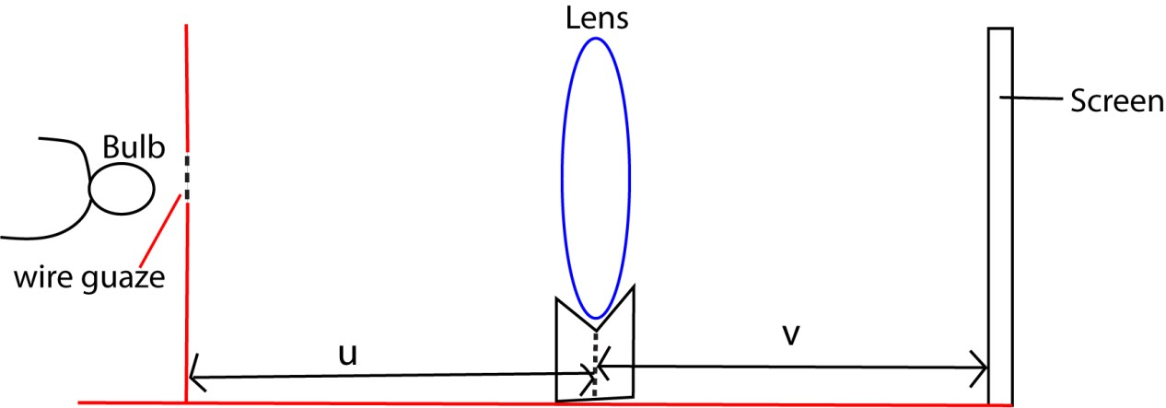
- Using illuminated object at measured distance from the lens, move the lens to and fro the lens until a clearly focused wire gauze forms on the screen and measure distance, d.
- Repeat the procedure for several values of u and each time measure the distance v.

- Tabulate your results
u(cm) | V (cm) | 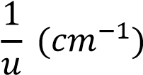 | 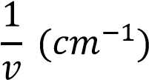 | (u+v)  (cm) | uv  (cm²)

(a) A plot of 1/u against 1/v gives a shape of the graph below

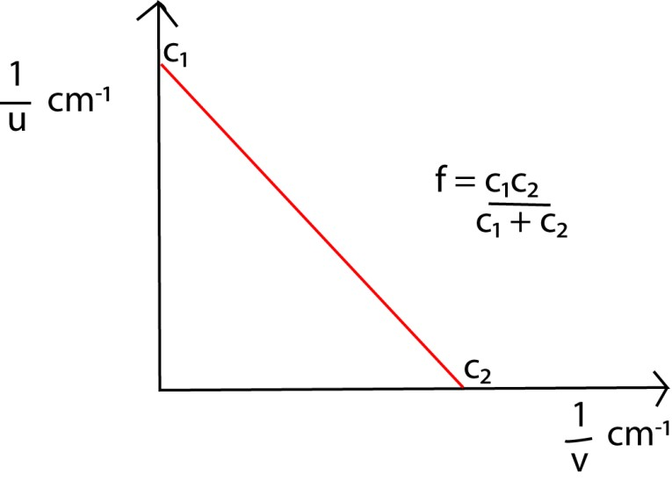
(c) A plot of uv against (u+v)
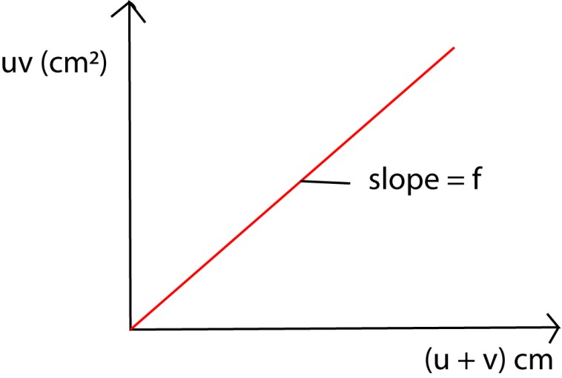

Example 29
A thin converging lens of 6cm focal length is placed in a container with a diverging lens of focal of focal length 10cm. Find the focal length of the combined lenses. Solution f₁ = 6cm, f₂ = -10cm
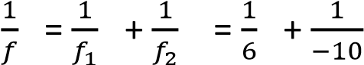 ; f = 15cm

Example 30
The deviation, d, by a prism of small angle ,A and refractive index, n is d = (n – 1)A. Use this to show that the focal length of thin converging lens of refractive index n is given by
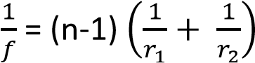 where r₁ and r₂ are radii of curvature of the surfaces.
(b) A thin lens with faces of small radii of curvature 20cm and 30cm is to be made from glass with refractive index 1.6. What is the focal length of the lens if it is
- biconvex
- biconcave
Solution
  - Refer to the notes above
  - (i)
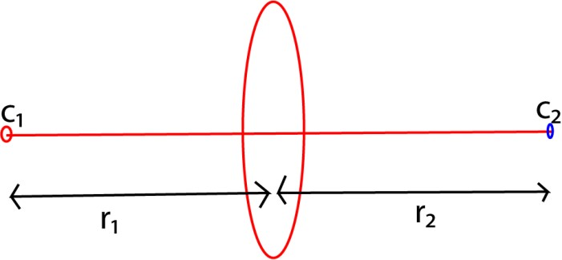
r₁= +20cm, r₂ = +30cm
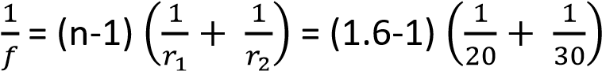
f = 20cm

(ii)
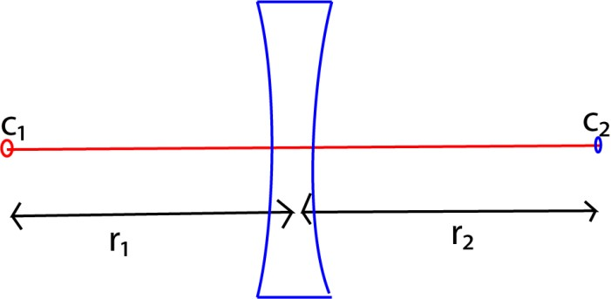
r₁= -20cm, r₂ = -30cm
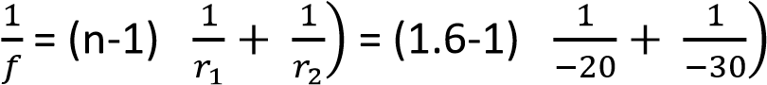 (
f = -20cm

Example 31
Calculate the focal length of a converging meniscus with radii 25cm and 20cm with refractive index 1.5

Solution
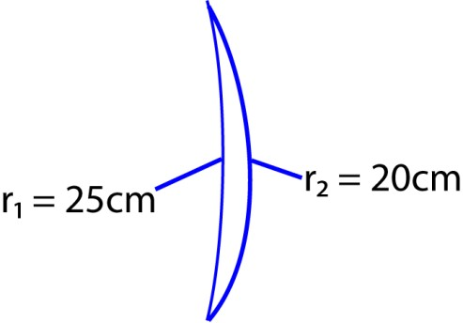
r₁= -25cm, r₂ = +20cm
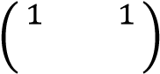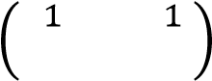
f = 200cm

Determination of focal length of concave lens
(a) Determination of focal length of concave lens using convex lens
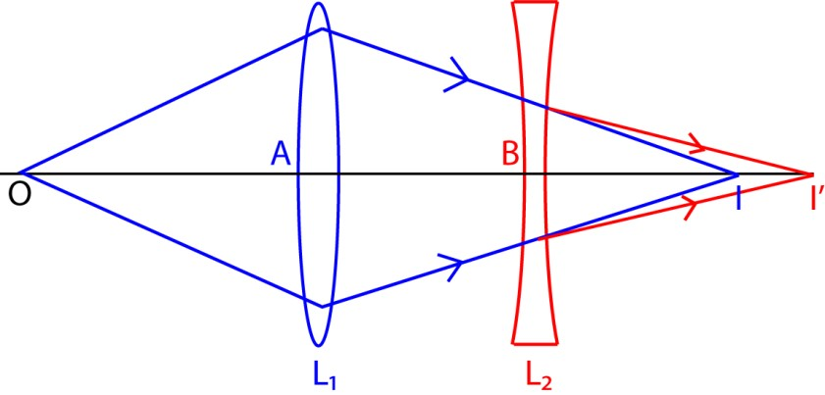
I’- is the image of lens L₂.
I – is a real image of lens L₁ and virtual object of L₂
- An object, O, is placed at a distance greater than f of lens L₁ to form real image I.
- The image formed by L₁ is I is the virtual object to lens L₂. Measure the distance AI.
- Lens L₂ is then placed between L₁ and a real image I’ is formed by L₂. Measure the distance AB and BI and BI’
- For lens L₂; image distance, v = BI’, and object distance, u = BI = AI – AB which is negative.
- The focal length f for L₂ is calculated from
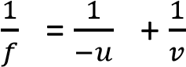

Example 32
A converging lens L₁ of focal length 10cm is placed at a distance, y, in front of a diverging lens L₂ of focal length 20cm. An illuminated object is placed at a distance of 20 cm in front of L₁ and the final image by L₂ formed at the principal focus of L2. Calculate the
- Distance y
- Final magnification

Solution
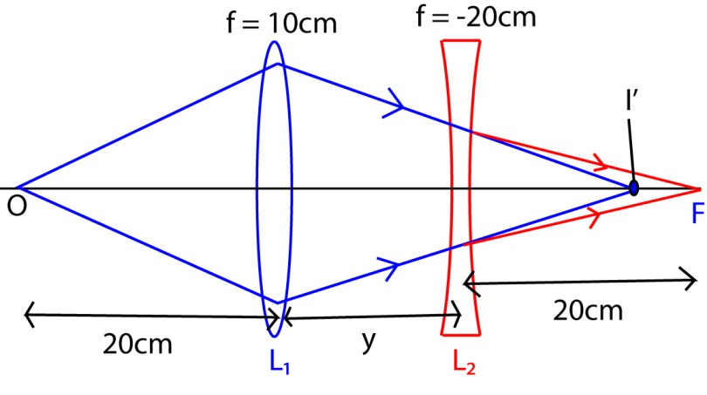
- For L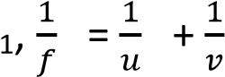
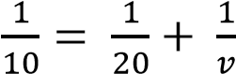
v = 20 cm For L₂

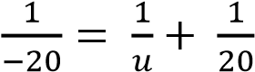
u = -10cm y= 20 – 10 = 10cm

- M = m₁ x m₂
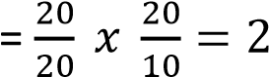
(b) Determining the refractive index of a small quantity of a liquid using a convex lens and plane mirror.
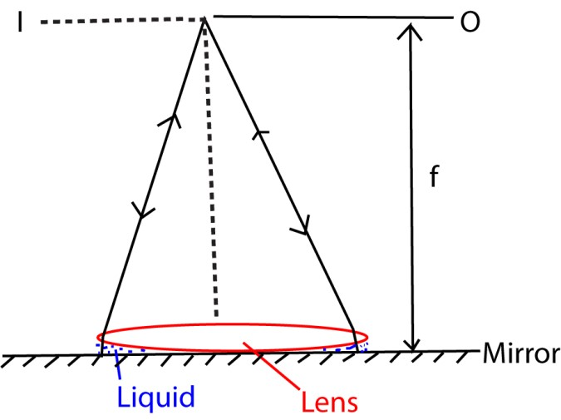
- Pour a small liquid on the plane mirror and place the convex lens on top.
- Move the object, O, along the principal axis until it coincides with its image, I.
- Measure the distance, F, from O to the lens which is the combination of the focal length of the liquid and the lens.
- Repeat the experiment (ii) with the convex lens and the plane mirror without the liquid and determine focal length, f, of the glass lens
From 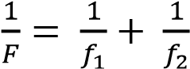
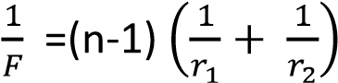
r₂ = (plane convex liquid lens)
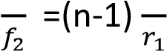

n = 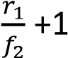

Example 33
A biconvex lens of radius of curvature 24cm is placed on a liquid film on a plane mirror. A pin clamped horizontally above the lens coincides with its image at a distance of 40cm above the lens. If the refractive index of the liquid is 1.4. What is the refractive index of the material of the lens?
Solution
For a biconvex, r₁ = r₂ = 24cm, f = 40cm, n_{L} = 1.4
From 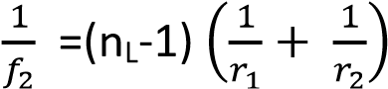
But r₁= r₂ = 24cm
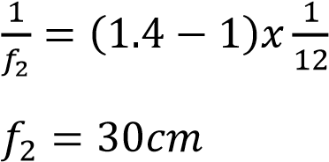
This is the focal length of the liquid
For the combed lens;
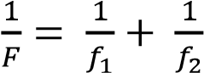
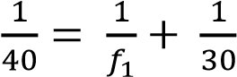
f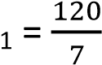
For the convex lens;
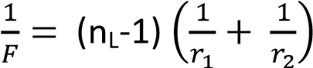
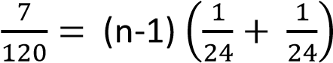
n = 1.7

Example 34
An equi-convex lens of refractive index 1.54 is placed on a horizontal plane mirror. A pin is moved along the horizontal axis of the lens and is found to coincide with its image at 25cm above the lens. The lens is then floated on the surface of mercury in a dish and coincides between the pin and its image is again obtained at height, h, above the lens. Find the value of n given that the refractive index of mercury is 1.42.

Solution
For an equi-convex lens, r₁ = r₂ = r n_{g} = 1.54, f₂ =25cm, f =h, n₁ =1.42
For the glass lens,
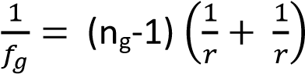
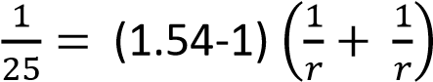; r = 27cm
For the liquid lens;
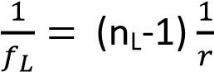
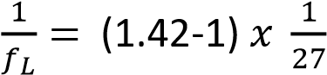
f_{L} = 64.3cm
Substitute in 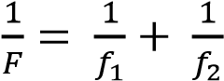
But f_{L} is negative because the lens is plano-concave
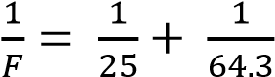
F = h = 40.9cm
(c) Determination of focal length of concave lens using concave mirror.
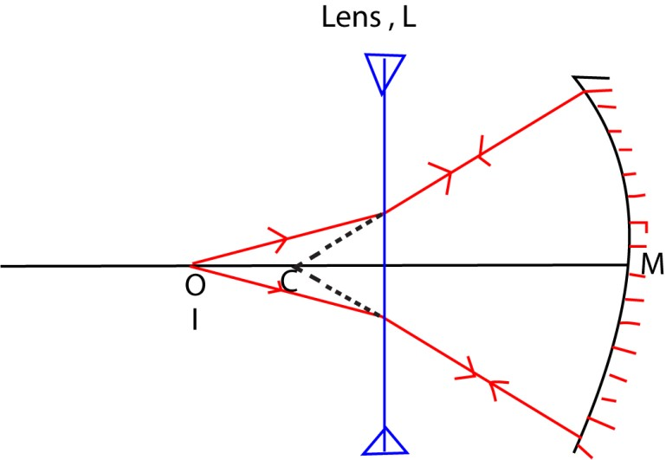
- An illuminated object is placed beyond the center of curvature of a concave mirror of known radius of curvature, r.
- A diverging less L is placed between O and M and its position is adjusted until a clear image I is formed besides O.
- Distance LI and LM are measured and recorded.
- For the lens, object distance, u = -CL = - (r-LM); image distance, v =LI or LO
The focal length, f, is calculated from 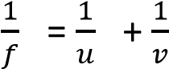

Defects of the lens

Chromatic aberration
Chromatic aberration (CA), also called chromatic distortion and spherochromatism, is a failure of a lens to focus all colors to the same point. It occurs due to dispersion since refractive index of the lens varies with the wave length of the color of light.

Correction of chromatic aberration
- Use lenses made of low-dispersion glasses, especially those containing fluorite
- By using combination of lenses of opposite nature (convex & concave) or chromatic doublet such that the dispersion produced by one lens is reversed by another.
- Placing the eye close to the lens such that images due to different colours subtend the same angle at the eye.

Spherical aberration
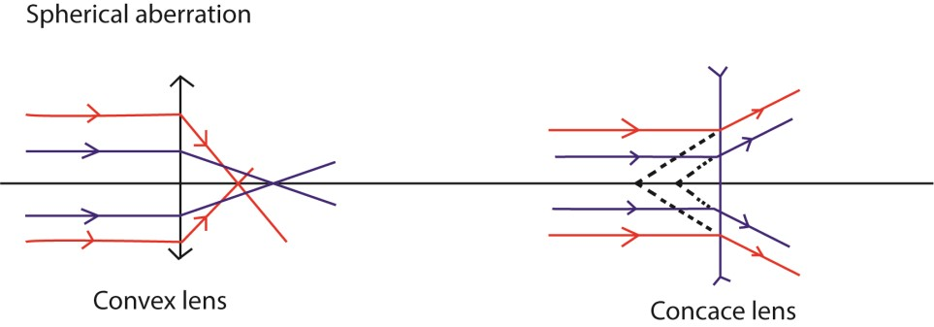
Spherical aberration occurs when the lens fails to focus all rays falling on it to the same point. Thus images formed by the lens at large apertures are therefore unsharp or blurred at the edges.
Note that in spherical aberration marginal rays are focused closer to the lens than paraxial rays in convex lens but appear to diverge far in concave lens.
Means of reduction of spherical aberration
- Using lenses with an aspheric surface - Using lens of small aperture.
- Using a stopper such that only light incident on the middle of the lens pass, but this method reduces the brightness of the image since it reduces the amount of light energy passing through the lens.

Revision exercise 6
1. (a)Define the following as applied to a converging lens (1mark)
- Principal axis (1mark)
Principal axis of a lens: This is the line joining the centres of curvature of the two surfaces of the lens.
- Center of curvature (1mark)
Centre of curvature of a lens: This is centre of the spheres of which the lens surfaces form parts.

- Find the power of a lens of focal length 15cm.
Power = 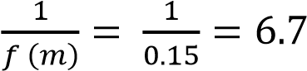

- Derive an expression for focal length of a lens in terms of radii of curvature of its surfaces and its refractive index. (5marks)

Solution
Consider a ray close and parallel to the principal axis, incident at height, h.

tan d = d is small in radian, d = ………………………………..(i)
For small angle prisms d = (n-l)A ………………………………… (ii)
From the diagram above, α + β =A ………………………..….. (iii)
For small angle
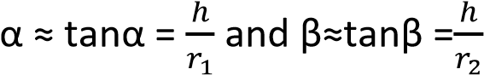
Substitution α and β in equation (iii)
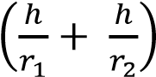= A ……………………………………………………………(iv)
Substituting equation (i) and (iv) in equation (ii)
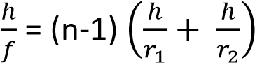
Dividing by h
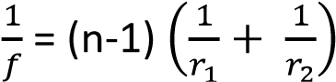

(d) Describe an experiment to determine the focal length of thin converging lens mounted inside a short cylindrical tube (05matks)

Solution Illustration

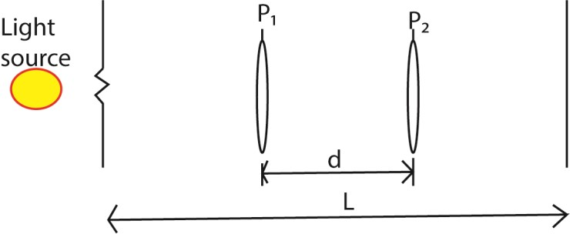

- The tube is placed between an illuminated object and a screen a distance l slightly more than 4 times the approximate focal length of a lens to form a clear magnified image at the screen. The position of the front part P₁ is noted

- The tube is moved towards the screen until a clear diminished image is formed on the screen and position P₂ of the front part is noted

- The displacement, d = P₂ – P₁ is noted
The focal length, f of the lens = 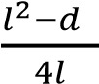

NB. This is the method recommended for measuring the focal length of a lens whose surfaces are inaccessible (for example, when· the lens is in a tube), when measurements of v and u cannot be made

2. (a) (i) Draw a sketch ray diagram showing formation of the image of a finite size real object by a concave lens (02marks)
(ii) A concave lens of focal length 15.0cm is arranged coaxially with a convex mirror of focal length 10cm, a distance of 4.0cm apart. An object is placed 20.0cm in front of the lens on the side remote from the mirror. Find the distance of the final image from the lens. (04marks)
Solution In the lens
u = 20cm
f = -15 cm (F is virtual)
from the lens formula; 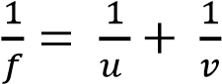
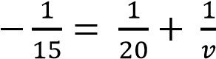
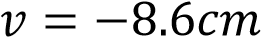, or 8.6cm behind the lens or 8.6 – 4 = 4.6cm behind the mirror.
For the mirror f = - 10cm v = -4.6cm
From mirror formula 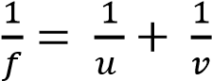
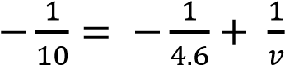
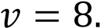5cm in from of the mirror or 8.5 – 4 = 4.5 in front of the lens.

(a) With the aid of a sketch ray diagram explain spherical aberration in concave lenses and state how it is minimized. (03marks)

Spherical aberration
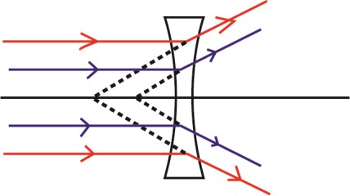
Spherical aberration in concave lens occurs when parallel marginal light rays to the lens after refraction appear to diverge from different points from that of paraxial rays.
Means of reduction of spherical aberration
- Using lenses with an aspheric surface
- By using combination of lenses of opposite nature (convex & concave) of different materials.
- Using lens of small aperture
- Using a stopper to block refraction marginal light rays

(b) With the aid of ray diagrams, explain the term conjugate point as applied to lenses
(02 marks)
These are two points; O and I, on the opposite side of a convex lens such that an object and its image at these points are interchangeable.

3. (a) An object, O, placed in front of a converging lens forms a real image, I, on the screen. The distance between the object and the real image is, d, while that of the image from the lens is r.
Derive the expression for the least possible distance between the object and the real image. (05marks)

Solution
For real image if converging lens, focal length, f, is positive and image distance, v is positive u = r
v = (d-r)
from lens formula
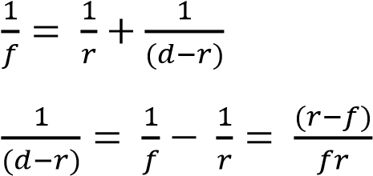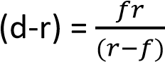
d = 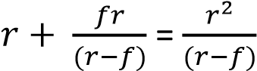
- Give the properties of a lens in achromatic combination (03marks)
Achromatic lenses are corrected to bring two wavelengths (typically red and blue) into focus on the same plane.
The lenses in achromatic combination are - Are made of concave and convex lens.
  - The radii of curvature of concave and convex are numerically equal
  - The dispersion caused by the concave lens should be cancelled by that of convex lens.
- A convex lens of focal length 10cm is arranged coaxially with a concave lens of focal length 18cm. the lens system is used to focus an object 24cm from the convex lens on ths side remote from concave lens. The final image is formed on the screen placed
18.6cm from the concave lens. Calculate the
  - Separation between the lenses
  - Magnification Solution
Let d be the separation of the lens
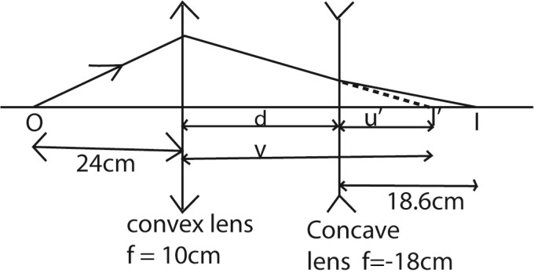
  - For convex lens, from 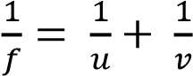
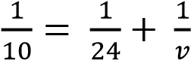; v = 17.14cm
For concave lens
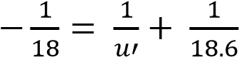; u’ = -9.15cm (-ve since object is virtual)
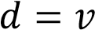—u’ = 17.14 -9.15 = 7.99cm
  - M = M₁ x M₂
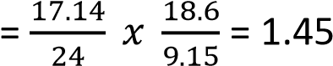

4. (a) Define the following terms applied to concave lens
- Principal focus (1mark)
It is a point on the principal axis where incident rays on the lens that are close and parallel to the principal axis appear to diverge from after refraction by the lens.

- Radii of curvature (01mark)
They are distances from the centers to the surfaces of the spheres of which the lens surfaces form part.
(b) A point object is placed at a distance, u, in front of a diverging lens of focal length, f, to form an image a distance, v, from the lens. Derive an expression that related u, v and f. (4marks)

Solution
Consider in each case a ray incident on the same lens at a small height h above the principal axis as shown:

From Fig (i), the close and parallel to principal axis ray appears to diverge from the focal point F and suffers a small deviation d; since h is very small
Thus d ≈ tan d 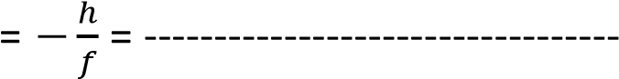(i) (F is virtual)
From Fig (ii), the ray from a point object O suffers the same small deviation D to give rise to a point image I.
From geometry, β = α +d or d = β - α
(image is virtual)
d = 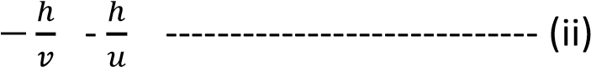
Equating equations (i) and (ii) gives
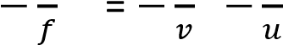

Thus 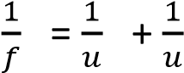
(c) Derive an experiment to determine the focal length of concave lens using a plane mirror, a converging lens and an illuminated object. (4marks)

Solution
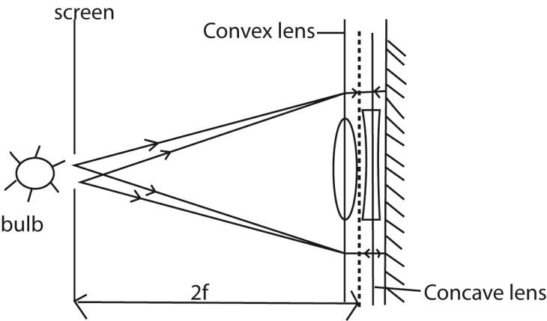
- A plane mirror is placed behind a concave and a convex lenses in contact
- A screen containing illuminated cross wire in a hole is moved to and fro in front of the lenses until the image of the cross wires is formed besides the object.
- The combined focal length, f is equal to half the distance between the center of the lenses and the screen.
Calculation
Let focal length of concave and convex lenses be f₁ and f₂ respectively
Then, 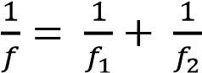; the unknown focal length of concave lens f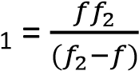

5. (a) State laws of refraction?
  - The incident ray, refracted ray and the normal at the point of incidence all lie in the same plane.
  - The ratio of the sine of angle of incidence to the sine of the angle of refraction is constant for given pair of media

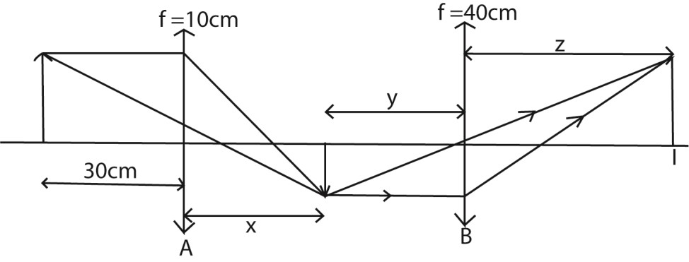
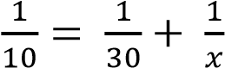
- A small placed at a distance of 30.0cm from a converging lens of focal length 10.0cm. Calculate the distance from the first lens where a second converging lens of focal length 40cm must be placed in order to produce an erect image of the same size of the object.
Solution

For lens A, from

=

+

; x = 15cm

Magnification, M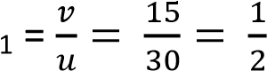
M 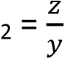=
M = M₁ x M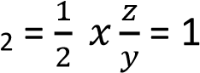
z = 2y
Lens B; 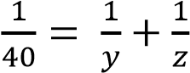
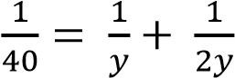; y = 60cm
Position = x + y = 15 + 60 = 75cm from the first lens.
- What is meant by the following:
- Total internal reflection
It is the bouncing back of all incident light into the denser medium when the angle of incidence exceeds the critical angle for a ray originally travelling from a denser to a less dense medium.
- Critical angle
It is an angle of incidence in a denser medium for which the angle of refraction is the less dense medium is 90⁰.

(d) Briefly explain why an observer sees a spectrum of colors through rain drops when it is raining on a sunny day.
White light undergoes dispersion as it enters into the rain drops of water in the sky. Total internal reflection takes place at the opposite side of the rain drops and different colors emerge from the rain drops after refraction. Hence the spectrum.
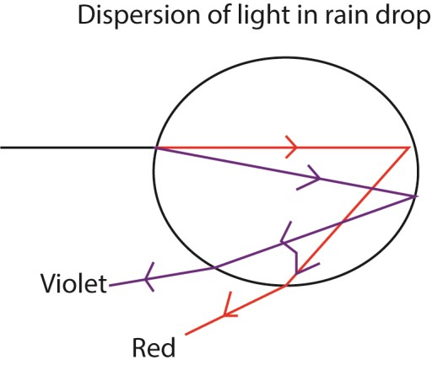

- (a) (i) Define principal focus of a concave lens (1mark)
It is a point on principal axis from which rays close and parallel to principal axis appear to diverge from after refraction
    - Draw a ray diagram to show formation of an image of an infinite object by a concave lens. (02marks)
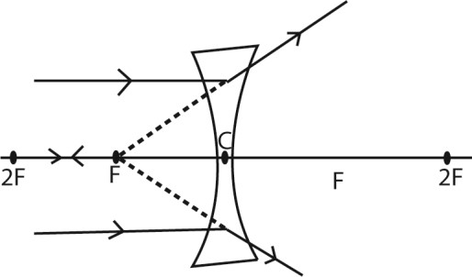
    - Describe the image formed in (a)(ii) above it is virtual, erect and diminished

(b) Explain how spherical aberration is minimized in photographic camera. (03marks)

  - By grinding a lens so that it protrudes more near the center and making some adjustments to the edges, the lens can correct for focusing at the edge and allow all light to align properly.
  - By blocking rays from outer edges of a spherical lens by Aperture blades to reach the film
  - By using combination of lenses of opposite nature (convex & concave) of different materials.

- (a)(i) Show that the effective focal length, f, of two thin lenses in contact is given by 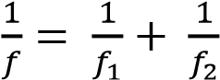 where f₁ and f₂ are the focal lengths of the individual lenses.
Derive the expression for the focal length of a combination of two thin converging lenses in contact, in terms of their focal lengths. (05marks)
Consider two thin lenses L₁ and L₂ of focal length f₁ and f₂.

For lens L₁,

………………………. (i)

For L₂, I’ acts as the object
……………………. (ii)

Eqn. (i) + Eqn. (ii)

Where F is the focal length of combined lens,

(ii) A compound lens consists of two lenses in contact having power of +12.5D and 2.5D. Find the position and nature of the image of an object placed 15.0cm from a compound lens. (03marks)
From,
Power of lens =
Focal length of first lens, f
Focal length of first lens, f
Combined focal F;
F = -10m
Let image distance be v
v = 30cm
Therefore, image distance = 30cm
(b) (i) Define refractive index. (01mark)
Refractive index, n is the ratio sine of an angle of incidence to the sine of an angle of refraction at the point of incidence.

(ii) An equi-convex lens is placed on a horizontal plane mirror and a pin held vertically above the lens is found to coincide with its image when positioned 20.0cm above the lens. When a few drops of a liquid is placed between the lens and the mirror, the pin had to be raised 10.0cm to obtain coincidence with the image. If the refractive index of the convex lens is 1.5, find the refractive index of the liquid. (05marks)

Solution
Focal length of the lens = 20
Combined focal length of the glass lens and liquid lens = (20+10) = 30 Let the focal length of liquid lens be f, from
Then,

Let n be the refractive index of the liquid, from

r₂ = (plane convex lens)
Refractive index of glass, n = 1.33

8. (a) (i)Define the terms linear magnification and angular magnification as applied to a lens. (02marks)

Linear magnification, m,

Angular magnification (magnifying power, M) is the ratio of the angle, α’, subtended at the eye by the image when using an instrument to the angle, α, subtended at unaided eye by the object.
M = where α’ and α are in radians

(ii) Derive the expression for the magnifying power of a magnifying glass when the final image is formed at the near point (04marks)

Solution
Consider a lens l, which forms an image I of height h’, at distance v from the lens of object an object, O of height, h, placed a distance u, from the lens.

tan θ =

=

Rearrangement,

Or, magnification M =

- An object is placed a distance f + x from a converging lens of focal length, f. the lens produces an image at a distance f+ y from the lens. Show that f² = xy. (3marks)

From
f² =xy

- (i) With the aid of a labelled diagram, describe the essential parts of photographic
camera.

Lens camera
- The lens focused light from the object on to film
- The diaphragm controls the amount of light reaching the film
- The shutter controls the exposure time of light reaching the film
- Film contains a photosensitive chemicals and is where the image is stored.

(ii) Explain how chromatic and spherical aberration are minimized in a photographic
camera (02marks)
- By grinding a lens so that it protrudes more near the center and making some adjustments to the edges, the lens can correct for focusing at the edge and allow all light to align properly.
- By blocking rays from outer edges of a spherical lens by Aperture blades to reach the film
- By using combination of lenses of opposite nature (convex & concave) of different materials.

9. (a)(i) Explain the terms chromatic and spherical aberration in lens (04marks)
  - Spherical aberration occurs when the lens fails to focus all rays falling on it to the same point. Thus images formed by the lens at large apertures are therefore unsharp or blurred at the edges.
  - Chromatic aberration occurs when the lens fails to focus all color wavelength to the same point. It gives an image with colored fringes

(ii) How the aberrations in (a)(i) are above minimized in a reflecting telescope?
- By grinding a lens so that it protrudes more near the center and making some adjustments to the edges, the lens can correct for focusing at the edge and allow all light to align properly.
- By blocking rays from outer edges of a spherical lens by Aperture blades to reach the film
- By using combination of lenses of opposite nature (convex & concave) of different materials.
- With the aid of a diagram, explain why the image seen in a magnifying glass is almost free from chromatic aberration when the eye is close to the lens. (04mark)
When the eye is close to the lens the apparent separation of colors reduce and dispersed colored rays overlap.
- A converging lens is used to form an image of an object 1.2m away from a screen
0.05m from the lens.
(i) Find the focal length of the lens (03marks)

Solution
Let the focal length of the lens be f.
From
f = 0.048 or 4.8cm
- If the lens is used to form an image of a distant object, how far from the screen would the clear image be formed? (02marks) Image of a distant object forms at f = 4.8cm
- State the type of lens that would be placed close to the first lens in order to enable the image in (ii) above to be formed on the screen. (01)

Concave lens

- Calculate the focal length of the lens you have stated in (iii) above. (03marks)
The combined focal length = 0.05m
From
f = -1.2m
Therefore the focal length of lens = 1.2m = 120cm

10. (a) Define terms; principal focus and power of a lens (02marks)
Principal focus of a lens is a point on principal where rays parallel and close to principal axis converge or appear to diverge from after refraction through the lens.
- Derive the relation between the focal length, f, object distance, u, and image distance, v, for a thin lens. (07marks) Solution
Consider in each case a ray incident on the same lens at a small height h above the principal
axis as shown:

From Fig (i), the ray parallel and close to principal axis is converged to the focal point F and suffer a small deviation d
Then, d tan d
From Fig (ii), the ray from a point object O suffers the same small deviation D to give rise to a point image I.
From geometry, d = α
d =

Equating equations (i) and (ii) gives

Thus

- A thin converging lend P, of focal length 10 cm and a thin diverging lens, Q, of focal length, 15 cm are placed coaxially 50 cm apart. If an object O is placed 12 cm from P on the side remote from Q.
  - Find the position, mature and magnification of the final image. (07marks) In lens P f= 12 u = 10 v = ?
From
; v = 60cm
In lens Q f = 15cm u = 60 – 50 = 10cm
v’ = ?
; v’ = -6cm
The virtual image is 6cm behind the lens Q or 44cm in front of lens P
Magnification =

  - Sketch a ray diagram to show the formation of the finite image in Q (02marks)
(d) Explain why lenses of narrow apertures are preferred to lenses of wide apertures in optical instrument. (02marks)
Lenses of narrow apertures show low spherical aberration.

(e)
In the diagram in the figure above, the image of the object is formed on the screen when a convex lens is placed at A or B. If A and B are 15 cm apart, find
- Focal length of the lens. (03marks)
From f = = 10cm

- Magnification of the image formed when the lens is at B. (03marks)

Solution
Let object distance be u Image distance = 45- u
From
At B, u = 30 and v = 45-30 = 15cm
M =

11. (a) (i) Define the principal focus of a converging lens

Principal focus is a point on principal axis where rays parallel and close to principal axis converge after refraction through the lens.
(ii) An object is placed 20 cm in front of a diverging lens place coaxially with a concave mirror of focal length 15cm. when the concave mirror is 20cm from the lens the final image coincides with the object.

- Draw the ray diagram to show how the final image is formed. (2marks)
- Determine the focal length of a diverging lens. (04marks)
From
In the mirror u = 20 + 20 = 40cm f = 15cm
v = ?
; v= 24cm
In lens v = -4cm u = 20cm f = ?
; f = 5cm
(b) A converging lens of focal length f is placed between a finite object and a screen. The position of a screen is adjusted until a clear magnified image is obtained on the screen.
Keeping the screen fixed in this position at a distance L from the object, the lens is displaced through a distance, d, to obtain a clear diminished image on the screen.
- Draw a ray diagram to shoe the formation of the images in the two cases. (2marks)

- Show that l²-d² = 4fl

Lens A forms an image of O at I

By the principle of reversibility of light, an object at I forms an image at O. When the object and the screen are fixed, another clear image can be formed by the lens when moved from A to B.

From the diagram
OB = IA and OA =IB
OA + BI = L-d
OA + OA + L-d ( since OA + IB) 2OA = L-d
AO = = u ……………………(i)

Also, AI = AB + BI
AI = AB + OA (since OA = BI
AI = d +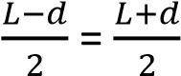 = v
Using the formula 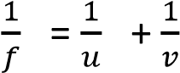
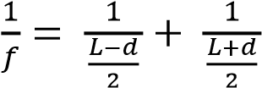
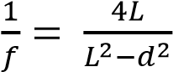
L²-d² = 4fl

(iii) Find the product of the magnification produced in the two cases.

Lens at position A, a magnified image is formed
Linear magnification,

Lens at position B, a magnified image is formed
Linear magnification, 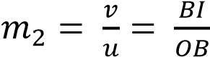

m₁ x m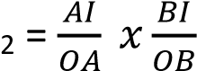

From the diagram, AI = OB and AO = BI m₁ x m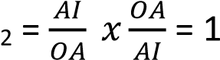

12. (a) Describe how the focal length of a diverging lens may be determined. (05mark)

Determination of focal length of concave lens using concave mirror.

- An illuminated object is placed beyond the center of curvature of a concave mirror of known radius of curvature, r.
- A diverging less L is placed between O and M and its position is adjusted until a clear image I is formed besides O.
- Distance LI and LM are measured and recorded.
- For the lens, object distance, u = -CL = - (r-LM); image distance, v =LI or LO
The focal length, f, is calculated from 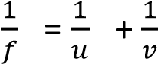

- A lens L₁ casts a real image of a distant object on the screen placed at a distance 15cm away. When another lens, L₂, is placed 5cm beyond L₁, the lens has to be shifted 10cm further away to locate the real image formed. Determine the focal length and the type of lens L₂.

Solution
Focal length of lens L₁ = 15cm

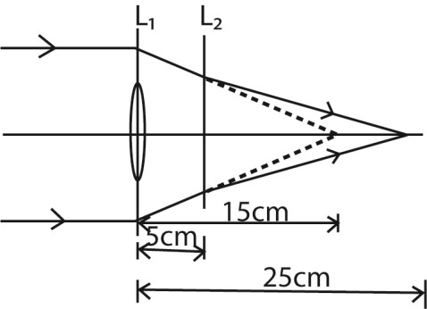

In lens L2
Object distance = -(15-5) = -10cm (object is virtual)
Image distance = 20 – 5 = 20cm (image is real)
From 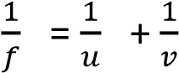
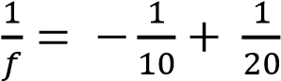
f = -20cm the focal length is negative because the lens is concave.

- A convex lens of focal length 60cm is arranged coaxially with a diverging lens of focal length 5cm. Find the combined focal length
From 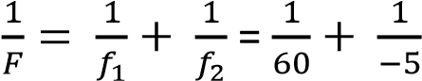
The combined focal length, F = -5.45cm
13. (a) Describe an experiment to determine the focal length of concave lens using a convex mirror of known focal length. (5marks)
Determination of focal length of concave lens using convex lens
I’- is the image of lens L₂.
I – is a real image of lens L₁ and virtual object of L₂
(i) An object, O, is placed at a distance greater than f of lens L₁ to form real image I. (ii) The image formed by L₁ is I is the virtual object to lens L₂. Measure the distance AI.
- Lens L₂ is then placed between L₁ and a real image I’ is formed by L₂. Measure the distance AB and BI and BI’
- For lens L₂; image distance, v = BI’, and object distance, u = BI = AI – AB which is negative.
- The focal length f for L₂ is calculated from
- A convex lens and concave lens of focal length 17.5 and 15cm respectively are mounted coaxially 7.5cm a part with the concave lens facing a distant object. Find
  - the final position of the image (3marks)
In lens 2
u = -(17.5 – 7.5) = -10cm
The final image distance is 30cm from concave lens
  - the magnification of the image produced by the concave lens.(2marks)
Magnification =
- Explain why a parabolic mirror is used in search lights instead of a concave mirror.
(3marks)
Parabolic mirrors cast a stronger reflected beam than concave mirrors when the bulb is place at the focal point.
- Differentiate between chromatic and spherical aberration

In chromatic aberration colored wavelength of white light are not focused at the same point while in spherical aberration rays of light through a lens are not focused to the same distance.

14. (a) Describe, giving the relevant equations, how the refractive index of a liquid can be determined using a convex lens of known radius of curvature (4marks)
Determining the refractive index of a small quantity of a liquid using a convex lens and plane mirror.
- Pour a small liquid on the plane mirror and place the convex lens on top.
- Move the object, O, along the principal axis until it coincides with its image, I.
- Measure the distance, F, from O to the lens which is the combination of the focal length of the liquid and the lens.
- Repeat the experiment (ii) with the convex lens and the plane mirror without the liquid and determine focal length, f, of the glass lens
From

r₂ = (plane convex liquid lens)

n =
- An object is placed 30cm from a converging lens of focal length 10 cm and an image formed on a screen. When a diverging lens is placed half way between the converging lens and the screen, the screen has to be moved 4.5 cm further to obtain a clear image. Calculate the focal length of the diverging lens. (5marks)

Solution
In converging lens
Image distance, v, in the converging lens
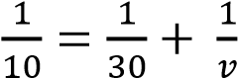 ; v = 15cm

In diverging lens
Object distance, u = -(5 – 7.5) = -7.5 (virtual)
Image distance v = (7.5 + 4.5) = 12cm
Let the focal length of diverging lens be f

- Explain the apparent shape of the bottom of a pool of water to the observer at the bank of the pool
The bottom appears magnified because the countless ripples form a convex surface of long focal length in which the bottom of the pool is a distance less than its focal length.

15. (a) The deviation, d, by a prism of small angle, A, and refractive index, n, is d = (n-1)A. use this to show that the focal length of a thin converging lens of refractive index, n, is
given by

Where r₁ and r₂ are the radii of curvature of the lens surfaces.

Solution
Consider a ray parallel to the principal axis, incident at height, h.

tan d = , d is small in radian, d = ………………………………..(i)
For small angle prisms d = (n-l)A ……………………………… (ii)
From the diagram above, α + β =A ………..…………………….. (iii)
For small angle
Substitution α and β in equation (iii)
= A ……………………………………………………………(iv)
Substituting equation (i) and (iv) in equation (ii)
Dividing by h

(b) Calculate the focal length of a converging meniscus with radii 25cm and 20 cm, and refractive index 1.5

f = 22.2cm

- (a)(i) What is meant by principal axis and principal focus as applied to converging lens. (2marks)

Principal axis is a line joining the center of curvatures of the surfaces of a lens

Principal focus is a point on principal axis where rays close and parallel to principal axis converge after refraction through the lens.

(ii) Describe how the focal length of a converging lens can be obtained using a plane mirror and the non-parallax method. (5marks)
Measuring the focal length of convex lens using a lane mirror method (Non parallax method)

  - Place a plane mirror M on a table and lens L on top of it.
  - Clamp a pin, O, horizontally with its tip lying horizontally along the principal axis of the lens
  - Move the pin O up and down along the principal axis to locate the position where it coincides with the image.
  - Measure the focal length, f, a distance from the pin to the lens.

(b) A converging lens of focal length 20 cm is placed coaxially with a diverging lens of focal length of 6 cm.
  - If the lens are 12 cm apart, determine the position of the image of a distant object placed on the same side of converging lens.
Solution
In concave lens u= -(20-12) = -8cm (virtual object)
From lens formula
24cm

  - What is the nature of the image formed in (i) above. (1mark)
The image is virtual
- (a) What is meant by the term radii of curvature as applied to converging lens? (b)(i) Show that the focal length, f, of a converging lens is given by:
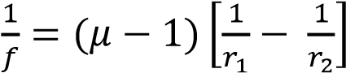
Where μ is the refractive index of the material of the lens and r₁ and r₂ are the radii of curvature of the surfaces of the lens.

Solution
Consider a ray parallel to the principal axis, incident at height, h.

tan d = , d is small in radian, d = ………………………………..(i)

For small angle prisms d = (μ-l)A ……………………………… (ii)
From the diagram above, α + β =A ………..…………………….. (iii)
For small angle
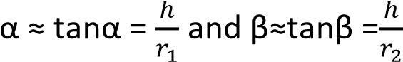
Substitution α and β in equation (iii)
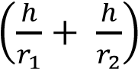= A ……………………………………………………………(iv)
Substituting equation (i) and (iv) in equation (ii)
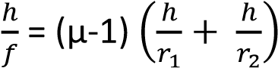
Dividing by h
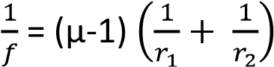

(ii) A biconvex lens of radius of curvature 24 cm is placed on a liquid film on a plane mirror. A pin clamped horizontally above the lens coincides with its image at a distance of 40cm above the lens. If the refractive index of the liquid is 1.4, what is the refractive index of the material of the lens?
Focal length of the lens =24/2 = 12
Let the focal liquid be f
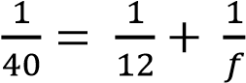 ; f = 17.14cm
Radius of plano-concave lens of the liquid
From 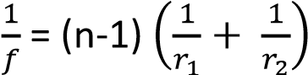
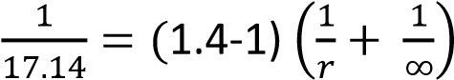
r = 0.4 x 17.14 =6.9cm
Let the refractive index of lens material be n
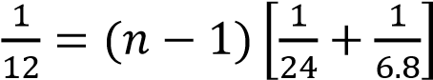
n =1.45
18. (a) What is meant by the term principal focus and focal length of a converging lens?
(2marks)
Principal focus is a point on principal axis where rays close and parallel to principal axis converge after refraction through the lens.

Focal length is the distance between the principal focus and the middle of he lens

- Name one defect of images formed by a lens and explain how the defect is minimized in practice (3marks)

Chromatic and spherical aberration and both can be minimized by using a compound lens of different type

- The magnification of an object in a thin converging lens is m. when the lens is moved a distance d towards the object, the magnification becomes m’. show that the focal length, f, of the lens is given by
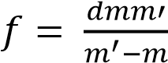

Solution
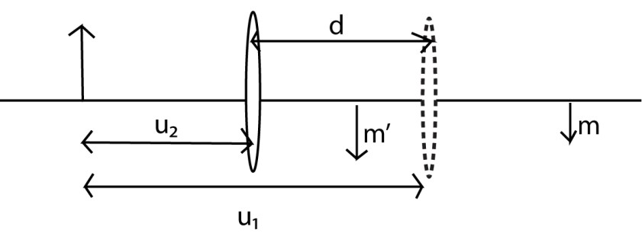
Case 1
Magnification = m
Object distance = u₁
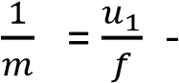1……………………. (i)
Case II

Magnification = m’
Object distance = u₂
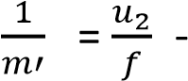1……………………. (ii)
Eqn (i) – Eqn (ii)
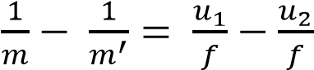
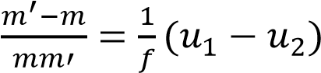 But, 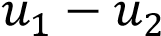 = d
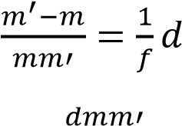
f = 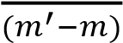
(d) Explain
- Why an object far away from the eye appears to be smaller than when it is near. (2marks)

An object far away subtends a small angle to the eyes while when it is near it subtends a bigger angle

- How loss of light by reflection at refractive surface can be minimized (3marks)

19. (a) Show that m + 1 = for a convex lens where symbols carry their usual meaning
(b) Calculate the magnification of the object if the focal length of the convex lens is 30cm and the object is 39cm form the lens.

Solution (a)
From, 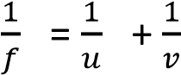
Multiplying by v
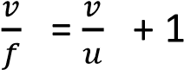
But = m
Thus, 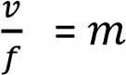 + 1 or, m+ 1 =
(b) f =30cm, u = 39cm, m = ?
From, 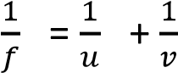
Multiplying by u
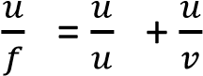
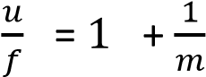
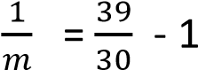
M = 3.3
20. A point screen is placed 125cm from a luminous object. A converging lens is placed between the object and the screen at a distance of 75cm from the screen such that a clear image is obtained on a screen. Find the height of the object given that the height of the image is 8cm.
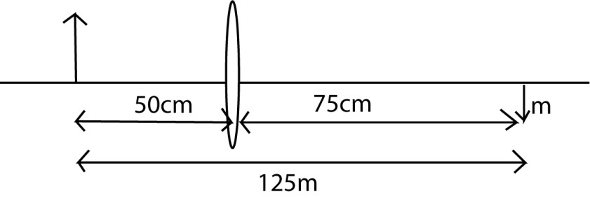
m = 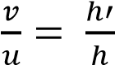
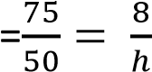
h = 5.3cm

21.
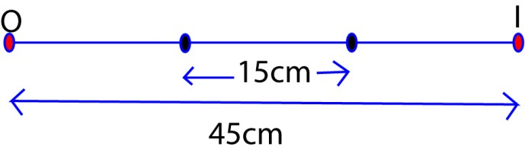
In the diagram above, the image of the object formed on the screen when a convex lens is placed either at A or B. if A and B are 15cm apart, find
- The focal length of the lens
- The magnification of image formed at B. At A
    - 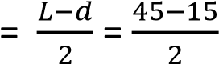 =15cm

    - 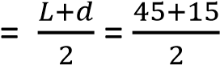 = 30cm

Using 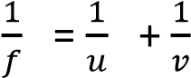
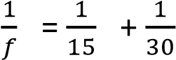
f = 10cm

(ii) u = OB = 30cm v = BI = 15cm
m = 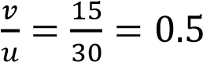

22. An object is placed 6cm from a thin converging lens, A, of focal length 5cm. Another thin converging lens B of focal length 15cm is placed co-axillary with A and 20cm from it on the side away from the object. Fins the
  - Position
In lens A; f = 5, u= 6, v = ?
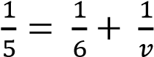; v = 30cm
In lens B; f = 15, u= 20- 30 = -10, v = ?
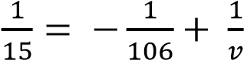; v = 6cm in from of B

  - Nature and
Real because image distance is positive (iii) Magnification of the image.

M = 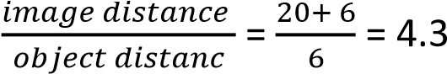

- (a) Explain what is meant by conjugate points (02mark)

These are two points each on the opposite side of a convex lens such that an object and its image at these points are interchangeable.

(b) A converging lens forms an image of height, h₁, on a screen of an object O of height,
  - When the lens is displaced towards the screen, an image of height, h₂ is formed on the screen.

  - Sketch a ray diagram to show the formation of the image on the screen. (02marks)

(
ii) Show that h =
√

(04
marks
)

Lens at position A, a magnified image is formed
Linear magnification, 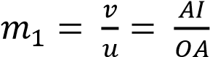
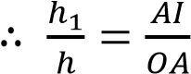……………………………………………. (i)

Lens at position A, a magnified image is formed
Linear magnification, 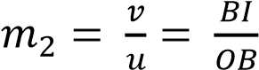
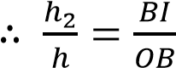……………………………………………. (ii)
From the diagram the diagram and the principle of reversibility of light
OB = AI = (u+d) and OA =IB= u

From (i) and (ii), it follows that by inverting (i)
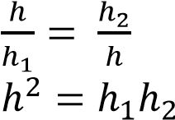
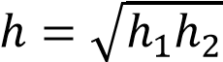

(c) The figure below show a glass lens in air with surface A and B having radii of curvature 10cm and 15cm respectively

If the refractive index of the glass material used is 1.50. Calculate the power of the lens.

Solution
Let the focal length of the lens be f
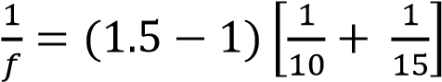
f = 12cm = 0.12m
Power of the lens = 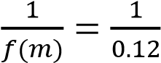 =8.3D
- An object, O, placed in front of a converging lens forms a real image, I, on the screen. The distance between the object and the image is, d, while that of the image from the lens is x. Derive the expression for the least possible distance between the object and image. Solution
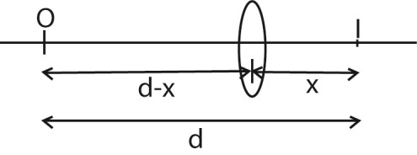
u = d-x v = x
From 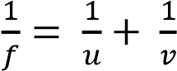
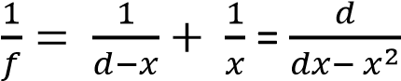
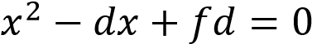
x = 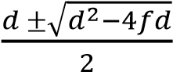
for real roots, d²>4fd or d > 4f

TOPIC 3/6: OPTICAL INSTRUMENTS
Competency: The learner explores the optical operation of different optical instruments that can be applied in a variety of fields such as medicine, military and navigation.

Optical instruments
An optical instrument is a device that aids vision working on the principles of reflection and refraction of light.
Examples are the human eye, microscope, telescope, projector and lens cameras.

Terminology in optical instrument
- Near point.
This is the nearest position that can be focused distinctly by the unaided eye. The distance from the eye to the near point is known as the least distance of distinct vision (LDDV), and it is usually denoted by D.
The least distance of distinct vision of a normal eye is 25cm.
- The far point
This is the furthest point which can be seen distinctly by the unaided eye. For normal eye, the farthest distance is infinity.
- Accommodation
This is the ability of the eye to clearly see near and far object.
- Visual angle (α)
This is the angle subtended by the object at the unaided eye.
- Angular magnification (magnifying power, M)
This is the ratio of the angle subtended at the eye by the image when using an instrument to the angle subtended at unaided eye by the object.
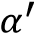
M = where α’ and α are in radians
Note that the height of the image formed by the eye on the retina is proportional to the angle subtended at the eye by the object. (I.e. the greater the visual angle, the greater is the apparent size of the object).

The mammalian eye
This an organ that helps us to see
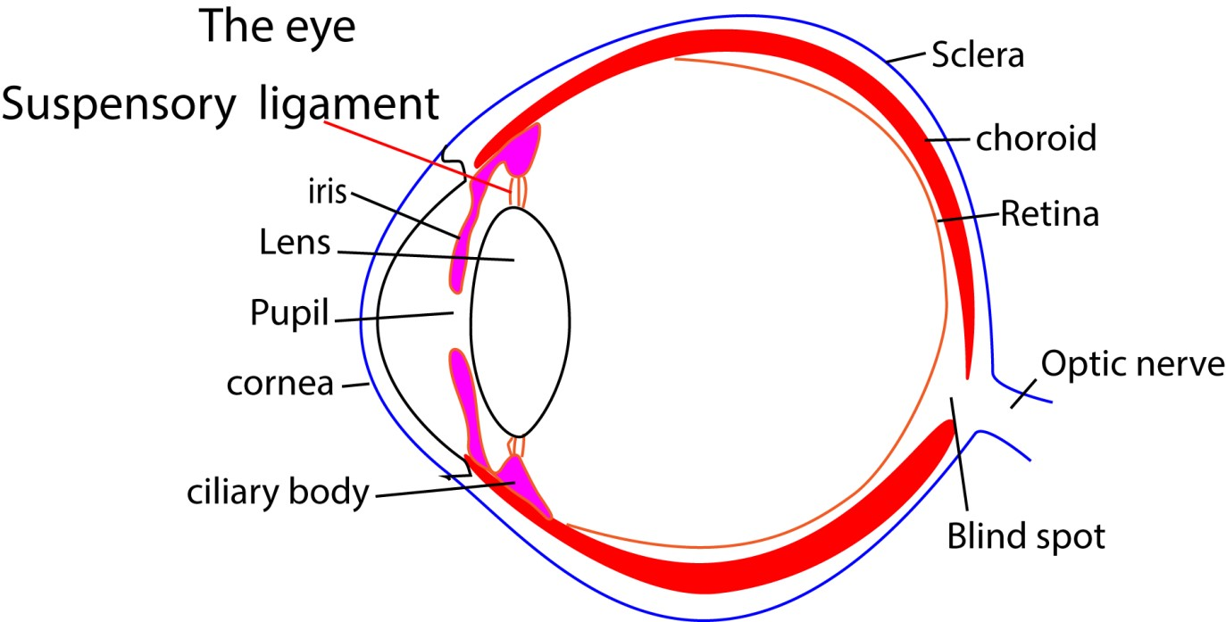
Parts of the eye
The iris controls the size of the pupil
The pupil allows in light into the eye
Ciliary body regulate the size of the lens
Cornea and lens refract light to the retina where the image forms
Sclera protects and maintains the shape of the shape of the eye.

Accommodation
This is the ability of the eye focus objects at different distances on the retina
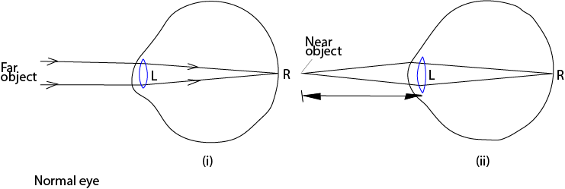
To view near object the ciliary muscle contract creating less tension on suspensory ligaments the lens fattens and its refractive power increases.
To view distant objects the ciliary relax creating a tension in the suspensory ligament, the lens this reducing its refractive power.

Eye defects

(a) Short sight/myopia
A person with short sightedness does not see distant objects clearly because rays of light from a distant object are focus in front of the retina

Short sightedness is caused by too long eye-ball or to strong lens
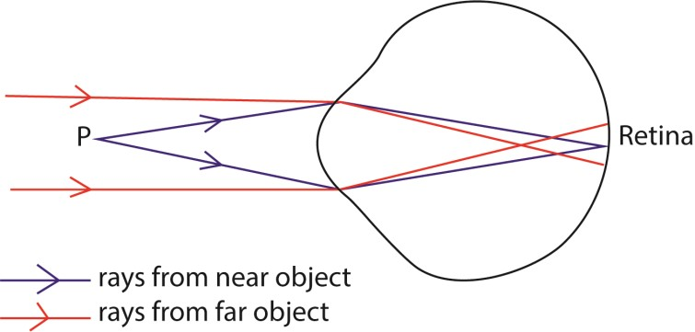

Short sightedness is corrected using concave lens
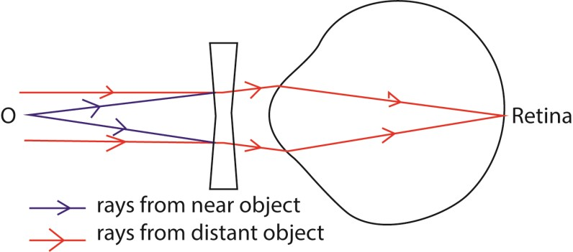

(b) Long sight/hyper myopia
A person with long sightedness does not see near objects clearly because rays of light from a near object are focus behind of the retina

Long sightedness is caused by too short eye-ball or to weak lens
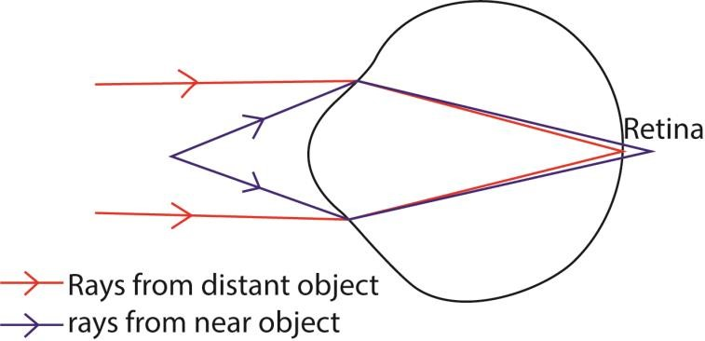
Long sightedness is corrected using convex lens
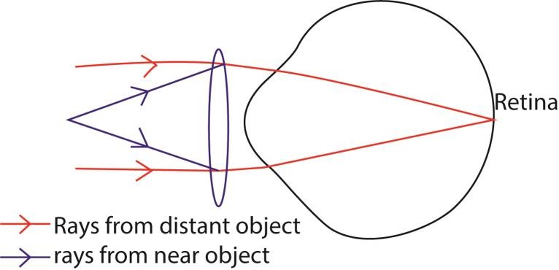

Microscope
These are used to magnify near objects when in normal use. The image formed by microscope is at the least distance of distinct vision from the eye.
Types of microscope
- Simple microscopes (magnifying glasses)
- Compound microscope

Simple microscope
A magnifying glass consists of a converging lens which forms a virtual, upright image of the object placed inside its focal point.

(a) Final image in normal adjustment
Consider an object subtending an angle α at the eye when the object is at the near point.
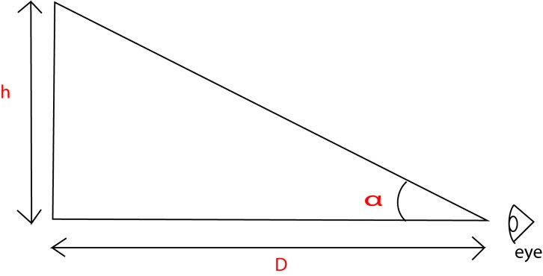
α = …………………………………. (i)
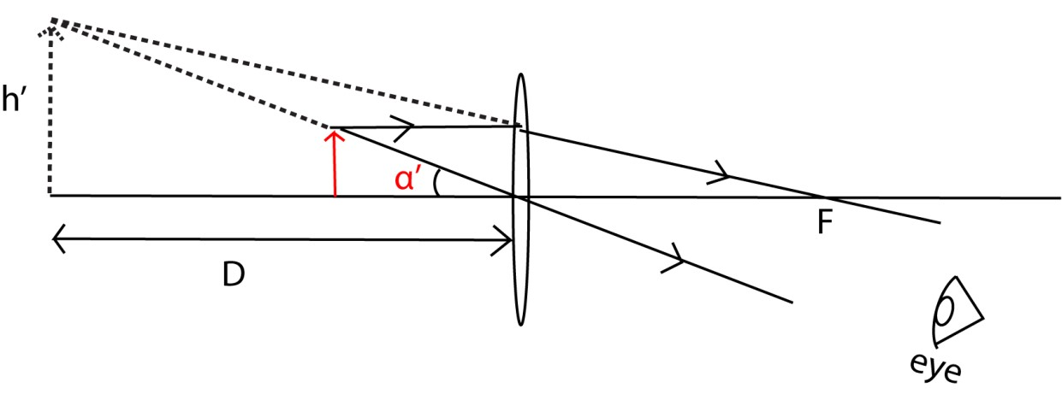
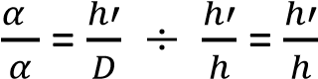
If a convex lens is used to view the object

For small angle tanα’ ≈ α’ for small angle in radians

α’ =

…………………………………. (ii)

Linear magnification from (i) a
nd (ii), m =

From 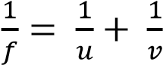 and multiplying through by v
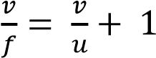
Since, v = D 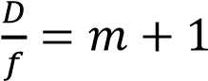 or m = 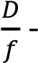 1 where f is the focal length

(b) Final image at infinity
For the image to be formed at infinity, the object must be at, f.
Using unaided eye


α = …………………………………. (i)
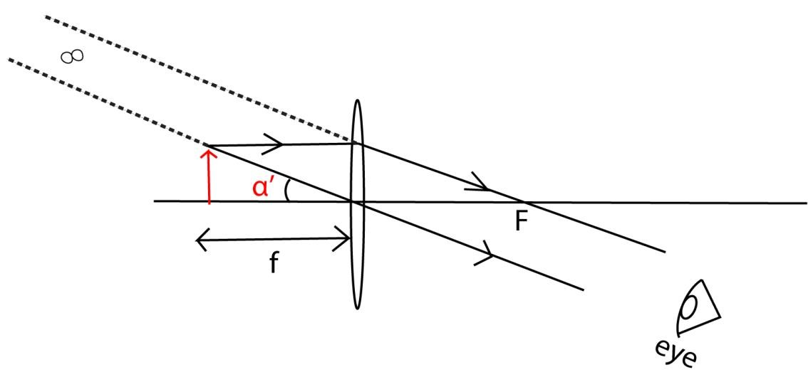
For small angle tanα’ ≈ α’ for small angle in radians
α’ =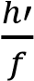 …………………………………. (ii)
Linear magnification from (i) and (ii), m = 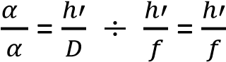

From 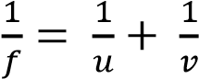 and multiplying through by v
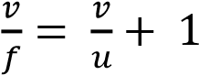
Since, v = f
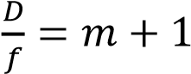 or m = 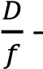 1 where f is the focal length
It should be noted that higher magnification is obtained from a lens of short focal length.

Compound microscopes
- These utilize two converging lenses of short focal lengths are used.
- The lens closer to the object is called objective lens while that through which the final image is viewed is called the eyepiece.
- When the microscope is used, the object O is placed at a distance slightly bigger than the principal focus, F, of objective lens, to form an inverted image I₁.
- I₁ the a real object of the eye piece forms between its principal focus F₀ and its optical center so that a large virtual image I₂ is viewed by the eyes at least distance D.

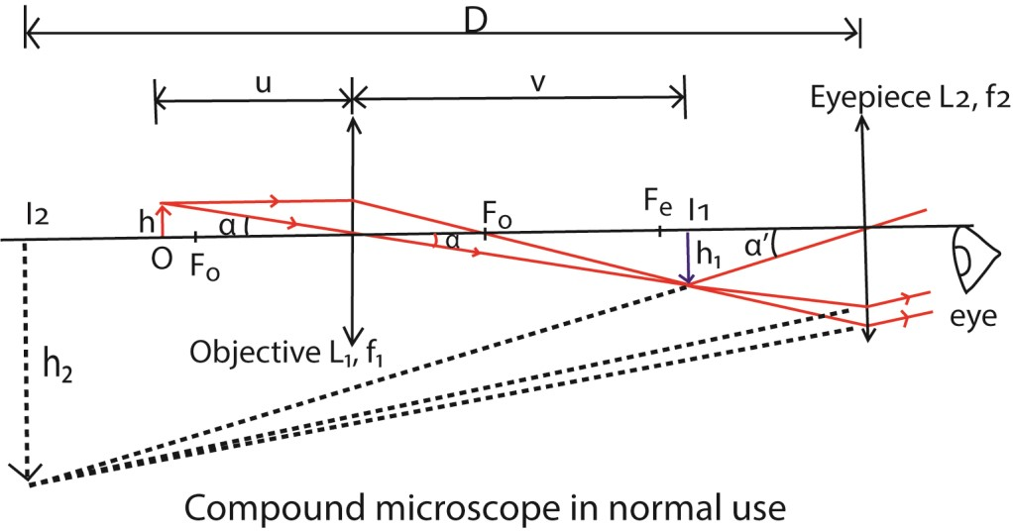

For an aided eye (using the instrument)
For small angle, tanα’ ≈ α’ for small angle in radians
α’ =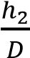 ………………………………………… (i)
For unaided eye
α 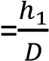 ………………………………………….. (ii)
Magnifying power, m = 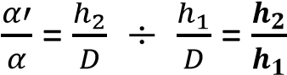

Or
Linear magnification can also be expressed as, m = 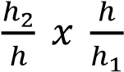 = m_{e} x m_{o}.
Where, m_{e} and m_{o} are linear magnifications of the eye piece and objective lenses respectively.
m_{o} 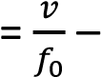 1 and me = 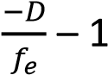

m = ( 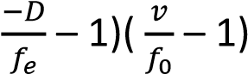

Examples 1
The objective of a compound microscope has a focal length of 2cm while the eye piece has a focal length of 5cm. an object is paced a distance of 2.5cm in front of objective lens. The distance of the eye piece from the objective is adjusted so that the final image is 25cm in front of the eyepiece. Find the separation of the lenses. Solution u₀ =2.5cm, f₀ = 2.0cm, v₀?, v_{e} = D = -25cm, u₂ ?
For objective lens
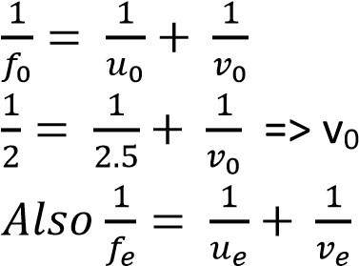= 10cm

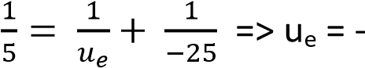4.2cm
= 10 - ⁻4.2 = 14.2cm

Example 2
The objective and eye piece of a compound microscope have focal lengths of 1cm and 5cm respectively. the distance of lens separation is 25 cm. The object is placed1.05cm from the objective lens.

- Find the position, and nature of the final image
- Calculate the magnification
Solution
In objective lens
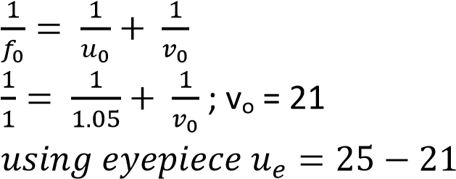= 4cm, f_{e} = 5
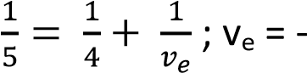20cm

Nature of image, virtual, magnified and inverted.

(b) Magnifying power, m = ( 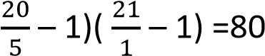

Microscope with image at infinity
To form the final image at infinity, the image of the objective lens must be formed at the principal focus. F_{e}, of eyepiece

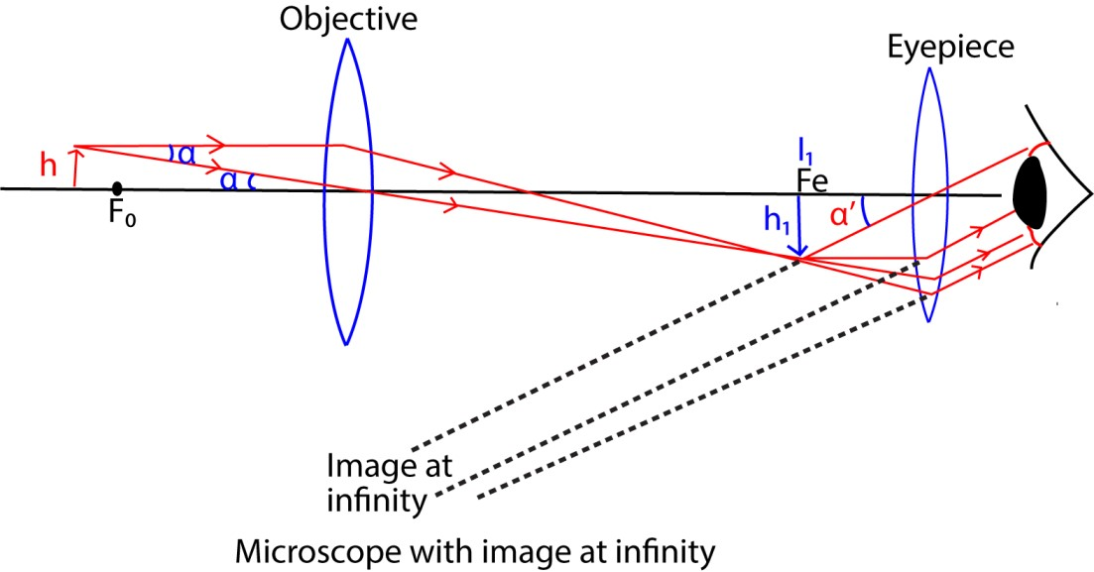

For unaided eye (using the instrument)
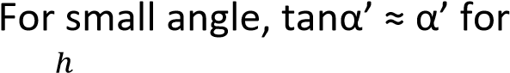 small angle in radians
α = ………………………………………… (i)
For aided eye
α' =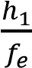 ………………………………………….. (ii)
Magnifying power, m = 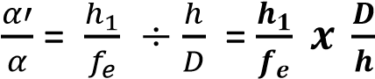
But 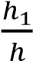 is the linear magnification of objective lens
m_{o} 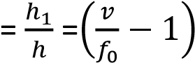
m = ( 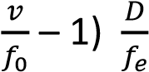
NB: D is always 25cm for this case

Example 3
An object is placed at a distance of 5cm from the objective of focal length 4cm. if the eye piece has focal length of 15cm and final image is formed at infinity, calculate
- Separation of the lens
- Final magnification of the microscope.

Solution
For objective lens, u =5cm, f₀ = 4cm, v =?
From 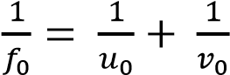
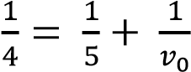 , vo = 20cm
Separation of lenses = v_{o} + f_{e} = 20 + 15 = 35cm.
(ii) D is always 25cm
Magnification, m = ( 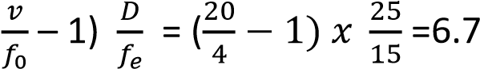

Telescopes
These are instruments focus the light and make distant objects appear brighter, clearer and magnified
They are mainly divided into two
- Refractive telescope
- Reflective telescope
Refractive telescope
These are telescopes which use lenses and they include
- Astronomical telescope
- Terrestrial telescope
- Galilean telescope

Astronomical telescope
This consists of two convex lenses: the objective of a long focal length and eye-piece of short focal length. The objective forms a real diminished image of a distant object at its focal length. (a) Astronomical telescope in normal adjustment (image at infinity)
Note,
- when an astronomical telescope is in normal adjustment, the final image is formed at infinity
- the focal length of the objective is bigger than that of eye piece
- the principal focuses of the two lenses coincide
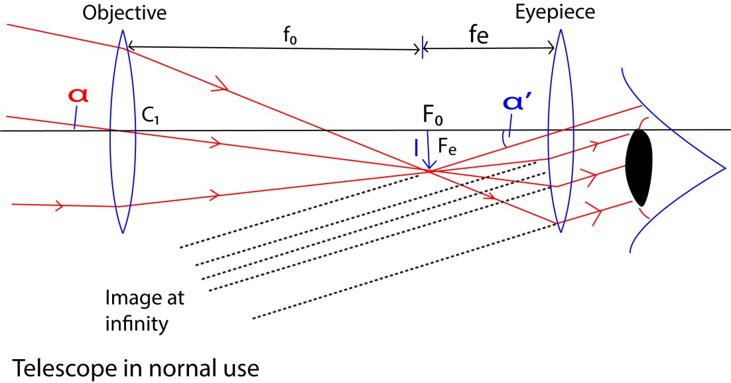
To obtain the magnification, m, we assume the eye is very close to the eye piece.
For an aided eye (using the instrument)
For small angle, tanα’ ≈ α’ for small angle in radians
α’ =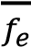 ………………………………………… (i)
Where, h, is the height of image I, f_{e} is the focal length of eye piece For unaided eye
α =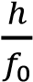 ………………………………………….. (ii)
f₀ is the focal length of objective lens
Combining equations (i) and (ii)
Magnifying power, m = 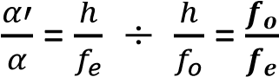
Thus the angular magnification is the ratio of the focal length of objective lens to the focal length of the eyepiece.
Note that, bigger magnification power is obtained when the focal length of objective lens is very big compared to the focal length of eye piece.
Secondly the separation of the lenses is the sum of the focal length of the objective and eyepiece lenses, (f₀ + f_{e}).

(b) Astronomical telescope with final image at near point
When the image of a telescope forms an image at near point, the telescope is not in normal adjustment, the eye is accommodated, although the image is still clearly seen. The diagram below illustrates the formation of the final image.
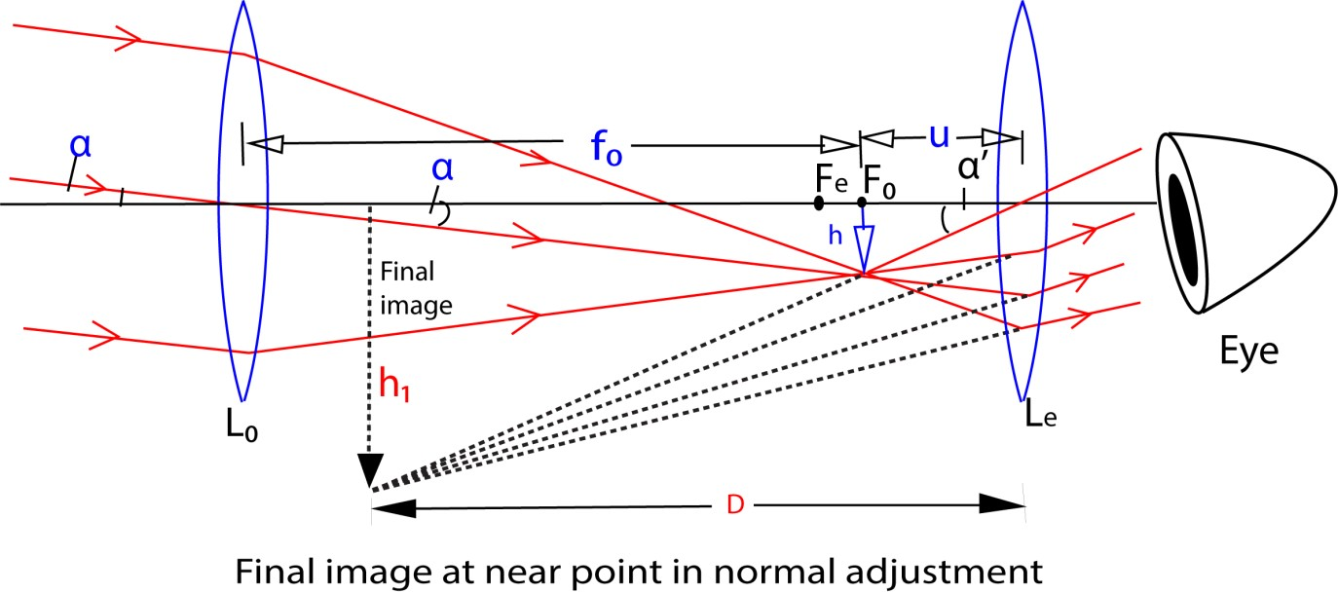
The objective lens forms a real image of the distant object at its the principal focus F₀, and the
eye piece is moved so that the image is nearer to it than its focus, F_{e}, thus acting as a magnifying glass. The separation of the lens is (f_{o} + u).
To obtain the magnification, m, we assume the eye is very close to the eye piece.
For an aided eye (using the instrument)
For small angle, tanα’ ≈ α’ for small angle in radians
α’ =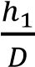 ………………………………………… (i)
Where, h, is the height of image I, f_{e} is the focal length of eye piece For unaided eye
α =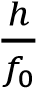 ………………………………………….. (ii)
f₀ is the focal length of objective lens combining equations (i) and (ii)
Magnifying power, m = 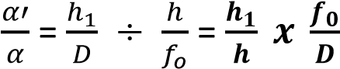
Since 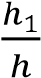 is linear magnification
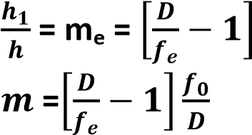
Note that the magnifying power of astronomical telescope in normal use is greater than when in its normal adjustment.

Eye ring
The eye-ring the best position for the eye, is the circular image of the objective in the eye-piece.
The figure below illustrates three rays from a point on the distant object which pass through the objective, forming an image at Y.
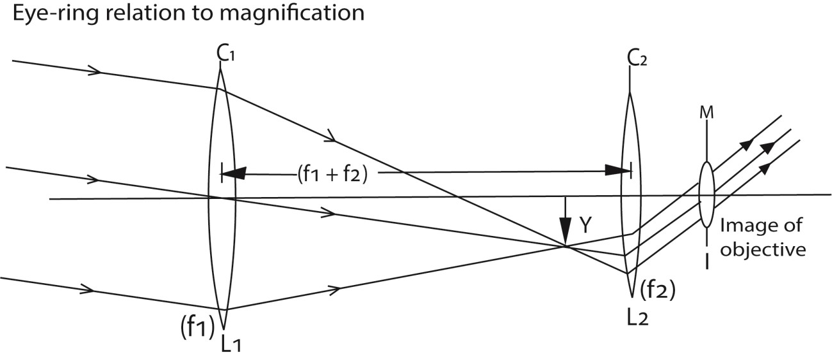
The position of the eye ring, M, can be calculated as follow position as
C₁C₂ = f₁ +f₂
The focal length of eye piece, L₂ = f₂
From 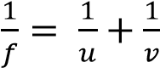
The distance C₂M or v is given by
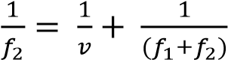
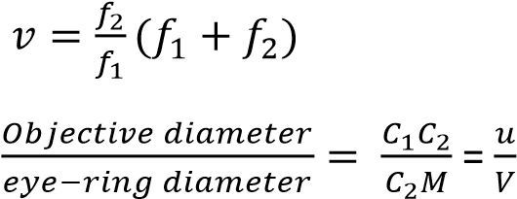
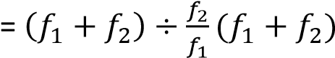
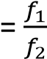
But angular magnification of telescope in normal adjustment = 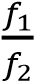
Thus anglar magnification, M = 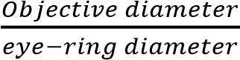

Advantages of refractive astronomical telescope
- It is less bulky since it is more compact
- Refractor telescopes are rugged. After the initial alignment, their optical system is more resistant to misalignment than the reflector telescopes.
- The glass surface inside the tube is sealed from the atmosphere so it rarely needs cleaning.
- Since the tube is closed off from the outside, air currents and effects due to changing temperatures are eliminated. This means that the images are steadier and sharper than those from a reflector telescope of the same size.
Disadvantages of astronomical telescope to view objects on earth
- form inverted images

Example 4
An astronomical telescope consists of two thin converging lenses of focal length 100m and 10cm respectively. if the final image of a distant object is virtual and is 20cm from eyepiece. Find the separation of the lenses. Solution f₀ = 100cm, f_{e}=cm, v = -20cm
From, 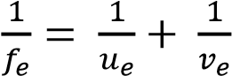
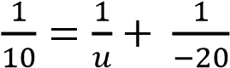, u = 7cm
Separation = f_{e} + u = 100 + 7 = 107cm

Example 5
- What is the meant by the following as applied to a telescope (i) Magnifying power
The ratio between the dimensions of the image and the object.
  - Eye ring
This is the ideal position of the eye for observing the image through the telescope.
- (i) Draw a ray diagram to show how the formation of the final image by an astronomical telescope in normal use.
  - With the aid of the diagram in (b)(i), derive an expression for the magnifying power of astronomical telescope in normal use.
  - Give the disadvantage of the telescope in (b)(i) when used to view distant object on earth. Describe how the telescope can be modified to overcome this disadvantage.

Disadvantage: it forms inverted image. This can be overcome by using an erect lens or converting it into a terrestrial telescope.

- Find the separation of eyepiece and objective of astronomical of magnifying power 20 and in normal adjustment if its eyepiece has a focal length of 5cm
Solution
Separation = f₀ + fe m = 20, f_{e} = 5cm but m = 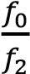
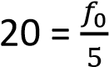
f_{o} =100cm

Separation = 100 +5 = 105cm

Terrestrial telescope
This uses one more convex lens than astronomical refracting telescope. It has an erecting lens of focal length, f, placed between the objective and the eyepiece lens.
The erecting lens is positioned such that image, I, of the object is formed at 2f.
The terrestrial telescope is longer than the astronomical telescope by 4f; where f is the focal length of the erecting lens.
Angular magnification, m = 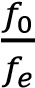
It is used to view different objects on the earth surface
The objective lens forms a real image I1
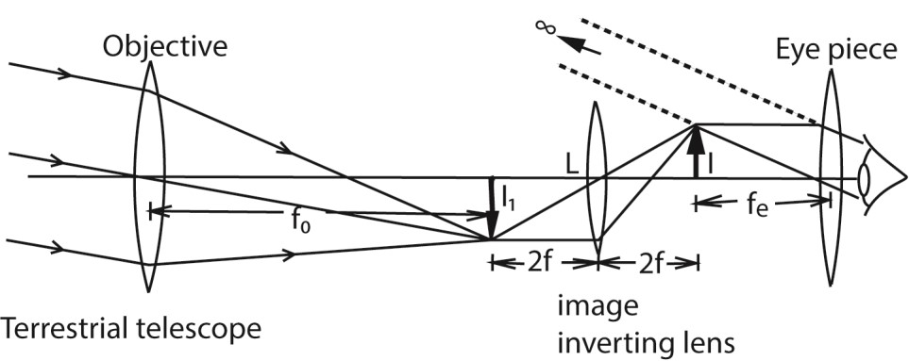
Action
- The objective lens forms a real image I₁ of the distant object at its principal focus, F_{o}. which is at 2f of erecting lens L
- The erecting lens L form an erect image I at its 2f and at principal focus, Fe, of the eye piece. The images I₁ and I have equal sizes
- The eye piece forms a virtual image at infinity.
- The angular magnification of terrestrial and astronomical telescopes is the same in the same adjustments.
Advantages of a terrestrial telescope
It forms upright images
Disadvantages of a terrestrial telescope
  - Long and bulky
  - Extra diffraction occurs in erecting lens reducing the clarity of the final image

Galilean telescope
It consists of two lenses, the objective which is converging lens of long focal length and the eye piece which is a diverging lens of short focal length. It is intended to produce an erect final image. Always the final image produced by the objective beyond the eyepiece.
The separation of the lenses is equal to the difference in the magnitude of focal lengths, i.e.
(f₀ – f_{e}).
- Galilean telescope in normal adjustment (final image is at infinity)
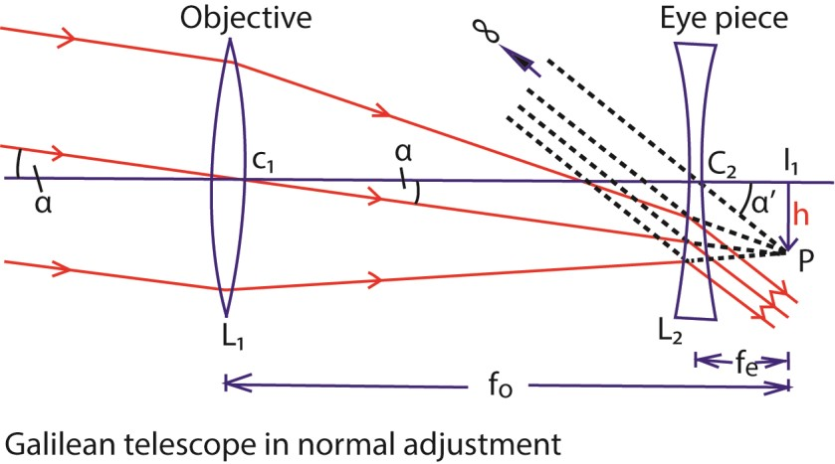
Light from distant object incident on objective lens is refracted to form real inverted image at its principal focus f₀. In normal adjustment, the principal focuses of both lenses coincide. The eye piece therefore forms the final image of the object at infinity.
To obtain the magnification, m, we assume the eye is very close to the eye piece.
m = 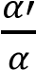
For small angles, α and α’ are measured in radians
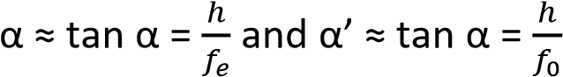
Substituting for α and α’
Magnifying power, m = 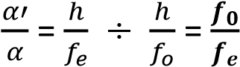
- Galilean telescope not in normal adjustment (final image at near point)

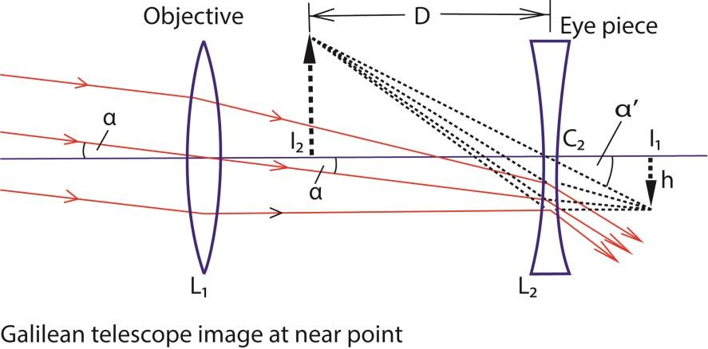
To obtain the magnification, m, we assume the eye is very close to the eye piece.
For an aided eye (using the instrument)
α’ =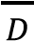 ………………………………………… (i)
Where, h, is the height of image I, f_{e} is the focal length of eye piece For unaided eye
α =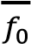 ………………………………………….. (ii)
f₀ is the focal length of objective lens

Combining equations (i) and (ii)
Magnifying power, m = 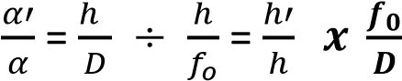
Since 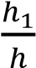 is linear magnification
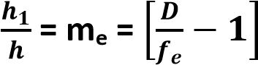
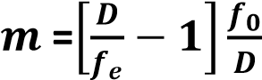
Advantages of a Galilean telescope It forms a final erect image.
It is shorter than the terrestrial and astronomical telescopes because the separation of lenses is f₀-f_{e}.
Disadvantages of a Galilean telescope It has a small field of view.
It has a virtual eye ring not accessible to the observer.

Example 6
A convex lens of focal length 60m is arranged coaxially with a diverging lens of focal length 5cm to view a distant star. Calculate the magnifying power if the image of the star is formed at a distance of 25cm in front of the eyepiece. Solution f₀ = 60cm, f_{e} = -5cm, D -25cm
From, m = 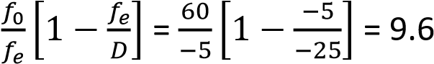
Eye ring of a telescope [Exit pupil]
This is the best position where the eye can be placed so as to receive all rays that are refracted by the objective lens Reflecting telescope
In these telescopes, a concave mirror of long focal length is used instead of convex lenses as objectives.
They include
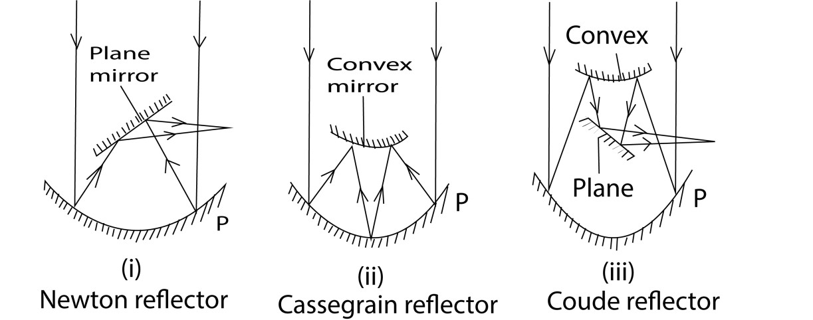

Advantages of reflecting telescopes
(i) There is no chromatic aberration since no refraction occurs at the objective (ii) There is no spherical aberration since a paraboloidal mirror is used.
(iii) It is cheaper to construct since only one surface requires grinding.
(iv)When curved mirrors of large diameter are used, a greater resolving power is obtained.

The prism binoculars
It consists of a pair of a refracting astronomical telescope with two reflecting prisms between each objective and eye piece
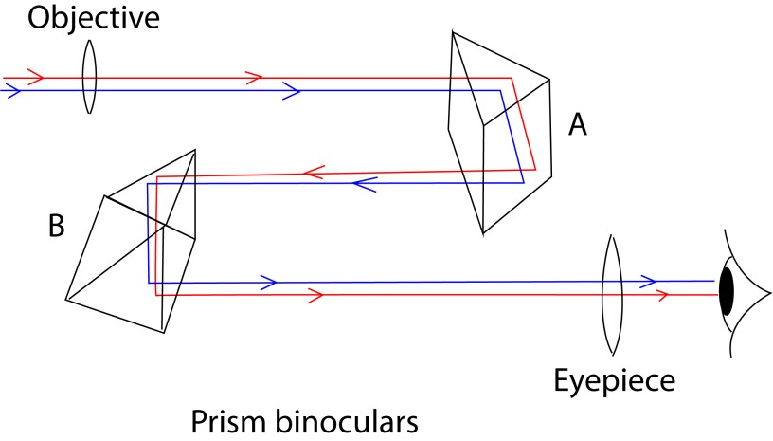

Action
- The objective lens forms a real inverted of a distant object at its principal focus in from of prism A
- By total internal reflection, the prism A causes a lateral inversion direction through 180⁰.
- The right angled prism B, then inverts the image such that an erect image is formed in front of the eye piece.
- The eye piece then forms a virtual magnified image of the object.
The lens camera
It consists of a lens system, a focusing device, an exposure system and light sensitive film.

Lens camera
- The lens focused light from the object on to film
- The diaphragm controls the amount of light reaching the film
- The shutter controls the exposure time of light reaching the film
- Film contain photosensitive chemicals and is where the image is stored.

Projection lantern
A projector is an instrument used to produce a large image of a small object.
- The slide, or film, is placed behind the projector lens outside its focal length and is illuminated buy a small but powerful source of light from concave reflector through condensing lenses. - A magnified, real and inverted image on the screen

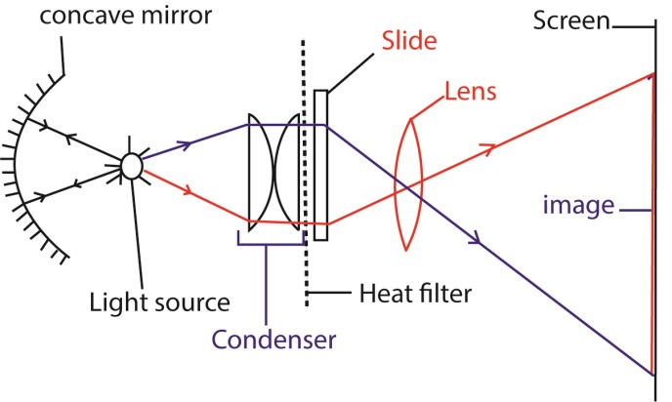

Area magnification = 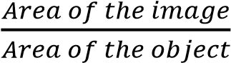

Elimination of chromatic aberration in images formed by magnifying lens
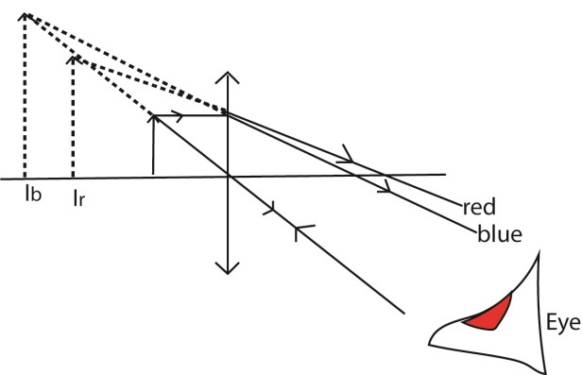
In the lens the light rays from the object are dispersed to form colored images I_{b} and I_{r} due the different refractive indices; but when the eye is placed close to the lens, the mages subtend the same angle to the eye. The images overlap reducing chromatic aberration

Revision exercise 1
1. (a) What is meant by
  - Visual angle
It an angle subtended by an object or image at the eye.
  - Near point.
It is the nearest point at which the eye is able to view the object clearly.
  - Linear magnification
This a ratio of image height to object height
  - Angular magnification
It a ratio of the angle subtended by the final image to eye when using a lens or optical instrument to the angle subtended by the object to unaided eye.

(b) A person with a normal near point distance of 25cm away wears spectacles with a diverging lens of focal length 200cm in order to correct the far point distance to infinity. Calculate the near point when viewing using spectacles.

Solution
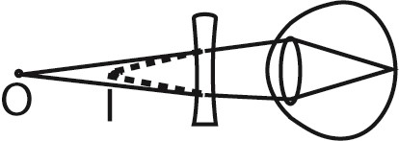
Object O appears to be at I, the near point of the eye.
Now, v = -25, f= 200cm
From 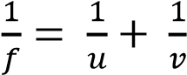
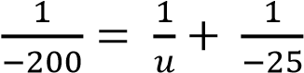
u = 28.6cm
Therefore, the near point = 28.6cm.
- Draw a ray diagram to show the formation of an image of a distant object in terrestrial telescope in normal adjustment.

- State two disadvantages of terrestrial telescope.
  - It long and bulky due extra image inverting lens
  - Extra diffraction occurs in erecting lens reducing the clarity of the final image

2. Derive an expression for magnifying power of magnifying glass when the final image is formed at near point.

Solution
Consider an object with height h viewed at near point by unaided eye
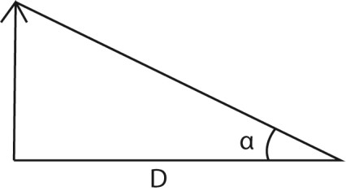
The visual angle α measured in radians is given by α ≈tan α =

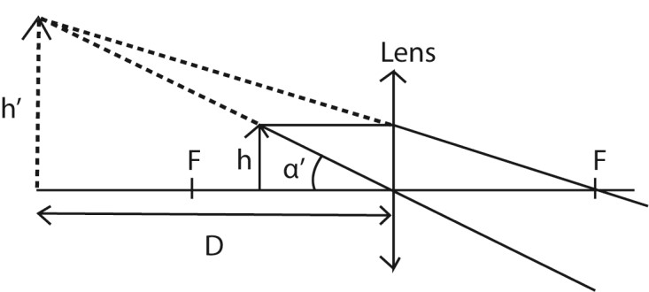
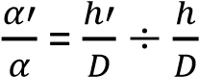
If the final image at near point subtends an angle α’ to the eye when a magnifying glass is used as in the diagram below

If α’ is small angle, in radian, α’ =

Magnification =

Or
Magnification, M = 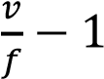 but v= -D (image is virtual)
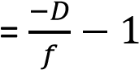
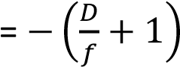
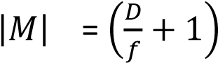

3. (a) Draw a diagram to show the formation of an image by a compound microscope in in normal adjustment and use it to derive an expression for magnifying power

The object is placed a distance u slightly greater than the focal length f₀ of objective lens to form a real image I₁ between the principal focus Fe of the eyepiece and its optical center to form a virtual image I₂.

For an aided eye (using the instrument)
For small angle, tanα’ ≈ α’ for small angle in radians
α’ =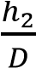 ………………………………………… (i)
For unaided eye
α =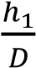 ………………………………………….. (ii)
Magnifying power, m = 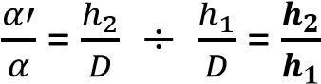

Or
Linear magnification can also be expressed as, m = 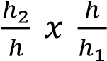 = m_{e} x m_{o}.
Where, m_{e} and m_{o} are linear magnifications of the eye piece and objective lenses respectively.
m_{o} 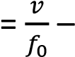 1 and me = 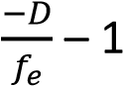

m = (

(e) A microscope has an objective of focal length 10.0cm and eyepiece of focal length 20cm. if the distance between the objective and eyepiece is 20cm, calculate the magnifying power of the microscope. (03marks)

Solution
Given f₀ = 10cm, f_{e} = 20cm, D = 25cm, v₀+ u_{e} = 20cm Using eye piece lens
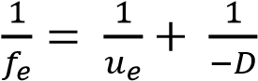
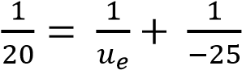 ; u_{e} = 11.11cm
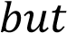 v₀+ u_{e} = 20cm
v_{o} = 20 – 11.11 = 8.89cm
From m = 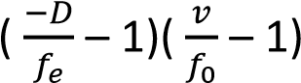
m = ( 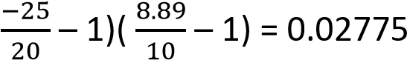

4. (a) A compound microscope consists of two thin lenses, an objective of focal length 1.0cm and eye piece of focal length 5.0 cm. the objective forms an image of an object placed in front of it at a point 16.0cm away. If the final image is formed at the near point of the eye, calculate
(i) Separation of the lenses (03marks)

Solution
Considering the eye piece; from 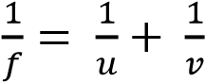
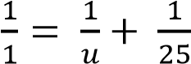; u = 4.2cm
Separation of lenses = v₀ + v_{e} = 16.0 + 4.2 = 20.2cm
(ii) Magnifying power of the instrument (03marks)

Magnifying power, M =
Negative magnification because the image is virtual
(b) Why should the objective and eye piece for compound microscope have short focal length?
From the expression of magnification i.e. M = 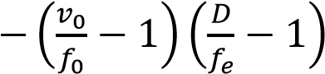 high magnification is achieved when the focal lengths f_{o} and f_{e} are small.

5. (a) A compound microscope consist of two converging lenses of focal lengths 1.0cm and 5.0cm respectively. An object is placed 1.1cm from objective and the microscope is adjusted so that the final image is formed 30cm from eye piece. Calculate (i) The separation of lenses.
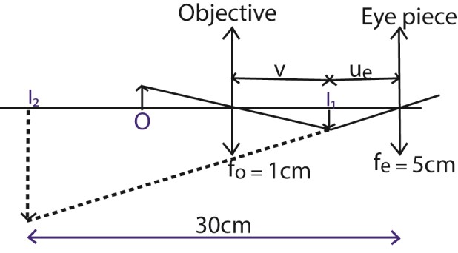

From

Objective

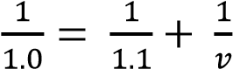 ; v = 11cm

For eye piece
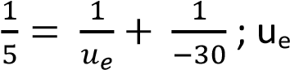= 4.3cm
(ii) The magnifying power of the lenses.

Magnifying power, M = 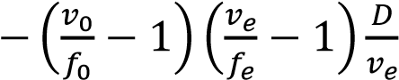
M = 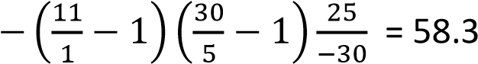
(b) State two differences between a compound microscope and an astronomic telescope
Compound microscope | Astronomical telescope
- View near objects  - Objective lens has smaller focal length  - In normal adjustment the final image is at near point  - Has greater resolving power | - View distant object  - Objective lens has longer focal length  - In normal adjustment, final image at  infinity  - Has lower resolving power

- An object of size 2.0mm is placed 3.0cm in front of objective of compound microscope. The focal length of objective is 2.5cm while that of the eye piece is 5.0cm. The microscope forms a virtual image of the object at near point of the eye. Find the (i) Size of final image
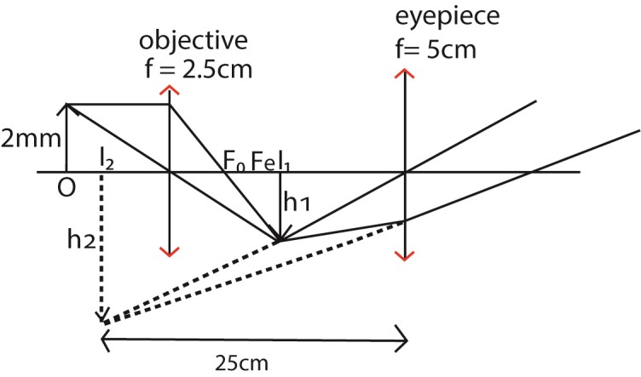
The objective forms a real magnified image I₁ of height, h₁ at a distance less than f_{e} from the eye piece. The eye piece forms a magnified image I₂of height h₂ at near point.
Action of objective
From 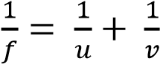
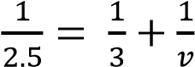; v =15
M0 = 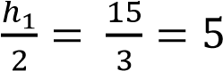; h1 = 10mm
Action of the eye piece
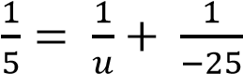; u = 4.2cm
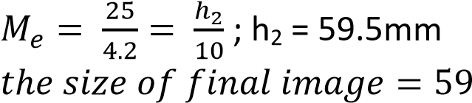.5mm

(ii) Position of eye-ring
Separation = 15 +4.2cm = 19.2cm
The distance, v, of the image of objective in eye piece is given by
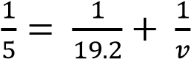; v = 6.8cm
.8cm from eye piece.

- Describe with aid of a diagram, a compound microscope forms image at near point

Note that
    - A compound microscope forms an image at the near point when the image of the objective is formed between principal focus and optical center of the eyepiece.
    - In normal adjustment and image at infinity, the image of objective is formed on the principal focus of the eyepiece.

- (a) Define the following as applied to a telescope
      - Eye-ring (01mark)
This is the image of objective formed by the eyepiece and is the best position to place an eye to view the image through a telescope.
      - Magnifying power
It is the ration of the angle subtended by the final image at the eye when using the telescope to the angle subtended by the object at the unaided eye.
  - What is the significance of the eye-ring of an astronomical telescope?
It is the best position for placing the eye, to view the image through the telescope; here the image is clearer and bright.

  - State two advantages of reflecting telescope over refracting telescope
        - There is no chromatic aberration
        - There is no spherical aberration
        - High resolution
        - The image is brighter
        - It is cheap

  - The figure below shows an optical system consisting of two thin converging lenses arranged coaxially. Lens A has a focal length of 40mm and lens B has focal length of 375mm. An object O of height 5mm is placed 5mm from A, I₁ is a real image of O in A and I₂ is a virtual image of I₁ in B and is 250mm from B.
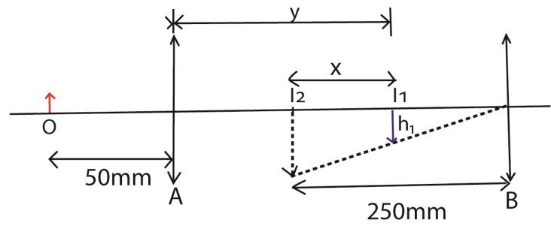
  - Determine the value of distance y of image I1 from lens A (02marks)
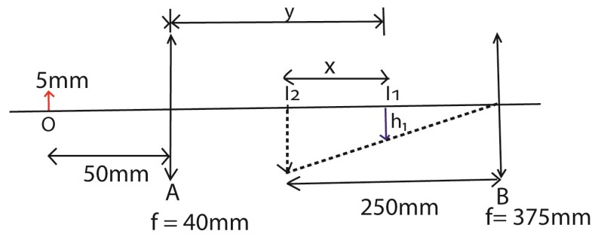
Using

; y = 200mm
  - Calculate the distance x between the image I₁ and I₂. (02marks) Let the object distance in lens B be u

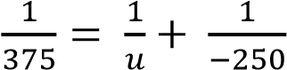; u = 150mm
x = v-u = 250 -150 = 100mm
(iii) Find the magnification of the system.
M = m_{A} x m_{B} 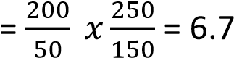
  - Name one defect of image formed by a lens and explain how the defect is minimized in practice
    - Chromatic aberration is minimized by
        - Placing the eye close to the lens such that images due to different colours subtend the same angle at the eye.
        - Use of a chromatic doublet such that the dispersion produced by one lens is reversed by another.
    - Spherical aberration is minimized by
- Using a stopper such that only light incident on the middle of the lens pass. - Using a lens of aspheric surface - Using narrow aperture lens.
  - Explain the following
      - Total internal reflection
It is the bouncing back of light moving from an optically denser medium to less dense medium when the angle of incidence exceeds the critical angle.
      - Formation of mirages
Mirage is an image of the sky formed by total internal reflection of light rays from the sky at air layer near the ground.
This occurs because the hotter layers of air near the ground are less optically dense than those above.

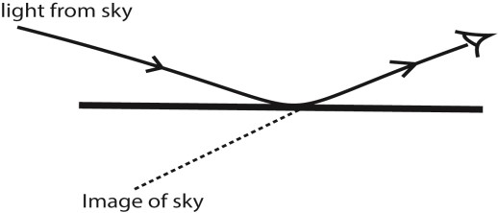

- (a) Describe with aid of a labelled diagram the structure and operation of a projection lantern. (04marks)

Solution

- The slide, or film, is placed behind the projector lens outside its focal length and is illuminated buy a small but powerful source of light from concave reflector through condensing lenses.
- A magnified, real and inverted image on the screen

(b) A projector produces an image of are 2m² on the screen placed 5m from the projection lens. If the area of the object slide is 8cm², calculate the focal length of the projected
lens. (02marks)

Solution
1m² = 10000cm²
Area magnification = 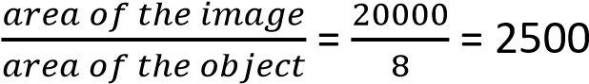
Linear magnification = 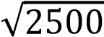 = 50
From m = 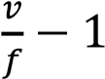 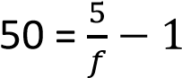; f = 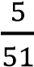 = 0.098m = 9.8cm
- The slide of a projection lantern has dimensions 36mm by 24mm. find the focal length the lens required to project an image 1.44m x 0.98m on the screen placed 4.0m from the lens.
Solution
Image area = 1.44 x 0.98 = 1.4112m²
Object area = (36 x 10⁻³ x 24 x10⁻³) = 8.64 x 10⁻⁴m².
Area magnification= 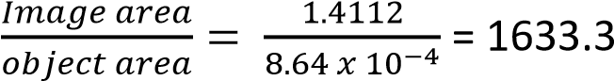
Linear magnification = 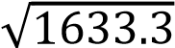 = 40.4
From M = 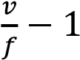, v = 4.0m
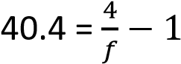; f = 0.097m

- (a) Explain the term eye-ring as applied to a telescope
This is the image of objective formed by the eyepiece and is the best position to place an eye to view the image through a telescope.
  - (i) Draw a ray diagram to show the formation of a final image in Galilean telescope in normal adjustment.
(ii) Derive an expression for angular magnification of the telescope in (b)(i) above

The angular magnification is the ratio of the angle subtended by the final image at the aided eye to the angle subtended by the object at the unaided eye.
To obtain the magnification, m, we assume the eye is very close to the eye piece.
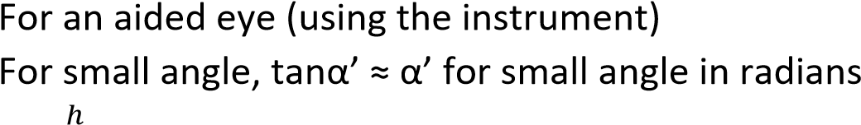
α’ =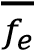 ………………………………………… (i)
Where, h, is the height of image I, f_{e} is the focal length of eye piece For unaided eye
α =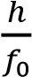 ………………………………………….. (ii)
f₀ is the focal length of objective lens Combining equations (i) and (ii)
Magnifying power, m = 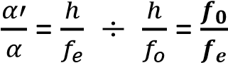

  - Explain two advantages and one disadvantage of the telescope in (b) above
Advantages
    - Forms an erect image with only two lenses.
    - It short and potable because the distance between the lenses is f_{o}-f_{e}.
Disadvantage
    - It has a virtual (inaccessible) eye ring hence limited field of view.

- (a) What is meant by reversibility of light as applied to formation of real image by convex lens.
Reversibility of light means that light travels along its original path when its direction is reversed.
  - (i) Draw the action of astronomical telescope in normal adjustment.

Note,
    - when an astronomical telescope is in normal adjustment, the final image is formed at infinity
    - the focal length of the objective is bigger than that of eye piece
    - the principal focuses of the two lenses coincide
To obtain the magnification, m, we assume the eye is very close to the eye piece.
For an aided eye (using the instrument)
For small angle, tanα’ ≈ α’ for small angle in radians
α’ =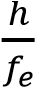 ………………………………………… (i)
Where, h, is the height of image I, f_{e} is the focal length of eye piece For unaided eye
α =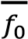 ………………………………………….. (ii)
f₀ is the focal length of objective lens Combining equations (i) and (ii)
Magnifying power, m = 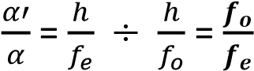
- The objective and eyepiece of an astronomical telescope have focal lengths of 75.0cm and 2.5cm respectively. Find the separation of lenses if the final image is 25cm from the eyepiece.

Object distance in eye piece
From
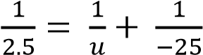; u =2.3vm
Separation of lenses = f₀ + u = 75 + 2.3 =77.3cm
- (i) What is the significance of eye ring in astronomical telescope
It is the position where an eye gets the clearest image
(ii) State two advantages of a reflecting telescope over a refracting telescope - No spherical aberration
  - No chromatic aberration since there is no refraction
  - Higher resolving power due bigger surface
  - Cheap

- Explain why chromatic aberration is not observed in simple microscope.
In the lens the light rays from the object are dispersed to form colored images I_{b} and I_{r} due the different refractive indices; but when the eye is placed close to the lens, the mages subtend the same angle to the eye. The images overlap reducing chromatic aberration

13. (a) The objective of an astronomical telescope in normal adjustment has a diameter of
150mm and focal length of 3.0m. The eye piece has a focal length of 25.0mm. Calculate (i) Position of the eye ring (03marks)

For eye-ring
u = f₀ + f_{e} = 3000 + 25 = 3025mm f = f_{e} = 25mm
From 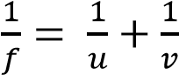
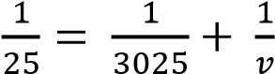; v = 25.2mm.

- Diameter of the eye ring (03mark)

m = 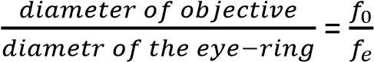
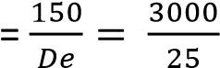
Diameter of eye-ring = 1.25mm
- Give the advantage of placing the eye at the eye ring (01mark) Clearest image is observed
(b) (i) Give the disadvantage of using astronomical telescope to view distant object on earth Images are inverted
(ii) Describe how astronomical telescope may be modified to overcome the disadvantage in (b)(i).
A converging lens (erecting lens) of focal length, f, is placed between the objective and eye piece. The distances of the erecting lens from objective and eye piece are 2f + fo and 2f +fe where fo and fe are the focal lengths of objective and eye piece respectively.

Or
Two right-angle isosceles prisms are used between the lenses. One placed with its refracting edge vertical another with its refracting edge horizontal.

(c) Find the separation of eye-piece and objective lenses in astronomical telescope of magnifying power 20 in normal adjustment, if its eyepiece has a focal length of 5.0cm.

M = 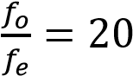
f_{o} = 20 x 5 = 100cm

Separation of lenses = f_{o} + f_{e} = 100 + 5 = 105cm

- An astronomical telescope has objective of focal length 100cm and eye piece of 10cm.find the separation of the objective and eyepiece lenses if the lenses are arranged such that the final image is formed 25cm away from the eyepiece.

Action of the eyepiece
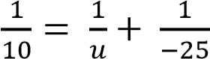= u = 7.14cm

Separation of lenses = f₀ +u = 100 + 7.14 =107.14cm

- (a) With the aid of a labelled diagram describe the essential parts of photographic camera

Lens camera
- The lens focused light from the object on to film
- The diaphragm controls the amount of light reaching the film
- The shutter controls the exposure time of light reaching the film
- Film contain photosensitive chemicals and is where the image is stored.

- Explain how chromatic and spherical aberration are minimized in photographic camera.
  - Chromatic aberration is minimized by using achromatic doublet made of convex and concave mirror such that the dispersion caused by one lens is nullified by another
  - Spherical aberration is reduced by using a stopper that prevents marginal rays from reaching the film.
- With aid of a diagram, explain why images seen in magnifying lens is almost free from chromatic aberration
In the lens the light rays from the object are dispersed to form colored images I_{b} and I_{r} due the different refractive indices; but when the eye is placed close to the lens, the mages subtend the same angle to the eye. The images overlap reducing chromatic aberration

16. (a) With the aid of a diagram describe the structure and action of reflecting telescope
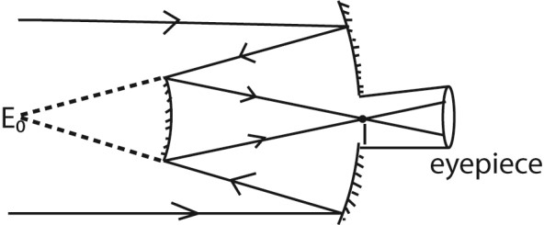

- The objective is large parabolic mirror with circular aperture along the focal length.
- A beam of light parallel to the principal axis of telescope from distant object to the convex mirror.
- The convex mirror the forms a real, inverted image at, I, the principal focus of eyepiece.
- The eye piece forms a virtual magnified image at infinity.

(c) State the advantages of reflecting over refracting telescopes
  - No chromatic aberration because there is no refraction
  - No spherical aberration
  - High resolution power due to larges surface area of the mirror.
  - Cheap
  - Produce brighter images

TOPIC 4/6: ELECTROSTATICS

Electrostatics
This is the study of electrical charges at rest.

There are two kinds of charges i.e., unlike charges which attract and like charges which repel.

Positive and negative charges
Glass rubbed with silk develops a positive charge whereas an ebonite rod rubbed with fur develops a negative charge. This is because during rubbing electrons move from glass to silk whence the glass become positively charged whereas silk becomes negatively charged.

Similarly, electrons move from fur to rubber during rubbing and rubber becomes negatively charged while fur becomes positively charged.

Insulators and conductors
In insulators, electrons in the atoms are firmly bound to the nucleus and the removal or addition of electrons at a place does not cause flow of electrons elsewhere.

In conductors, the electrons are free to move from individual atoms and if such materials gain electrons these can move about in them. The loss of electrons by conductors cause a redistribution of those left. A charge on the conduct therefore spreads over entire surface.

Examples of insulators include glass, rubber and plastics.
Examples of conductors include metals, water, and electrolytic solutions

Charging insulators by contact rubbing or friction
Insulators can only be charged by contact rubbing or friction. Consider two bodies A and B of different work functions.

NB. Work function is the minimum energy required by an electron to escape from the surface of an atom.
When a body A has a low work function compared to B, then, during rubbing, body A will lose electron to body B due to heat energy that increases the kinetic energy of electrons. Body A becomes positively charged while body B becomes negatively charged.

Example 1
Explain how charging by rubbing occurs.

Electrostatic induction
This is the process by which a neutral body places near a charged body gets charged with contact.

Induction is used when charging conductors where induced charges are obtained without contact with other charges.

Consider two insulated metal spheres A and B, arranged such that they touch one another. A negatively charged rod C is brought near A.

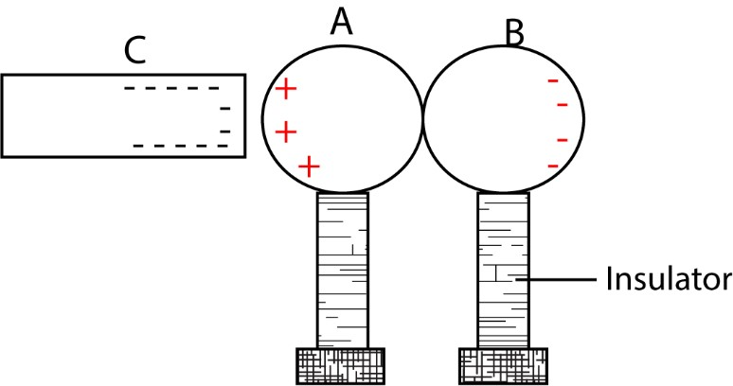

While keeping the inducing rod C in position, the spheres are separated and tested with a charged pith ball. It is discovered that A has a positive charged and B has a negative charge.

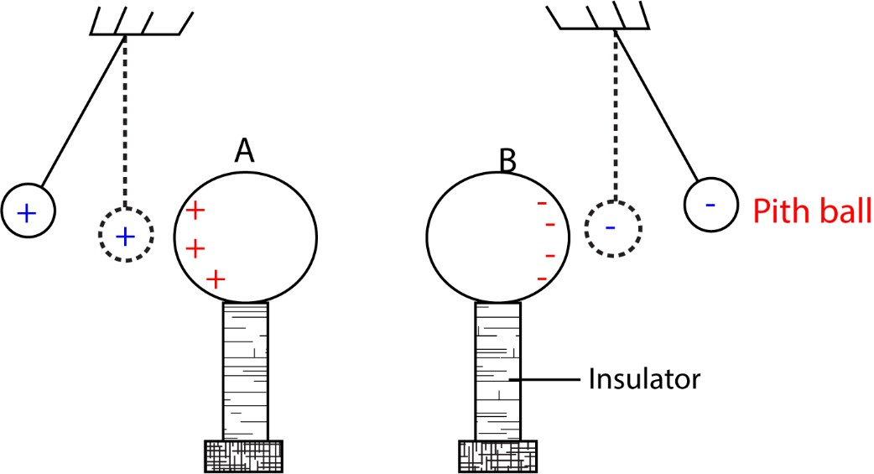

If the spheres are brought back in contact, it is found that they have no effect on the pith ball.
Their charges have neutralized each other. This shows that (i) positive and negative charges are created.
(ii) the number of electrons which move is equal to the number of positive charges that are created.

2. Charging by induction
- Charging a conductor negatively by induction.
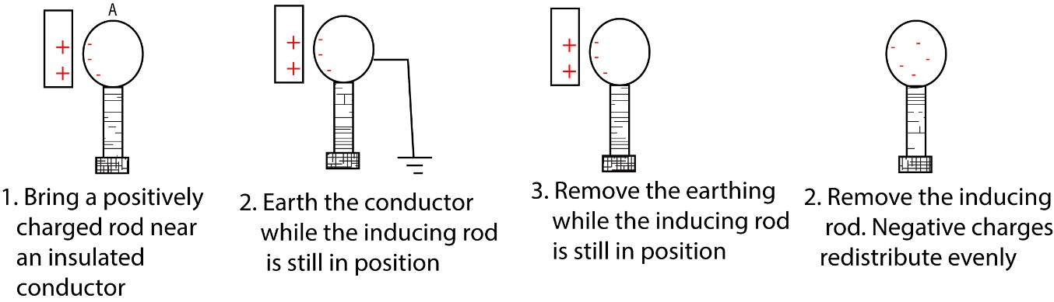

- Charging a conductor positively by induction

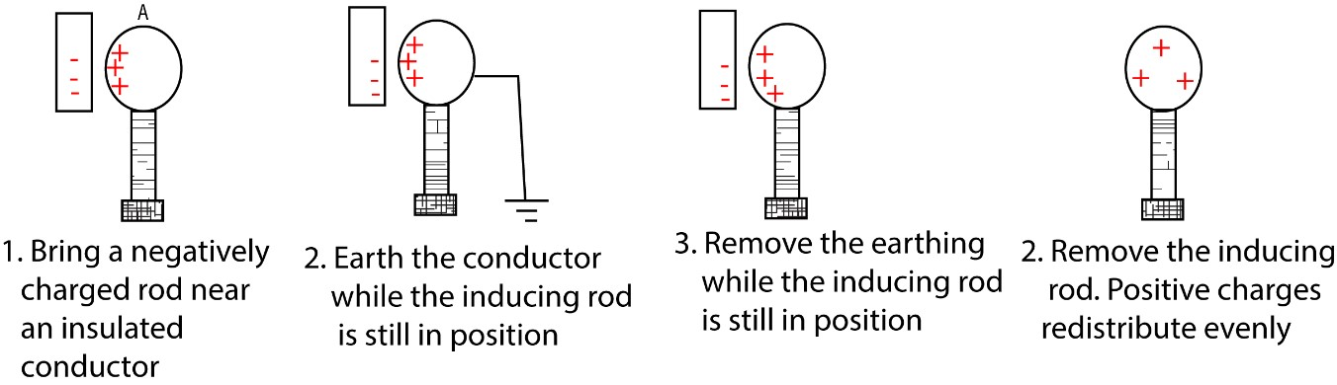

Gold leaf electroscope
This is an instrument for testing the presence, the sign and the magnitude of the charge.

It consists of a circular metal disc (cap) attached to a metal rod with a brass plate to which is attached a thin foil of gold or aluminium.

It is fitted in a metal case with help of a plug (insulator) using perspex windows. The metal case is earthed in order to screen the electroscope from outside influences other than those brought nearer the cap and it is insulated from the ground.

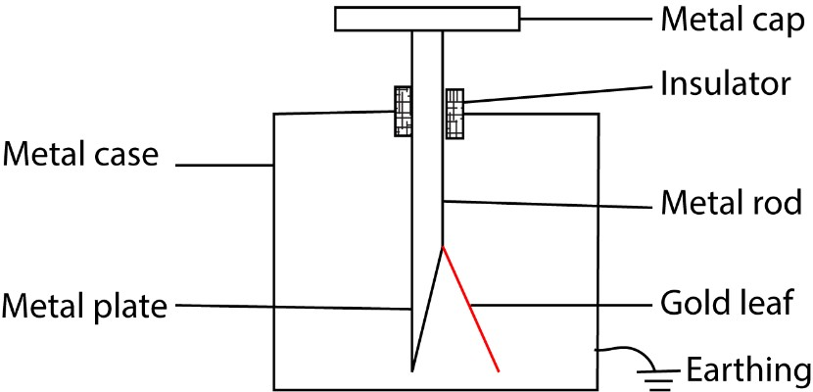

Mode of action
When a charged body id brought near or in contact with the cap of the electroscope, the cap will acquire an opposite charge by induction. The charge on the body will repel all charges similar to it down to the rod, to the plate and the leaf.

Due to presence of like charges on the plate and gold leaf, the leaf diverges as it is repelled by the plate.

Leaf divergence indicates that the body brought nearer or in contact with the cap carries a charge.

Uses of the gold leaf electroscope
- Detecting of charge on a body
- Testing the nature and sign of charge on the body
- Comparing the magnitude of charge on various bodies
- Test the insulating and conducting properties of various substances (v) Measure potential difference

1. Testing for the nature or sign of charge
Charge a gold electroscope (GLE) negatively. Bring the body under test near the cap of GLE, it the leaf diverges further, then the body has a negative charge but if the gold leaf collapses, then that body is either has a positive or a neutral conductor.

The experiment is repeated is repeated where the GLE is charged is charged positively. A charged body is brought near the cap; if the gold leaf diverges more, the body is positively charged. If the gold leaf collapses, the charged body is either negatively charged or neutral conductor.

Note that an increase in divergence occurs when the charge on electroscope and the tested charge are the same. Therefore, an increase in divergence is the only sure test for a sign of charge on the body.

2. To detect the presence of a charge on a body
Bring the b0dy to be tested near the metal cap of a neutral gold leaf electroscope. When
the leaf deflected, then the body has got a charge. However, it the leaf remain undeflected, then a charge is absent on the body.

3. To compare and measure potentials
Two bodies which are similarly charged are brought into contact with the metal cap of the gold electroscope one after another. The body that cause a big divergence has a big charge.

4. To classify conductors and insulators
Bring the body to be tested in contact with the metal cap of a charged gold leaf electroscope. When the leaf collapses suddenly, then the body is a good conductor. If it collapses gradually, the body is a bad conductor. However, if it does not collapse then, it is an insulator.

Example
Describe how a gold leaf can be charged positively and negatively by induction.

(a) Charging gold leaf electroscope positively by induction Procedures
- A negatively charged rod is brought a cap of GLE - The cap is earthed while the charged body is still in place.
- Earth connection is removed.
- Lastly the charged body is removed.

Observation/explanation
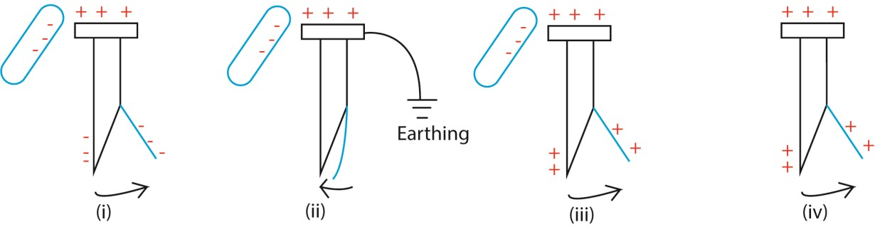
- When a negatively charged body is brought near a cap of GLE, positive charges are induced on the cap while electrons are repelled to the metal plate and the gold leaf. The gold leaf is repelled and diverges.
- When the cap is earthed say by touching it with a finger, electrons flow to the earth and the leaf collapses.
- When the earth connection is removed, the remaining positive charge on the cap redistributes itself on the Gold leaf and the leaf diverges again.
- When the charged body is removed, the GLE acquires a permanent positive charge.

(b) Charging gold leaf electroscope negatively by induction
Procedures
- A Positively charged rod is brought a cap of GLE
- The cap is earthed while the charged body is still in place.
- The earth connection is removed.
- Lastly the charged body is removed.

Observation/explanation

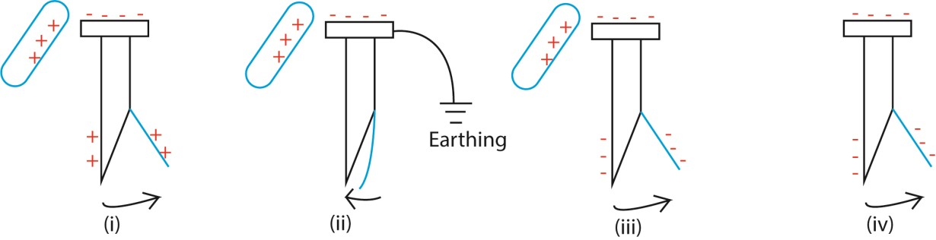
- When a positively charged body is brought near a cap of GLE, positive charges are induced on the cap while electrons are repelled to the metal plate and the gold leaf. The gold leaf is repelled and diverges.
- When the cap is earthed say by touching it with a finger, electrons flow from the earth and the leaf collapses.
- When the earth connection is removed, the acquired negative charge on the cap redistributes itself on the Gold leaf and the leaf diverges again.
- When the charged body is removed, the GLE acquires a permanent negative charge.

Electrophorus
This a device which provides large quantities of charge by induction. It consists of an insulator (e.g. polyethylene) and a metal disc with an insulated metal handle.
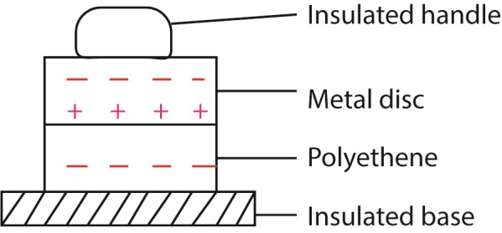

Procedure
The polyethene is charged negatively by rubbing it vigorously with a duster, when the metal disc is laid up on it. It acquires induced positive charge after earthing it with a finger. Very little negative charge from the polyethene to disc because the material has uneven surface preventing them from touching at more than a few point. Little charge escapes from these points only because the polyethene is a nonconductor. On removing the disc, it has a sufficient positive charge.
The disc can be discharged and charged again until the charge on the polyethene has disappeared by linkage.
Electrophorus is a device used for converting mechanical energy into electrical energy. Since work is done in raising the disc against the attraction of the opposite charge.
Electrophorus and the advantage of charging by induction
- Supply of charge is almost unlimited because the origin of charge in not carried away.
- A greater charge nearly equal to that of the whole of polyethene can be concentrated on the conducting disc.
- Only a very small charge can be transferred by contact leakage because the polyethene is not a conductor.
- The disc can be discharged and recharged.

Charge distribution
Surface density is a charge per unit area in a conductor’s surface. Surface density increases with the curvature of the body. The charge density is higher on the pointed and sharp surfaces than on round ones.

Testing charge distribution using proof planes
A proof plane consists of an aluminium foil (leaf) which can be modeled to fit any shape. It is made from a small sheets of the different shapes but to the same size.

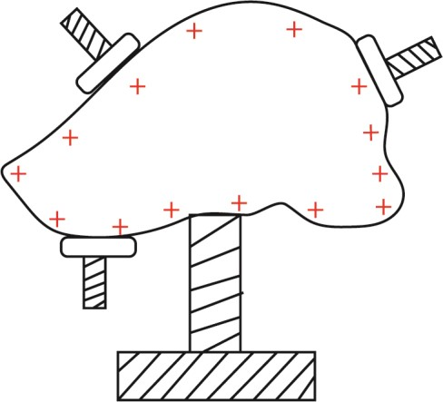
When a proof plane is placed at any point when contact with any surface, it carries away the charge which is directly proportional to the charge per unit area of the body at this point.
This charge is tested by lowering the proof plane in the can connected to an electrophorus. Different shapes of the conductors are investigated, it found that the charge per unit area or surface density increases with the curvature of the body, i.e. the leaf divergence is directly proportional to the charge density at the point of the body.

Faraday’s ice pail experiments
The ice pail is placed on an insulator and connected to a gold leaf electroscope
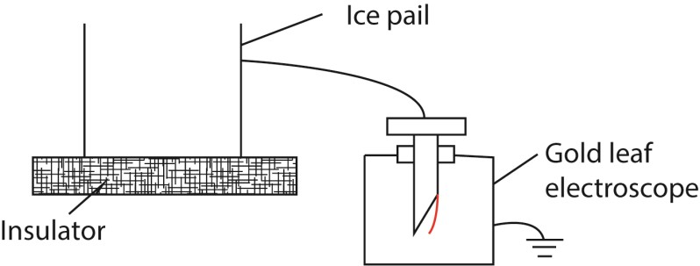
A metal ball held on a long silk thread is charged positively and then lowered into the pail without allowing it to touch the pail side or the bottom of the pail. The positive charge is induced on the outside of the pail and the leaf diverges
Once the ball is inside the pail, the divergence of the leaf does not change when the ball is moved around, near to or further from the bottom of the pail which shows that the amount of induced positive charge does not the position of the ball once it is in the pail
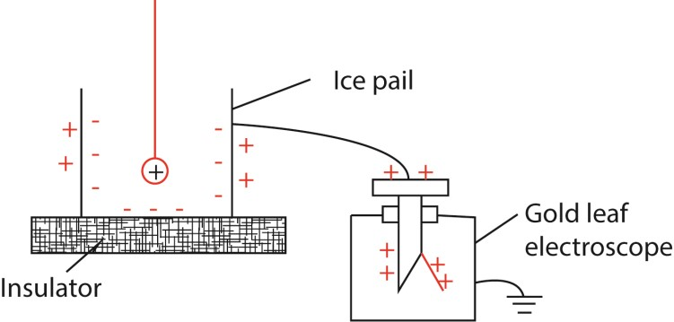
The metal ball is allowed to touch the pail and no leaf divergence is observed. This means that when the ball touches the pail no charge is given to or taken away from outside of the pail.
The metal ball is then removed and tested for the charge with gold leaf electroscope. It was found that the ball had no charge, hence, the induced charge on the inside of the pail must have been equal in magnitude to the original positive charge on the ball
These conclusion apply only to hollow closed conductors
- When a charged body is enclosed in a hollow conductor, it induces on the inside of a conductor a charge equal and opposite its own and on outside a charge equal and similar to its own
- The total charge inside the conductor is always zero, either there is equal and opposite charges on the inside (before the ball touches) or there is zero no charge at all after the ball has touched.

Example 3
A charged body of 10C is lowered in a charged ice pail which carries a charge of -3C in the inside and +5C on the outside. Find the total charge on the pail when
- The ball is lowered without touching
- The ball is allowed to touch the bottom of the pail.

Solution
- Without touching the pail Outside = +10C + 5C = +15C
Inside = -10C – 3C = -13C
- When the ball touches the bottom Inside = -13C + 10C = -3C
Outside = +15C – 3C = +12C

Corona Discharge
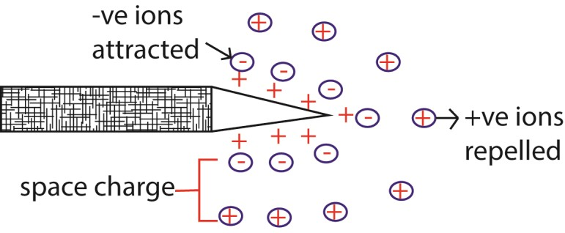
- On a pointed charged conductor, there is high charge density and thus high electric field at the sharp point.
- This causes air molecules around the sharp point to ionize and form positive and negative ions.
- The similar charges to those on the conductor are repelled while those opposite are attracted to neutralize some of the charges on the conductor.
- The apparent loss of charge from a sharp point of the conductor in this way is called Corona discharge.

Definition
Corona discharge is a phenomenon where a strong electric field of a conductor causes the surrounding air (or another gas) to become ionized, leading to a faint glow, hissing sound, and sometimes ozone formation.
Or
Corona discharge is ionization of the surrounding medium caused by intense electric fields at sharp points of a conductor.

Importance corona discharge in Electrostatics
Demonstrates field concentration: Corona occurs more easily at sharp points because electric fields are strongest there.
Practical relevance: of corona discharge
- In high-voltage transmission lines, corona discharge causes power loss and radio interference.
- Corona discharge cause apparent loss of charge from sharp points. o In electrostatic devices (like photocopiers or ozone generators), corona is deliberately used to ionize air.
- In insulation testing, corona discharge helps detect weak spots

Example 4
Explain what is meant by Action at points in electrostatics (Corona discharge)
Lightning
Lightning is a sudden, powerful electrical discharge that occurs during thunderstorms, caused by the buildup of static electricity between regions with opposing charges within a cloud or between a cloud and the ground. This massive energy release creates a bright flash and a sound called thunder, which is the rapid expansion of air heated by the lightning strike.

How lightning forms
- Charge buildup: Thunderstorms form when warm, moist air rises and cools, condensing into water droplets and ice crystals. Collisions between these ice crystals and water droplets generate static electricity. Lighter, positively charged particles are carried higher in the cloud, while heavier, negatively charged particles gather at the bottom.
- Opposite charges attract: This separation of charge creates a potential difference between different parts of the cloud and between the cloud and the ground, which becomes positively charged underneath a storm cloud.
- Electrical discharge: When the opposite charges build up enough to overcome the air's resistance, the electrical potential difference becomes too strong, and an electrical discharge occurs to equalize the charges.
- The flash: This discharge is the lightning flash, a giant spark that travels through the air. The intense heat from the electrical current causes the air to expand rapidly, creating the shockwave we hear as thunder.

How lightening causes damages to buildings and trees
Lightning damages buildings through three primary mechanisms: fire, explosive shock waves, and power surges.
- Fire: The extreme heat of a lightning bolt (up to 50,000°F) can easily ignite flammable building materials like wood framing, roofing shingles, or insulation.
- Shock Waves: The explosive shock wave created by the rapid heating and expansion of air (which we hear as thunder) can cause physical destruction. This force can crack or shatter hard materials like brick, stone, concrete, and cinderblock, causing damage to chimneys, walls, and foundations, and can also shatter windows.
- Power Surges: Lightning current travels through conductive paths such as electrical wiring, plumbing, and communication lines. The resulting massive power surge can instantly destroy appliances, computers, and entire electrical systems, even if they are not directly struck. These surges can also melt wiring, posing a serious latent fire hazard

The lightning conductor
A lightning conductor protects a building by safely directing the enormous electrical energy of a lightning strike into the ground instead of letting it pass through the structure.
A lightning conductor consists of a pointed metal rod fixed at the highest point of a building connected to a thick metal strip or cable that runs down the building into the earth. Because of its sharp tip, it attracts the lightning discharge when a storm occurs and conducts the massive electrical current harmlessly into the ground. This prevents damage to the building, its occupants, and electrical systems.

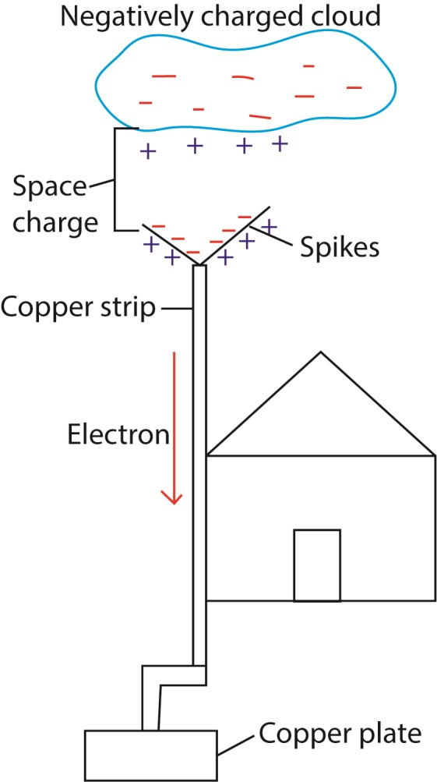

How a lightning conductor works
- Attraction & Interception: The metal rod, positioned at the building's peak, is the most likely point for lightning to strike because it's the highest and most conductive point.
- Conduction: Once struck, the electrical current flows through the thick metal cable connected to the rod.
- Grounding: This cable runs down the side of the building to a copper plate buried deep in the earth, safely dissipating the energy into the ground.
- Prevention: By providing this dedicated, safe pathway, the conductor prevents the lightning's intense heat and current from passing through the building itself, averting fires, explosions, and electrical damage.
Example 5
Explain how a lightening conductor works.

Van der Graff generator
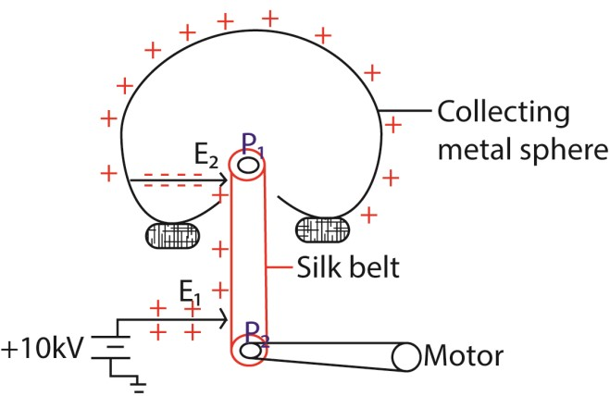
Main features
- It consists of a large hollow metal sphere (collecting sphere) supported on insulating stand.
- A silk belt inside the tube driven by an electric motor possesses the sharply pointed electrode metal E₁, held at electric potential of about 10kV relative to the earth.
- As the belt moves up, it passes another sharply pointed metal electrode E₂ connected inside the hollow sphere.

Mode of operation
The generator works by continuously transferring electric charge from a lower potential to a higher potential using a moving belt.
- Charge Production: A comb or brush, E₁, near the bottom of the belt sprays charges (usually positive) onto the belt using a high-voltage source or corona discharge. This is often achieved by ionizing air molecules near the comb.
- Charge Transport: The insulating belt (made of rubber or fabric) carries the charges upward as it moves.
- Charge Collection: At the top, another comb or brush E2, is positioned close to the belt transfers the charges from the belt to the large hollow metal dome (sphere). The high electric field intensity around ₂ ionizes air there, repelling negative charge onto the belt. The negative charge neutralizes positive charge on the belt before it goes over the upper pulley.
- Charge Accumulation: The dome accumulates charge, and because it is large and smooth, it can hold a very high potential (millions of volts). The electric field around the dome increases until limited by leakage or breakdown of air.

Main Uses of the Van de Graaff Generator
- Physics Education & Demonstrations o Commonly used in classrooms and science museums to illustrate electrostatics. o Demonstrations include hair standing on end, sparks, and charge distribution on conductors.
- Particle Acceleration o Early nuclear physics experiments used Van de Graaff generators to accelerate protons and other ions.
  - Helped in studying nuclear reactions and discovering subatomic particles.
- X-ray Production o High voltages from the generator can be used to produce energetic X-ray beams.
  - Applications in nuclear medicine and material testing.
- Industrial & Scientific Applications o Used to sterilize food and process materials by accelerating electrons.
  - Helps in insulation testing of materials under high-voltage stress.
- Entertainment & Public Outreach o Popular in science shows for dramatic demonstrations of sparks and static electricity effects.

Why It’s Important
- Safe for demonstrations: Produces very high voltage but very low current, making it safe for controlled experiments.
- Foundation for modern accelerators: The principle of charge accumulation and acceleration paved the way for more advanced particle accelerators.
- Versatile tool: From classrooms to laboratories, it bridges theory and practice in electrostatics and high-voltage physics.

Example 6
Describe with aid of a diagram the mode of operation of a van der Graff generator.
Or
Describe the application of Corona discharge in Van der Graff generator.
Or
Describe the applications of electrostatics

Example 7
The belt of a van der Graff generator is of width 20 cm and travels at a speed of 15ms⁻¹. The charge density is 1.5 x 10⁻⁴Cm⁻². The generator is connected to a resistor of 6.0 x 10⁹Ω.
Determine
(i) The maximum current that can be drawn from the generator (ii) Maximum possible power output of the motor that drives the belt.
(iii) Maximum potential difference

Solution
- Area per second = speed x width
= 15 x 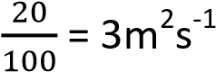
Charge carried per second = charge density x width
= 1.5 x 10⁻⁴ x 3
= 4.5 x 10⁻⁴Cs⁻¹
But rate of flow charge is current
Maximum stead current, I_{max} = 4.5 x 10⁻⁴Cs⁻¹ = -4
4.5 x 10 A
- From ohm’s law
V_{max} = I_{MAX} x R
= 4.5 x 10⁻⁴ x 6.0 x 10⁹
= 2.7 x 10⁶V
- Power output = 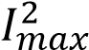 R = (4.5 x 10⁻⁴)² x 6.0 x 10⁹ = 1.215kW
Example 8.
A large van der Graff generator has a top terminal in the form of a sphere of diameter 3.5m. When the terminal is at the operating potential of 3.5 x 10⁶V, what is
- The stored charge
- The energy stored
- The electric field intensity of the surface of the sphere.
Solution
- Potential, V= 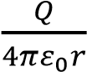
⇨ Q = 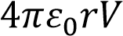
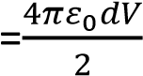
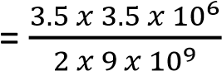
= 6.0806 x 10⁻⁴C
- Energy stored = 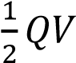
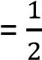x 6.0806 x 10⁻⁴ x 3.5 x 10⁶
= 1191J
- E = 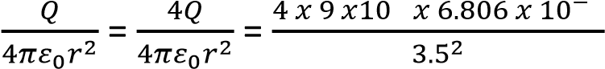 = 2.0 x 10⁶ NC⁻¹

Force between two point charges
Consider two electrically charged bodies at a separation r which is much larger than the dimension of the bodies. The bodies at such a separation behave like point charges.
- The electrostatic force, F, between two pints charges Q₁ and Q₂ is directly proportional to the product of the magnitude of the charge.
  - 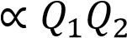
- It is inversely proportional to the square of the distance between the two equation
  - 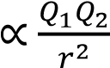
F 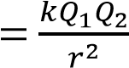
Where k is a constant of proportionality k = 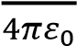 is called the permittivity of the medium.
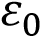 = permittivity of free space (vacuum) = 8.855 x 10⁻¹²Fm⁻¹. The permittivity of air = 1.005 x permittivity of free space.
F = 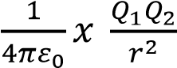
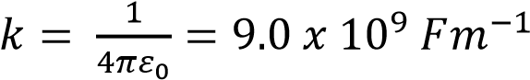

Permittivity of a medium
Permittivity (ϵ\epsilon) is the measure of a medium’s ability to store electrical energy in an electric field.
Permittivity of a medium is a fundamental concept in electrostatics and electromagnetism. It describes how much a material allows electric field lines to pass through it, or in other words, how easily the medium can be polarized by an electric field.

Coulomb’s Law
The force between any two point charges is directly proportional to the magnitude of the product of the charges and inversely proportional to the square of the distance between them.

Example 9
Calculate the value of two equal charges if they repel each other with a force of 0.1N when placed 50cm apart in the vacuum. What would be the size of the charge if they were situated in an insulating liquid whose permittivity was ten times that of the vacuum?
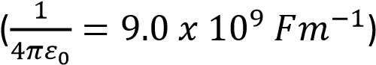

Solution
- From F = 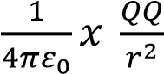
0.1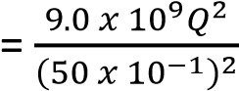
Q =
√

(

)

= 1.667 x 10⁻⁶C
- Permittivity of the insulating liquid = 10ε₀
F = 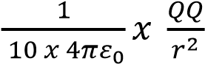
0.1 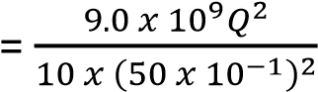
Q =
√

(

)

= 5.27 x 10⁻⁶C
Relative permittivity ε_{r} is the ratio of the permittivity of any medium to the permittivity of free space
Subunits
10⁻³ - mill (m)
10⁻⁶ – micro(μ)
10⁻⁹ – nano (n) 10⁻¹² – pico (p)
10³ – kilo (k)
10⁶ – Mega (M)
10⁹ – Giga (G)

Example 10
Find the force between two point charges of +4μC and -3μC placed at a distance of 10cm apart in air.
F = 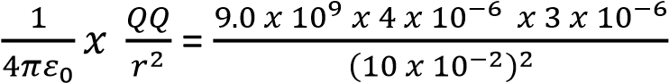 = 10.0N (attraction)

Example 11
Four charges are placed at the corner of a square ABCD as shown below.
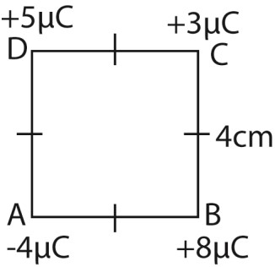
Find the resultant force on the charge at C
Solution
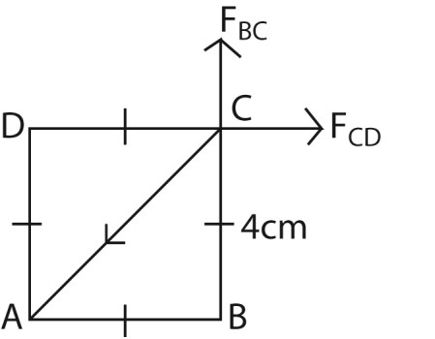
From F = 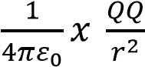
Force, F_{BC}, at C due to charge at B
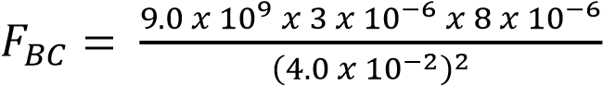= 135N Force, F_{CD}, at C due to charge at D
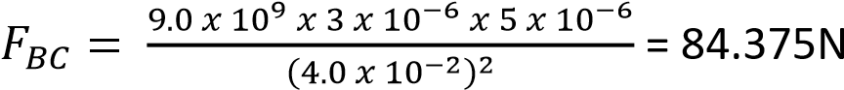

Distance AC
(AC)² = (AB)² + (BC)²
AC = 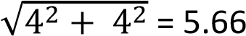
Force, F_{CA}, at C due to charge at A
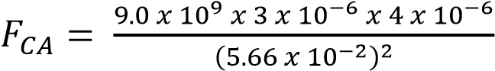= 33.75N
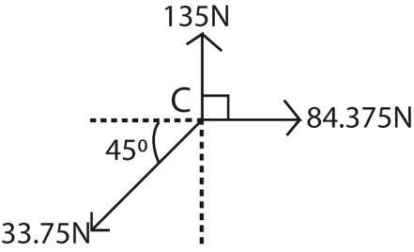
Resolving vertically
F_{y} = 135 – 33.75sin45 = 111.135N
Resolving horizontally
F_{x} = 84.375 – 33.75cos 45 = 60.51N
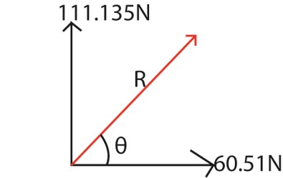
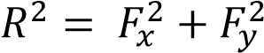
= 111.135² + 60.51² R = 126.52N
tanθ = 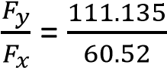
θ = 61.4⁰
Hence the resultant force at C = 126.54N at 61.4⁰ to the horizontal Example 12
Find the resultant force at A
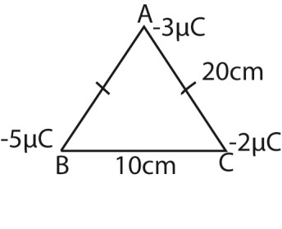
Solution
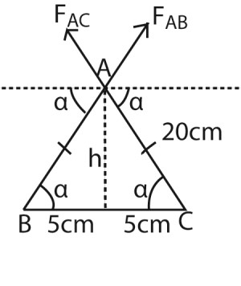
h²+ 5² = 20² h = 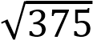 = 19.36cm Cos α =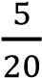; sin α = 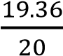
Force on A due to charge at B
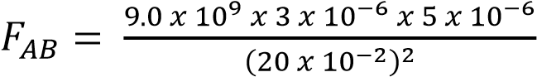= 3.375N
Force on A due to charge at C
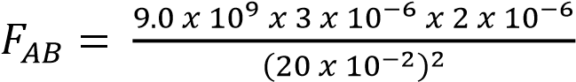= 1.35N
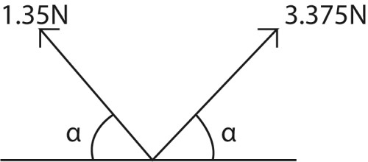
Resolving vertically
F_{y} = 1.35sinα + 3.375sin α
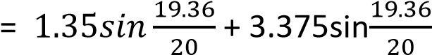 = 4.575N
Resolving horizontally
F_{x} = 1.35cosα + 3.375cos α
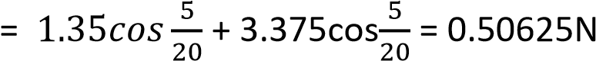
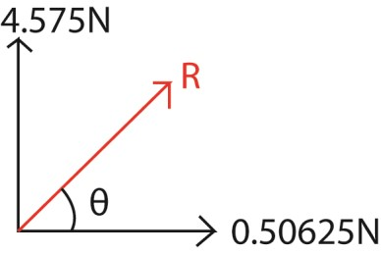
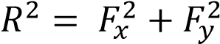
0.50625² + 4.575² R = 4.603N
tan θ = 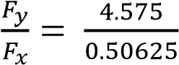
θ = 83.7⁰
Hence the resultant force at C is 4.603N at 83.7⁰ to the horizontal

Example 13
Find the force at O
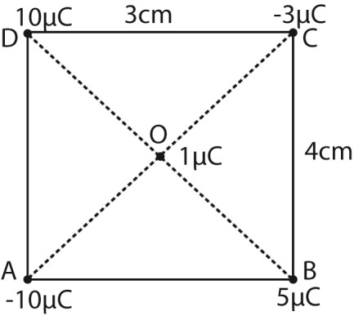

Solution
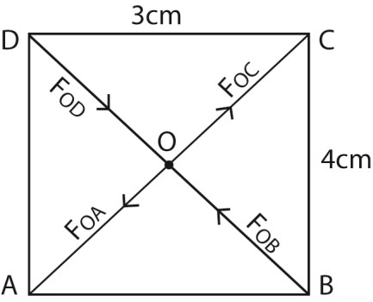
Force on O due to charge at A
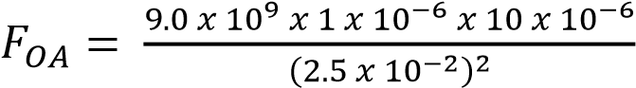= 144N
Force on O due to charge at B
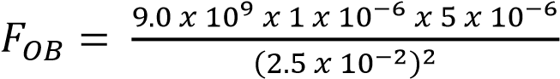= 72N
Force on O due to charge at C
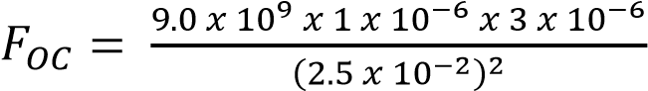= 43.2N
Force on O due to charge at D
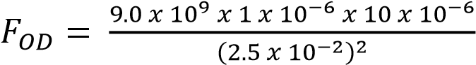= 144N
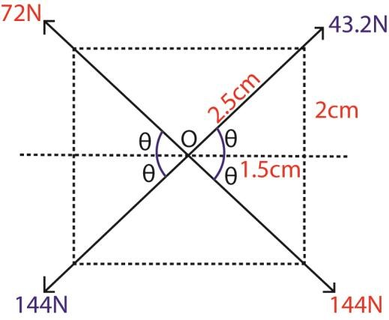
sin θ = 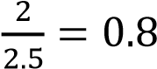, cosθ = 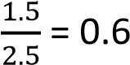
Resolving vertically;
F_{y} = 72sinθ + 43.2sinθ -144sinθ-144sinθ
= 172.8 sinθ
= 172.8 x 0.8
= 138.24N
Fx = 43.2cosθ + 144cosθ – 144cosθ – 72cosθ
= -28.8cosθ
= -28.8 x 0.6
= -17.2N
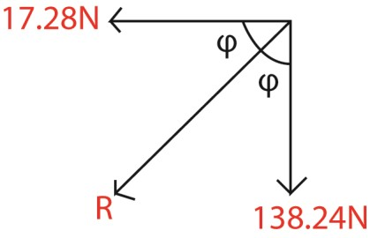
R² = 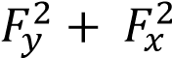 =17.28² + 138.24²
R = 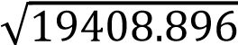 = 139.3N tanφ = 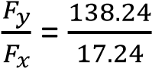
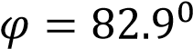
Hence the resultant force at O is 139.3N at 82.9⁰ to horizontal

Example 14
Find the resultant force on B
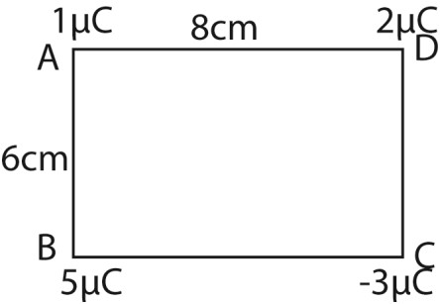
Force B due to charge at D
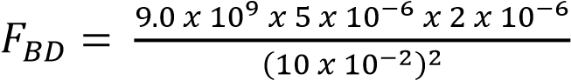= 9N
Force B due to charge at C
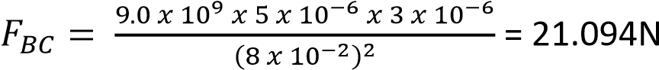
Force B due to charge at A
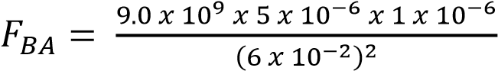= 12.5N
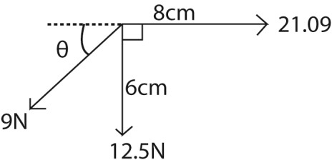
Sin θ =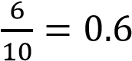 , cosθ =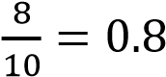
Resolving vertically
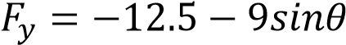 = -12.5 – 9 x 0.7 = 17.9N
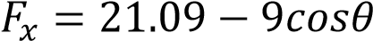 = 21.09- 9 x0.8 = 13.89N
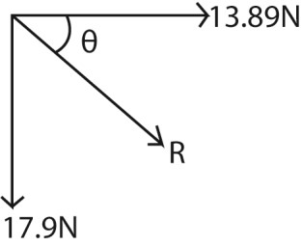
R² = 13.89² + 17.9²
R =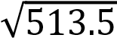 = 22.7N tan θ = 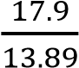
θ = 52.1⁰
The resultant force at C is 22.7N at 52.1⁰ to the horizontal

Example 15
Find the resultant force on B
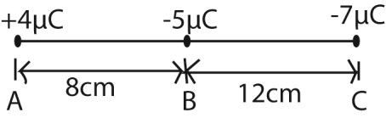
Solution
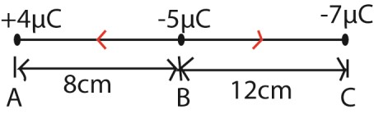
Force on B due to charge A
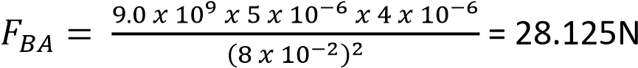
Force on B due to charge C
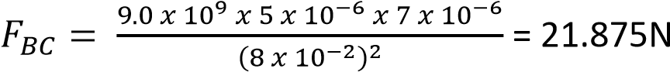
Resultant force, R = 28.125 – 21.875 = 6.25N towards A

Electric field
Al electric field is a region around an electric charge where an electric force is experienced. This can be mapped out by electrostatic lines of force.
Lines of force or electric field lines show the direction and strength of the electric field at different points in space. They are drawn such that the tangent at any point gives the direction of the electric field vector at that point. A collection of lines of force is called an electric flux. Properties of Electric Field Lines
- Start and End:
  - They begin on positive charges and end on negative charges.
  - For an isolated positive charge, lines radiate outward; for a negative charge, they converge inward.
- Density of Lines:
  - The closer the lines, the stronger the field.
  - Sparse lines indicate weaker fields.
- Never Intersect:
  - Two field lines can’t cross, because the electric field at a point has only one direction.
- Perpendicular to Conductors:
  - At the surface of a charged conductor, field lines are always drawn perpendicular to the surface.
Electric field pattern
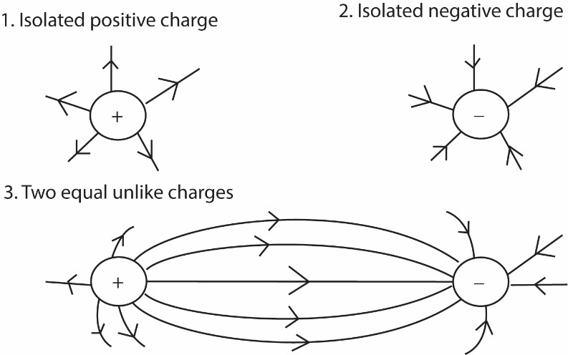

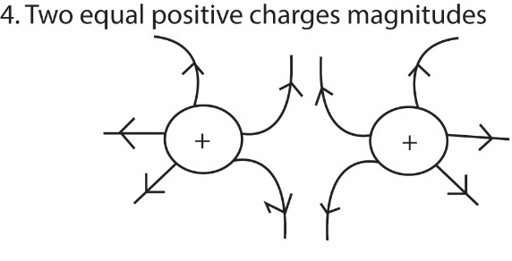
x

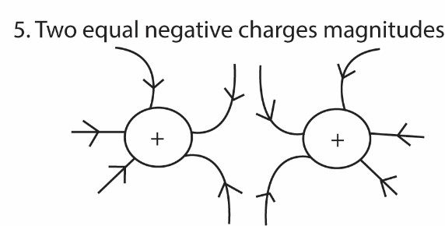
-

-

x

6. Two equal oppositely charged parallel plates
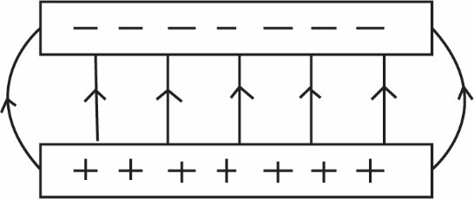

Definition
- A neutral point, x, is a point where the resultant electric field intensity is zero.

The force exerted on the charged body in an electric field depends on the charge on the body and the intensity or strength of the field.

- Electric field intensity or strength is defined as the force exerted on a positive charge of 1 coulomb placed at a point in electric field

Therefore, electric field intensity, E is a vector quantity
E =
The S.I. unit of E is NC⁻¹

Consider the diagram below
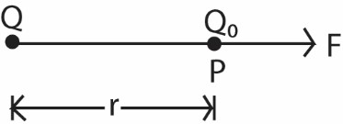

Placing a small charge Q₀ at point P, in an electric field, the force at P due to Q is given by
F= 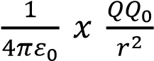

Electric field intensity, E, at P = 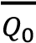
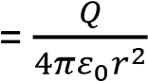
Therefore electric field intensity, E, at a point due to charge Q is given by
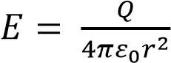
Note E is directed away from a positive charge and directed towards the negative charge.

Example 10
Find the electric field intensity at P
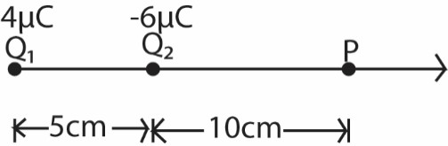

Solution
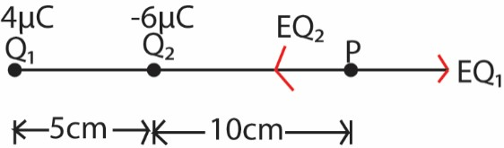

Solution
E at P due to Q₁
EQ 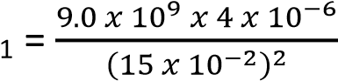= 16 x 10⁵ NC⁻¹( )
E at P due to Q₂
EQ 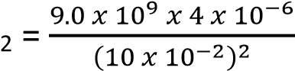= 54 x 10⁵ NC⁻¹( )
EP = EQ₁- EQ₂
= (16 x10⁵ – 54 x 10⁵) NC⁻¹
=38 x 10⁵ NC⁻¹( )

Example 11
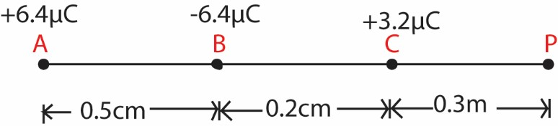
Three point charges of +6.4μC, -6.4μC and +3.2μC are arranged in line at points A, B, and C respectively as shown in diagram above. Find the electric field intensity at P.

Solution
E at P due to A (+6.4μC)
E_{AP} 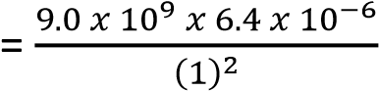= 5.76 x 10⁴NC⁻¹( ) (repulsive)
E at P due to A (- 6.4μC)
E_{BP} 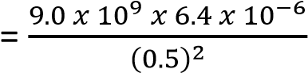= 2.304 x 10⁵NC⁻¹( ) (attractive)
E at P due to A (+3.2μC)
E_{CP} 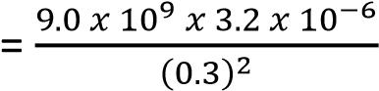= 3.2 x 10⁵NC⁻¹( ) (repulsive)
EP = EAP - EBP + ECP
4 5 5 -1
= (5.76 x 10 -2.30 x 10 + 3.2 x 10 ) NC 5 -1
= 1.472x 0 NC ( )
Hence the electric field at P is 1.472x 0⁵NC⁻¹ to the right

Example 12
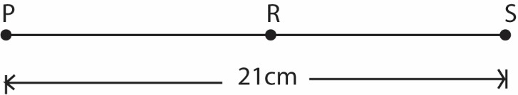
Two point Charges P and S of -17.6μC and -9.0μC respectively are placed in a vacuum at a distance of 21cm apart. When a 3rd charge R is placed midway between P and S as shown in figure above, then, the net force at S is zero
- Determine the charge on R
- Calculate the electric potential at position R.
- Sketch the electric field lines corresponding to charge distribution
Solution
Let the charge on R be Q
From
F= 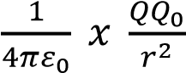 where 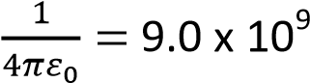
Force on S due to R
FSR 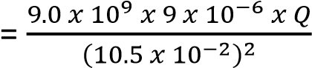
Force on S due to P
FSP 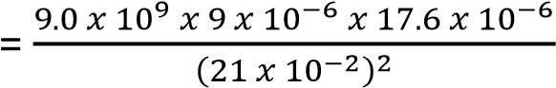
Resultant force on S = F_{SP} – F_{SR} = 0
⇨ F_{SP} = F_{SR}

Q = 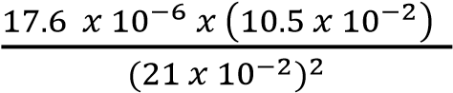 = 4.4 x 10⁻⁶C
Hence the charge on R = +4.4x 10⁻⁶C
(ii) Electric field potential, at a distance r fro charge D is given by
V = 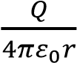
Electric potential at R due to S
V_{RS} 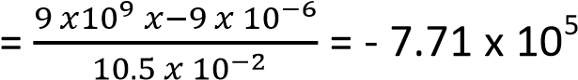V
Electric potential at R due to P
V_{RP} 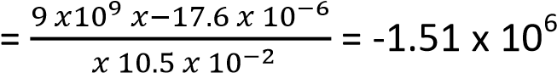V
V_{R} = V_{RS} + V_{RP}
= - 7.71 x 10⁵ +-1.51 x 10⁶
= -2.28 x 10⁶V

Example 13
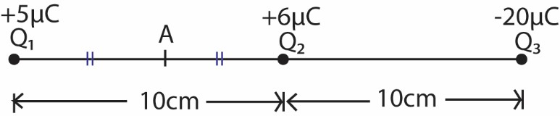
Calculate the electric field intensity midway between Q1 and Q2
Solution
From E = 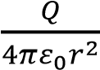 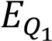 at A due to Q 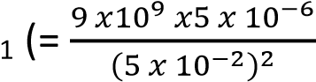= 1.8 x 10⁷NC⁻¹( ) 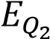 at A due to Q 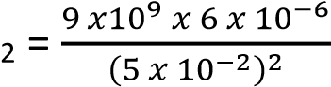= 2.16 x 10⁷NC⁻¹( ) 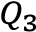at A due to Q 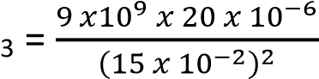= 8.0 x 10⁶NC⁻¹( ) E_{A} = 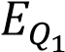- 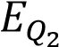 + 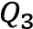
= 1.8 x 10⁷ - 2.16 x 10⁷ + 8.0 x 10⁶
= 4.4 x 10⁶NC⁻¹( )

Example 14
Charges Q₁ and Q₂ of -5μC and +2.0μC respectively are placed at two opposite corners of a rectangle of sides 5.0cm and 10.0cm as shown below
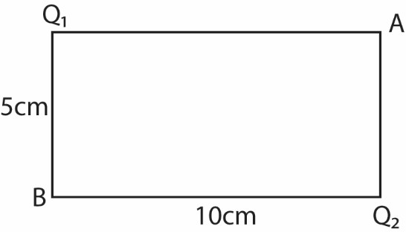
Calculate the electric field at A

Solution
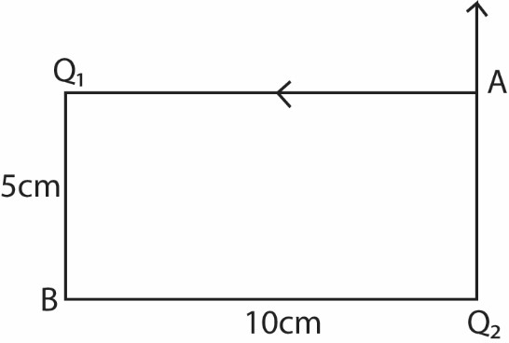
From 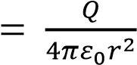 , and 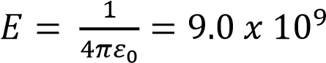
E at A due to Q1
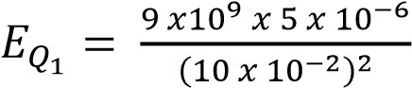= 4.5 x 10⁶NC⁻¹
E at A due to Q₂
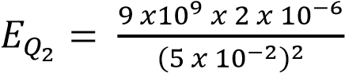= 7.2 x 10⁶NC⁻¹
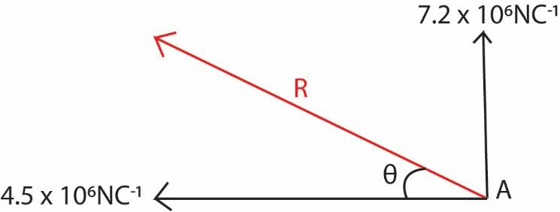
R² = (4.5 x 10⁶)² + (7.2 x 10⁶)² R = 8.49 x 10⁶ NC⁻¹
tan θ = 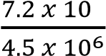
θ = 58⁰
Hence the electric filed intensity at A is 8.49 x 10⁶ NC⁻¹ at 58⁰ to the horizontal Example 15
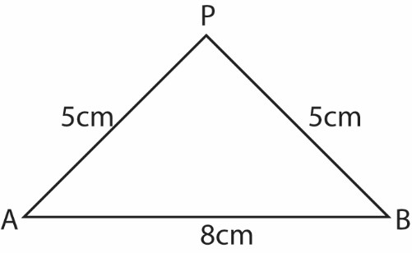
Two point charges A and B of +10μC and +0.05μC are separated by a distance of 8cm along the horizontal as shown above. Find the electric field intensity at P. Solution
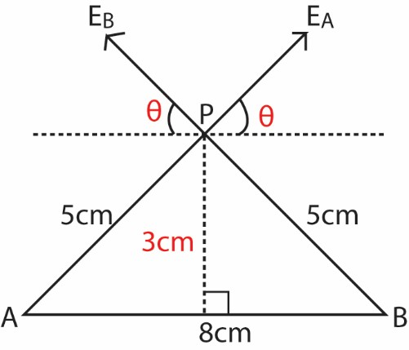
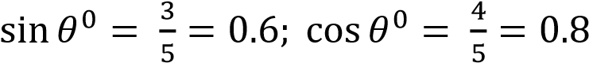
E at P due to charge at A
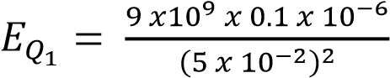= 3.6 x 10⁵NC⁻¹
E at A due to charge at B
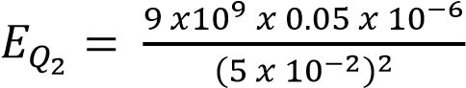= 1.8 x 10⁵NC⁻¹
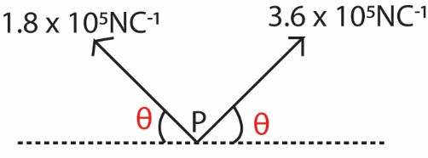
Resolving vertically
E_{y} = 3.6 x 10⁵sin θ + 1.8 x 10⁵sin θ
= 5.4 x 10⁵sinθ
= 5.4 x 0.6 = 3.24 x 10⁵ NC⁻¹
Resolving horizontally
E_{x} = 3.6 x 10⁵cos θ - 1.8 x 10⁵cos θ
= 1.8 x 10⁵ x 0.8
= 1.44 x 10⁵ NC⁻¹
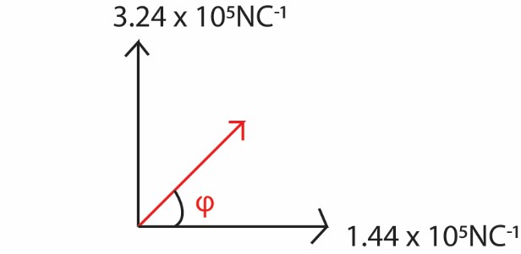
R² = (1.44 x 10⁵)² + (3.24 x 10⁵)² R = 3.55 x 10⁵ NC⁻¹
tan θ = 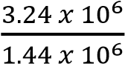
θ = 66⁰
Hence the electric field intensity at A is 3.55 x 10⁵NC⁻¹ at 66⁰ to the horizontal
Example 16
Find the electric field intensity at P.
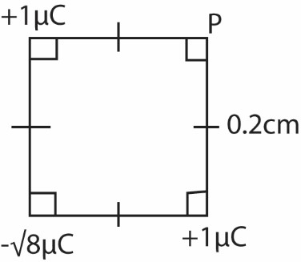

Solution
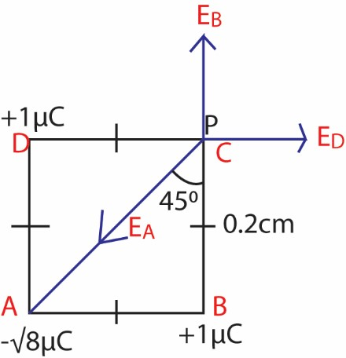
AP² = 0.2² + 0.2²
AP = x 10⁻¹ m
√

E at P due to charge at A
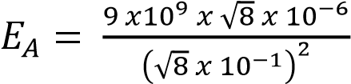= 3.18 x 10⁵NC⁻¹
E at P due to charge at B
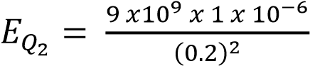= 2.25 x 10⁵NC⁻¹ E at P due to charge at D
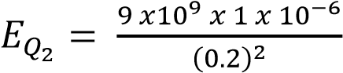= 2.25 x 10⁵NC⁻¹
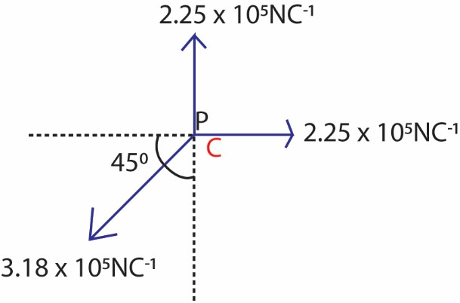
Resolving vertically
E_{y} = 2.25 x 10⁵ – 3.18 x 10⁵sin45⁰ = 1.4 x 10²NC⁻¹ Resolving horizontally
E_{x} = 2.25 x 10⁵ – 3.18 x 10⁵sin45⁰ = 1.4 x 10²NC⁻¹
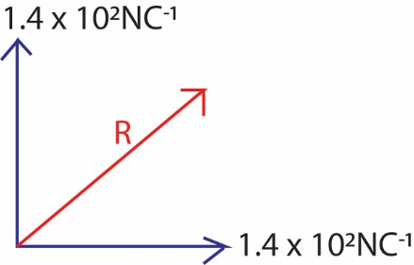
R² = (1.4 x 10²)² + (1.4 x 10²)² R = 1.98 x 10² NC⁻¹
tan θ = 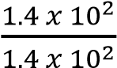
θ = 45⁰
Hence the electric field intensity at P is 1.98 x 10² NC⁻¹ at 450 to horizontal

Example 17
Two point charges are separated by 10cm in air as shown
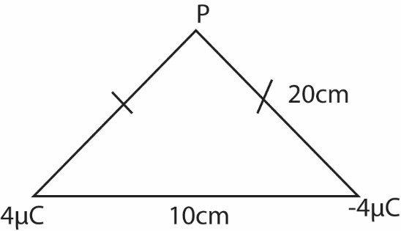
Find the electric field intensity at P.

Solution
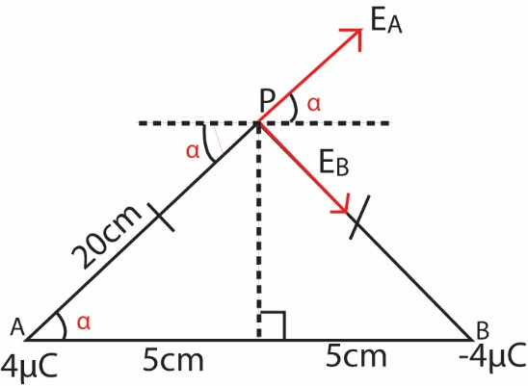
E at P due to charge at A
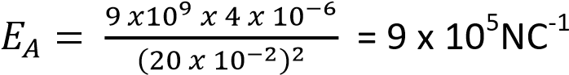
E at P due to charge at B
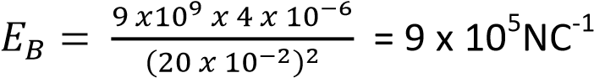

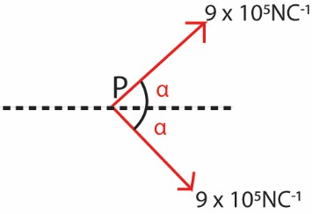
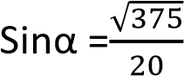; cos α = 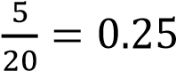
Resolving vertically
E_{y} = 9 x 10⁵NC⁻¹sinα - 9 x 10⁵NC⁻¹sinα = 0
Resolving horizontally
E_{x} = 9 x 10⁵NC⁻¹cosα + 9 x 10⁵NC⁻¹cosα
= 18 x 10⁵ x .25 = 4.5 x 10⁵NC⁻¹
R² = (4.5 x 10⁵)² + (0)² R = 4.5 x 10⁵ NC⁻¹
tan θ = 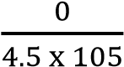
θ = 0⁰
Hence the electric field intensity at P is 4.5 x 10⁵ NC⁻¹ at 0⁰ to the horizontal

Example 18
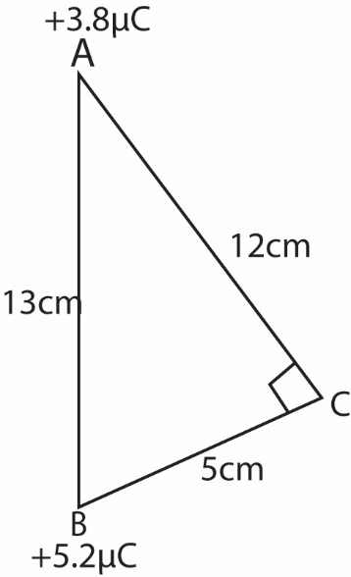
Two points +3.8μC and -5.2μC are place in air at points A and B as shown. Determine the electric field intensity at C

Solution
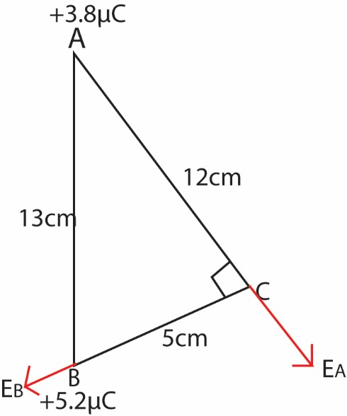
E at C due to charge at A
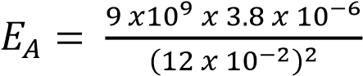= 2.38 x 10⁵NC⁻¹ E at C due to charge at B
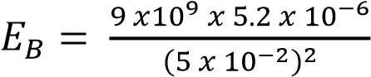= 1.87 x 10⁷NC⁻¹
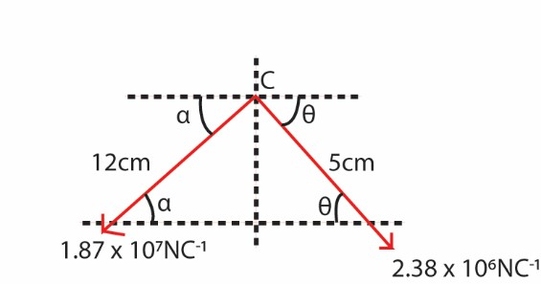

tan α =

; α = 22.6

tan θ =

; θ =67.4

Resolving vertically;
E_{y} = 1.87 x 10⁷sin 22.6 + 2.38 x 10⁶sin 67.4
= 9.39 x 10⁶NC⁻¹
Resolving horizontally
E_{x} = 2.38 x 10⁶cos67.4 - 1.87 x 10⁷cos 22.6
= 9.16 x 106 – 1.73x107
= -1.64 x 10⁷NC⁻¹
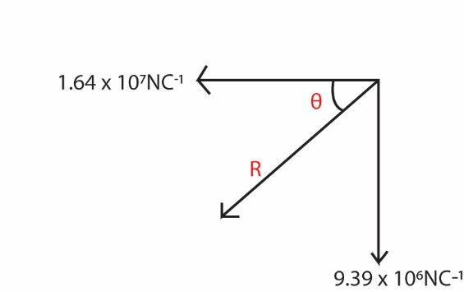
R² = (1.64 x 10⁷)² + (9.39 x 10⁶)² R = 1.89 x 10⁷NC⁻¹
tan θ = 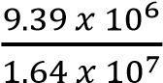
θ = 29.79⁰
Hence the electric field intensity at C is 1.89 x 10⁷NC⁻¹ acting at 29.7⁰ to horizontal.

Example 19
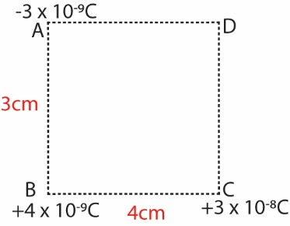
Three charges of -3 x 10⁻⁹C, +4 x 10⁻⁹C and +3 x 10⁻⁹C are placed at vertices A, B, C respectively of a rectangle ABCD of side 3cm x 4cm as shown. Calculate the resultant electric field intensity at D

Solution
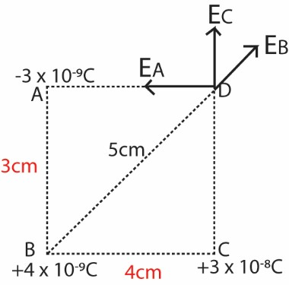
E at D due to charge at A
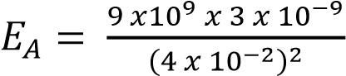= 1.69 x 10⁴NC⁻¹ E at D due to charge at B
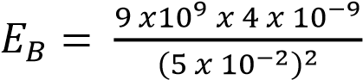= 1.44 x 10⁴NC⁻¹
E at D due to charge at C
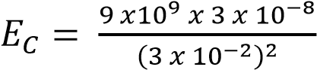= 3.0 x 10⁵NC⁻¹
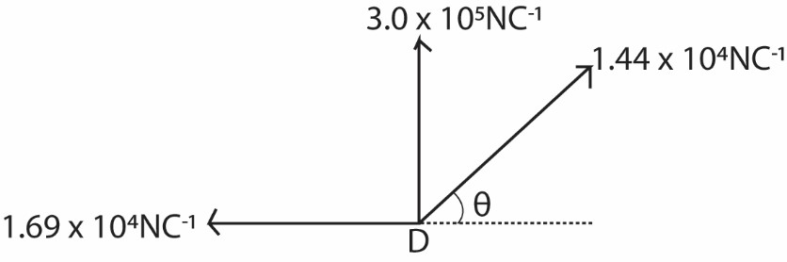
sin θ = 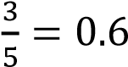; cos θ = 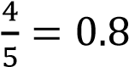

Resolving vertically;
E_{y} = 3.0 x 10⁵ + 1.44 x 10⁴sin θ
= 3.0864 x 10⁵ NC⁻¹
Resolving horizontally
E_{x} = -1.69 x 10⁴+ 1.44 x 10⁴cos θ
= -1.69 x 10⁴ + 1.44 x 10⁴ x 0.8
= -5380NC⁻¹
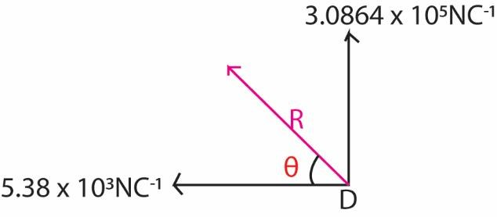
R² = (3.0864 x 10⁵)² + (5380)² R = 3.09 x 10⁵NC⁻¹
tan θ = 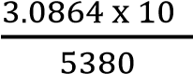
θ = 89⁰
Hence electric field intensity at D = 3.09 x 10⁵NC⁻¹ at 89⁰ to horizontal
Field strength and charge density of a hollow sphere
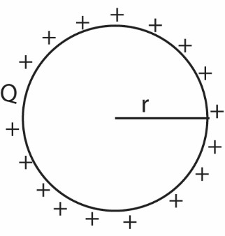
Let Q be the charge on the surface of the sphere and δ be the charge density (charge per unit area)
Charge on the sphere = charge density x area
Q = δ x 4πr²
Now E = 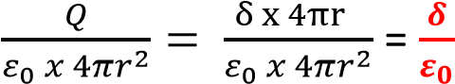

Flux from a point charge
The density of lines of force increase near the charge where the intensity is high. The electric field intensity; E, at a point can be represented by the number of lines per unit area through the perpendicular unit area through the perpendicular surface to the line of force at a point. The product E x area is called the electric flux through a perpendicular area to a line of force.
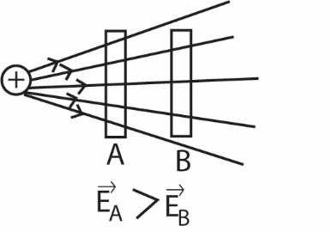
Flux across a sphere
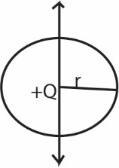
For a sphere of radius, r, drawn concentric with positive +Q in free space, then
Electric flux, Φ = 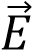 x area
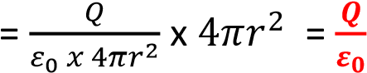

Electric field intensity of a hollow conductor
Inside a charged hollow sphere, there is no charge so
Q = 0 and I = 0, hence E = 0
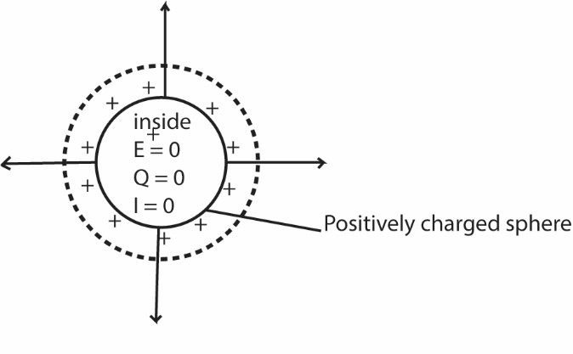
Therefore, at all points inside the sphere, the field strength is zero. There is no work done when a charge is moved between any two points inside a sphere.
A graph showing electric intensity of a hollow conductor of radius, a

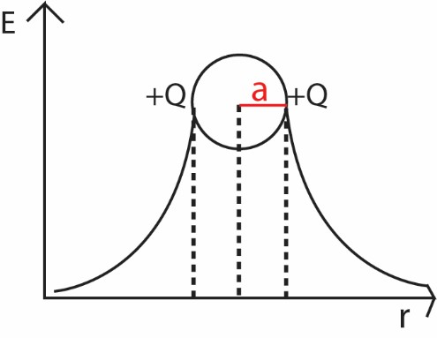
Or
A graph showing electric intensity from the center of a hollow conductor of radius, a

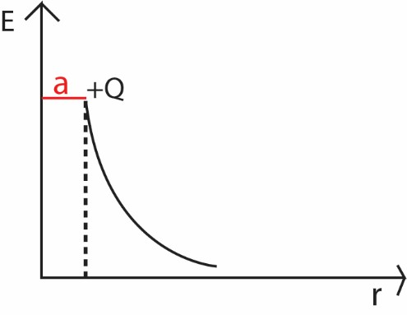

Electrode potential
Electric potential, the amount of work needed to move a unit charge from a reference point to a specific point against an electric field without producing an acceleration.

Consider a charge Q₀ moved distance δr against an electric field of charge Q from point B to point A as shown below
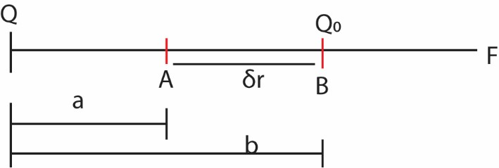

Work done = force x distance δW = Fδr 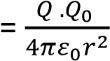 δr Total work done, W is given by W =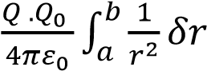
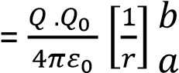
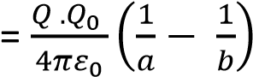
Note: the zero of potential is at an infinity distance from an electric charge.

Electric potential at a point

Electric potential at a point is the work done in moving a positive charge of one coulomb from infinity to that point in an electric field against electrostatic force.

Potential is a property of a point in a field and therefore it is a scalar quantity since it defines work done or potential per unit charge. It is measured in volts.

Consider charge +1C in the diagram below
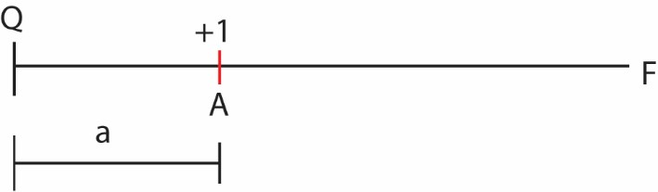

The electric field at A = 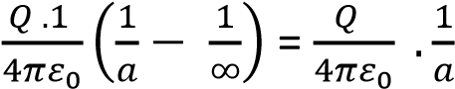

Example 20
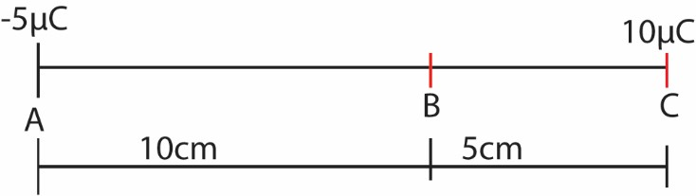
Find electric field at B
Electric potential at B due to charge at A
Solution
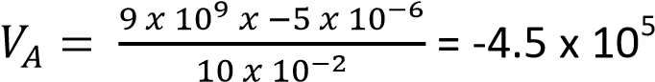V
Electric potential at B due to charge at C
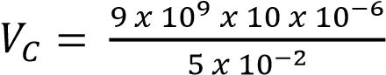= 1.8 x 10⁶V
Potential at B = 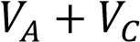
= -4.5 x 10⁵V + 1.8 x 10⁶V
= 1.35 x 10⁶V

Example 21
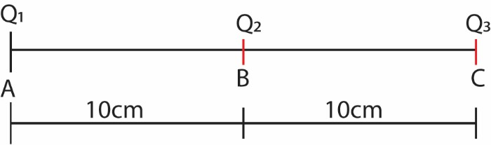
Three point charges Q₁, Q₂ and Q₃ of magnitude +5μC, +6μC and -20μC respectively are situated along a straight line as shown in figure above. Calculate the electric field
- Intensity mid-way between Q₁ and Q₂
- Potential midway between Q₁ and Q₂
Solution
Let M be midpoint between Q₁ and Q₂
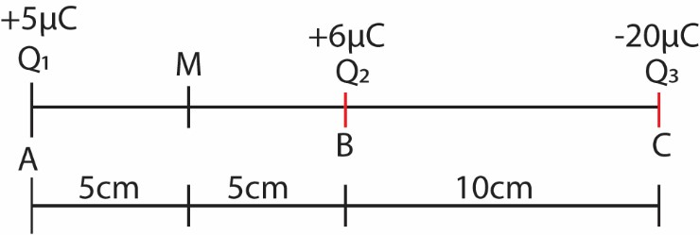
- E at M due to Q₁
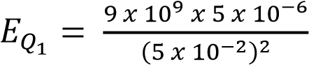= 1.8 x 10⁷NC⁻¹ (→)
E at M due to Q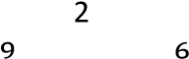
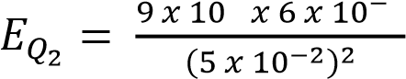= 2.16 x 10⁷NC⁻¹ (←)
E at M due to Q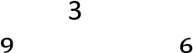
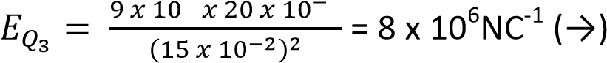

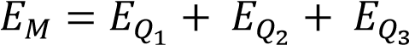
= 1.8 x 10⁷ - 2.16 x 10⁷ + 8 x 10⁶ NC⁻¹ = 4.40 x 10⁶ NC⁻¹

Therefore the electric field intensity midway between Q₁ and Q₂ is 4.40 x 10⁶ NC⁻
1 towards right.
- Electric potential at M midway between Q₁ and Q₂

Electric potential at M due to charge Q₁
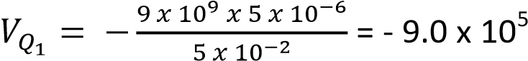V

Electric potential at M due to charge Q₂

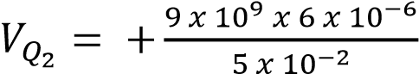= 1.08 x 10⁶V

Electric potential at M due to charge Q₃

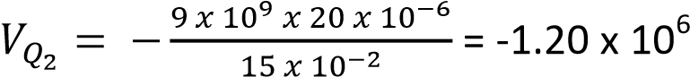V

V_{M} = 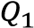+ 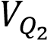+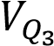
= - 9.0 x 10⁵ + 1.08 x 10⁶ +-1.20 x 10⁶
= 1.02 x 10⁶V

Example 22
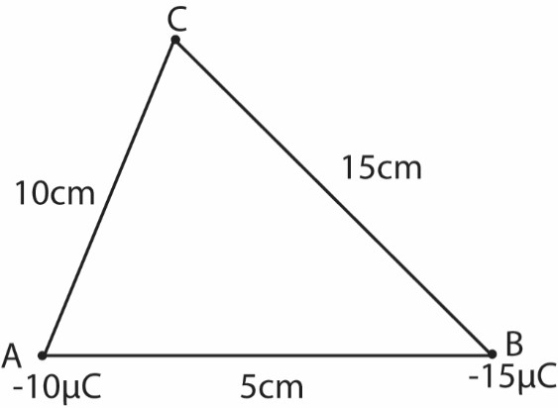
Two point charge A and B are situated along a straight line as shown in figure above. Calculate the electric potential at C.
Solution
Electric potential at C due to A
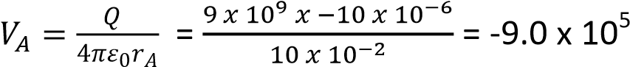V Electric potential at C due to B
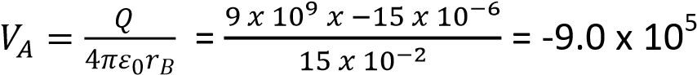V
Potential at C, 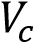 = 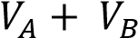 = -9.0 x 10⁵ +-9.0 x 10⁵ = -1.8.0 x 10⁶V

Potential due to a conducting sphere

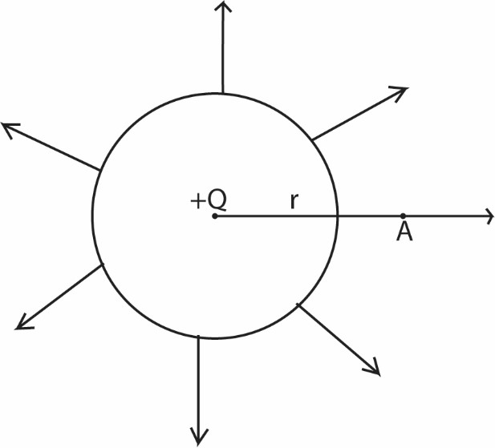
Note that potential at the surface and any point inside a sphere of radius r
0

=

𝑉
𝐴

𝑄

𝜋
𝜀

𝑟

Where r is the distance of A from center of sphere

Potential due to a point charge
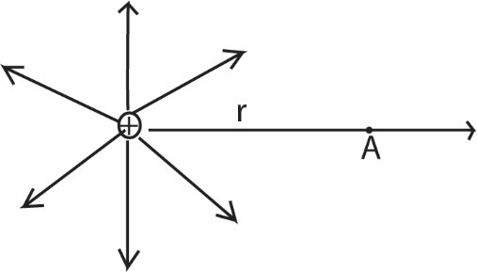
𝑉
𝐴

𝑄

𝜋
𝜀

𝑟

Where r is t
he distance of A from center of charge

Variation of potential with distance from the center of hollow conductor.
The potential inside a hollow sphere is constant equal to the potential on the surface of the sphere. From the surface of the sphere the potential varies with the inverse of the distance, r, of a point from the center of the sphere.
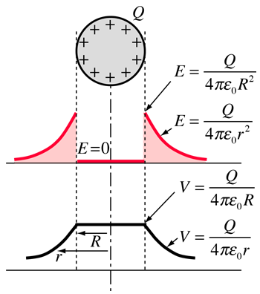
Drawn from the center
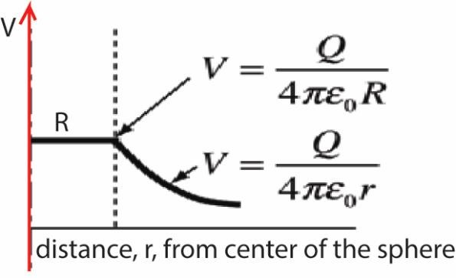
Potential difference (p.d)
P.d between two points is the work done per unit charge (or the energy per unit charge) passing from one point to another

Example 23
Consider two points A and B at a distance of 15cm and 20cm respectively from a point charge of 6.0μC as shown below
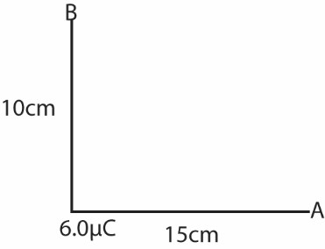
- Find electric potential difference between A and B
- Calculate the energy required to bring a charge 1μV from infinity to point A
- What is the significance of the sign of the energy above
Solution
- Potential at A
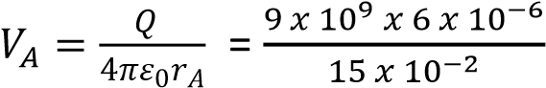= 3.60 x 10⁵V
Potential at B
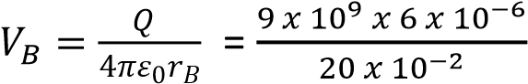= 2.70 x 10⁵V
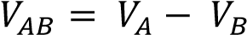
3.60 x 10⁵ - 2.70 x 10⁵V = 9.0 x10⁴V
- Work done = Q x V_{A}
= 1.0 x 10⁻⁶ x 3.60 x 10⁵ = 0.36J
- Positive energy implies that work was done by external force on the charge to bring it from infinity of A

Example 24
A figure below shows charges Q₁, Q₂, Q₃ and Q₄ of -1, +2, -3, and +4μC arranged in a straight line as shown
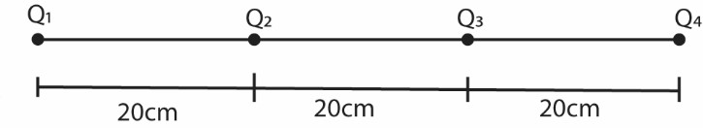
- Calculate the potential energy of Q₂
- What is the significance of the sign of the potential energy.
Solution
Electric potential at Q₂ due to Q₃
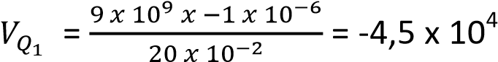V

Electric potential at Q₂ due to Q₃
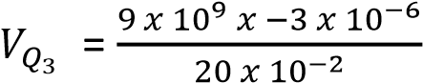= 1.35 x 10⁵V
Electric potential at Q₂ due to Q₄
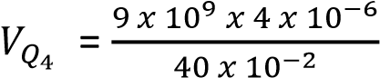= 9.0 x 10⁴V

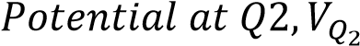 = 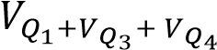
= -4,5 x 10⁴ + 1.35 x 10⁵ + 9.0 x 10⁴
4
= -9.0 x 10 V
Potential energy at Q₂ = Q₂ x 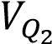 = 2.0 x 10⁻⁶ x -9.0 x 10⁴ = -0.18J
(ii) Negative sign on energy shows that work is done by electric field on the charge from infinity to that point.

TOPIC 5/6: CAPACITORS
Competency: The learner models capacitors for use in electronic devices.

Definition
A capacitor also known as a condenser, is a device which is used to store electric charge.
A capacitor consists of two metal plates separated by an insulator called dielectric usually air or oil.
A dielectric is a nonconductor of electric charge in which an applied electric field causes a displacement of charge but not flow of charge. Electrons within the atom of a dielectric are on average, displaced by an electric field with respect to the nucleus, giving rise to a dipole that has an electric moment in the direction of the field. In this case, we say the molecules have been polarized.
A dielectric does not only keep the two metal plates apart, but also increase the capacitance of a capacitor.

Charging and discharging a capacitor
A capacitor is charged when a battery or e.m.f source is connected across it.


A

A

B

Direction o
f electron flowing
during charging

On connecting the battery across the capacitor, electrons are drawn from metal plate A by the positive terminal of the battery, whilst at the same time they are deposited on metal B by the action of negative terminal. Thus there is a momentary flow of current as indicated by the ammeter.
After some time, the number of electrons deposited on plate B keeps on reducing due to electrostatic force of repulsion between already deposited electrons and those that are flowing to plate B. At one point, no further deposition occurs. At this point, the potentials at A and B become equal to that across the battery and oppositely directed to it. The current drops to zero. The capacitor is said to be fully charged.
The charging process leaves A with a positive charge and B with an equal but negative charge.
When the battery is disconnected and the plates are joined by a wire, electrons flow from plate B to A until the positive charge on A is completely neutralized. A current thus flows for a time in the wire and at the end of time, the charges on the plates become zero. The capacitor is said to be discharged.
The graph below shows how the currents vary when the capacitor is being charged and when

being discharged.

Charging

Discharging

Time

+

-

0

Capacitance
Capacitance of a capacitor is the ratio of the magnitude of charge on either plate of the capacitor to the potential difference between the plates.
Or
It is charge required to cause a potential difference of 1V between plates of the capacitor C =
where C is capacitance, Q is the magnitude of charge on either plate and V is the potential difference between the plates.
The units of C is Coulomb per volt (CV⁻¹) or Farad (F). The farad is a very large unit, 1μF(micro) = 10⁻⁶F , nF (nanofarad) = 10⁻⁹F,1mF (picofarad) = 10⁻¹²F.
The Farad
The farad is the capacitance of a capacitor such that 1C of charge is stored when the p.d of 1V is applied.
i.e. 1F = CV⁻¹

Comparison of capacitances or measurement of capacitance of a capacitor



C
1

K
1

K
2

G

Large capacitances, of order micro-farads, can be compared with the aid of a ballistic galvanometer. The circuit is shown above. The capacitor of capacitance C1 is charged by a battery of e.m.f V, and then discharged through ballistic galvanometer G. The corresponding deflection, θ1 is noted.
The capacitor is now replaced by another capacitor C2, charged again by the battery, and the new deflection θ2 is noted when the capacitor is discharged.
Now
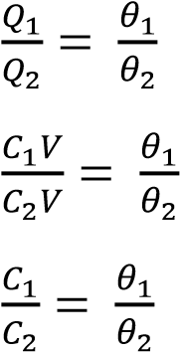
If C₂ is a standard capacitor, whose capacitance is known, then the capacitance C₁ can be found

Factors that affect capacitance of a capacitor
- The plate separation
- The area of overlap (or area common) between the plates
- The dielectric or medium between the plates, and most specifically the permittivity of the dielectric material.

Experiments show the following
- C 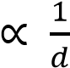
- C 
- C
Experiment to verify that C = εA/d for parallel plate capacitor.

(a) To show that C A
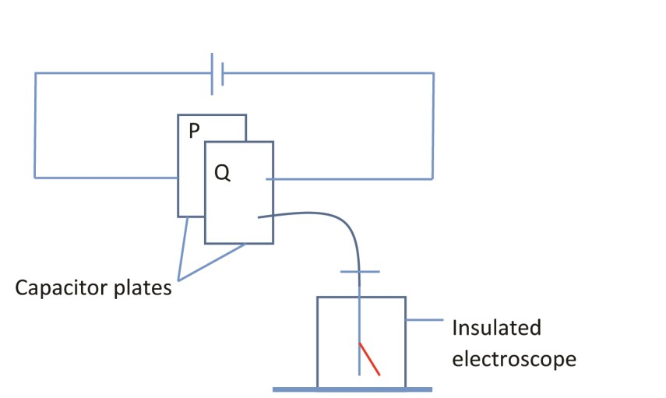

A p.d is set across the capacitor plates P and Q, by connecting a cell across it. One plate Q is connected to the cap of electroscope. With the p.d constant and the plates in the above position with air in between them, the divergence of the leaf of electroscope is noted.

Place P is then slid relative to Q keeping the separation constant, hence reducing the effective area of the plate. The divergence is seen to decrease.

Since divergence is proportional to charge on the plates, which in turn is proportional to the capacitance, C, then, C is reduced.
This shows that C A

(b) To show that C 1/d
The plate P is then slid back and separation between the plates is increased by moving P away from Q. The divergence of the leaf is observed to decrease. Since divergence of the leaf is proportional to charge on the plates, which in turn is proportional to capacitance C, then C is reduced. This shows that C 1/d.

(c) To show that C ε
The position of P and the separation between the two plates are restored. A dielectric is then put in the space between the plates. The divergence of the leaf is seen to increase. Since divergence is proportional to the charge on the plates, which in turn is proportional to capacitance C, then C has increased. This shows that C ε.

Alternative experiments


P
1

P
2

P₁ and P₂ are capacitor plates initially with air between then. P₂ is earthed while P₁ is charged and connected to the cap of electroscope. Note that for this arrangement, the charges remain constant while the p.d between the plates varies.

(a) To show that C A
Plate P₂ is displaced sideways relative to P₁ to reduce the effective area A of the plates. The divergence of the leaf increase. This shows that the p.d. between the plates has increased since divergence is proportional to p.d between the plates. From C = Q/V, since Q is constant, c decreases. Thus C A.

(d) To show that C 1/d
Plate P₂ is restored to its initial position, and it is then moved closer to P₁. The divergence of the leaf is seen to decrease. This shows the p.d between the plates has decreased. From C = Q/V, this show that C has increased. Thus C increases as d decreases. Thus C 1/d

(e) To show that C ε
The position of P2 is again restored and dielectric (an insulator) like paper is inserted between the plates. The divergence of the leaf decreases. This shows that V has decreased. From C = Q/V, C has increased. Thus C ε.

Experiment to describe the factors affecting capacitance of capacitor using a red switch
(Factors which determine the capacitance of a capacitor using reed switch)


V

G

R

Reed switch

Capacitor

The capacitor is alternatively charged and discharged trough a sensitive light beam galvanometer, G by the reed switch.

- Keeping the separation and the plate area constant, the capacitor is given a charge Q for different p.d. (V).
  - It is found that charge is proportional to V (QV)

- Keeping the p.d V and plate area constant, the deflection θ is measured for different separation, d.
  - Results show that charge is proportional to deflection. C 1/d
- Keeping the p.d V and the separation constant, the deflection θ is measured for different overlapping plate area A. The results show that C A
- Keeping the area, separation of the plates, and p.d constant; the charge is measured with a dielectric constant.
  - The results show that the charge increases, implying that C also increases. Thus C ε.

Capacitance of a parallel plate capacitor

d

d

Consider a parallel-plate capacitor above, where the charge on either plate is Q and the p.d between them is V. the surface density σ is then
Wher A is the area of either plate, and the intensity between the plates, E = 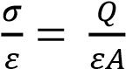
The work done in taking a unit charge from one plate to another = force x distance
= Ed ( d = the distance between the plates)
But the work per unit charge = V, the p.d between the plates.
V = 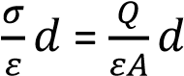
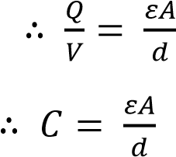
It should be note that the formula for C is approximate, as the field becomes nonuniform at the edges

Capacitance of isolated sphere
An isolated metal sphere acts as a capacitor. The sphere itself is one plare; the earth is the other plate.
Suppose a sphere of radius r meter situated in air is give a charge of Q coulombs. We assume that the charge on a sphere gives rise to potentials on and outside the sphere as if all the charge were concentrated at the center.
Then V = 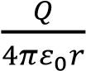
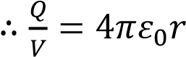
C = 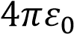

Example 1
Suppose r = 10cm = 0.1m, then
C = 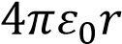 = 4π x 8.85 x 10⁻ ¹² x 0.1= 11 x 10⁻¹²F = 11pF

Capacitance of two concentric spheres


r
1

r
2

+
Q

-
Q

A

B

V

Faraday used two concentric spheres to investigate the dielectric constant of liquids. r₁ and r₂ are the respective radii of the inner and outer spheres as shown above and the outer sphere earthed, with air between them.
Let +Q be the charge on the inner sphere, the induced charge on outer sphere = -Q. The potential of the inner sphere = potential due to +Q + potential due to –Q
i.e. 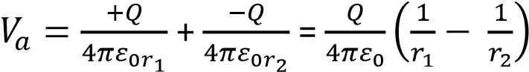

since the outer sphere is earthed 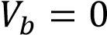
therefore the potential differnce V = 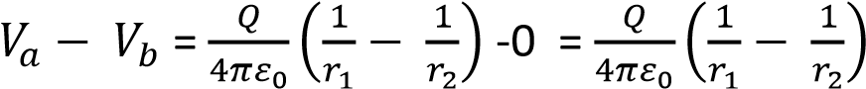
thus V = 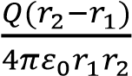
From C = , then capacitance, C = 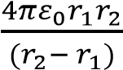

Example 2
Suppose r₂ = 10cm = 0.1m and r₁ = 9cm = 0.09m
C = 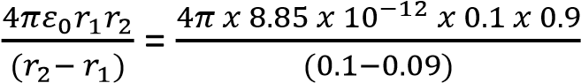 = 100pF

Relative permitivity, 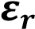 or dielectric constant
It is defined as the ratio of permitivity of a substance to the permitivity of free space
Taking the case of a parallel plate capacitor as an example, then
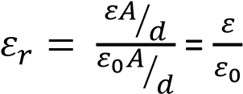
Relative permitivity is a ratio without units.

Dielectric strength
It is the maximum potential gradient that can be applied to a dielectric material without causing its insulation to break down.
Or
It is the potential gradient at which insulation of dielectric breaks downn and spark passes through it.
Note: once the insulation of dielectric breaks down, it becomes a conductor anf the capacitor becomes useless since it can long store charge.

Effect of dielectric between the plates of a charged capacotor
Introducing a dielectric into a capacitor decreases the electric field, which decreases the voltage, which increases the capacitance. A capacitor with a dielectric stores the same charge as one without a dielectric, but at a lower voltage. Therefore a capacitor with a dielectric in it is more effective.
Dielectric, insulating material or a very poor conductor of electric current. When dielectrics are placed in an electric field, practically no current flows in them because, unlike metals, they have no loosely bound, or free, electrons that may drift through the material.
Instead, electric polarization occurs. The positive charges within the dielectric are displaced minutely in the direction of the electric field, and the negative charges are displaced minutely in the direction opposite to the electric field as shown in the figure below. This slight separation of charge, or polarization, reduces the electric field within the dielectric.



𝜀

Units of 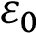
From C = 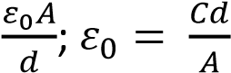
Thus, the units of 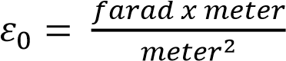 = faradmeter⁻1

Measurement of 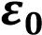



P

S

Capacitor

C

V

D

B

X

Vibrating reed switch

Galvanometer

Air

(
ε
0
)

G

The circuit above is used.
C is a parallel capacitor with are in between the plates of area A (m²) and separation, (d m)
P is a high tension of about 200V,
G is a sensitive galvanometer,
S is a vibrating switch unit, energized by a low a.c. voltage from the mains.
When operating, the vibrating bar X touches D and then B, and the motion is repeated at the mains frequency, fifty times a second.
When the switch is in contact with D, the capacitor is charged from the supply P to a potential difference of V volts, measured on a voltmeter.
When the contact moves over to B, the capacitor discharges through the galvanometer. The galvanometer thus receives fifty pulse of charge per second.
This gives an average steady current I
From C = 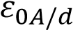
On charging the charge stored, Q = CV = 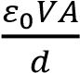
The capacitor is discharged fifty times per second. And since current is the charge flowing per second
I = 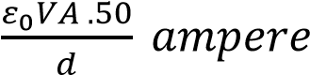
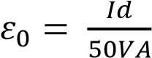 farad meter⁻¹
The following results were obtained in one experiment
A = 0.0317m², d = 1.0cm = 0.02m, V = 150V, I = 0.21 x 10⁻6A
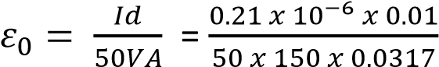= 8.8 x 10⁻¹² farad meter⁻¹

This method can also be used to find the permittivity of various material. Thus if the experiment is repeated with a material of permittivity ε completely filling the space between the plates, then
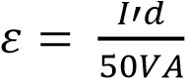 where I’ is the new current
If only the relative permittivity or dielectric constant 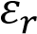 is required, there will be no need to know p.d or dimension of the capacitor. In this case
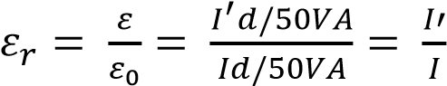
Thus 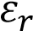 is the ratio of respective currents in G with and without the dielectric between plates. Arrangement of capacitors

)
a
(

Parallel connection

V

C
3

C
2

C
1

Q
+
2

Q
+
1

+
Q
3

In parallel each capacitor experiences the same p.d.
For charged capacitor, Q = CV
Therefore, Q₁ = C₁V; Q₂ = C₂V; Q₃ = C₃V;
The total charge, Q = Q₁ + Q₂+ Q₃ = C₁V + C₂V + C₃V = V(C₁ + C₂ + C₃)

If C is the capacitance of a single capacitor which has the same effect as these three capacitors store charge equal to Q then,
Q = CV = V(C₁ + C₂ + C₃)
C = 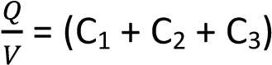
C = (C₁ + C₂ + C₃)
Therefore for capacitors in parallel, the total capacitance is the sum of individual capacitances of individual capacitor.

(b) Series connection

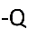

V
AB

V
DF

V
GH

V

A

B

D

F

G

H

+
Q

+
Q

+
Q

-
Q
-
Q

-
Q

C
1

C
2

C
3

On connection, the battery draws electrons from plate A and leaves it with a positive charge +Q. this induces a charge –Q on B. A and D form an isolated conductor and the charge that appears on B results from electrons moving from D to B. D is left with charge +Q and this induces a charge –Q on F, and so on.

The p.d across each capacitor is given by
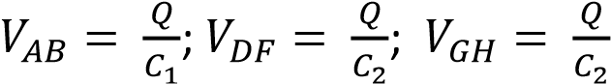;

Total voltage, V =  + 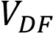 + 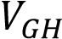
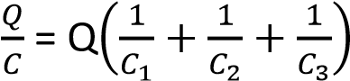
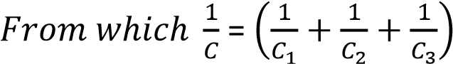

Comparison of capacitors and resistor in network
 | Capacitors in network | Resistors in network
Series connection | 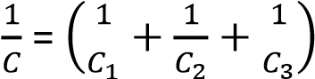 | R = (R₁ + R₂ + R₃)
Parallel connection | C = (C₁ + C₂ + C₃) | 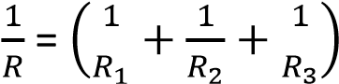

Example 3
In the figure below, two capacitors of capacitances, C₁ and C₂ of 3μF and 6μF respectively are connected across a 90V d.c. calculate the charge on C₁ and C₂, and the p.d across each.



Solution

90
V

3

μ
F

6

μ
F

C
1

C
2

The effective capacitance, c is obtained from
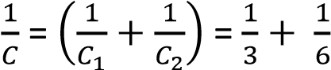
C = 2μF
Q = CV =2 x 10⁻⁶ x 90 = 1.8x 10⁻⁴ C

For C 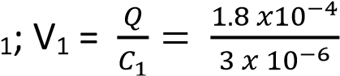= 60V and.
For C 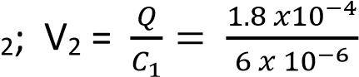= 30V

Example 4
Calculate the charge on the capacitors below and the p.d across each.


V
120

3

μ
F

4

μ
F

C
1

2

μ
F

Solution
The effective capacitance, C₁ for parallel capacitors 2μF and 4μF = 2 + 4 = 6μF.
Now 3μF and 6μF are in series and their effective capacitance C is given by
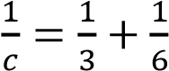
C = 2μF
For the whole circuit, Q = CV = 2 x 10⁻⁶ x 120 = 2.4 x 10⁻⁴C
The charge 3μF capacitor = 2.4 x 10⁻⁴C
The p.d across the 3μF capacitor = 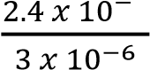 = 80V
The p.d across each either 2μF or 4μF = 120 – 80 = 40V
From Q = CV
The charge on 2μF capacitor = 40 x 2 x 10⁻⁶ = 8 x 10⁻⁵ C
Charge on 4μF capacitor = 40 x 4 x 0⁻⁶ = 1.6 x 10⁻⁴ C

Energy stored in a charged capacitor
A charged capacitor stores electrical energy. To find the energy stored, we assume that a capacitor of capacitance C is already charged to a potential difference V.
When the charge on the plates is increased from Q to Q + δQ where δQ is very small, then a charge δQ is transferred from the negative to the positive plate.
The increase in potential difference δV =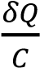
Since δQ is very small compared with Q, δV will be very small compared to V and the potential difference will be almost constant at value V.
Then the work done, δW, in displacing the charge δQ is given by
δW = VδQ
Since V = ; δW = δQ
For a fully discharged capacitor charged to a value Q1, work done is given by
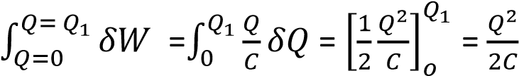
In general, the energy stored by a capacitor of capacitance C, carrying a charge Q at a potential difference V is
W = 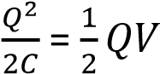
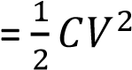
If C is in farad, Q in coulomb and V in volt, then W is in joules.

Joining two charged capacitors

S

C
₁

C
₂

When two capacitors are joined together by means of switch S, charge flows from one capacitor with greater p.d to the other until the p.d across each is the same.
The final p.d and energy of each can be calculated by considering the following
- There is no change in the total charge
- Two capacitors acquire the same p.d
- Capacitors are considered to be in parallel and therefore the effective capacitance of the combination, C = C₁ + C₂
Note that the final energy stored by the capacitors is less that the initial energy before the capacitors are joined together. This is because some energy is dissipated as heat in the connecting wires when the charge flows from one capacitor to another.

Example 5
A 5μF capacitor X is charged by a 40V supply and then connected across an charged an uncharged 20μF capacitor Y. Calculate
- Final p.d across each
- Final charge on each, and
- Initial and final energies stored by the capacitors.

Solution
The initial charge, Q₀ = CV = 5 x 10⁻⁶ x 40 = 2 x 10⁻⁴C
After connection

S

5
μ
F

20
μ
F

X

Y

V

Since the capacitors are in parallel, the effective capacitance, C = C₁ + C₂ = 5 +20 = 25μF
Initial charge = final charge
Let V be the final voltage, then
2.0 x 10⁻⁴ = 25 x 10⁻⁶V
V = 8V
- charge on 5μF capacitor = CV = 8 x 5 x10⁻⁶ = 4.0 x 10⁻⁵C
Charge of 20μF capacitor = CV = 20 x 20⁻⁶ x 8 = 1.6 x 10⁻⁴C
- from W = 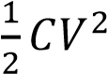
Initial energy =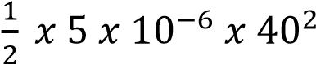 = 0.004J
Final energy = 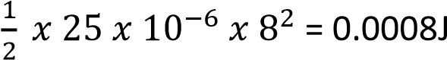
The final energy is less than the initial energy because some energy is lost as heat due to flow of charge from 5μF to 20μF

Example 6
Two parallel capacitors, one with air as dielectric and the other with mica as dielectric, are identical in all other respect. The air capacitor is charged from 400V d.c supply, isolated and then connected across the mica capacitor which is initially uncharged.
The p.d across this parallel combination becomes 50V. Assuming the relative permittivity of air to be 1.00, calculate the relative permittivity of mica.
Solution
Let C_{a} = capacitance of the air capacitor, C_{m} = capacitance of mica capacitor
Charge stored by air capacitor, Q_{a} = C_{a}V = 400C_{a} …………………..(i)
For air = 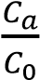 =1, where C0= capacitance of free space or vacuum.
Then, C_{a} = C₀ and,
Q_{a} = 400C_{a}
Charge store in mica capacitor before connection = 0
Therefore total initial charge = 400C_{a} + 0 = 400C_{a}……………..(ii)
After connection


S

air

mica

C
a

C
m

50
V

Total charge before = total charge after
400C_{a} = 50(Ca + C_{m})
Since C_{a} = C₀
400C₀ = 50(C₀ + C_{m})
7C₀ = C_{m}
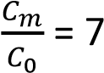
Therefore relative permittivity of mica = 7

Example 7
- Define a capacitance of a capacitor.
- Explain how, using a capacitor in conjuction with a gold-leaf electroscope, the voltage sensitivity of electroscope may be increased.
- Two capacitors, of capacitance 4μF and 2μF respectively are joined in series with a battery of e.m.f 100volts. The connections are broken and the terminals of the capacitors are then joined. Find the final charge on each capacitor.

Solution

The combined capacitance, C, of capacitors is given by
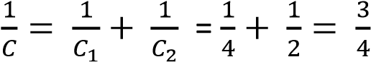
C = 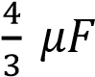
The charge on each capacitor = charge on the effective capacitance
= CV = 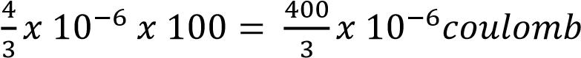
When like terminals are joined together, the p.d across each capacitor, which is different at first, becomes equilized. Suppose it reaches a p.d V, as the total charge remains constant.

Initial toatal charge = (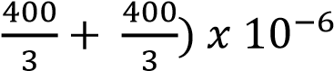 = final charge total chagre = 4 x 10⁻⁶V + 2 x 10⁻⁶
V

4 x 10⁻⁶V + 2 x 10⁻⁶ V = 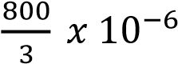
V = volts,
Therefore, the charge on 4μF capacitor = CV = 4 x 10⁻ 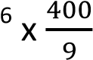= 1.78 x 10⁻⁴C
The charge on 2μF capacitore = CV = 2 x 10⁻ 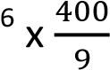= 8.89 x 10⁻⁵C

Example 8
- Define the electrostatic potential of an isolated conductor.
- Obtain an expression relating the enrgy of a charged conductor to the charge on it and its capacitance
- Two insulated spherical conductors of radii 5.00cm and 10.00cm are charged to potentials of 600volts and 300 volts respectively. Calculate (i) the total energy of the system.
  - The energy after the spheres have been connected by a fine wire.
  - Comment on the difference between the two results in C(i) and C(ii).
Solution
  - The electrostatic potential of an isolated conductor is work done to move a unit positive charge from infinity to a point in an electric field of the conductor.
  - Refer to the notes
  - (i) Capacitance C of a sphere of radius r = 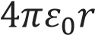
For 5cm = 0.05m radius, C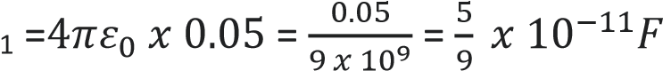
Since 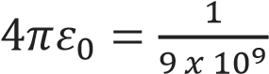
For 10cm = 0.1m radius, C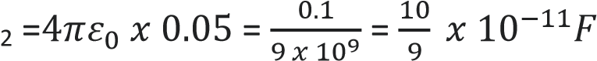
But work = 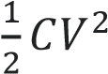
Total energy = = 1.5 x 10⁻⁶J

    - when the spheres are connected by a fine wire, the potentials become equalized
Let V be the common voltage, since Q = CV and the total charge is constant
Original total charge = total final charge
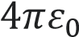(5 x 10⁻² x 600 + 10 x 10⁻² x 300) = (5 x 10⁻²V + 10 x 10⁻²V)
V = 400volts
Total final energy = 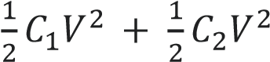
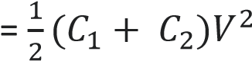
= 13.33J
    - When spheres are connected stored energy is less because part of energy is converted into heat because current flows to equalize. Example 9
- Define electrical capacitance.
- Describe experiments to demonstrate the factors which determine its value for parallel plate capacitance
- The plates of a parallel plate air capacitor consisting of two circular plates each of radius 10cm and laced 2mm apart, are connected to terminals of an electrostatic voltmeter. The system is charged to give a reading of 100 on the voltmeter scale. The space between the plates is then filled with oil of dielectric constant 4.7 and the voltmeter reading falls to 25. Calculate the capacitance of the voltmeter. You may assume that the voltage recorded by voltmeter is proportional to the scale reading.

Solution

Let V be the initial p.d across the air capacitor, and C1 be the voltmeter capacitance.

Then total charge = CV + C₁V = (C + C₁)V …………………….(i)

When the plates are filled with oil the capacitance increases to 4.7C, and the p.d falls to
V₁.
But the total charge remains constant.

From (i)
4.7CV₁ + C₁V₁ = (C + C₁)V
(4.7C + C₁)V1 = (C + C₁)V
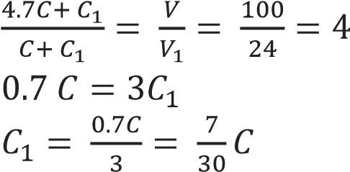
But C = 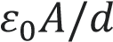, where A in meter² and d in meter

C = 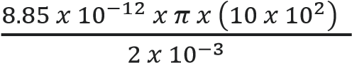 = 1.4 x 10⁻¹⁰ F
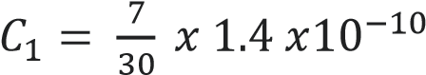= 3.3 x 10⁻¹¹ F

Discharging a capacitor through a resistor.

V
S

R
+

-

When switch, S is closed, the resistance R limits the current flow and discharge is not intataneous which makes the capacitor to discharge slowly. Thi

Determining capacitance of a capacitorusing a reed switch

S

Capacitor

C

V

A

B

X

Vibrating re
ed switch

Galvanometer

G

R

- The circuit isconnected as shown above.
- The capacitor is discharged by connecting the contact of the vibrating reed switch X with A.
- The p.d across the capacitor plates is recorded as V from the voltmeter.
- When the contact of the reed switch is ta B, the capacitor discharges rapidly and the current I flows through galvanometer is noted
- If the frequency of the vibrating switch is f;
I = charge per second= fQ ……………………………….. (i)
But Q = CV
Eqn (i) becomes I = fCV
C = 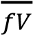
Hence the capacitance of the capacitor can be determined.

Main Uses of Capacitors
- Energy Storage o Store electrical energy and release it when needed (like a temporary battery).
  - Used in camera flashes and defibrillators for quick energy discharge.
- Filtering & Signal Processing o Smooth out voltage fluctuations in power supplies (filtering ripples in rectifiers).
  - Separate AC signals from DC in circuits (coupling and decoupling capacitors).
- Timing & Oscillators o In combination with resistors, capacitors set timing intervals in circuits (RC circuits).
  - Used in oscillators to generate signals for radios, clocks, and communication devices.
- Power Factor Correction o Improve efficiency in AC power systems by compensating for lagging current.
  - Widely used in industrial electrical systems.
- Motor Starters o Provide the phase shift needed to start single-phase induction motors (like in fans, pumps, washing machines).
- Tuning Circuits o Adjust frequency response in radios, TVs, and communication equipment.
  - Variable capacitors help tune to different stations.

(vii) Energy Pulses
o Deliver short bursts of energy in applications like welding, particle accelerators, and medical equipment.

(viii) Memory Storage
o Dynamic RAM (DRAM) in computers uses tiny capacitors to store bits of information.

Everyday Examples
- Electronics: Smartphones, laptops, TVs, radios.
- Appliances: Refrigerators, washing machines, fans.
- Medical Devices: Defibrillators, X-ray machines.
- Industrial Systems: Power grids, motor drives, welding equipment.

Revison exercerse
1. A 10.0μF capacitor charged to 200V is connected across an uncharged 50μF capacitor. Calculate the total energy stored in both capacitors before and after connection (Ans.

0.2J, 0.033J)
- A 2.5μF capacitor is charged to a p.d of 100V and is disconneted from th supply. Its terminals are then connected to shose os an uncgarged 10μF capacitor. Calculate the
  - Resulting p.d across the two capacitors. (Ans. 20V)
  - Initial and final total energy stored in then (0.0125J, 0.0025J)
- Three capacitorsof capaciances 4.0μF, 6.0μF and 12.0μF are connected in series across a
6V d.c supply. Calculate
  - The charge on 12.0μF capacitor
  - Total energy stored in the capacitors
  - P.d across the 4.0μF capacitor

[(a) 12 x 10-6C, (b) 3.6 x 10⁻⁵J, C 3.0V]
4. The capacitance of variable radio capacitor can be charged continuously from 25pF to
500pF by turning the dial from 0⁰ to 180⁰. With the dial set at 180⁰, the capacitor is
connected to a 600V battery. After charging, the capacitor is disconnected from the battery and then the dial is turned to 0⁰. Calculate the
- Charge on the capacitor’
- Energy stored in the capacitor,
- The work required to turn the dial from 180⁰ if friction I s neglected. [ans. (a) 3.0 x 10-7C, (b) 9.0 x 10⁻⁵J, (c) 1.71 x 10⁻³J]

TOPIC 6/6: DIGITAL ELECTRONICS
Competency: The learner models capacitors for use in electronic devices.

Digital electronics


Digital electronics is a branch of electronics that deals with systems and devices that process and control digital signals, which are represented by discrete values, typically binary (0s and 1s), unlike analog electronics that use continuously varying signals.
This field forms the foundation of modern electronic devices and systems like computers, smartphones, and communication systems, utilizing logic gates and other components to perform calculations and process information.
Components of digital electronic and their uses

1. Potential divider
A potential divider is any circuit arrangement used to reduce voltage by cartain fraction to suit a certain part of the circuit.
For instance, in the circuit Fig. 1 below
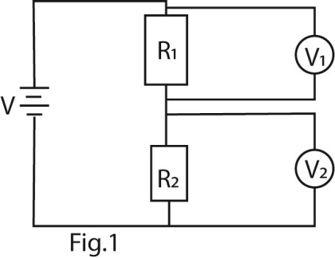
The current through the resistors is the same, therefore the voltage is divided as follows
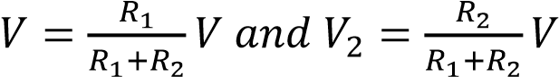
⇨ 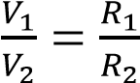
Hence, potential dividers are used to provide specific voltages to certain parts of the circuit in devices from the main voltage. They are used in smartphones, televisions,etc
Example 1.
Find the value of the varible resistor if the bulb is designed to operate at 9V in the Fig
2
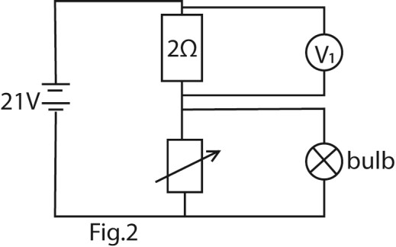
Solution
Let the resistance of the bulb be R
Resultant resistance of the bulb and the variable resistor = 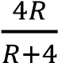
Total resistance in the circuit =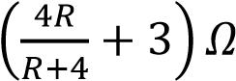
Since the variabe resistor and the bulb are in parallel each must be at 9V
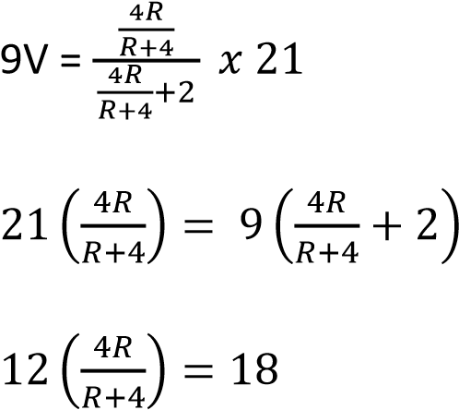
48R =18R + 72
30R = 72
R = 2.4Ω

Trial 1
Compute the missing value in the following circuits, Fig. 3

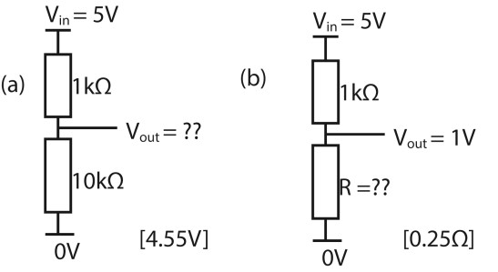

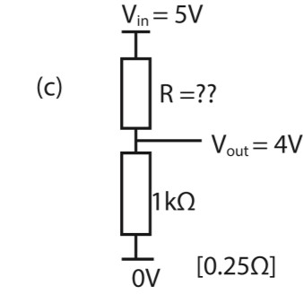
Fig. 3

Applications of potential dividers in electronic devices
- Volume Controls in Audio Devices: Turning a volume knob usually adjusts a potential divider circuit, changing the voltage sent to an amplifier and controlling sound output smoothly.
- LED Brightness Control: In some basic circuits, varying the input to an LED through a potential divider can adjust its brightness.
- Sensor Readouts: Many sensors (like temperature or light sensors) change their resistance. Combined with a fixed resistor, they form a divider that outputs a voltage representing the sensor's reading.
- Biasing Transistors: In amplifiers and other circuits, potential dividers set the correct base voltage for transistors, ensuring they operate in the right region for amplification.
- Reference Voltages for Comparators: Comparators compare an input voltage with a reference. That reference is often set using a potential divider to establish precise threshold levels.
- Battery Monitoring: To safely measure high battery voltages with a microcontroller, a potential divider scales the voltage down to within safe limits for the device’s analog inputs.

Binary System
It is the system that uses 1 to represent a true value/ on/high or conducting state and 0 to represent false value/off/low/cut off state in a circuit.
It is used in electronic to formulate and stored data, and in component such as switches and transistors can easily represent these two distinct states (on/off, conducting/cut off) or voltage levels (high/low)..

Logic gates
Logic gates are electronic switches. They take one or more input signals, (0s and 1s), and process them to produce a single binary output based on specific rules of logic. Logic gates can be represented by symbols or algebraic equations called Boolean algebra.
Logic gates are like the decision-makers of the digital world, flipping switches to make sense of 1s and 0s.

Function of logic gates
- Perform Logical Decisions: They take input values (0s and 1s) and decide the output based on logic rules—just like "if this, then that."
- Enable Arithmetic Operations: By combining a bunch of them it is possible to get adders, subtractors, and even complex arithmetic units inside processors.
- Store and Transfer Data: Using flip-flops (built from gates), they can store bits of data—essential for memory, registers, and timing.
- Control Signal Flow: In circuits, they help route signals, acting like intelligent traffic cops directing digital signals to the right destinations.
- Build Complex Systems Everything from microcontrollers to CPUs is constructed using layers and layers of logic gates working together. Types of logic gates
They are three types of basic logic gates
  - An AND gate only gives a 1 if both inputs are 1.
  - An OR gate gives a 1 if at least one input is 1.
  - A NOT gate flips the input—turns 1 into 0, and 0 into 1.
Boolean algebra, Symbols and Truth tables of of logic ates
Note:
- A truth table represents all possible combinations of inputs in a logic circuit together with their possible outcomes.
- If n is the number of inputs into a logic circuit, the total possible number of combination of inputs is givenby 2n.

(i) The AND gate
Boolean algebra: The AND gate is also known as the multiplication operation and is represented by dot (.) sign in Boolean algebra of digital logic gates. The logic operation A AND B canbe written as A.B = AB. Note that A.B = 1 if and only if both A and B have value .
Circuit symbol of AND gate
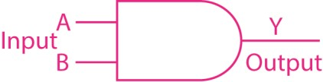
Truth table of the AND gate with two inputs
A | B | A.B
1 | 1 | 1
1 | 0 | 0
0 | 1 | 0
0 | 0 | 0
Truth table of the AND gate with three inputs

A | B | C | A.B.C
1 | 1 | 1 | 1
1 | 1 | 0 | 0
1 | 0 | 1 | 0
1 | 0 | 0 | 0
0 | 1 | 1 | 0
0 | 1 | 0 | 0
0 | 0 | 1 | 0
0 | 0 | 0 | 0

(ii) The OR gate
Boolean algebra: The OR gate is also known as the Addition operation and is represented by the plus (+) sign in Boolean Algebra of digital logic gates. The logic operation A OR B is written as A + B = B + A. Note that A + B = 1 if and only if both A and B each has a value of 1
Circuit symbol of OR gate
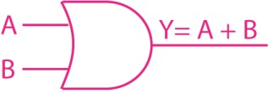
Truth table of the OR gate with two inputs
A | B | A+B
1 | 1 | 1
1 | 0 | 1
0 | 1 | 1
0 | 0 | 0
Truth table of the OR gate with three inputs

A | B | C | A.B.C
1 | 1 | 1 | 1
1 | 1 | 0 | 1
1 | 0 | 1 | 1
1 | 0 | 0 | 1
0 | 1 | 1 | 1
0 | 1 | 0 | 1
0 | 0 | 1 | 1
0 | 0 | 0 | 0

- A NOT gate
Boolean algebra:The logic operation for NOT A is represented as 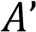 or 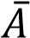 and the circuit diagram is
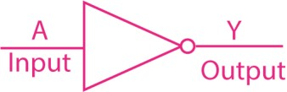
Other gates
- NAND gate
The Boolean algebra for a NAND gate expresses its logical function, which is the inverse of an AND gate, meaning it outputs a logical "0" only when all inputs are logical "1". For a two-input
NAND gate with inputs A and B, the Boolean expression is Q =  or (A . B)' or Q = ~(A * B), where the over line or apostrophe denotes the logical negation (NOT) of the AND operation.
Symbol for NAND gate
A | B | (A+B)՛
1 | 1 | 0
1 | 0 | 0
0 | 1 | 0
0 | 0 | 1
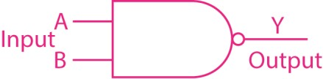
NAND

Truth table of the NAND gate with two inputs
A | B | (A.B)՛
1 | 1 | 0
1 | 0 | 1
0 | 1 | 1
0 | 0 | 1

Logic circuits
Logic circuits are the building blocks of digital electronics. They process binary signals—just 1s and 0s—to perform specific logical operations like AND, OR, and NOT.
(v) NOR gate They are decision-making tools because
The Boolean expression for a NOR gate represents the logical NOT of the OR operation of its inputs, meaning the output is true (1) only when all inputs are false (0), otherwise the output is false (0). For a 2-input NOR gate with inputs A and B, the Boolean expression is
commonly written as Q =  or (A+ B)’ or (A+B) where the over line or apostrophe denotes the logical negation (NOT) of the OR operation.
Symbol for NOR gate
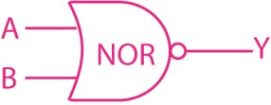
Truth table of the NOR gate with two inputs

depending on the input, they produce a certain output.
There are two main types:
- Combinational Logic Circuits These provide outputs based only on the current inputs. Examples: adders, multiplexers, encoders, and decoders.
- Sequential Logic Circuits These depend on both current inputs and past inputs (they have memory). Examples: flip-flops, counters, and registers.

Memory circuits in electronics
Memory circuits are the storage units of electronic systems—they hold data either temporarily or permanently, depending on their type. For example
- RAM (Random Access Memory) o Volatile memory, meaning it loses data when power is off.
  - Used for temporary storage while a device is running (like keeping apps open on your phone).
- ROM (Read-Only Memory)
  - Non-volatile, retaining data even without power.
  - Stores permanent instructions for a device (like firmware that boots your computer).
- Flash Memory o A kind of non-volatile memory that can be rewritten electronically. o Found in USB drives, SSDs, and
memory cards.
- Registers and Caches o Extremely fast, small memory inside CPUs for quick data access. o Help speed up processing by
minimizing delays.
- Flip-Flops and Latches o Fundamental building blocks of memory circuits in digital logic. o Each stores one bit of data and can
be combined into larger structures.

Clock signal
In sequential circuits there are many processes going on; the output of one circuit is the input of other(s). For orderly operations, the inputs and outputs have to be timed. This is done using clock signals

Definition
A clock signal is a periodic electric signal that oscillates between high and low states
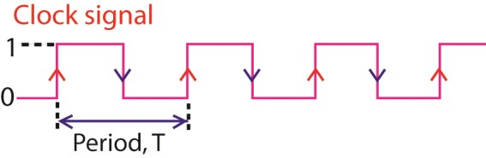
Clock signals are heartbeats of digital circuits. They synchronize digital circuits, ensuring that data is processed and transferred at the right time. Functions of the clock
A clock controls when data is moved, stored, or processed in devices like microcontrollers, processors, and memory. Each pulse tells the system, “Now is the time to act!”

Components where timing is required in electronic devices
- Microprocessors (keeping all tasks in sync)
- Flip-flops and counters (updated on clock edges)
- Communication circuits (timing data transmission)
- Digital watches and timers (literally counting the seconds)

Clock signal characteristics
- Clock Signal: is a repetitive square wave (alternating HIGH and LOW states) used to control the timing of operations in circuits.
- Clock source: It is where clock signal originates. It can be a port of design or a pin of cell inside the design. It is usually generated by crystal oscillator, phase-locked loop (PLLs) or external clock in some systems
- Clock Pulse: A single cycle of the clock signal—used to trigger or advance operations in sequential logic like flipflops or counters.
- Clock Frequency: The number of clock cycles per second, measured in Hertz (Hz). Higher frequency means faster operations. It determines how often a
clock signal switches between high • Rising edge: LOW → HIGH
and low states. • Falling edge: HIGH → LOW Many
- Clock Period: The time it takes for one circuits are edge-triggered, full clock cycle. It indicates time after meaning they respond only which the clock repeats its behaviors. when a specific edge occurs.
It's the inverse of the frequency
(Period = 1/Frequency).
- Rising Edge / Falling Edge Refers to transitions in the clock signal:

- Duty Cycle The percentage of time the clock signal stays HIGH during each cycle.
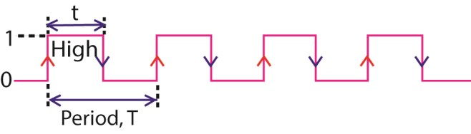
In the diagram above duty cycle 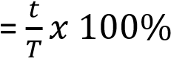
Example 2
Calculate the duty time in clock pulses below:
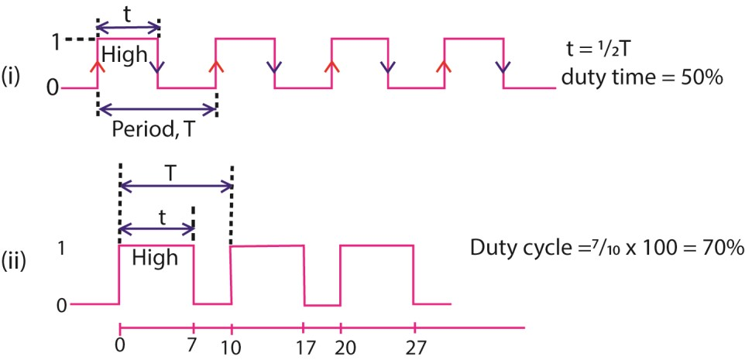
(viii) Asynchronous / Synchronous
Most complex designs requre more than one clock. When there are multiple clocks in a desgn, they would need to interact or share a relationship. This relationship can be synchronous or asychronous.
- Synchronous clock share a fixed phase relationship, as they are often derived from the same source.
- Asynchronous clocks do not share a fixed phase relationship.
- Clock Skew A small delay difference in clock signals reaching different parts of a circuit. Too much skew can cause timing errors.
- Clock Divider A circuit that reduces a high-frequency clock signal into a slower one—used when different parts of a system need different speeds.

Vitual clock
Vitual clocks are clocks that don’t physically exist in the specific block but represent an external trigger that impacts the timing of the clock.

Types of clock pulse
- Single Pulse (One-Shot Pulse)
  - A solitary high signal generated in response to a trigger.
  - Useful for initiating a single action, like flipping a flip-flop once.
- Continuous Pulse (Free-Running Clock)
  - A regular stream of pulses at a fixed frequency—typical in microprocessors and timers.
  - Generated by oscillators, crystals, or clock generator ICs.
- Gated Clock
  - A clock pulse that can be turned on/off by an enable signal.
  - Helps conserve power or coordinate multiple subsystems.
- Edge-Triggered Pulse
  - Devices respond on either the rising edge (LOW to HIGH) or the falling edge (HIGH to LOW) of the clock pulse.
  - Common in flip-flops and counters.
- Duty-Cycled Clock
  - The pulse has a specific high/low ratio (e.g. 50% duty cycle for even on/off times).
  - Affects timing and energy consumption in circuits.
- Variable Frequency Clock
  - The frequency of the pulses can change during operation.
  - Seen in adaptive systems like dynamic CPU scaling.

Multivibrators circuits
Multivibrator is circuit in electronics used to generate and manipulate signals. It is like the rhythm section in a band—providing beats or holding a state until the next cue.
There are three main types, each with a unique personality:
- Astable multivibrator is a freerunning multivibrator that has NO stable state but switches continuously between two states; this action produces a train of square pulses at a fixed known frequency. The time for which the output remains in a particular state can be decided by

passive components like a resistor and a capacitor. It is like a blinking light that never stops—it’s always on the move.
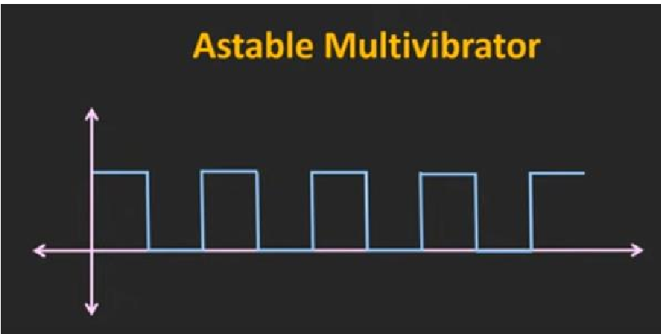
Used for: generating square waves, LED flashers, clock signals.
- Monostable Multivibrator is a one short multivibrator that has only ONE stable state and one temporary state. Once externally triggered it returns to its first stable state

Used for: timers, pulse stretching, delay circuits. For instance, a camera flash: press the button (trigger) → bright flash (temporary state) → back to normal.
- Bistable Multivibrator
Bistable multivibrator has two stable states; it toggles between them when triggered.
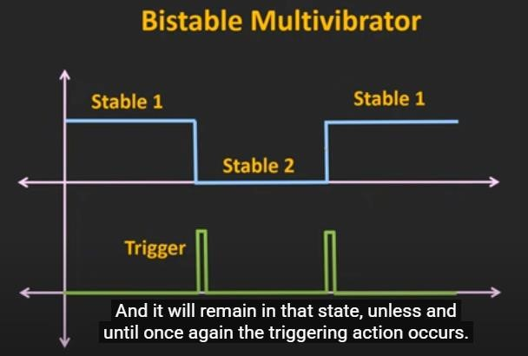

Used for: memory storage, flip-flops, switch debouncing. This is the basis for storing binary data—just a fancy way of saying ON or OFF.

Classification of substances as conductors, insulators and semiconductors in terms of energy band gaps
An energy band gap (or bandgap) is a forbidden energy range in a solid where no electron states exist, separating the filled valence band (where electrons are bound) from the empty conduction band (where electrons can move freely). It's the minimum energy an electron needs to jump from the valence band to the conduction band, determining if a material

is a conductor (no gap), semiconductor (small gap), or insulator (large gap
- Conductors (Metals): Have no band gap; the valence and conduction bands overlap, allowing electrons to move freely.
- Semiconductors (e.g., Silicon): Have a small, finite band gap, meaning electrons can jump to the conduction band with some energy (heat, light).
- Insulators (e.g., Glass): Have a very large band gap, making it extremely difficult for electrons to jump to the conduction band, hence poor conductivity.
How semiconductors conduct electricity.
Silicon and germanium for example are tetravalent. They have four electrons in their outermost shell, called valence electrons. One valence electron is shared with each of four surrounding atoms in a tetrahedral arrangement, forming 'covalent bonds' which maintain the crystalline solid structure. Fig. 4 is a two-dimensional representation of the silicon structure.
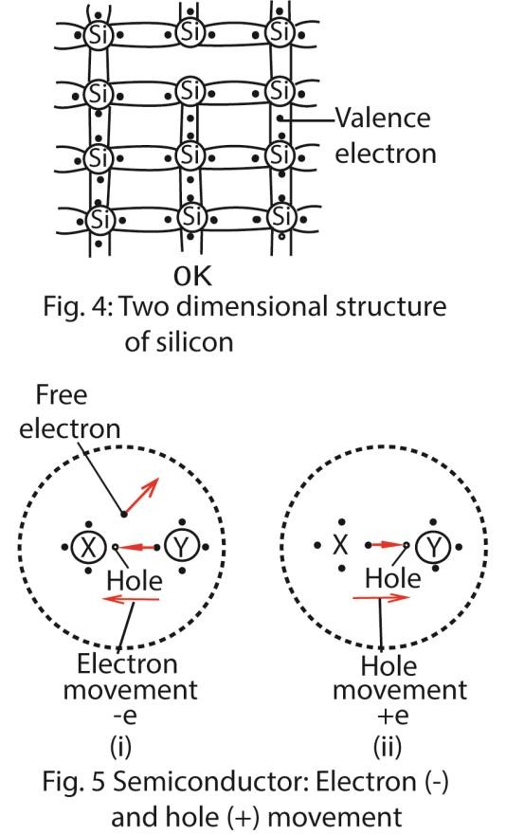
At 0 K, all the valence electrons are firmly bound to the nucleus of their particular atom. At room temperature, however, the thermal energy of a valence electron may become greater than the energy binding it to its nucleus. The covalent bond is then broken. The electron leaves the atom, X say, and becomes a free electron. This leaves X with a vacancy or hole. Fig. 5 (i). Since X now has a net positive charge, an electron in a neighboring atom may then be attracted. Thus the hole appears to move to
Y.
The hole movement through a semiconductor is random. But if a battery is connected, the valence electrons are urged to move in one direction and to fill the holes. The holes then drift in the direction of the field. Thus the holes move as if they were carriers with a positive charge + e, where e is the numerical value of the charge on an electron. Fig. 5 (ii). The current in the semiconductor is also carried by the free electrons present. These are equal in number to the holes in a pure semiconductor and drift in the opposite directions since they are negative charges. The mobility of an electron, its average velocity per unit electric field intensity, is usually much greater than that of a hole.
It should be noted that, in a pure semiconductor, there are equal numbers of electrons and holes. Electron-hole pairs are said to be produced by the movement of an electron from bound state in an atom to a higher energy level, where it becomes a free electron.

Effect of temperature on resistance of conductors and semiconductors
For conductors; increase in temperature increases the resistance because it increases the vibrations of atoms that impede movement of electrons.
For nonconductors, increase in temperature decreases the resistance because it breaks the covalent bonds to produce more electron-hole pairs that act as carriers of current.

Doping of semiconductors
It is an intentional introduction of impurity atoms (dopants) into pure (intrinsic) semiconductors (silicon or germanium) in order to increase and control their conductivity.

Doping Method
It is done via thermal diffusion in a furnace, by introducing dopant gases like Boron tribromide or Phosphoryl chloride.
N-Type Semiconductor Formation (Negative)
Dopant Type: Pentavalent impurities
(Group 15 elements like
Phosphorus (P), Arsenic (As), Antimony (Sb))
Mechanism: A pentavalent atom replaces a silicon atom, forming four bonds with neighbors, but has one extra valence electron.
Result: This extra electron is loosely bound and easily moves into the conduction band, becoming a free charge carrier.
Majority Carriers: Electrons (negative).
N-type semiconductors offer advantages like higher conductivity due to abundant free electrons, enabling faster current flow, making them great for digital electronics like transistors and diodes.

P-Type Semiconductor Formation
(Positive)
Dopant Type: Trivalent impurities (Group 13 elements like Boron (B),
Aluminum (Al), Gallium (Ga)).
Mechanism: A trivalent atom replaces a
 | silicon atom, forming only three bonds, leaving a missing electron in the fourth bond, known as a "hole".
Result: | Nearby electrons jump into this hole, effectively making the hole move, behaving like a positive charge carrier.
Majority Carriers: Holes (positive).

P-N Junction
It is made by fusing p- and nsemiconductors to form a boundary or junction between them.
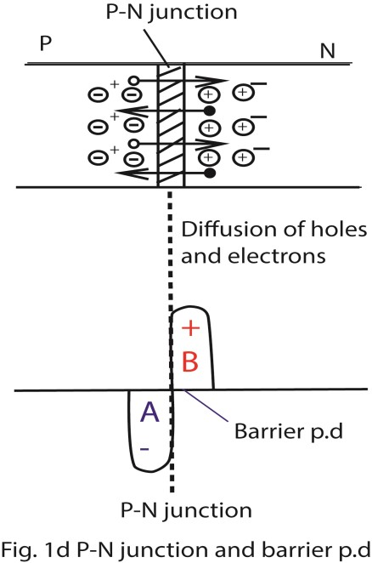

Fig. 6
.

P
–

N
junction and
barrier

p
.
d

During the process of junction formation, the high concentration of holes (positive charges) on one side of a p-n junction, and the high concentration of electrons on the other side, causes the two carriers to diffuse respectively to the other side of the junction, as shown in Fig. 6
The electrons which move to the psemiconductor side recombine with holes there. These holes therefore disappear, and an excess negative charge A appears on this side as shown in figure (ii).
In a similar way, an excess positive charge B builds up in the n- semiconductor when holes diffuse across the junction.
Together with the negative charge A on the p-side, an e.m.f. or p.d. is produced which opposes the diffusion of charges across the junction. This is called a barrier p.d. and when the flow ceases it has a magnitude of a few tenths of a volt.

Junction Diode
When a battery B, with an e.m.f greater than the barrier p.d., is joined with its positive pole to the p-semiconductor, P, and its negative pole to then-semiconductor, N, p-charges (holes) are urged across the p-n junction from P to N and n-charges
(electrons) from N to P. Fig. 7 (i) below.
Thus an appreciable current is obtained. The p-n junction is now said to be forwardbiased, and when the applied p.d. is increased, the current increases.
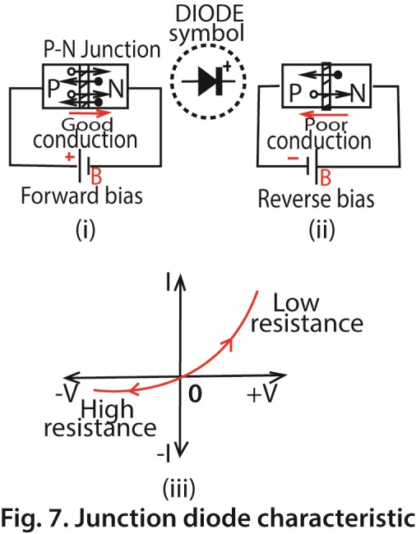
When the poles of the battery are reversed only a very small current flows as shown in Fig. 7. (ii) above. In this case the p-n junction is said to be reverse-biased. This time only the minority carriers, negative charges in the p-semiconductor and positive charges in the n-semiconductor, are urged across the p-n junction by the battery. Since the minority carriers are thermally-generated, the magnitude of the reverse current depends only on the temperature of the semiconductors.
It can now be seen that the p-n junction acts as a rectifier. It has a low resistance for one direction of p.d. and a high resistance for the opposite direction, as shown by the characteristic curve in Fig. 7(iii).
It is therefore called a junction diode.

Advantages of Junction diode over diode valve
- It low voltage battery B to function.
- It does not need time to warm up
- It less bulky
- Cheaper to manufactures
On this account, the junction diode has replaced the diode valve in receivers.

Characteristics of Junction diodes
- Unidirectional Current Flow: Conducts current primarily in one direction (Anode to Cathode) and blocks it in the opposite.
- Anode & Cathode: Two terminals; the arrow in the symbol points from the positive anode to the negative cathode.
- Forward Bias: When positive voltage is applied to the anode, current flows easily (low resistance) after overcoming a small threshold voltage (e.g., ~0.7V for silicon).
- Reverse Bias: When negative voltage is applied to the anode, the diode acts as an insulator (high resistance), blocking current.
- Forward Voltage Drop (Vf): The small, relatively constant voltage drop across the diode when conducting forward current (e.g., 0.7V for silicon, 0.3V for germanium).
- Reverse Breakdown: If reverse voltage exceeds a specific limit (Peak Inverse Voltage - PIV), the diode breaks down, allowing large reverse current, potentially damaging it.
- I-V Curve: A graph showing current (yaxis) vs. voltage (x-axis), illustrating the sharp turn-on in forward bias and the blocking/breakdown in reverse bias.

Zener Diode
In Zener diodes both forward and reverse biases cause an increase in conduction across a p-n junction as shown in the Fig. 8 (i) below.
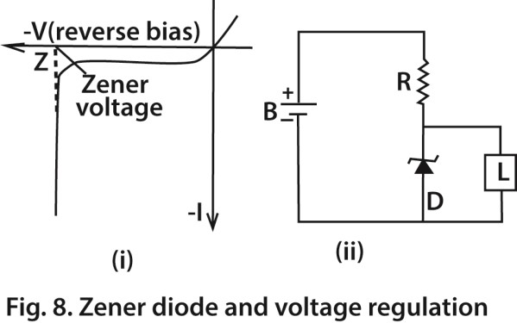
The increase in conduction of reverse bias (Zener effect, after the discoverer) is partly due to the high electric field which exists across the narrow p-n junction at the breakdown or Zener voltage Z, which drags more electrons from their atoms and thus increases considerably the number of electron-hole pairs. Ionization by collision also contributes to the increase in carriers.
Zener diodes are used as voltage regulators or stabilizers in circuits. In Fig. 8. (ii), a suitable diode D is placed across a circuit L. Although the battery supply B may fluctuate, and produce changes of current in L and D, if R is suitably chosen, the voltage across D remains practically constant over a reverse current range of tens of milliamperes at the Zener voltage. The voltage across L thus remains stable.

Applications by Diode Type
- Rectifier Diodes: Convert alternating current (AC) to direct current (DC) in power supplies, battery chargers, and automotive alternators.
- Zener Diodes: Maintain a constant voltage, protecting circuits from overvoltage and providing stable reference voltages.
- Light-Emitting Diodes (LEDs): Produce light for indicators, displays, and general illumination; also used in laser diodes for pointers, scanners, and optical communication.
- Photodiodes: Detect light, used in light sensors, solar cells, and optical receivers.
- Switching Diodes: Enable rapid switching in digital circuits, logic gates (AND, OR, NOT), and high-frequency applications.
- Varactor/Variable Capacitance Diodes: Used in voltage-controlled tuning circuits, like in radios.

General Functions of diodes
- Power Conversion: Rectifying AC to DC for electronics.
- Protection: Preventing current from flowing the wrong way (reverse polarity).
- Signal Processing: Demodulating radio signals to extract audio/data.
- Sensing: Detecting light, temperature, or other physical changes.

The Transistor
The transistor is a current amplifier. A transistor is made from three layers of p- and n-semiconductors. They are called respectively the emitter (E), base (B) and collector (C). Fig. 9. (i) illustrates a p-n-p transistor, with electrodes connected to the respective three layers.
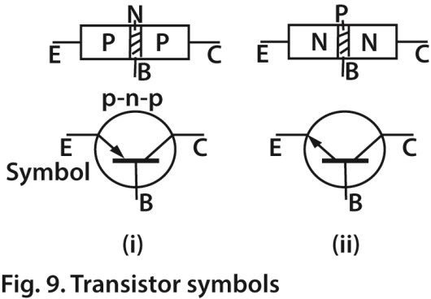
In n-p-n transistor, the emitter is n-type, the base is p-type and the collector is ntype. Fig. 9. (ii). The base is deliberately made very thin in manufacture.
The transistor, like the triode valve, is thus a three-terminal device. Fig. 9.(i) and (ii) shows the circuit symbols for p-n-p and n-pn transistors respectivly. In an actual transistor, the collector terminal is displaced more than the others for recognition or has a dot near it.

Common-Base. (C-B) Arrangement
The transistor may be regarded as two p-n junctions back-to-back. Fig. 41.24 (i) shows batteries correctly connected to a p-n-p transistor. The emitter-base is forward-biased; the collector-base is reverse-biased; and the base is common. This is called the commonbase (C-B) mode of using a transistor. Note carefully the polarities of the two batteries. The positive pole of the supply voltage X is joined to the emitter E but the negative pole of the supply voltage Y is joined to the collector C.
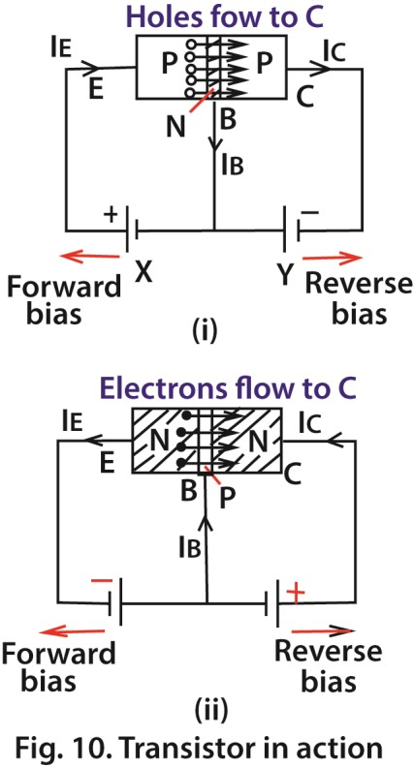
If batteries are connected the wrong way round to a transistor the latter may be seriously damaged. In the case of a n-p-n transistor, therefore, the negative pole of one battery is joined to the emitter and the positive pole of the other is joined to the collector. Fig. 10. (ii).
Consider Fig. 10. (i). Here the emitter-base is forward biased by X, so that positive charges or holes flow across the junction from E to the base B. The base is so thin, however, that the great majority of the holes are urged across the base to the collector by the battery Y. Thus a current Ic flows in the collector circuit. The remainder of the holes flow in the base circuit, so that a small current 1_{B} is obtained here. From Kirchhoff's first law, it follows that, if I_{E} is the emitter current,
IE = lC + lB
Typical values for a.f. amplifier transistors are:
I_{E} = 1 ·0 mA, I_{C} = 0·98 mA, I_{B} = 0·02 mA.
Although the action of n-p-n transistors is similar in principle to p-n-p transistors, the carriers of the current in the former case are mainly electrons and in the latter case holes. Electrons are more speedy carriers than holes . Thus n-p-n transistors are used in high-frequency circuits, where the carriers are required to respond very quickly to signals.

Common-Base Characteristics
The behaviour of a particular transistor in the common-base arrangement can be obtained from its characteristic curves. Fig. 11 shows a circuit for determining the curves. V_{CC} represents the supply voltage, for example 9 V; A₁, A₂ are current measuring instruments; V are voltmeters; and the two potentiometers of 1 megohm and 50 kilohm are used to vary the input or emitter current, I_{E}.
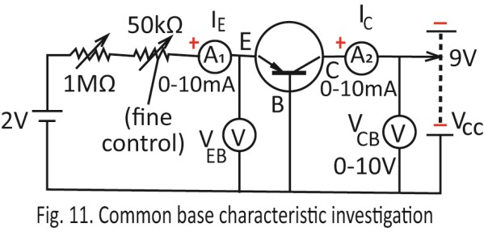
The more important curves are:
- Output characteristics (I_{C} v. V_{CB}, with I_{E} constant),
- input characteristics (I_{E} v. V_{EB}, with V_{CB} constant),
- transfer characteristics (I_{C} v. I_{E}, with
V_{CB} constant). Are shown below
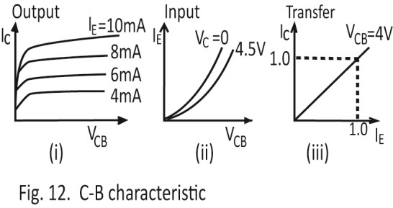
Typical results are shown in Fig. 12. (i), (ii),
(iii).
- The flat output characteristics in Fig. 12 (i) show that the output resistance,
V_{CB}/ I_{E} is high.
- The input resistance, V_{EB}/I_{E}, varies with the slope of the curve in 12. (ii) and is generally low.
- From the straight line graph of the transfer characteristic in Fig. 12(iii), it follows that a linear relation exists
between I_{C} and I_{E}·

Common-Emitter (C-E) Arrangement
The slope of the transfer characteristic in Fig. 12 (iii) provides the current gain of the
transistor, I_{C}/I_{E}· It is practically 1, showing that the common-base arrangement is unsuitable for current amplification. Now in a typical transistor, as already seen, l_{C}= 0·98 mA and I_{B} = 0·02 mA. Thus l_{C} is 49 times as large as 1_{B} and a similar order of magnitude for current gain occurs with changes in I_{B}. On this account the common-emitter (or grounded-emitter) arrangement is widely used in a.f. amplifiers. Fig. 13 shows a circuit for determining the output characteristics, input characteristics and transfer characteristic in the common-emitter (C-E) arrangement.
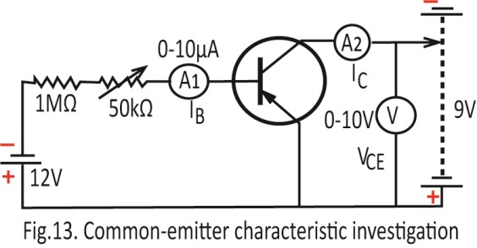
The results are shown in Fig. 14 (i), (ii), (iii).
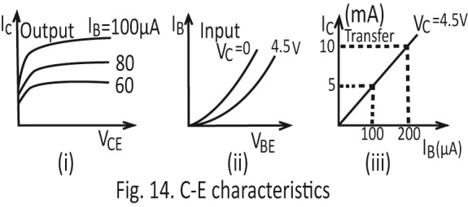
Output characteristic: Since the knee of the curve occurs at a low voltage of the order of 1 V, only low battery supply voltages are needed to operate a transistor in the linear region beyond the knee. This is an advantage of the transistor compared with the valve. Further, the small slope of the straight line shows that the output resistance is high. Thus although the load in the collector circuit may vary, the collector current is constant for a given alternating input or base current. Hence the transistor can be considered as a constant current generator in circuitry, whereas the triode valve is treated as a constant voltage generator with a given input
Transfer characteristic:The output current l_{C} varies fairly linearly with the input current I_{B}, The current gain, denoted by β, is the ratio I_{C}/I_{B}, V_{C} constant. From Fig. 14 (iii), β = (10-5) mA/(200-100) µA = 50. The reader should note that 'current amplification' usually refers to variations in current in amplifier circuit analysis. The
ratio I_{C}/I_{B} provides the d.c. current amplification.
Input characteristic: The input resistance, r_{i}, is the ratio V_{BE}/I_{B} with V_{C} constant. It varies at different points of the curve and has a medium value such as 10000 or 1 kΩ.

Relation between Current Gain in C-E and C-B Arrangements
In the C-B arrangement, the current gain is denoted by α and is the ratio l_{C}/I_{E}. In the C-E arrangement, the current gain is denoted by β and is the ratio l_{C}/I_{B}.
Since, I_{E} = l_{C}+l_{B}, hence I_{E} = l_{C} + l_{B}. Using I_{C}/I_{B} = β , then IB = I_{C}/β. Thus, by substitution for I_{E} = l_{C} + l_{B},
I_{E} 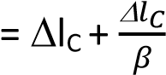
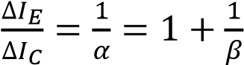
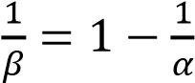
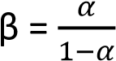 …………………………………..(i)
If α = 0.98, then 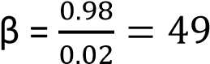 from (i)

Leakage Current
When the base current I_{B} is zero, some current still flows in the collector circuit in the common-emitter arrangement. This is due to the minority carriers present in the collector-base part of the transistor, which is reverse-biased. The collector current when I_{B} is zero is denoted by I_{CE0} and is called the leakage current.
In the common-base arrangement, the leakage current obtained when I_{E} is zero is denoted by I_{CB0}. This is also due to minority carriers in the collector-base, which is reverse-biased. Thus the leakage current flows when a transistor is in the C-E or C-B arrangement.
Since the current gain pin the C-E arrangement is the ratio I_{C}/I_{B}, with the usual notation, it follows that, generally,
I_{C} = βI_{B} + I_{CE0}……………………………..(i)
Similarly
I_{C} = αI_{E} + I_{CB0}……………………………..(ii)
Now any change in I_{CE0} or minority carriers is magnified β times in the C-E arrangement, since I_{CEO} also flows in the base-emitter circuit when the transistor is operating. A temperature change from 25°C to 45°C, which would increase the current I_{CE0} by 10 µA say, would thus be amplified to about 49 x 10 µA or 490 µA, if β is 49. This increase in current, nearly 0·5 mA, would have a considerable effect on the output in the collector circuit, and it would lead to a distorted output, for example.
On the other: hand, α= 0·98 for the same transistor. Thus in the C-B arrangement, a similar temperature rise and current increase of 10 µA would produce a change in 0·98 x 10 µA, or nearly 10 µA, in the output or collector circuit. This is only a very small change compared to the C-E case. On this account the C-E arrangement, which is very sensitive to temperature change, must be stabilized for excessive temperature rise. Silicon transistors are much less sensitive to temperature change than germanium transistors and are hence becoming used more widely.
Simple C-E Amplifier Circuit Fig. 15 shows a p-n-p transistor in a simple or basic C-E arrangement. It uses one battery supply, V_{CC}. A load, R_{L}, is placed in the collector or output circuit. A resistor R provides the necessary bias, V_{BE}, for the base-emitter circuit.
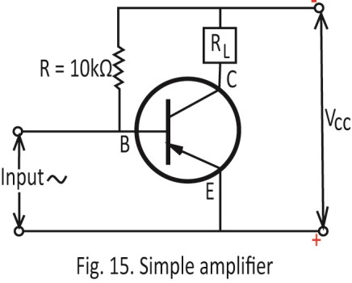
The base-emitter is then forward-biased but the collector-base is reverse-biased, that is, the potential of B is negative relative to E but positive relative to C.
Suppose a small signal is applied, so that the base current changes by an amount I_{B}. Then I_{C} changes by βI_{B}.
voltage gain = 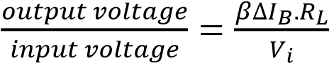
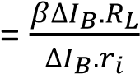 where is input resistance or resistance to a.c between base-emitter.
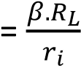
If β = 49, R_{L} = 4700 Ω, r_{i} = 1000 Ω, the voltage gain = 49 x 4·7 = 230 (approx.).
C-E Amplifier Circuit In practice, Fig. 15 is unsuitable as an amplifier circuit since there is no arrangement for temperature stabilization. A more reliable C-E a.f amplifier circuit is shown in Fig. 16. Its principal features are:
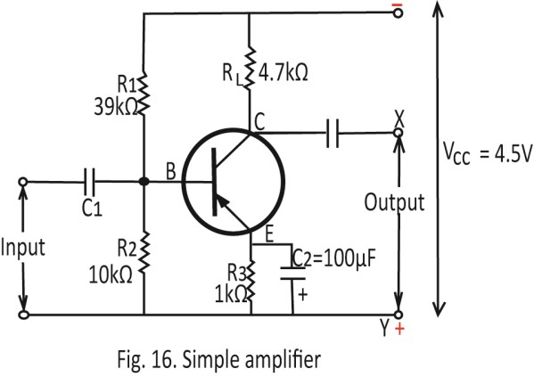
- V_{CC} =4·5V a potential divider arrangement, R₁, R₂, which provides the necessary base-bias;
- a load R_{L} which produces the output across X, Y;
- a capacitor C₁ which isolates the d.c. component in the input signal from the circuit ;
- a large capacitor C₂ across a resistor R₃, which prevents undesirable feedback of the amplified signal to the base-emitter circuit;
- an emitter resistance R₃, which stabilizes the circuit for excessive temperature rise. Thus if the collector current rises, the current through R₃ increases. This lowers the p.d. between E and B, so that the collector current is automatically lowered.

Transistor Oscillator Circuit
Like the triode valve, a transistor can be arranged to provide 'positive feedback' to an oscillatory (L-C) circuit. Oscillations in the L-C circuit can thus be maintained.
Fig. 17 shows one form of transistor oscillator circuit.

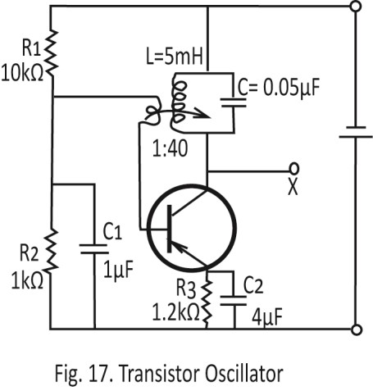
Its main features are:
- a coil-capacitor, L-C, load in the collector circuit;
- positive feedback through the coil L₁ to maintain the oscillations in the L-C
circuit;
- a potential divider arrangement, R₁,
R₂, to provide the necessary base bias;
- an emitter resistor R₃ to stabilize the circuit for excessive temperature rise ;
- large capacitors C₁ and C₂ across R₂ and R₃ respectively, which prevent undesirable feedback to the base circuit.
Approximately, the frequency of oscillation is given by 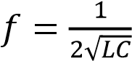, in this case an audiofrequency. Other frequencies may be obtained by changing the magnitude of C.

Thermistor
A thermistor is a heat-sensitive resistor usually made from semiconductor materials which have a high negative temperature coefficient of resistance. Its resistance thus decreases appreciably with temperature rise.
One use of a thermistor is to safeguard against current surges in circuits where this could be harmful, for example, in a· circuit where the heaters of radio valves are in series.
A thermistor, T, is included in the circuit, as shown (Fig. 18). When the supply voltage is switched on, the thermistor has a high resistance at first because it is cold. It thus limits the current to a moderate value. As it warms up, the thermistor resistance drops appreciably and an increased current then flows through the heaters. Thermistors are also used in transistor receiver circuits to compensate for excessive rise in collector current.
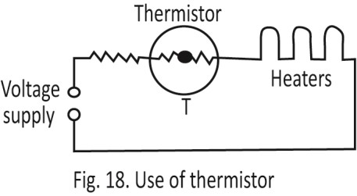

Phototransistor
A photodiode is a junction diode sensitive to light. When the diode is reverse- biased, minority carriers flow in the circuit and constitute a so-called 'dark· current. If the junction of the diode is now illuminated, the light energy produces more electronhole pairs, which are then swept across the junction. The increased current which flows is the 'light' current.
A phototransistor is a transistor sensitive to light in which the base is usually left disconnected. When light falls on the emitter side, more electron-hole pairs are produced in the base. This is amplified by transistor action, and a larger collector current is obtained. In principle the phototransistor is a photodiode plus amplifier.

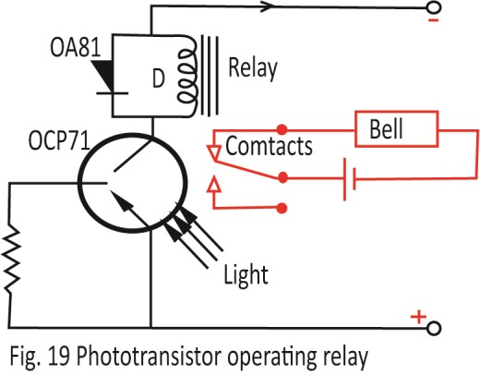
Fig. 19 shows a circuit in which a Mullard phototransistor OCP71 is connected in series with a relay coil D and a d.c. supply voltage .
When the photo- transistor is illuminated, the increase in collector current closes the contacts of a magnetic relay. Current then flows in a circuit connected to the relay, and a bell, for example, may then ring. Fig. 19. When the light is switched off, the falling current in the relay coil produces an induced voltage in the same direction as the battery supply. This would raise the collector voltage and prevent the switch-off at the contacts. The diode OA81 across the coil acts as a safeguard. As soon as the rising induced voltage becomes equal to the battery voltage the diode conducts, and prevents any further rise in collector voltage.

Common Applications of transistors
- Computing: Billions of transistors make up microprocessors (CPUs) and memory chips (RAM).
- Communication: Amplifying signals in cell phones, radios, and Wi-Fi devices.
- Power Control: Regulating power in power supplies, managing motors, and converting energy in solar systems (inverters, charge controllers).
- Signal Generation: Creating precise frequencies for clocks and oscillators in digital devices.
- Automotive: Used in engine control, power windows, and electronic systems in modern vehicles.
- Healthcare: Powering wearable health monitors and pacemakers.

Revision exercise
1. Explain, with reference to the carriers, the effect of temperature rise on the resistance of a pure metal and on the resistance of a pure semiconductor. 2. Explain what is meant by
(i) a p- and a n-semiconductor. (ii) a p-n junction.
- Draw a sketch of the characteristic of a p-n junction diode. Explain, in terms of the movement of carriers, why the resistance of the diode is low in one direction and high in the reverse direction.
- Draw a sketch of a p-n-p transistor used in
  - a common-base (CB) and
  - a common-emitter (CE) arrangement, showing clearly the· polarities of the batteries. Explain why the commonemitter arrangement is
preferred in an a.f. amplifier circuit.
- Draw a circuit showing how the collector current-collector voltage and the emitter current-emitter voltage characteristics of a transistor can be found for the common-emitter (CE) arrangement. Sketch the characteristics obtained. Draw a sketch of a simple CE a.f. amplifier.

